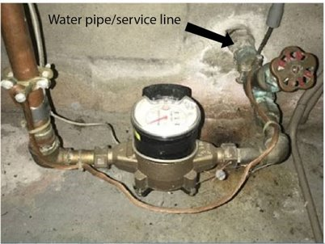 | How do you know if there’s lead in your water? Check out #ProtectYourTap, an online guide created by USEPA to help homeowners and renters identify lead pipes and reduce exposure to lead in drinking water:  epa.gov/protectyourtap #PYT <your website>  <other hash tags>
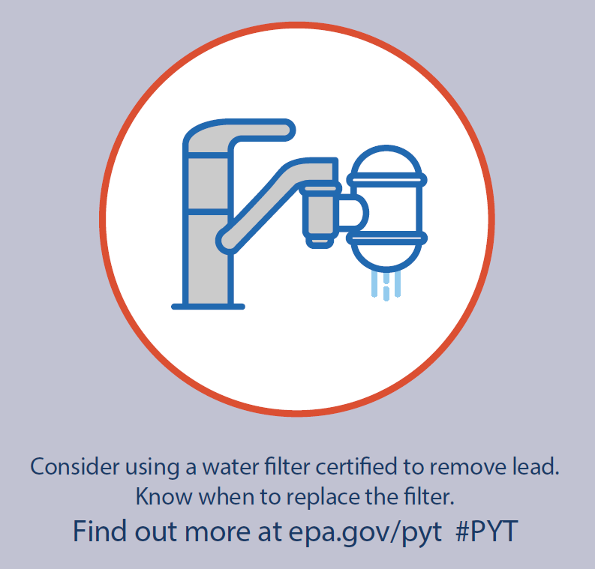 | Water filters that are certified to remove lead will help reduce potential lead exposure. Learn more about lead in drinking water and how to identify lead pipes with this online guide: epa.gov/protectyourtap #ProtectYourTap  #PYT  <other hash tags>
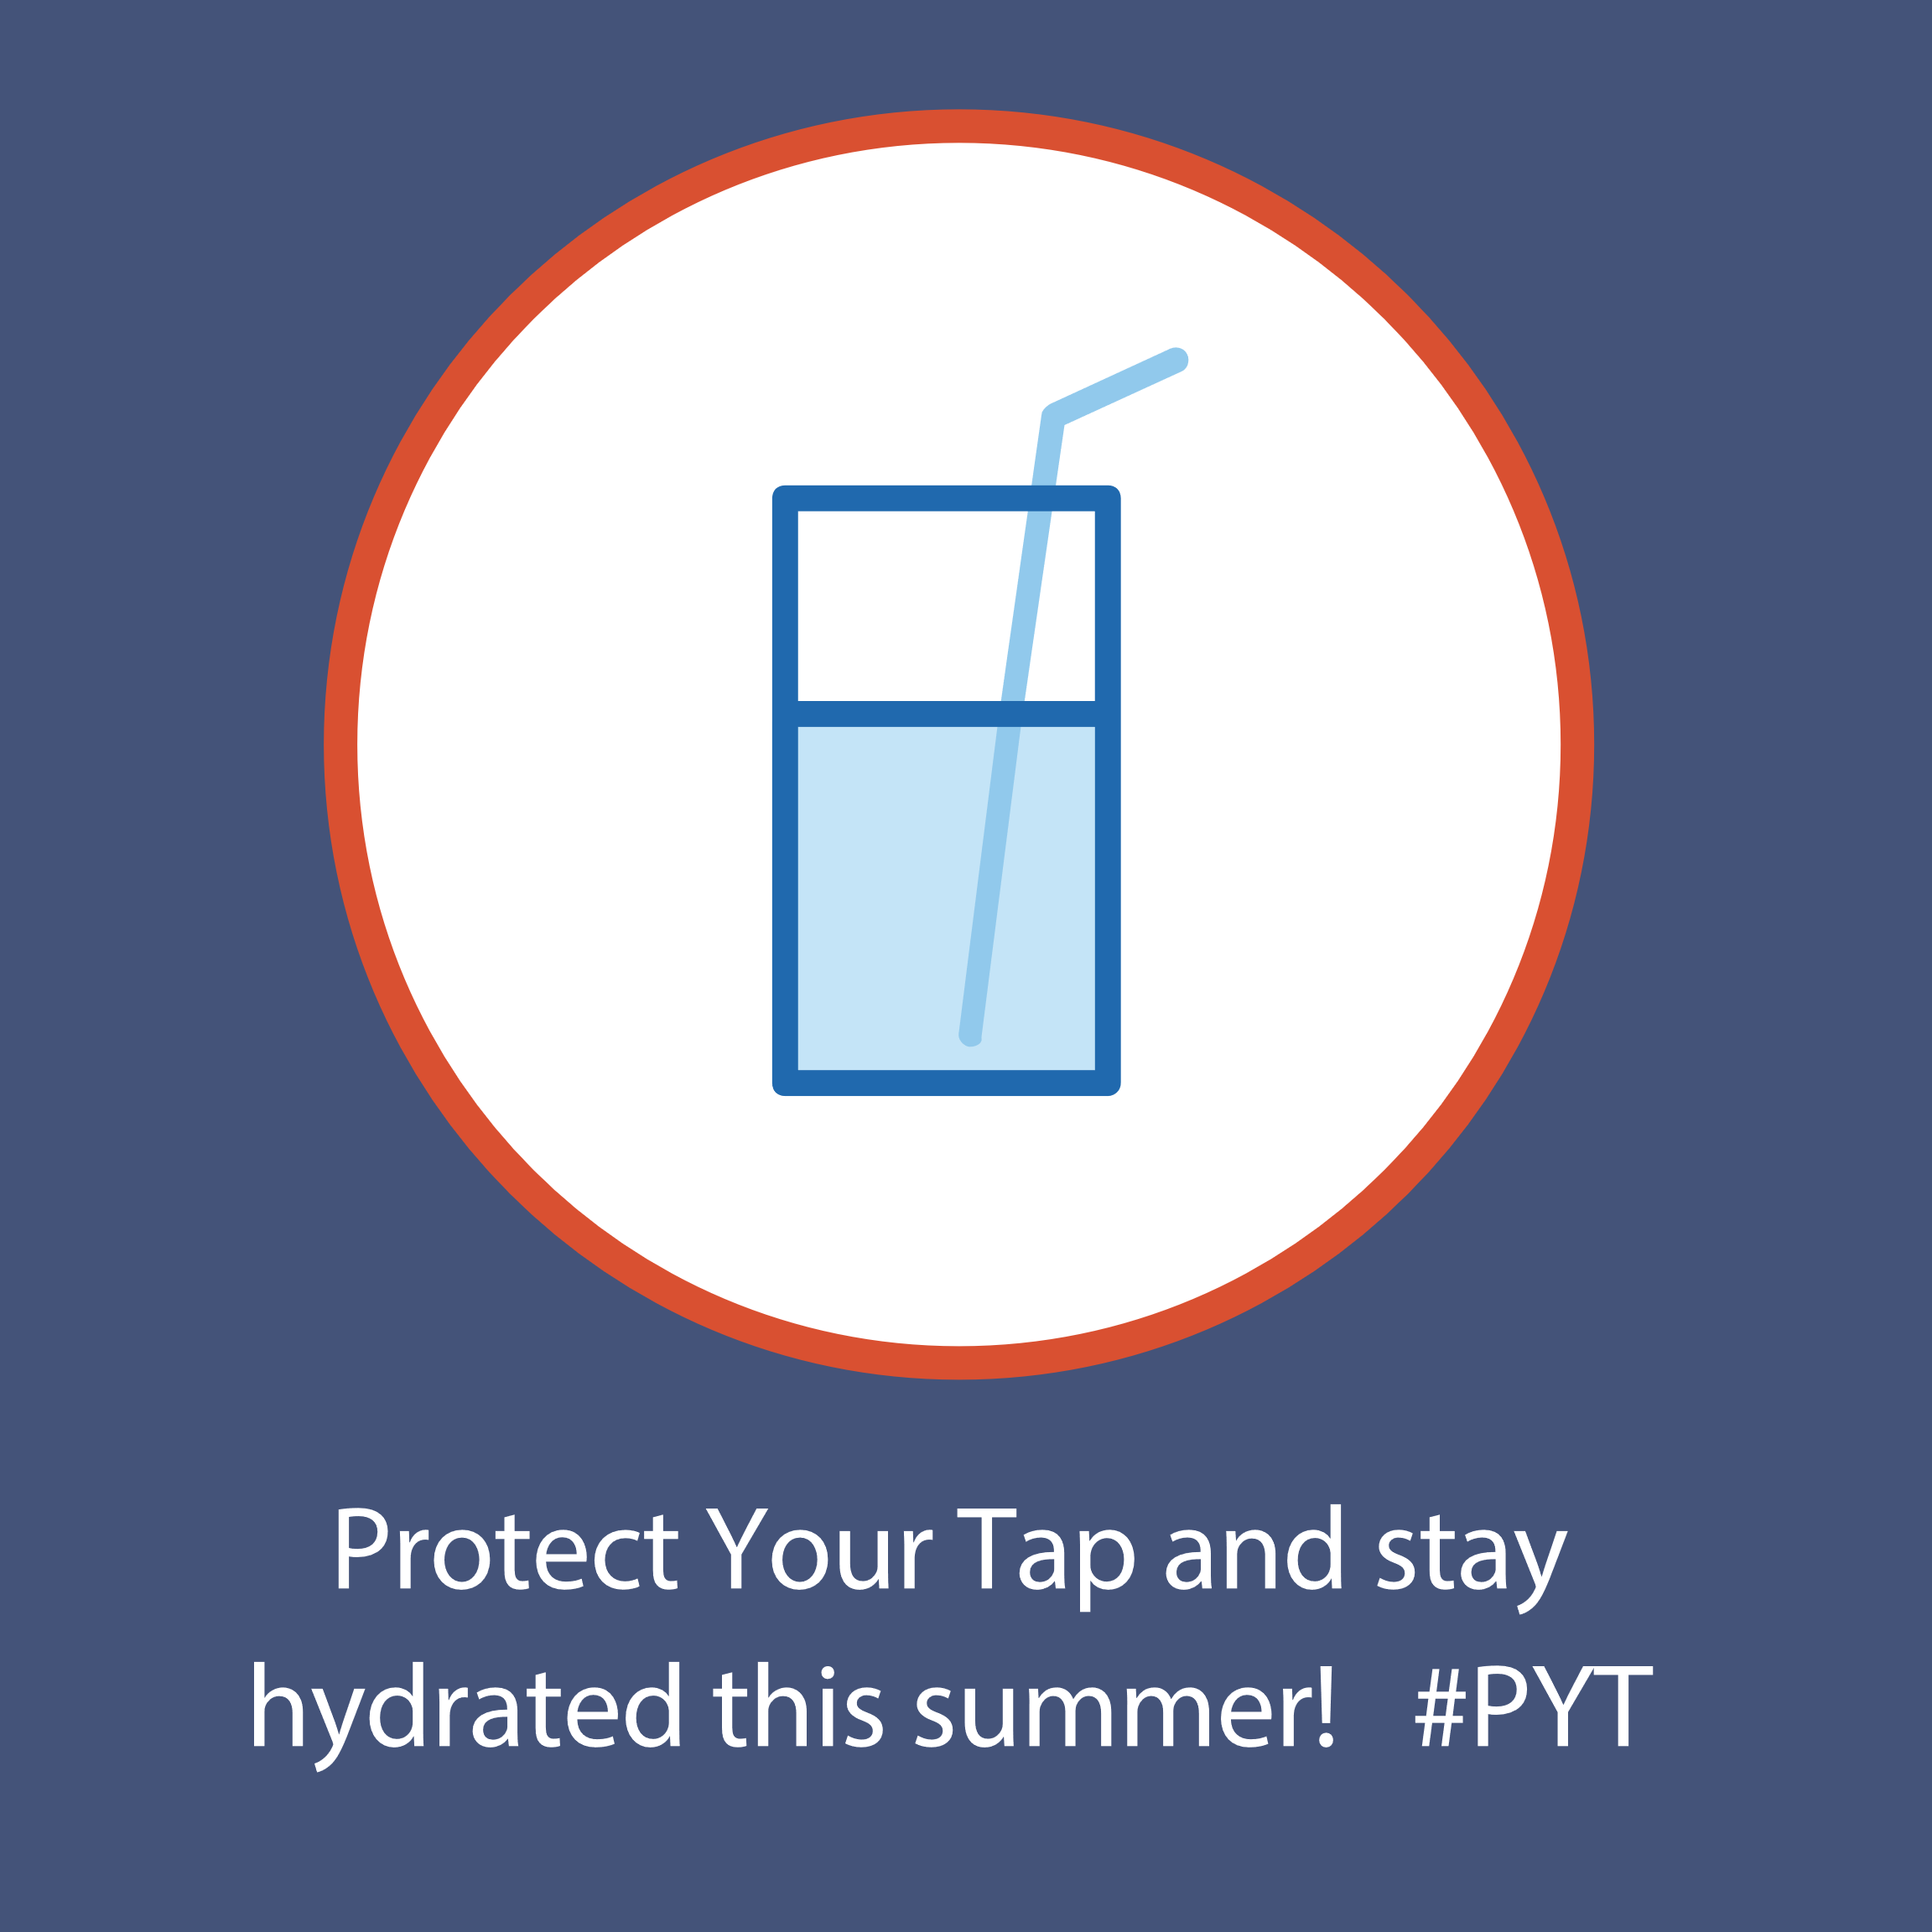 | Check out #ProtectYourTap, an online guide created to identify lead pipes and reduce exposure to lead in drinking water:  epa.gov/protectyourtap #PYT  <your website>  <other hash tags>
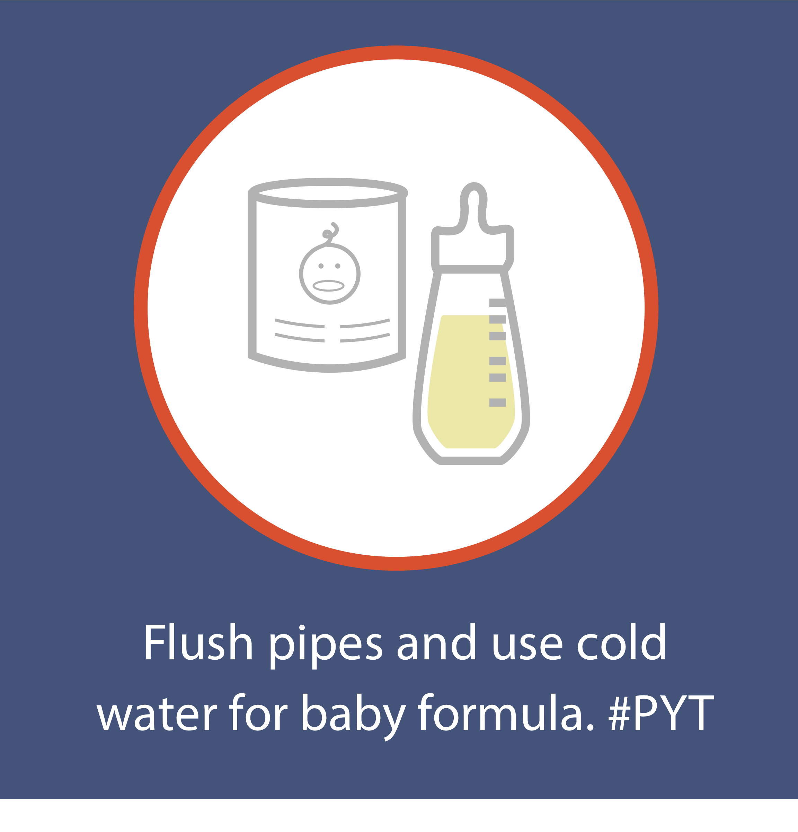 | Concerned about lead in drinking water? Find out how you can get your water tested and other tips to reduce lead: #ProtectYourTap is an online guide to identify lead pipes and reduce lead exposure:  epa.gov/protectyourtap #PYT  <your website>  <other hash tags>
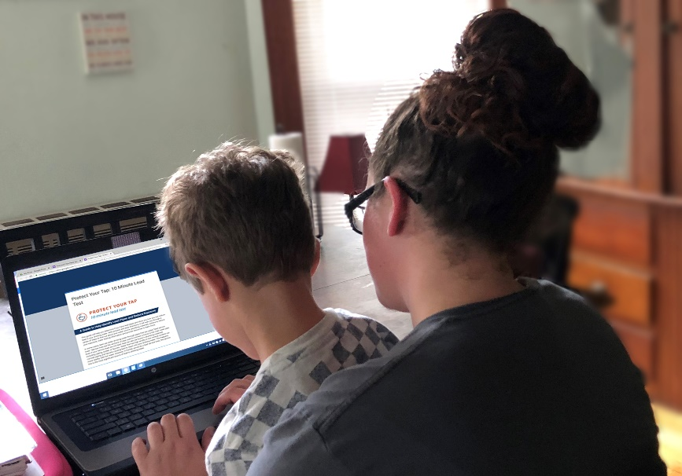 | Concerned about lead in drinking water? Find out how you can get your water tested and other tips to reduce lead: #ProtectYourTap is an online guide to identify lead pipes and reduce lead exposure.  epa.gov/protectyourtap #PYT  <your website>  <other hash tags>
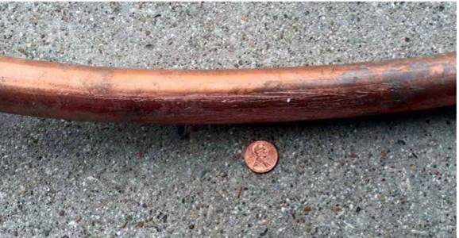 | Do you know about the pipe that brings in the water you drink? Find out how to identify it and other tips: #ProtectYourTap  epa.gov/protectyourtap #PYT  <your website>  <other hash tags>
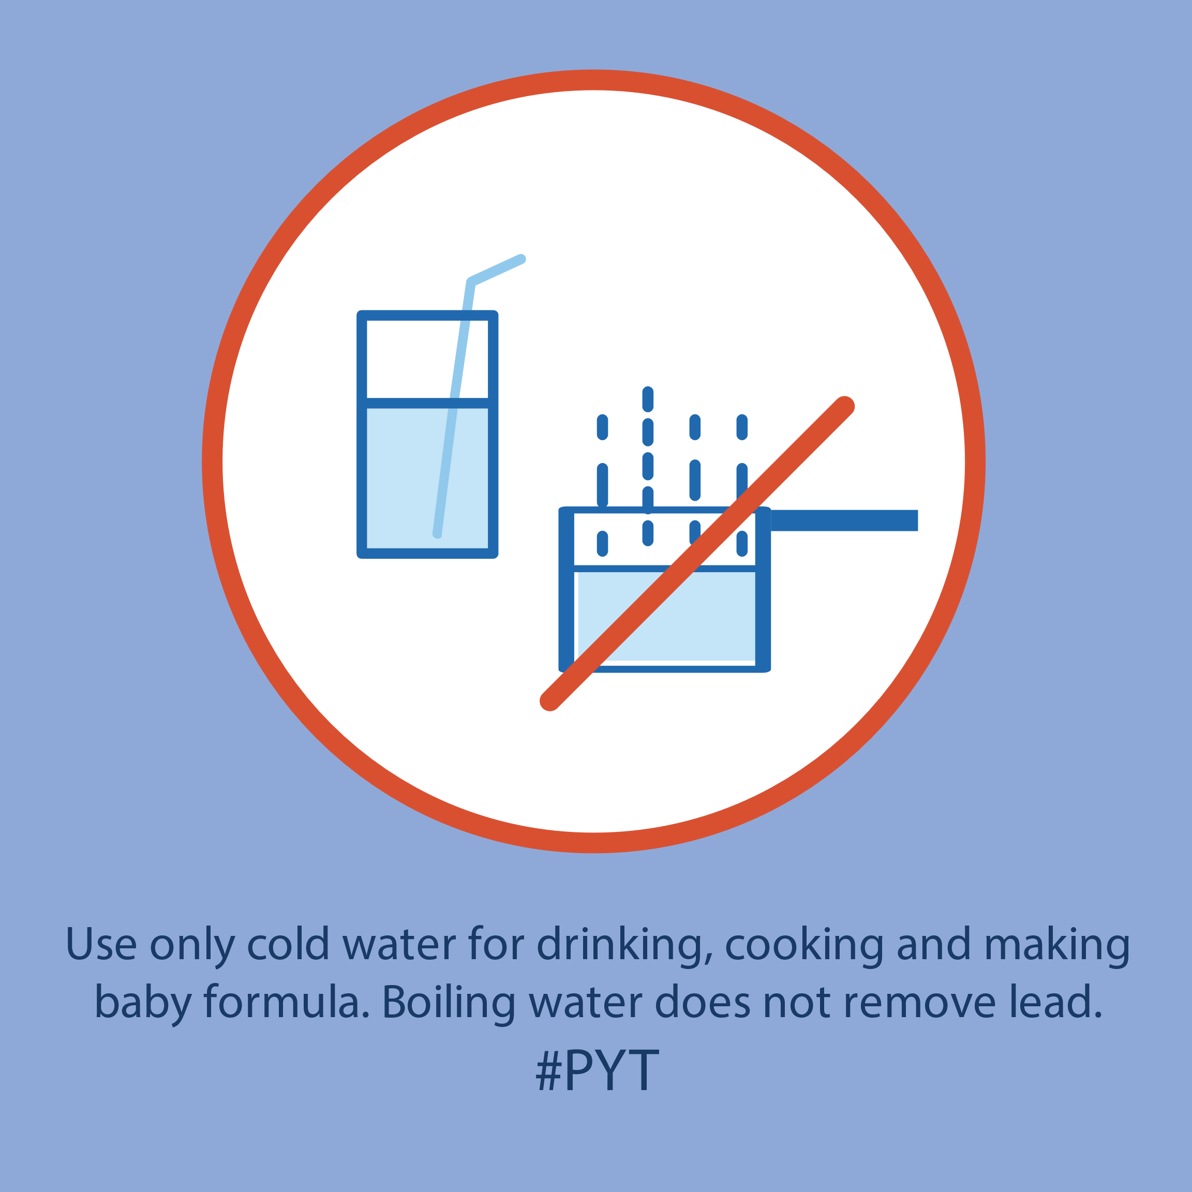 | Concerned about lead in drinking water? Find out how you can get your water tested and other tips to reduce lead: #ProtectYourTap is an online guide to identify lead pipes and reduce lead exposure:  epa.gov/protectyourtap #PYT  <your website>  <other hash tags>

