Protect Your Tap Web banners
Font is Myriad Pro. Colors are red: #cc3300, lt blue #99ccff, dk blue #003366
Be sure to hyperlink these banners to https://www.epa.gov/pyt
Right click the banner and “Save as Picture”

pixels | banner
300 x 25

300 x 100

300 x 250 | 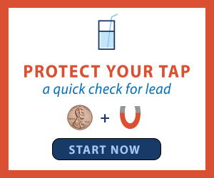
468 x 60
728 x 90

