Field Dissipation of [test compound]

Report: | [Provide full citation]
Document No.: | [MRID xxxxxxxx]
Guideline: | OCSPP [guideline number]  [If the study was conducted under a different guideline than it is being reviewed under, state ‘Conducted by’ and provide the most relevant guideline(s) the study was conducted under. Then state ‘Reviewed by OCSPP [guideline number].’ If this review is multilateral, also provide the guideline numbers under which participating agencies are reviewing the study.]
Statements: | [Indicate whether the study was conducted in compliance with FIFRA GLP standards and whether signed and dated Data Confidentiality, GLP Compliance, Quality Assurance, and Authenticity Certification statements were provided. If the study was not conducted in compliance with FIFRA GLP standards, indicate how not or why not.]
Classification: | This study is [provide classification and very concise statement of any deficiencies that impacted the classification]. [If multiple classification terminologies are needed for multilateral reviews, list or tabulate them.]
PC Code: | [xxxxxx]
Reviewer: | [Provide final reviewer(s)’s name Signature:  and title.] Date: [Type date of signature.]

Executive Summary

[Modify the Executive Summary as needed, incorporating the following critical elements and level of detail.]

Dissipation of [test material] under [Country] field conditions was examined in [bare plots or cropped plots] at [number] site(s) in [location(s), state(s), province(s)]. The site(s) where the studies were conducted were at [locations]. The experiment(s) in [site(s)] was/were conducted for [number] days. The nominal application rate[s] in [site(s)] were [value] lbs. a.i./A. The treated plots were [value] m apart, and the control plot was [value] m away from the treated plot. [Provide details if cropped plots are used.]

Under field conditions at Site 1, [test material] had a dissipation half-life value of ___day(s), and a DT90 value of ___day(s). At the end of the ___day period, the total carryover of residues of [test material] was ___ % of the measured applied amount. The major route(s) of dissipation of [test material] under field conditions at [each Site] was/were [leaching, transformation, volatilization, plant uptake, etc.].

[FOR EFED SCIENTISTS: The TFD study report should present a conceptual model of dissipation, identifying which routes of dissipation are important. EFED scientists should include a description of whether or not this can be verified in laboratory studies by considering the sum of dissipation rates from abiotic and biotic degradation studies given as:

K_{field} = Σ ( k_{metabolism} + k_{photolysis} + k_{volatilization} + k_{runoff} + k_{leaching} +…..k_{x}).

Ideally, the field rate of dissipation would be equal to the sum of the important dissipation rates identified from the laboratory fate studies. To determine whether the field study result is consistent with the conceptual model proposed rate, the EFED scientist should calculate the rate of dissipation from the original compartment (e.g., the top X inch(es) of soil) using the latest guidance on degradation kinetics. This field rate should be compared to the sum of the rates from the laboratory fate studies for important processes in the conceptual model. Adsorption and desorption properties of the test substance from batch equilibrium studies should also be considered in characterizing the field dissipation from the test plot.]

Table 1. Dissipation Synopsis
Test System | Major Dissipation Route | Maximum Concentrations (lb/A)  in Media  (cm soil, ft water, or cm air),  at Time Period  (days after application)
[Soil Location]  [USGS Soil Series]  [Soil Texture]  [pH #] | [Biodegradation] | [list concentrations, depths/heights in media, and time periods of measurement for all measured constituents]
[Soil Location]  [USGS Soil Series]  [Soil Texture]  [pH #] | [Biodegradation] | [list concentrations, depths/heights in media, and time periods of measurement for all measured constituents]

Table 2. Results Synopsis
 | Observed Total Field DT₅₀ (days) | Calculated Total Field Dissipation Half-life (days)  Method | Model Parameters and Statistics | Transformation Products  Common Name (maximum % of nominal application, associated interval)
[Soil Location]  [USGS Soil Series]  [Soil Texture]  [pH #] | [value] | [value]  [method] | [values] | [name] (#%, # d)
[Soil Location]  [USGS Soil Series]  [Soil Texture]  [pH #] | [value] | [value]  [method] | [values] | [name] (#%, # d)

[Add on to tables as necessary for different locations, plots, or applications. Model parameters include model variables, Sc values, and correlation coefficients.]

I. Materials and Methods

A. Materials:
Provide (a) small image(s) of the test compound(s) in the right margin.
1. Test Material: Product Name:
Formulation Type (e.g., liquid or granular):
CAS #:
Storage stability: [Indicate the time period that the test material was stable as well as the percentage degradation over this period of time.]

2. Storage [Indicate if the test material was frozen, refrigerated, and/or maintained Conditions: in the dark for [#] days.]

B. Test Sites:

The site description is provided in Table 3.

Table 3. Site Description
Parameter |  | Value
Site 1: [Description (location/ soil series)]
Geographic Coordinates | Latitude
 | Longitude
 | County
 | Province/State
 | Country
Hydrologic setting -
Location within watershed
Slope/Gradient
Depth to Ground Water Table (m)
Distance from weather station used for climatic measurements
Indicate whether the meteorological conditions before starting or during the study were within 30 year normal levels (Yes/No). If no, provide details.
Field Surface (e.g. bare soil, trees, or crops)
Other Details, if any
Property |  | Depth (cm)
 |  | 0 | 15-30 |  | 30-45 | x-y |  | y-z
Textural classification
% sand
% silt
% clay
pH (1:1 soil:water or other)
Total organic carbon (%)
CEC (meq/100 g)
AEC (meq/100 g)
Bulk density (g/cm3)
Soil Moisture at 0.1 bar (%)
Soil Moisture at 1/3 bar (%)
Taxonomic classification (e.g., ferro-humic podzol)
Others
Site Usage |  | Previous Year |  | 2 years previous |  |  | 3 years previous
Crops Grown
Pesticides Used
Fertilizers Used
Cultivation Methods
Comments

[Add to table as necessary for different locations or plots.]

C. Experimental Design:

Specifications on the design for the field dissipation study are shown in Table 4.

Table 4. Study Design
Details |  | Site 1 | Site n
Pesticides used during study [a.i., % a.i., and product]:

name of product/a.i concentration:
amount applied:
application method:
Amount applied (lbs. a.i./A)
Number of applications
Maximum single labelled application rate ? (yes/no)
Application method
Application Dates(s) (dd mm yyyy)
Duration of study
Control used (Yes/No)
No. of replications | Controls
 | Treatments
Plot size  (L x W m) | Control
 | Treatment
Distance between control plot and treated plot
Distance between treated plots
Type of spray equipment, if used
Total volume of spray solution applied/plot or total amount broadcasted/plot
Identification and volume of carrier (e.g., water), if used
Name and concentration of co-solvents, adjuvants, and/or surfactants, if used
Indicate whether the following was submitted:

Hourly/Daily/Monthly Precipitation
Daily/Monthly average minimum and maximum air temperature
Daily/Monthly average minimum and maximum air temperature
Average annual frost-free periods
Indicate whether the pan evaporation data were submitted
Meteorological conditions during application | Cloud cover
 | Temperature (ºF)
 | Humidity
Indicate if any extreme climatic events occurred during the study (e.g., drought, heavy rainfall, flooding, storm, etc.)
Supplemental irrigation used (Yes/No)

If yes, provide the following details:

No. of irrigation:
Interval between irrigation:
Amount of water added each time:
Method of irrigation:
Indicate whether water received through rainfall + irrigation equals the 30-year average rainfall (Yes/No)
Were the application rates verified?
Were field spikes used?
Were good agricultural practices followed (Yes or No)
If cropped plots were used, provide the following details:

Plant - Common name/variety:
Details of planting:
Crop maintenance (e.g., fertilizers used):
Was volatilization included in the study? (Yes/No)
Was leaching included in the study? (Yes/No)
Was runoff included in the study? (Yes/No)
Was plant uptake or canopy monitoring included in the study? (Yes/No)

D. Sampling:

Specifications on the methods used for the field dissipation study are shown in Table 5.

Table 5. Sampling
Details | Site 1 | Site n
Method of sampling (random or systematic)
Sampling intervals
Method of collection (e.g., soil cores)
Sampling depths or heights
Number of cores collected per plot
Number of segments per core (if applicable)
Length of soil segments (if applicable)
Core diameter (Provide details if more than one width) (if applicable)
Method of sample processing, if any
Shipping time to Storage Facility (hours)
Storage conditions
Storage length (days)

[Include only applicable information in similar tables for air, plant, runoff water, or water body sampling, if applicable]

- Analytical Procedures:

Briefly describe the analytical methodology for the analyses of soil, plant, air, runoff water, and water body samples (provide references for the environmental chemistry method(s) and independent laboratory validation(s)):

- Number of soil samples or samples from appropriate media (air, plants, runoff water, or water bodies) analyzed per treatment or composite sample:
- Extraction and clean up of soil, air, plant, runoff water, or water body samples:
- Identification and quantification of parent compound (briefly describe HPLC/GC/TLC/MS conditions, e.g., column, mobile phase, detector, etc.):
- Identification and quantification of transformation products (briefly describe HPLC/GC/TLC/MS conditions, e.g., column, mobile phase, detector, etc.):
- Detection limits (LOD, LOQ) for the parent compound in soil, air, plant, runoff water, or water bodies (indicate the criteria/reference, if provided):
- Detection limits (LOD, LOQ) for the transformation products in soil, air, plant, runoff water, or water bodies (indicate the criteria/reference, if provided):

- Verification of the Extraction Method and Storage Stability:

            - Spike Recoveries:

[Most/All] field spike recoveries are within the acceptable range with overall recoveries between [x and y percent]. The exceptions include field spikes extracted during [period] with an average percent recovery of [x percent + y percent] at the fortification level of [<c1 mg/kg, c1 mg/kg – c2 mg/kg, or c2 mg/kg>]. [Repeat for additional unacceptable field spike extractions (less than 70 percent or greater than 120 percent)].

[Spike recoveries for all products applied in the field should be reported. Also apply above similar information regarding travel spikes and laboratory spikes according to available data.]

- Storage Stability Study:

[Provide the study MRID and a brief description of the storage conditions of samples after collection and the longest duration of storage for each media analyzed. Indicate the stability of the residues based on the submitted storage stability study(ies) for each media (provide a reference(s)) and whether the storage stability study duration(s) was/were sufficient to evaluate the longest field study storage duration(s). State whether corrections were made to account for any instability.]

[Note: Details of the storage stability study can be discussed in a separate study review.]

II. Results and Discussion

- Application Verification:

Briefly describe the application verification methods used, e.g., petri dish, saturation pads, spray tank analysis, etc.

Recoveries achieved on extraction and analysis of application monitors was in the range [xx to xy %]. Recovery achieved on analysis of field spiked samples was [xx %].

- Findings:

Concentrations of constituents measured in the [#] module of the [soil, aquatic, forestry] field dissipation study are shown in Table 6.

[Table 6 below shows an example based on a soil profile module of the field dissipation study. Tables for other modules of the field dissipation study should be included as appropriate. These tables are available in the Excel files attached in Attachment 2.]

[Note: If a volatility module is included, a separate study review should be developed to address this study.]

Table 6. Concentration of [Test compound] in Soil, Expressed as mg/kg
Sampling Intervals (days)  Replicate |  | Concentration (mg/kg)
 |  | #  # | #  # | #  # | #  # | #  # | #  # | #  # | #  #
Site 1: [Description (location/ soil series)]
[Parent Compound] | 0 -15 cm | [#] | [#] | [#] | [#] | [#] | [#] | [#] | [#]
 | depth 2 | n.a. | n.a. | [#] | [#] | [#] | [#] | [#] | [#]
 | depth n | n.a. | n.a. | [#] | [#] | n.d. | n.d. | n.d. | n.d.
[Transformation Product 1] | 0 -15  cm | n.a. | n.a. | [#] | [#] | [#] | [#] | n.d. | n.d.
 | depth 2 | n.a. | n.a. | [#] | [#] | [#] | [#] | n.d. | n.d.
 | depth n | n.a. | n.a. | [#] | [#] | [#] | [#] | n.d. | n.d.
[Transformation Product n] | 0 -15 cm | n.a. | n.a. | [#] | [#] | [#] | n.d. | n.d. | n.d.
 | depth 2 | n.a. | n.a. | [#] | [#] | [#] | n.d. | n.d. | n.d.
 | depth n | n.a. | n.a. | [#] | [#] | [#] | n.d. | n.d. | n.d.
n.d. = not detected n.a. = not analyzed (LOD = x mg/kg)

[Add on to table as necessary for different locations, plots, or applications.]

[For multiple applications, time for sampling intervals should be referenced from the beginning of the specific application being reported (i.e., NOT from the beginning of the first or last application for all applications).]

C. Dissipation of Test Compound:

Dissipation of [test compound] on soil was [gradual, rapid, or some other characterization] in the field. The DT₅₀ ranged from [x] to [x] as tabulated in Table 7 (calculated half-lives and model parameters for the best fit kinetics models are in bold). [Field dissipation half-lives for the whole field including the total soil profile should be determined. Indicate the software used to determine model parameters. Indicate whether reviewer-reported half-lives are consistent with study-reported values and the relationship between calculated and observed values. Discuss any abnormalities observed in the data.]

[Images of kinetics calculation results using the R program may replace Table 7. R images should include the model parameters and statistics that are otherwise reported in Table 7.]

Table 7. Transformation Kinetics of [Test Compound] in the Field ^{A, B}
 | Observed DT₅₀  (days) | Observed DT₉₀  (days) | Calculated Half-life (days) | Kinetics Model ^{C} | Model Parameters | Model Statistics
[Location 1]  [USGS Soil Series]  [Soil Texture]  [# °C, pH #] | [#] | [#] | [#] | SFO | C₀=[#], k=[#] | S_{SFO}=[#], r²=[#], p=[#]
 |  |  | [#] | IORE | C₀=[#], k=[#], n=[#] | S_{IORE}=[#], S_{C}=[#], r²=[#], p=[#]
 |  |  | [#] | DFOP  [if applicable] | C₀=[#], g=[#], k₁=[#], k₂=[#], | S_{DFOP}=[#], r²=[#], p=[#]
[Location n]  [USGS Soil Series]  [Soil Texture]  [# °C, pH #] | [#] | [#] | [#] | SFO | C₀=[#], k=[#] | S_{SFO}=[#], r²=[#], p=[#]
 |  |  | [#] | IORE | C₀=[#], k=[#], n=[#] | S_{IORE}=[#], S_{C}=[#], r²=[#], p=[#]
 |  |  | [#] | DFOP  [if applicable] | C₀=[#], g=[#], k₁=[#], k₂=[#], | S_{DFOP}=[#], r²=[#], p=[#]
^{A} Data were obtained from [location of data in study report] and calculations in the attached Excel workbook [name(s) of worksheets, if needed]. See Attachment 3 for calculations.
^{B} Calculated half-lives and model parameters for the best fit kinetics models, in accordance with the NAFTA kinetics guidance (USEPA, 2011), are in bold.
^{C} Kinetics models: Single First-Order (SFO); Double First-Order in Parallel (DFOP), and Indeterminate Order Rate Equation (IORE).
[Rows may be added for transformation product half-lives and DT₅₀s as needed. Half-lives should be calculated following the NAFTA kinetics guidance (USEPA, 2011).]

[Add information as necessary for additional sites, plots, or applications.]

[Briefly summarize the transformation products per system in Table 8. If transformation product decline is observed over four time intervals, calculate a half-life and discuss the pattern of decline.]

Table 8. Transformation Products of [Test Compound] in the Field
 | Transformation Product(s) | Maximum %AR Observed | Associated Interval | Final %AR Observed | Final Interval
[Location]  [USGS Soil Series]  [Soil Texture]  [# °C, pH #] | [common name] | [#] | [# d] | [#] | [# d]
 | [common name] | [#] | [# d] | [#] | [# d]
[Location]  [USGS Soil Series]  [Soil Texture]  [# °C, pH #] | [common name] | [#] | [# d] | [#] | [# d]
 | [common name] | [#] | [# d] | [#] | [# d]

D. Mass Accounting:

[State whether a reasonable attempt to quantify the mass accounting of various dissipation pathways was demonstrated considering the number of dissipation pathways quantified, levels of residue extracted, and existing validated methods. Provide a summary of the mass accounting of dissipation pathways in Table 9. Insert tables showing detailed calculations for each dissipation pathway contribution by depth and sampling period electronically and in Appendix 2.]

[Note: The purpose of this section is to identify the most significant routes of dissipation. This section is NOT intended to verify whether material balance is acceptable since a field dissipation study is an open system. Only the major dissipation pathways identified in the conceptual model in the study report should be included in the study review.]

[All of the percent ranges of the mass accounting over the study duration attempted for any of the dissipation pathways in the table below should be referenced with the nominal application rate].

[Add information as necessary for additional sites, plots, or applications.]

Table 9. Summary of Mass Accounting for Dissipation Pathways ^{A}
Field Study Module | Percentage of Applied Mass at Time 0 (%) | Maximum Percentage of Applied Mass (%) and Time After Application (days) | Percentage of Applied Mass at Study Termination (%) and Time After Application (days)
Soil Profile | [# %] | [# %]  [# days] | [# %]  [# days]
Volatilization | [# %] | [# %]  [# days] | [# %]  [# days]
Runoff or Water Body (Water and Sediment) | [# %] | [# %]  [# days] | [# %]  [# days]
Plant and Canopy Residue or Plant Uptake (Shoots and Roots) | [# %] | [# %]  [# days] | [# %]  [# days]
^{A} Percentages of the applied are based on the nominal application rate. For transformation products, parent-equivalent percentages of the applied are reported, considering the ratio of the molecular weights between the transformation products and the parent compound.

E. Residue Carry-Over:

The observed DT₉₀ value was ___ days at Site 1. After ___ days, ___ % of the applied parent compound was detected at Site 1, and has [the/low] potential to carry over into the following season. At the end of the study, carryover of the transformation products was expected to be ____ %. [Provide details for other sites, if any.]

III. Study Deficiencies and Reviewer’s Comments

[This section is titled “Conclusions” in the original T2S template.]

[List any deficiencies with the study and any additional salient information. Specifically report any discrepancies between the nominal application rate and target application rate and related causes for the discrepancies in this section.]

[Results and conclusions contained in the Executive Summary are not repeated in this section.]

IV. References

[List any references cited in the review.]

U.S. Environmental Protection Agency (USEPA). 2011. Guidance for Evaluating and Calculating Degradation Kinetics in Environmental Media. (Interim draft document dated Dec. 21, 2011.)

Appendix 1: Mass Accounting Calculations

Table X. Total on-field material balance from soil expressed as percent of the nominal application rate
Table Y. Dissipation due to volatilization of [analytes(s)] from soil expressed as percent of the nominal application rate
Sampling Intervals (days or hours)  Replicate | Percent of applied
 | #  # | #  # | #  # | #  # | #  # | #  # | #  # | #  # | #  #
Site 1: [Description (location/ soil series)]
Parent Compound | [#] | [#] | [#] | [#] | [#] | n.d. | n.d. | n.d. | n.d.
Transformation Product 1 | [#] | [#] | [#] | [#] | [#] | [#] | [#] | n.d. | n.d.
Transformation Product n | n.d. | n.d. | n.d. | n.d. | n.d. | n.d. | n.d. | n.d. | n.d.
n.d. = not detected (LOD = x mg/kg a.i. soil)
*Percent of the applied based on nominal application rate.

[Add on to table as necessary for different locations, plots, or applications.]

Table X. Percent of the applied of [test material] in water body and sediment
Sampling Intervals (days)  Replicate |  | Percent of applied
 |  | #  # | #  # | #  # | #  # | #  # | #  # | #  # | #  #
Site 1: [Description (location/ soil series)]
Parent compound | water | - | - | [#] | [#] | n.d. | n.d. | n.d. | n.d.
 | sediment | - | - | [#] | [#] | n.d. | n.d. | n.d. | n.d.
 | total | - | - | [#] | [#] | n.d. | n.d. | n.d. | n.d.
Transformation product 1 | water | - | - | [#] | [#] | [#] | [#] | n.d. | n.d.
 | sediment | - | - | [#] | [#] | [#] | [#] | n.d. | n.d.
 | total | - | - | [#] | [#] | [#] | [#] | n.d. | n.d.
Transformation product n | water | n.d. | n.d. | n.d. | n.d. | n.d. | n.d. | n.d. | n.d.
 | sediment | n.d. | n.d. | n.d. | n.d. | n.d. | n.d. | n.d. | n.d.
 | total | n.d. | n.d. | n.d. | n.d. | n.d. | n.d. | n.d. | n.d.
n.d. = not detected (LOD = x mg a.i./L)
*Percent of the applied based on nominal application rate.

[Add on to table as necessary for different locations, plots, or applications.]

Table X. Residues of [analyte(s)] in plants and canopies expressed as % of applied
Sampling Intervals (days)  Replicate |  | Percent of applied
 |  | #  # | #  # | #  # | #  # | #  # | #  # | #  # | #  #
Site 1: [Description (location/ soil series)]
Parent compound | shoots | - | - | [#] | [#] | n.d. | n.d. | n.d. | n.d.
 | roots | - | - | [#] | [#] | n.d. | n.d. | n.d. | n.d.
 | total | - | - | [#] | [#] | n.d. | n.d. | n.d. | n.d.
Transformation product 1 | shoots | - | - | [#] | [#] | [#] | [#] | n.d. | n.d.
 | roots | - | - | [#] | [#] | [#] | [#] | n.d. | n.d.
 | total | - | - | [#] | [#] | [#] | [#] | n.d. | n.d.
Transformation product n | shoots | n.d. | n.d. | n.d. | n.d. | n.d. | n.d. | n.d. | n.d.
 | roots | n.d. | n.d. | n.d. | n.d. | n.d. | n.d. | n.d. | n.d.
 | total | n.d. | n.d. | n.d. | n.d. | n.d. | n.d. | n.d. | n.d.
n.d. = not detected (LOD = x mg a.i./kg dry weight)
*Percent of the applied based on nominal application rate.

[Add on to table as necessary for different locations, plots, or applications.]

Attachment 1: Chemical Names and Structures

[A table (i.e., structure table) of the chemical names, SMILES strings, CAS numbers, and structures of the test compound, identified transformation products, and reference compounds that were not identified in study samples should be either referenced as a separate, associated document or attached to the study review. Multiple versions of structures that show or do not show radiolabeling and multiple versions of chemical names and SMILES strings should not be included in the table. Sources of data need not be included. However, formatting the structure table in conformance with the guidance for tabulating transformation product data for EFED ROCKS memoranda is recommended. This formatting includes table columns for MRIDs and associated study data such as maximum and final concentrations of transformation products and their intervals (values from individual replicates are reported, not mean values). At a minimum, repeat the table below for the test compound, identified transformation products, and reference compounds not identified in the study samples.

For multilateral reviews, chemical names, SMILES strings, structures, and CAS numbers are captured elsewhere in the Monograph. Therefore these data are not attached to each study review within the Monograph. When the Monograph is split into individual reviews in EFED’s files, however, the Monograph’s structure table should be either referenced as a separate, associated document or attached to each individual review.]

[Sample structure table with the minimum information needed.]

[Common name [list other common names] [if the same common name is used in different studies for different compounds, provide in parentheses the MRID associated with the common name for this compound.]]
IUPAC Name: | [Provide one IUPAC name.]
CAS Name: | [Provide one CAS name.]
CAS Number: | [Provide if available.]
SMILES String: | [Provide one SMILES string.]
[Paste structure here.]

[Sample EFED ROCKS memorandum format for structure tables.]
Attachment 2: Statistics Spreadsheets and Graphs

[Supporting electronic spreadsheet files should be inserted here (electronic attachment files should be electronically finalized as separate files as well). Electronic attachments should have the same file name as the Microsoft Word study review file with the addition of “Calc” for Excel workbooks and WinZip files, the addition of “Data” for Adobe Acrobat and Document Imaging files, and the addition of brief descriptors as appropriate for SigmaPlot Notebooks. Electronic attachment files should be compressed into a WinZip file when three or more are prepared for a study review.]

[Hard copies of a study review and any attachment sheets from separate electronic files should be printed and finalized together as one hard copy file.]

[Example Excel files and spreadsheets follow below.]

[Example spreadsheets for mass-balance in terms of verified analyte-equivalent percent of applied:
Soil Profile -  Example 1  Soil Core Sampled Incrementally | 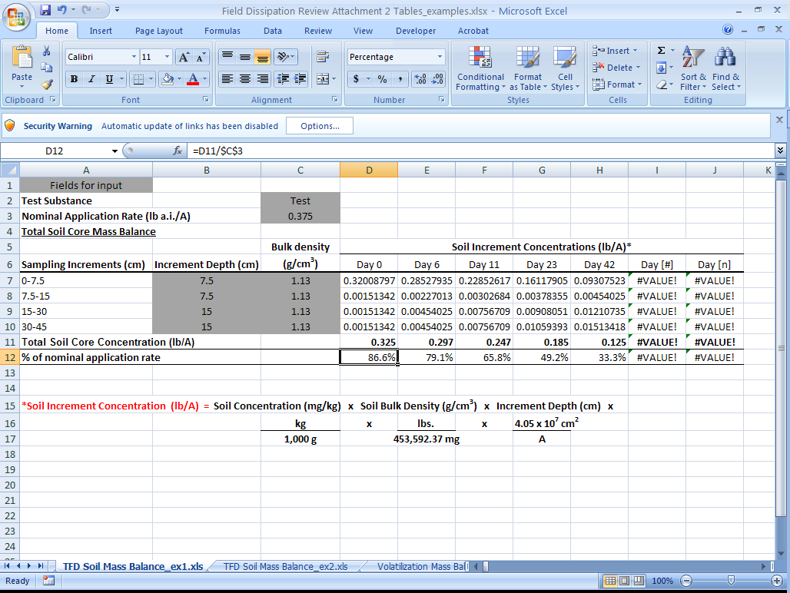  *Mass Balance calculated by the formula = Measured total soil core concentration/Nominal application rate
Soil Profile -  Example 2  Soil Core Sampled Locally  Note: This is not the method specified in the guidelines. The study reviewer should use best professional judgment to determine if there is sufficient sampling conducted using this method (e.g., fine sampling at top of the core and sufficient sampling intervals within soil core). | 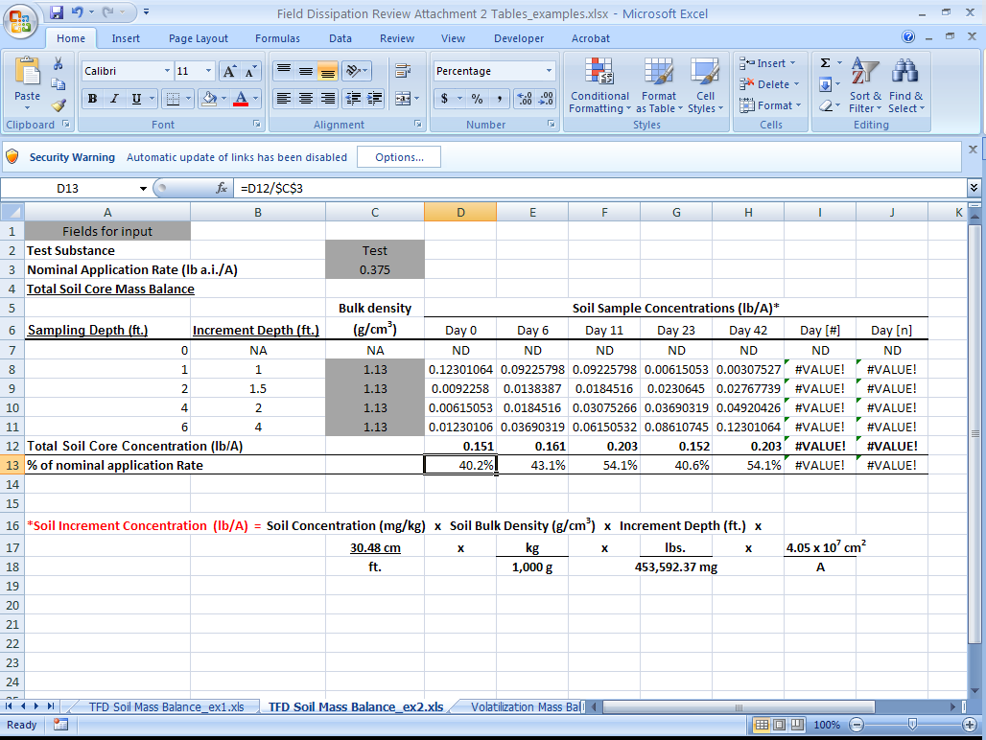  * Increment depth based on centered finite difference of local sampling depths.  * Mass Balance calculated by the formula = Measured total soil core concentration/Nominal Application Rate
Volatilization | 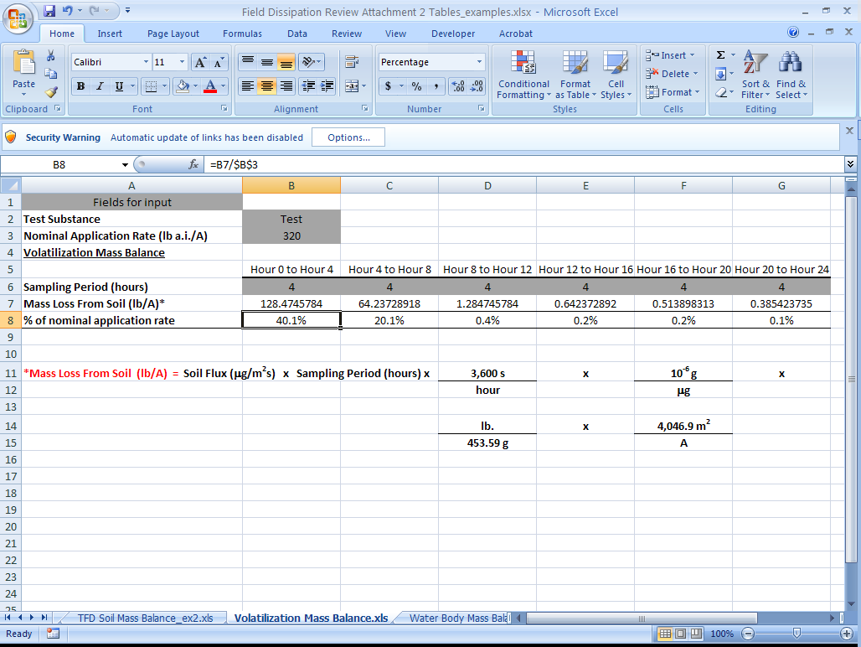  *Mass Balance for sampling period calculated using the following formula = Total Measured Volatile Flux/Nominal Application Rate
Water Body  (Water and Sediment) | 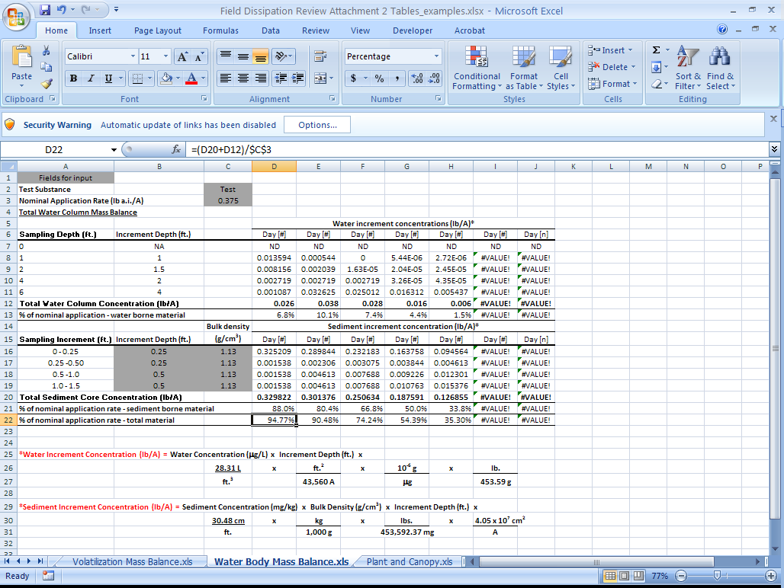  *Mass Balance for sampling period calculated using the following formula= Measured total water column or sediment core concentration /Nominal application rate
Plant and Canopy Residues | 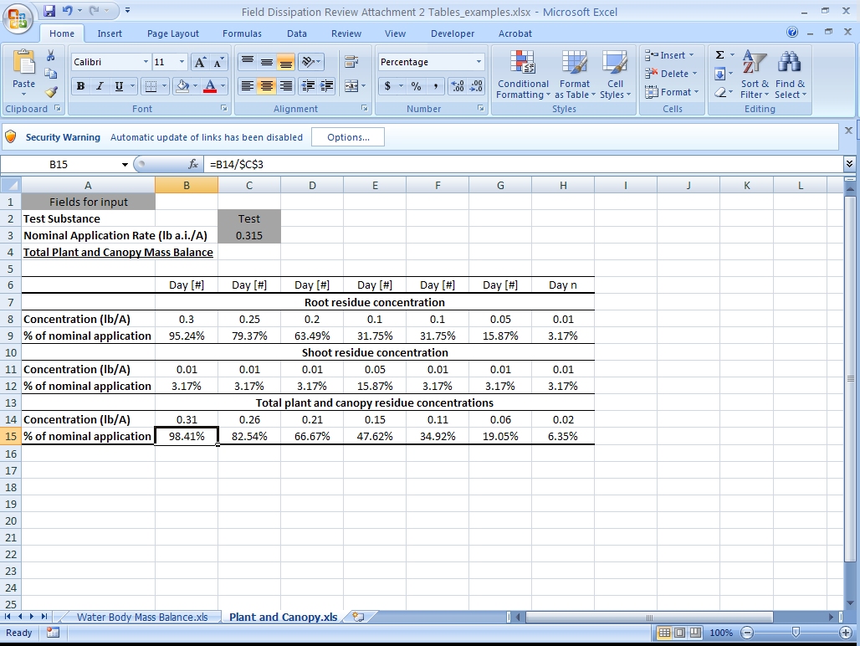  *Mass Balance for sampling period calculated using the following formula= Measured total shoot or root residue concentration /Nominal application rate

Attachment 3: Calculations

Calculations were performed by the reviewer using [indicate program(s) used for calculations] and the following equations. [The following equations are anticipated to reflect the NAFTA kinetics guidance as of January, 2012. If these equations are not current, they should be replaced by the applicable equations from current guidance.]
Single First-Order (SFO) Model
${C_{t}=C_{0}e}^{-kt}$ (eq. 1)
where,
C_{t} = concentration at time t (%)
C₀ = initial concentration (%)
e = Euler’s number (-)
k = SFO rate constant of decline (d⁻¹)
t = time (d)

The SFO equation is solved [with the Excel Solver] by adjusting C₀ and k to minimize the objective function (S_{SFO}) shown in equation 9.
DT₅₀ = natural log (2)/k (eq. 2)
DT₉₀ = ln (10)/k (eq. 3)
Indeterminate Order Rate Equation (IORE) Model
$C_{t}={\left[C_{0}^{\left(1-N\right)}-\left(1-N\right)k_{IORE}t\right]}^{\left(\frac{1}{1-N}\right)}$ (eq. 4)
where,
N = order of decline rate (-)
k_{IORE} = IORE rate constant of decline (d⁻¹)

This equation is solved [with the Excel Solver] by adjusting C₀, k_{IORE}, and N to minimize the objective function for IORE (S_{IORE}), see equation 9. Half-lives for the IORE model are calculated using equation 5, which represents a first-order half-life that passes through the DT₉₀ of the IORE model. (Traditional DT₅₀ and DT₉₀ values for the IORE model can be calculated using equations 6 and 7.)
$t_{IORE}=\frac{log⁡(2)}{log(10)}\frac{{C_{0}}^{1-N}\left({1-0.1}^{(1-N)}\right)}{\left(1-N\right)k_{IORE}}$ (eq. 5)
DT₅₀ = (eq. 6)
DT₉₀ = (eq. 7)
Double First-Order in Parallel (DFOP) Model
$C_{t}=C_{0}g^{-k_{1}t}+C_{0}{\left(1-g\right)}^{-k_{2}t}$ (eq. 8)
where,
g = the fraction of C₀ applied to compartment 1 (-)
k₁ = rate constant for compartment 1 (d⁻¹)
k₂ = rate constant for compartment 2 (d⁻¹)

If C₀ x g is set equal to a and C₀(1-g) is set equal to c, then the equation can be solved [with the Excel Solver] for a, c, k₁, and k₂ by minimizing the objective function (S_{DFOP}) as described in equation 9.

DT₅₀ and DT₉₀ values can be calculated using equations 2 and 3, with k₁ or k₂ in place of k.

Objective Function: SFO, IORE, and DFOP are solved by minimizing the objective function (S_{SFO}, S_{IORE}, or S_{DFOP}).
$S_{SFO},S_{IORE},or S_{DFOP}=\sum{{(C_{model},t-C_{d,t})}^{2}}$ (eq. 9)
where,
S_{SFO} , S_{IORE}, or S_{DFOP} = objective function of kinetics model fit (%²)
n = number of data points (-)
C_{model,t} = modelled value at time corresponding to C_{d,t} (%)
C_{d,t} = experimental concentration at time t (%)

Critical Value to Determine Whether SFO is an Adequate Kinetics Model

If S_{SFO} is less than S_{C}, the SFO model is adequate to describe kinetics. If not, the faster of t_{IORE} or the DFOP DT₅₀ for compartment 2 should be used.
$S_{c}=S_{IORE}\left(1+\frac{p}{n-p}F\left(α,p,n-p\right)\right)$ (eq. 10)
where,
S_{c} = the critical value that defines the confidence contours (%²)
p = number of parameters (3 in this case)
α = the confidence level (0.50 in this case)
F(α, p, n-p) = F distribution with α level of confidence and degrees of freedom p and n-p

