Note to Reader: The language below is intended to replace Chapter 10, sections VI.A.4 – VI.A.6 in the current Label Review Manual (LRM), which available at https://www.epa.gov/sites/production/files/2016-02/documents/chap-10-feb-2016.pdf.

In LRM Chapter 10, Unit VI covers precautionary statements and Unit VI.A addresses handler personal protective equipment (PPE). The language below -
- Replaces the current Unit.VI.A.4 “Product Specific Respiratory Protection Device (RPD) Selection for Handlers” with Unit VI.A.4 “Product-Specific Respirator Selection for Handlers”;
- Creates a new Unit VI.A.5 “Relative Protection of PPE for Handlers”;
- Renumbers current Unit VI.A.5 “Required Location for Handler PPE” to be Unit VI.A.6 without any changes; and
- Renumbers current Unit VI.A.6 “States May Require the Use of Additional PPE” to be Unit VI.A.7 without any changes.

Respirator Section of Label Review Manual Chapter 10

4. Product-Specific Respirator Selection for Handlers
a) Introduction
Respirators are required for all products classified as toxicity category I or II for acute inhalation 40 CFR 156.212(e). EPA may also determine respirators are necessary based on a risk assessment, Reregistration Eligibility Decision (RED), registration review, or other risk management decision. This section provides information on determining what respirator language to include on the label; respirator descriptions that use current National Institute for Occupational Safety and Health (NIOSH) terminology, and how to convert outdated respirator descriptions on pesticide labels to respirator descriptions using current NIOSH terminology.
In June 1995, NIOSH revised its certification criteria and definitions for non-powered, air-purifying respirators. The 1995 NIOSH regulations in 42 CFR Part 84 replaced the outdated respirator certification standards of the Mine Safety and Health Administration in 30 CFR Part 11. The 42 CFR Part 84 regulation created a total of nine classes of particulate filters; these classes apply only to non-powered, air-purifying, particulate filter respirators. EPA updated the Label Review Manual to include the nine classes of particulate filters following issuance of PR Notice 98-9.
The 42 Part 84 regulations also revised the terminology used to describe respirators and the Testing and Certification (TC) designations for non-powered, air-purifying respirators. This section of the Label Review Manual addresses the changes to the NIOSH designations and terminology in several formats. EPA is not requiring TC codes and recommends that TC codes not be included in the respirator descriptions. However, if they are used they must be consistent with the type of respirator that is required on the label using the NIOSH TC designations specified in the NIOSH Fact Sheet (DHHS (NIOSH) Publication No. 2011-179, as follows:
- 13F: self-contained breathing apparatus (SCBA)
- 19C: supplied air respirator (SAR)
- 14G: gas mask with canister

- 23C: air-purifying respirator with chemical cartridge or powered air-purifying respirator (PAPR) with chemical cartridge and particulate filter

- 21C: powered air-purifying respirator with particulate filter
- 84A: respirator with particulate filter or combination chemical cartridge with particulate filter
Table 5 identifies the respirator appropriate for various situations where a respirator is required and that incorporates the current NIOSH terminology. Table 6 provides a crosswalk for changing outdated respirator descriptions on pesticide labels to include the updated NIOSH terminology for the two most common respirator scenarios for pesticides. Table 7 provides information that registrants and label reviewers can use to change other outdated respirator descriptions to incorporate current NIOSH terminology by identifying outdated phrases and the comparable NIOSH language.
The respirator descriptions in Tables 5 and 6 are label statements recommended to be used while EPA revises 40 CFR 156.212 to be consistent with the current NIOSH terminology.
b) Determining the Appropriate Respirator
Use Table 5 to determine the appropriate respirator PPE language to include on the label for new or existing products based on the specific scenario. The specific scenario depends on the general type of protection needed by the handler and if available, the assigned protection factor (APF) specified by a risk assessment, RED, registration review, or other risk management decision. In the case of microbial pesticide products, the scenario also includes the potential for respiratory sensitization.
If the registrant has information available showing that a more protective respirator should be selected, the registrant should include that respirator requirement on the label and should use current NIOSH-terminology. 40 CFR 156.212(g)(3)(i), (h)(2).
The recommended respirator descriptions in the last column of Table 5 identify the minimum type of respirator needed for appropriate protection under 42 CFR Part 84 to make it clear to handlers and their employers what level of protection needs to be worn to comply with label directions and provide the necessary protections. These recommended descriptions also allow handlers to wear more protective respirators and provide some examples of more protective respirators.

Table 5. Respirators Typically Required in Different Scenarios and
Recommended Descriptions Using Current NIOSH Terminology
General Type of Protection Needed by the Handler | Assigned Protection Factor (APF) from risk assessment or RED | Product Hazard that Triggers Requirement for Respirator | Recommended Respirator Description Using Current NIOSH Terminology and Images of Example Respirator
Protection from:  - Particulates;  - Aerosols;  - Solid products  - Liquid products  [Note to registrants: For microbial pesticides, see the last row of this table for a modified version of the respirator description.] | APF = 10  [If an APF 5 respirator is identified in a risk assessment, RED or other risk management document, use this APF 10 particulate respirator description.] | Inhalation  Tox I or Tox II Products | Wear a minimum of a NIOSH-approved particulate filtering facepiece respirator with any N¹, R, or P filter; OR a NIOSH-approved elastomeric particulate respirator with any N¹, R, or P filter; OR a NIOSH-approved powered air purifying respirator with HE filters.  ¹ Note to registrant: Drop the “N” option if there is oil in the product’s formulation and/or the product is labeled for mixing with oil-containing products.  Example images:  Left: N95 filtering facepiece respirator. Photo courtesy of N. Fitz  Right: P100 filtering facepiece respirator. Photo courtesy of G. Cooke  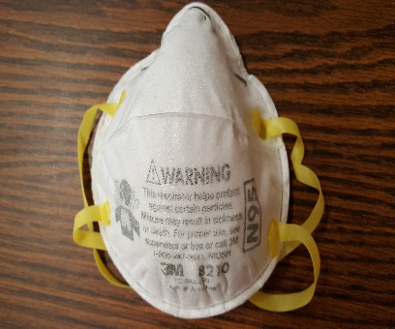
Protection from:  - Organic vapor and  - Particulates or aerosols | APF = 10 | Inhalation  Tox I or Tox II Products | Wear a minimum of a NIOSH-approved elastomeric half mask respirator with organic vapor (OV) cartridges and combination N¹, R, or P filters; OR a NIOSH-approved gas mask with OV canisters; OR a NIOSH-approved powered air purifying respirator with OV cartridges and combination HE filters.  ¹ Note to registrant: Drop the “N” option if there is oil in the product’s formulation and/or the product is labeled for mixing with oil-containing products.  Example image: Half mask elastomeric respirator with OV cartridges and combination N95 filters. Photo courtesy of G. Cooke  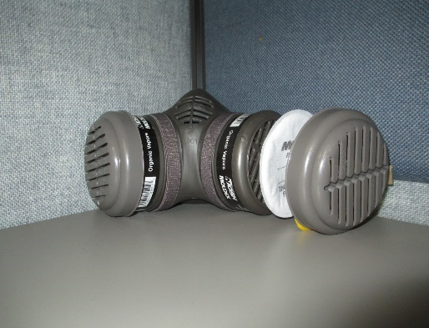
Protection from:  - Organic vapors only; or  - Inorganic vapors (such as phosphine and sulfur dioxide) | Any | Case by case basis | Case by case basis
All Microbial Pesticide Products, unless the regulatory decision indicates a different respirator is needed  Protection from:  - Particulates;  - Aerosols;  - Solid products  - Liquid products | APF = 10  [If an APF 5 respirator is identified in a risk assessment, RED or other risk management document, use this APF 10 particulate respirator description.] | Respiratory Sensitization  . | Wear a minimum of a NIOSH-approved particulate filtering facepiece respirator with any N¹, R, or P filter; OR a NIOSH-approved elastomeric particulate respirator with any N¹, R, or P filter; OR a NIOSH-approved powered air- purifying respirator with an HE filter. (Repeated exposures to high concentrations of microbial proteins can cause allergic sensitization.)  ¹ Note to registrant: Drop the “N” option if there is oil in the product’s formulation and/or the product is labeled for mixing with oil-containing products.  Example images:  Left: N95 filtering facepiece respirator. Photo courtesy of N. Fitz  Right: P100 filtering facepiece respirator. Photo courtesy of G. Cooke
c) Converting Old Respirator Descriptions on Pesticide Labels to Descriptions Using Current NIOSH Terminology
For products currently registered, it may be easiest to “translate” the outdated respirator descriptions into respirator descriptions with the current NIOSH terminology. Table 6 provides recommended language for two respirator types commonly required for pesticides. If the respirator language on the label is shown in the first column (Pre-1995 NIOSH language), that language should be replaced with the Recommended Respirator Description Using Current NIOSH Terminology in the second column. For other situations, use the information in Table 7 to translate outdated label language to descriptions using the current NIOSH terminology.
Table 6. Crosswalk from Outdated Respirator Descriptions to Recommended Descriptions Using Current NIOSH Terminology for Two Common Respirator Types Needed for Pesticides
Pre-1995 Respirator Description | Recommended Respirator Description Using Current NIOSH Terminology
“Use a dust/mist filtering respirator (MSHA/NIOSH approval number prefix TC-21C) or a NIOSH-approved respirator with any N*, R, P or HE filter.”  *Note to registrant: Drop the “N” option if there is oil in the product’s formulation and/or the product is labeled for mixing with oil-containing products. | “Wear a minimum of a NIOSH-approved particulate filtering facepiece respirator with any N¹, R, or P filter; OR a NIOSH-approved elastomeric particulate respirator with any N¹, R, or P filter; OR a NIOSH-approved powered air-purifying respirator with a HE filter.”  ¹ Note to registrant: Drop the “N” option if there is oil in the product’s formulation and/or the product is labeled for mixing with oil-containing products.
“Use a respirator with an organic-vapor removing cartridge with a pre-filter approved for pesticides (MSHA/NIOSH approval number prefix TC-23C) or a canister approved for pesticides (MSHA/NIOSH approval number prefix TC-14G) or a NIOSH- approved respirator with an organic vapor (OV) cartridge or canister with any N*, R, P or HE filter.”  *Note to registrant: Drop the “N” option if there is oil in the product’s formulation and/or the product is labeled for mixing with oil-containing products. | “Wear a minimum of an NIOSH-approved elastomeric half mask respirator with organic vapor (OV) cartridges and a combination N¹, R, or P filter; OR a NIOSH-approved gas mask with OV canisters; OR a NIOSH-approved powered air-purifying respirator with OV cartridges and combination HE filters.”  ¹Note to registrant: Drop the “N” option if there is oil in the product’s formulation and/or the product is labeled for mixing with oil-containing products.

For agricultural pesticides covered by the Worker Protection Standard, EPA recommends including the full recommended respirator description using current NIOSH terminology from Tables 5 and 6 on labels to provide information about alternative respirator options to handlers, handler employers, and state and federal pesticide inspectors. Information about alternatives is useful for agricultural mixers, loaders, applicators, and other handlers – and their employers – to select a respirator that could work for multiple products, while only requiring one fit test under the Worker Protection Standard, rather than a fit test for each type (and size/style) of respirator.

Regardless of whether a registrant chooses to allow many respirator options or chooses to limit the number of respirator options listed on the label, the respirator statement must include the correct NIOSH description using Tables 5, 6, and 7. In addition, the statement should be worded to clearly allow the handler to use a more protective respirator. This can be achieved by including the phrase “Wear a minimum of…” or including the information that NIOSH-approved respirators that offer more protection can be used.

Use Table 7 and the information below it to translate outdated respirator descriptions that are not included in Table 6 to descriptions using current NIOSH terminology.

Table 7. Crosswalk from Previous Respirator Descriptions to Current NIOSH Terminology
Outdated Respirator Language | Current NIOSH Terminology
NIOSH/MSHA | NIOSH
Dust/Mist | Particulate
Pre-filter approved for pesticides | N, R, or P filters to be used in combination with a chemical cartridge OR combination gas/vapor/particulate cartridge (N, R, or P)
Canister approved for pesticides | Canister
N, R, P, or HE filters | N, R, or P filters  (Note to registrants: HE filters can only be used on powered air purifying respirators)

In terms of the filters, cartridges, and canisters that are parts of the respirators:

- N, R, or P filters protect against liquid and solid particulates and aerosols. These filters are used with particulate filtering facepiece and elastomeric particulate respirators. These respirators have approval numbers starting with TC-84A.
- Chemical cartridges in combination with N, R, or P filters provide protection against certain gases and vapors as well as particulates and are used with elastomeric respirators. It is critical to select cartridges that provide protection against the chemical of interest. These respirators have approval numbers starting with TC-84A.
- Chemical cartridges (only) protect against certain gases and vapors and are used with elastomeric respirators. It is critical to select cartridges that provide protection against the chemical of interest. These respirators have approval numbers starting with TC-23C.
- Canisters protect against certain gases and vapors as well as particulates and are used on gas masks. These respirators have approval numbers starting with TC-14G.
- HE filters are used only on powered air-purifying respirators. These respirators have approval numbers starting with TC-21C for particulates only or TC-23C in conjunction with a chemical cartridge.

d) Determining the Correct Filter Series
In determining whether a pesticide product label should require the use of non-oil resistant N-series, oil-resistant R-series, or oil-proof P-series respirators, the reviewer should first examine the Confidential Statement of Formula (CSF) for the presence of oil compounds in the product formulation at any concentration. NIOSH defines oil as a high boiling point, liquid hydrocarbon that will accumulate on the particulate filter of a respirator with minimal evaporation. This includes any of a large class of substances which are viscous, combustible, liquid at ordinary temperatures, and soluble in ether or alcohol but not in water. Some examples of oil type products or products that contain oil are mineral oils (e.g., petroleum/hydrocarbon lubricating oils), as well as certain adjuvants such as crop oils and surfactants added when a pesticide product is mixed with water or with other pesticides in tank mixes. The reviewer should examine the Directions for Use section of the label for instructions calling for the addition of crop oils, surfactants, and other organic substances that may be oils as defined by NIOSH. If the reviewer has any question whether a substance listed in either the CSF or the Directions for Use is actually an oil, this question should be referred to the product chemistry reviewer.
If a respirator is required (e.g., if the product is in toxicity category I or II for inhalation toxicity) and if oil is present at any level in the pesticide itself or in the spray mixture (e.g., pesticide with water, solvent, fertilizer, or adjuvants) to be applied to the crop, then only an R- or P-series respirator is appropriate. An N-series respirator is only appropriate when there is no oil involved, per guidance outlined in PR Notice 98-9.
Generally, N-series respirators are only appropriate for non-oil based aerosols. R-series respirators may be appropriate for oil based aerosols with a time limitation of 8 hours. P-series respirators can be used for periods of time longer than 8 hours with considerations of resistance, soiling, or damage. This information is summarized in Table 8.
Table 8. Oil Resistance and Efficiency of Particulate Filters

Filter  Efficiency* | N-series filters  Not resistant to oil | R-series filters  Oil-resistant | P-series filters  Oil-proof
95%,  99%, and  99.97% | N95/ N99/ N100  Not resistant to oil  Time limitations: Use and reuse of N-series filters would be subject only to considerations of hygiene, damage, and increased breathing resistance.  (See manufacturer’s recommendations for guidance on  determining whether a respirator filter can still function after a particular exposure). | R95/ R99/ R100  Oil-resistant  Time limitations: The R-series filters should be used only for a single shift (or for 8 hours of continuous or intermittent use) when oil is present. (See manufacturer’s recommendations for guidance on determining whether a respirator filter can still function after a particular exposure). | P95/ P99/ P100  Oil-proof  Time limitations: Use and reuse of the P-series filters would be subject to the manufacturer’s recommendation. Repeated exposures may degrade the filter below its rated efficiency. (See manufacturer’s recommendation for guidance on determining whether a  respirator filter can still function after a particular exposure).
*The filter efficiency refers to the amount of contaminant that is removed by the filter. For example, a filter that is 95% efficient will remove 95% of the contaminants. A 95% efficient filter is generally adequate for APF 10 filtering face piece or elastomer half mask respirators though higher level filters might be required for certain chemicals. In cases where the required protection is greater than APF 10, such as when APF 50 full face respirators are required, only the 99% and 99.97% filters should be used. If the label says “with any N, R, or P filter,” a respirator with 95%, 99% or 99.97% efficiency can be used.
5. Relative Protection of PPE for Handlers
Table 9 provides a general comparison of the protection provided by different types of handler PPE. The appropriate product-specific PPE for handlers should be determined as explained in the previous four subsections. This table simply provides a summary of different PPE options and the relative protection of each. Table 10 provides a comparison of the protection provided by different respirators as a reference for registrants and label reviewers.
Table 9. Levels of Protection of Handler PPE

Type of PPE | Minimum  Required | Next Highest Level of Protection | Next Highest Level of Protection | Highest Level of  Protection
Protective  clothing | Long-sleeved shirt and long pants | Coveralls over short-sleeved shirt and short pants | Coveralls over long-sleeved shirt and long pants | Chemical-  resistant Suit
Protective  footwear | Socks and Shoes | Chemical-resistant footwear | Chemical-resistant boots | See previous level
Gloves | None | Waterproof or chemical-resistant gloves | See previous level | See previous level
Protective headwear | None | Chemical-resistant headgear | See previous level | See previous level
Chemical- resistant apron | None | Chemical-resistant apron worn over long- sleeved shirt and long pants | Chemical- resistant apron worn over coveralls over long-sleeved shirt  and long pants | See previous level
Respiratory protection device (see Table 10 for more details) | None | Particulate filtering facepiece respirator1  Elastomeric Half mask respirator² | Full facepiece Respirator with vapor-removing cartridges or canisters with particulate combination filters | Atmosphere-Supplying Respirator (supplied-air respirators, combination atmosphere-supplying respirators, and/or self-contained breathing apparatus (SCBA))
1 Can be used only for filtering particulates
2 Can be used when it is necessary to filter particulates and/or vapor

Table 10. Respirator Levels of Protection
Level of Protection | Respirator Examples
Highest  Lowest | 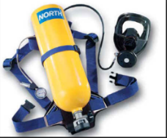 |  | Atmosphere-Supplying Respirators:  Self-contained breathing apparatus (SCBA), NIOSH approved
 | 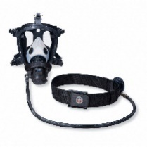 Photo courtesy of Grainger |  | Atmosphere-Supplying Respirators:  Supplied-Air Respirator, NIOSH approved
 | 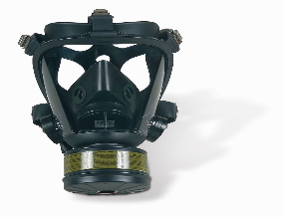  Photo courtesy of Honeywell | Air purifying  full facepiece respirator with canister,  NIOSH approved | 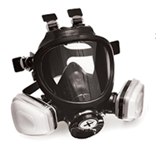 | Air-purifying  full facepiece respirator with OV cartridge + combination N-filter,  NIOSH approved
 | 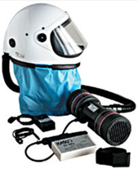 | Powered air- purifying respirator (PAPR)  OV + HE filters, NIOSH approved | 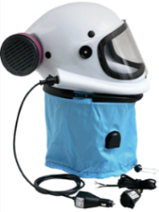 | Powered air purifying respirator (PAPR)  particulate HE filters, NIOSH approved
 | 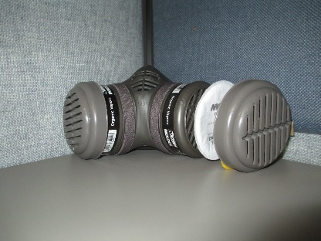 |  | Air-purifying half-mask elastomeric respirator with OV cartridge + combination N-95 particulate filter, NIOSH approved
 | 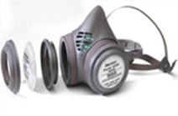 |  | Air-purifying half-mask elastomeric respirator with particulate P-100 (magenta) or N filters (white), NIOSH approved
 | 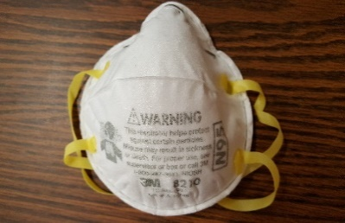  Photo courtesy of N. Fitz | N95 filtering facepiece respirator, NIOSH approved. |  | P100 filtering facepiece respirator, NIOSH approved
Photos courtesy of G. Cooke, Pesticide Coordinator, Oregon Occupational Safety and Health Administration, except where otherwise noted.
6. Required Location for Handler PPE
Handler PPE statements for applicators and other handlers must appear in the PRECAUTIONARY STATEMENTS section of the labeling in the “HAZARDS TO HUMANS (AND DOMESTIC ANIMALS)” section. See 40 CFR 156.212(c)(1).
7. States May Require the Use of Additional PPE
The Agency will approve additional state-required language if it is clear that it applies only in that state.
B. Statements for Contaminated PPE
…

