**Distribution System Contamination Response Procedure Template**

**How to use this template**

This template assists water utilities with developing a Distribution System Contamination Response Procedure (DSCRP) tailored to their specific needs and purposes. It is only a starting point and should be modified as needed.

This template contains all the necessary sections for a plan to respond to a distribution system contamination incident. However, a DSCRP is intended to supplement a utility’s emergency response plan (ERP), usually as an annex or appendix, providing only the instructions and procedures unique to responding to a contamination incident. Some sections in the template may already be contained in your utility’s ERP (for example, utility background), and should be removed from this template during development of your utility’s DSCRP. You may also need to add sections that are important to your utility or to address specific requirements for your local, regional, or state authorities.

Additionally, this template represents a comprehensive response to a contamination incident. For smaller utilities, it is likely that some sections are beyond the capability of the utility to implement and a response partner would be required. The template should be customized to reflect the capabilities of the utility.

See the United States Environmental Protection Agency’s (U.S. EPA) [*Guidance for Responding to Drinking Water Contamination Incidents*](https://www.epa.gov/waterqualitysurveillance/water-contamination-response-resources) for additional information on the topics contained in this template. This guidance discusses each of the topics in depth and points to additional resources for developing the capabilities to respond to distribution system contamination.

Use the Template Instructions, starting on page 2, to complete the template that follows. The template begins on page 7. In the template, [blue text] serves as a prompt for inserting a piece of information and should be removed/replaced as needed. The example figures recommended in this template are available in an editable format in the PowerPoint file to the right. It can be opened and saved by right-clicking the file icon, selecting presentation object and open. The fil can also be downloaded from the [*SRS Water Contamination Response*](https://www.epa.gov/waterqualitysurveillance/water-contamination-response-resources) page.



This PowerPoint file contains editable versions of the figures in the template.

Save the template to your computer before making any changes.

**Template instructions**

**Section 1: Introduction**

Briefly introduce the DSCRP and provide any introductory information that is deemed relevant for responding to a contamination incident. The topics prepopulated in this template are common themes that should be revised as needed to meet the objectives of your utility. Some of the topics may be covered in other plans, such as your utility’s ERP, and do not need to be repeated in your utility’s DSCRP. If covered by other plans, ensure only details unique to a contamination incident are included and do not duplicate or contradict the other plans.

Purpose

Describe the purpose and role of the DSCRP in the response to a contamination incident. Also, discuss the relationship of the DSCRP to other response plans and procedures. Related plans may include ERPs (if separate), standard operating procedures, risk communication plans, public notification plans, continuity of operations plans, remediation strategies, and other agency/government emergency plans.

Scope

Describe the incidents this DSCRP will cover, such as intentional/accidental/natural contamination, types of contaminants, and extent/scale of contamination. Include any assumptions.

Authority

Describe the authority for the plan, if relevant. The plan may be required by a local, state, or federal regulation, by the utility’s response practices, or by a specific utility need. Also, note if the plan was reviewed and approved by any other agencies, such as the primacy agency, local emergency planning committee, or response partners.

Priorities

Describe the priorities for responding to the incident. These priorities will help to guide decision-making throughout the incident. They should be high-level concepts that influence all areas of the response, such as protecting life, protecting public health, protecting infrastructure, protecting the environment, stabilizing the incident, maintaining fire-flow, maintaining system pressure, and maintaining service to key customers (hospitals).

System and Utility Background

Provide background information on the utility and system that could be relevant to implementing the DSCRP, but may not be known by all users. This information could include a description of the source water, system-specific information (e.g., treatment capacity, population served, number of service connections), the jurisdictions/municipalities served by the system, any large volume/critical customers, or a map of the system/service area denoting general flow patterns.

Communication and Information Management

Describe the means of communication and information management that will be used during an incident, including the methods, equipment, and procedures as well as any differences between utility personnel, response partners, stakeholders, and the public.

Health and Safety

Describe the health and safety guidelines that personnel should follow during an incident, particularly for field personnel, such as proper personal protective equipment, health and safety plan requirements, and required approvals.

**Section 2: Roles and Responsibilities**

Describe the roles and responsibilities of all parties involved in the response to a contamination incident. Topics to cover include the Incident Command System (ICS) command structure, when and how to activate the command structure, assumption and transfer of command between different department personnel and higher-ranking supervisors, roles and responsibilities for utility personnel, and roles and responsibilities for response partners. For utility personnel, describe the responsibilities for any critical utility functions that may play an important part in the response, such as water quality management, operations, or laboratory operations, in addition to the incident-specific ICS roles. For partners, describe authorities, roles, and capabilities to support the response. Furthermore, note the phase of the incident or circumstances under which a partner would become involved. Example ICS command structure figures for a small-scale and a large-scale incident are available in the embedded PowerPoint file.

**Section 3: Response Procedure Overview**

Provide a summary of the response procedure to orient new users and ensure that all personnel have knowledge of the “big picture” of the response. Include a figure, such as a flow diagram, to illustrate the overall response process and demonstrate how the later sections of the DSCRP fit together. An example overview figure is available in the embedded PowerPoint file.

**Section 4: Investigation and Response Phase**

Describe how your utility will investigate and respond to a suspected contamination incident. Detail the steps and activities personnel should follow to determine the credibility of the incident and its potential impact on public health and the system. Include decision trees, checklists, and/or forms to aid personnel along with appropriate instructions or details for using these aids. The following are several elements to include in this section.

Investigation and Response Phase Decision Tree

Include a decision tree to provide personnel with a visual step-by-step overview of the investigation and response process. Add a description of each step following the decision tree to provide further details. An example decision tree is available in the embedded PowerPoint file.

Record of Decisions

Include a form to log important decisions and actions during the incident along with the reasoning or considerations for the decision/action. This log will provide a summary of the incident for personnel as well as a record of activities and decision for review during incident close-out. Place the form in the appendix and include instructions for using the form in this section. An example form is available in the template’s appendix.

Information Useful During an Investigation

List any sources of information that may be useful during the investigation (e.g., customer calls, maintenance and repair work orders, routine water quality data). These sources of information are not directly generated by the investigation or response, but are collected as part of routine operations by your utility or response partners. Include the information type, the source with instructions for accessing the information, and any other details about the information that personnel may need during an incident.

Confidence and Impact

Include a ranking system for the utility’s confidence that contamination has occurred and the impact the contamination could have on public health and the system. Such a ranking system will enable quickly conveying the incident status to personnel and will better inform planning the investigation and response activities.

To support the ranking system, include a form to log information gathered during the incident for evaluating the confidence and impact of the contamination. Place the form in the appendix and include instructions for using the form in this section. Customize the included example form located in the appendix to your utility’s needs.

Contaminant Resources and Fact Sheets

It can be helpful to include a list of resources (e.g., online databases, websites) that provide useful information on contaminants that personnel can reference during an incident to inform decision-making throughout the incident. Free resources exist that provide information on contaminant properties, analytical methods, health effects, and treatability, such as Water Contamination information Tool (U.S. EPA) and TOXNET (National Institutes of Health). In addition, for contaminants of concern that are widely used (e.g., petroleum products, pesticides), include Safety Data Sheets or develop short (1 page) factsheets to provide basic background and relevant response information to personnel and response partners. Include information on resources and any factsheets in the appendix.

**Section 5: Site Characterization, Sampling, and Analysis**

Describe the process of site characterization, sampling, and analysis. Include a figure, such as a flow diagram, to illustrate the process. An example figure is available in the embedded PowerPoint file. Develop a Site Characterization and Sampling Plan (SC&P) form that can guide the planning and implementation of field activities. Include resources to expedite the planning of activities, such as listing the field and laboratory capabilities of the utility and response partners, and any important locations for sample collection. Include forms for individual field activities for personnel to record findings, samples collected, and any test results. Note how field and laboratory results should be reported and reviewed.

Site Characterization and Sampling Plan

A Site Characterization and Sampling Plan is a checklist-style form containing all of the utility’s field capabilities. It can be filled out quickly during an incident and distributed to field personnel as a set of instructions for the field activities to perform at a location. Describe who will be responsible for completing and approving the SC&SP, notifying any response partners needed to help implement the SC&SP, and notifying laboratories that samples will need to be analyzed for the selected parameters. Also note how/when to communicate with the field team implementing the plan to report findings and issue additional approvals. An example SC&SP is included in the template’s appendix.

Field Activities Report Forms

Include report forms for documenting findings from field activities called for in the SC&SP (e.g., visual site hazard assessment, site safety screening, water quality testing, and rapid field testing). These report forms are used by personnel to record findings, report any test results, and indicate any important communication points. Also include a chain of custody form for any samples that are collected for laboratory analysis. Example forms (Visual Site Hazard Assessment, Site Safety Screening Report, Water Quality Parameter Report, Rapid Field Testing Report, and Emergency Response Chain of Custody) are available in the template’s appendix.

Field and Laboratory Capabilities

Include a list or table of your utility’s and response partners’ field and laboratory capabilities, such as field equipment, laboratory instrumentation, and analytical methods. Note the parameter, contaminant, or contaminant class, the testing method or application (e.g., test strips), who can perform each capability (utility or partner) and any important details, such as sample turnaround time or capacity.

Potential Sampling Locations

Include a list or table of potential sampling locations for collecting water samples throughout the system. Include the location or asset ID, the type of facility (e.g., tap, hydrant, tank), a description or address for the location, and the significance of the location (e.g., pressure zone, cross-connection).

**Section 6: Operational Responses**

Describe the process for developing operational responses, evaluating their feasibility and impact to customers and the distribution system, and implementing the approved responses. Include a decision tree and any preplanned operational responses to aid personnel.

Operational Response Planning Decision Tree

Include a decision tree to provide personnel with a step-by-step process for evaluating operational responses. Add a description of each step following the decision tree to provide further details. An example decision tree is available in the embedded PowerPoint file.

Table of Preplanned Operational Responses

Include a list or table of preplanned operational responses that can be quickly evaluated and implemented during an incident. Include instructions for how to implement the operational response and the potential impacts of the change on customers and the system.

**Section 7: Risk Communication / Public Notification**

Describe the process for performing risk communication. It is recommended to develop a Risk Communication Plan that is separate from this DSCRP as risk communication covers many aspects of communication (e.g., public outreach, public notification, media tracking). If a Risk Communication Plan is developed, it can be referenced in this section. Include an overview, such as a flow diagram that describes how risk communication fits into the overall response process along with any contamination incident-specific information or procedures. An example overview figure has been provided in the embedded PowerPoint file. If a separate plan is not developed, all communication procedures, templates, and example notifications should be provided in this section.

Public Notification Decision Tree

Include a decision tree to provide personnel with a step-by-step process for determining if public notification is required and which type of notification is appropriate. Add a description of each step following the decision tree to provide further details. An example decision tree is available in the embedded PowerPoint file.

**Section 8: Remediation and Recovery Phase**

Describe how your utility will recover from confirmed contamination and return the system to service. Detail the steps and activities personnel should follow to select and implement a remediation/decontamination strategy, maintain/update existing responses, provide alternate water sources if needed, keep the public updated, and ultimately return to normal operations. While basic remediation techniques may be detailed here (e.g., flushing), it is recommended that a separate remediation/decontamination plan be developed that will guide personnel through the complexities of treating and disposing of contaminated water and infrastructure. Indicate in this section how the other response activities (e.g., operational response, risk communication) continue alongside the remediation/decontamination strategy.

Remediation/Decontamination Strategy

Develop a strategy that will guide personnel through the complexities of treating and disposing of contaminated water and infrastructure. It is impossible to create a flexible strategy that can be applied to a range of contamination incidents. The strategy should provide an approach for characterizing the contamination, selecting and implementing treatment/disposal methods, and evaluating the success of the selected methods. It is recommended that this strategy be detailed in a separate plan. If a separate plan is developed, it should be referenced and an overview provided in this DSCRP.

Remediation and Recovery Phase Decision Tree

Include a decision tree to provide personnel with a visual step-by-step overview of the remediation and recovery process. Add a description of each step following the decision tree to provide further details. An example decision tree is available in the embedded PowerPoint file.

Section 9: Incident Close-Out and After-Action Report/Improvement Plan

Describe the actions personnel should take to document and close out an incident. Preparing an After-Action Report/Improvement Plan (AAR/IP) is an important step for the utility to learn from the incident in order to improve its plan(s) and response activities in the future.

**Appendix: Template Forms**

Place any forms developed to support sections of the DSCRP in the appendix. These forms are meant to be utilized during the incident and multiple copies may be needed. The following forms are included in this template: Record of Decisions, Confidence / Impact Evaluation Record, Site Characterization and Sampling Plan, Field Activities Report Forms (Visual Site Hazard Assessment, Site Safety Screening Report, Water Quality Parameter Report, Rapid Field Testing Report, and Emergency Response Chain of Custody).

**CONFIDENTIAL INFORMATION**

[Utility Name]

Distribution System Contamination Response Procedure

Version [Version Number]

Approval Date: [Date]

**Document Handling Instructions**

[*It may be necessary to include a confidentiality/security disclaimer, instructions for using and distributing the document, and special measures to avoid disclosure of sensitive plans under State Sunshine or Freedom of Information laws. Also, include instructions for version control, such as designating a location for a master copy, to ensure all personnel use only the most up-to-date version during an emergency and note who is in charge of maintaining/updating the document.*]

**Version History**

|  |  |  |  |
| --- | --- | --- | --- |
| **Version Number** | **Date** | **Approved by** | **Changes** |
|  |  |  |  |
|  |  |  |  |
|  |  |  |  |
|  |  |  |  |
|  |  |  |  |
|  |  |  |  |
|  |  |  |  |
|  |  |  |  |

**Contact Lists**

[*These contact lists should be the only location to contain actual names and contact information; in all other locations, personnel should be identified by their role, department, agency, or other generic identifier. Add additional rows if multiple contacts share a role.*]

Key [Utility Name] Personnel Contacts

[*Modify the following contact list and add contact information (for each department, include a main office contact as well as any supervisors/other contacts)*]

|  |  |  |  |  |  |
| --- | --- | --- | --- | --- | --- |
| **Department** | **Contact** | **Phone Numbers** | | **Email Address** | **Location** |
| **Office** | **Cell/Emergency** |
| *Utility Director* | *Jane Brown* | *xxx-xxx-xxxx* | *xxx-xxx-xxxx* | *xxxx@utility.com* | *Main 123* |
| *Security* | *-* | *xxx-xxx-xxxx* | *-* |  | *Main 450* |
| *Supervisor* | *Terry Long* | *xxx-xxx-xxxx* | *xxx-xxx-xxxx* | *xxxx@utility.com* | *Main 456* |
| *Plant Operations* |  |  |  |  |  |
| *Supervisor* |  |  |  |  |  |
| *Distribution Operations* |  |  |  |  |  |
| *Supervisor* |  |  |  |  |  |
| *Water Quality* |  |  |  |  |  |
| *Supervisor* |  |  |  |  |  |
| *Laboratory* |  |  |  |  |  |
| *Supervisor* |  |  |  |  |  |
| *Engineering* |  |  |  |  |  |
| *Supervisor* |  |  |  |  |  |
| *Asset Management* |  |  |  |  |  |
| *Supervisor* |  |  |  |  |  |
| *Communications* |  |  |  |  |  |
| *Supervisor* |  |  |  |  |  |
| *Administrative* |  |  |  |  |  |
| *Supervisor* |  |  |  |  |  |
|  |  |  |  |  |  |
|  |  |  |  |  |  |

Key [Utility Name] ICS Contacts

[*Modify the following contact list and add contact information*]

|  |  |  |  |  |  |
| --- | --- | --- | --- | --- | --- |
| **Role** | **Contact** | **Phone Numbers** | | **Email Address** | **Location** |
| **Office** | **Cell/Emergency** |
| *Incident Commander* | *Sam Wright* | *xxx-xxx-xxxx* | *xxx-xxx-xxxx* | *xxxx@utility.com* | *Main 789* |
| *Communications Officer* |  |  |  |  |  |
| *Liaison Officer* |  |  |  |  |  |
| *Safety Officer* |  |  |  |  |  |
| *Operations Section Chief* |  |  |  |  |  |
| *Planning Section Chief* |  |  |  |  |  |
| *Logistics Section Chief* |  |  |  |  |  |
| *Finance and Administration Section Chief* |  |  |  |  |  |

**[Utility Name] Response Partners and Stakeholders Contacts**

[Modify the following contact list and add contact information]

| **Agency** | **Contact** | **Phone Numbers** | | **Email Address** | **Location** |
| --- | --- | --- | --- | --- | --- |
| **Primary** | **Emergency** |
| **Local** | | | | | |
| *Contract Laboratory* | *John Doe* | *XXX-XXX-XXXX* | *XXX-XXX-XXXX* | [*xxxx@lab.com*](mailto:xxxx@lab.com) | *Street Address* |
| *Local Fire Department* |  |  |  |  |  |
| *Local Hazmat Team* |  |  |  |  |  |
| *Local Police Department* |  |  |  |  |  |
| *Local emergency planning and management groups* |  |  |  |  |  |
| *City Office of Emergency Management* |  |  |  |  |  |
| *City Public Health Department* |  |  |  |  |  |
| *County Public Health Department* |  |  |  |  |  |
| *City Mayor’s Office* |  |  |  |  |  |
| *Local Media Outlets* |  |  |  |  |  |
| *Neighboring Utility* |  |  |  |  |  |
| *Mutual Aid/Assistance Partners* |  |  |  |  |  |
| **State/Regional/Federal** | | | | | |
| *State Drinking Water Primacy Agency* |  |  |  |  |  |
| *State Environmental Protection Agency* |  |  |  |  |  |
| *State Department of Public Health* |  |  |  |  |  |
| *Poison Control Center* |  |  |  |  |  |
| *State Public Health Laboratories* |  |  |  |  |  |
| *State Environmental Laboratories* |  |  |  |  |  |
| *State Office of Emergency Management* |  |  |  |  |  |
| *State Law Enforcement* |  |  |  |  |  |
| *National Guard (via Governor’s Office)* |  |  |  |  |  |
| *WWARNs* |  |  |  |  |  |
| *Interstate Mutual Aid/Assistance Partners* |  |  |  |  |  |
| *USEPA Regional Office* |  |  |  |  |  |

# Table of Contents

Table of Contents vi

List of Figures vi

List of Tables vi

Acronyms vii

Key Terminology vii

Section 1: Introduction 1

Section 2: Roles and Responsibilities 3

Section 3: Response Procedure Overview 7

Section 4: Investigation and Response Phase 8

Section 5: Site Characterization, Sampling, and Analysis 10

Section 6: Operational Responses 13

Section 7: Risk Communication / Public Notification 16

Section 8: Remediation and Recovery Phase 19

Section 9: Incident Close-Out and After-Action Report/Improvement Plan 21

Appendix: Template Forms 22

# List of Figures

[Insert list of figures]

# List of Tables

[Insert list of tables]

# Abbreviations

|  |  |
| --- | --- |
| **Abbreviation** | **Term** |
|  |  |
|  |  |
|  |  |

# Key Terminology

|  |  |
| --- | --- |
| **Term** | **Definition** |
|  |  |
|  |  |
|  |  |

# Section 1: Introduction

This document presents the Distribution System Contamination Response Procedure (DSCRP) for [Utility Name].

Purpose

[*Insert purpose description*]

Scope

[*Insert scope description*]

Authority

[*Insert authority description*]

Priorities

[*Insert priorities description*]

System and Utility Background

Table 1.1. System Information

[*Add system and utility background information*]

|  |  |
| --- | --- |
| **Service Area** |  |
| *Average Demand* |  |
| *Customers Served* |  |
| *Municipalities Served* |  |
|  |  |
| **Source Water** |  |
|  |  |
| **Treatment Plants** |  |
| *[Plant Name] Capacity* |  |
| *[Plant Name] Capacity* |  |
| *Total Treatment Capacity* |  |
|  |  |
| **System Components** |  |
| *Number of Service Connections* |  |
| *Miles of Pipe* |  |
| *Listing of all Storage Tanks (volume, location)* |  |
| *Listing of all Pump Stations (capacity, location)* |  |
|  |  |

Communication and Information Management

Communication during the response to an incident should be conducted using the following methods and/or equipment:

[*Insert communication details*]

All information gathered or generated during the response should be recorded and stored using the following:

[*Insert information management details*]

Health and Safety

[*Insert health and safety guidelines*]

# Section 2: Roles and Responsibilities

Implementation of this DSCRP requires the coordinated participation of [Utility Name] personnel and response partner agencies. This section details the ICS command structure, and the roles and responsibilities of key [Utility Name] personnel and response partners.

Command Structure

Implementation of this DSCRP and management of the incident should be accomplished through the following:

[*Insert ICS command structure description*]

[*Insert example ICS command structure figures*]

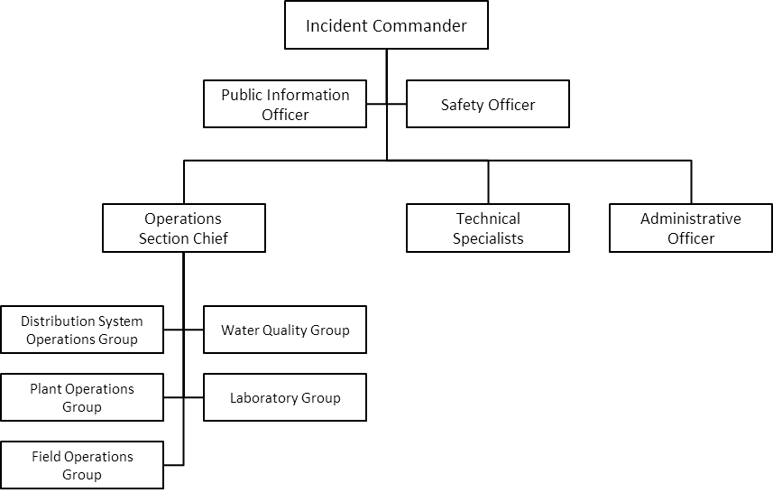

Figure 2-1. Small-scale ICS Structure

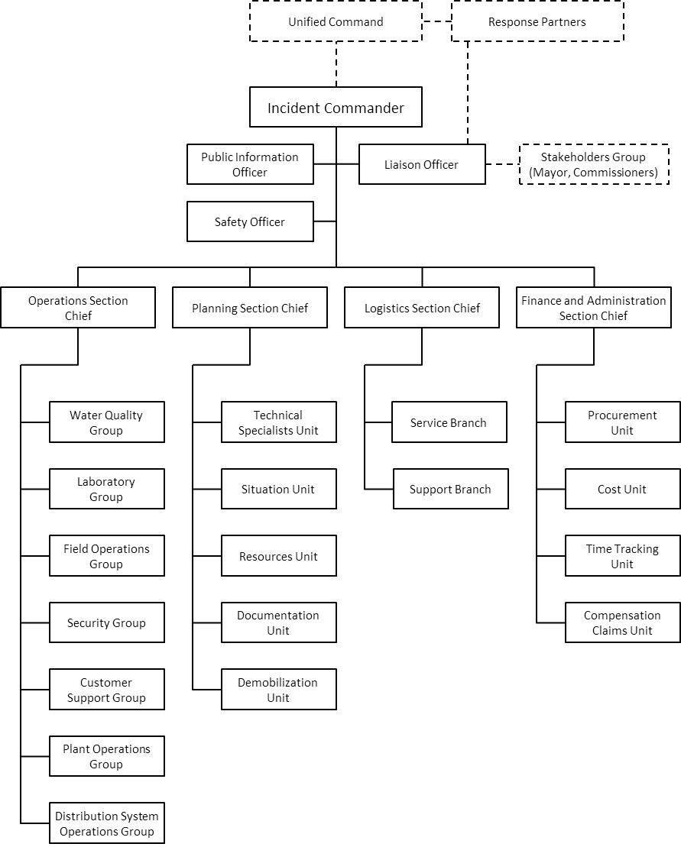

Figure 2-2. Large-scale ICS Structure

Roles and Responsibilities of Key Personnel

The following are the general roles and responsibilities of key [Utility Name] personnel during an incident. Specific roles and responsibilities will be defined based on the nature of the incident.

Table 2-1. Key Personnel Roles

[*Update the utility roles and add responsibilities*]

| **Role** | **Responsibilities** |
| --- | --- |
| *Water Quality Group* |  |
| *Laboratory Group* |  |
| *Distribution System Operations Group* |  |
| *Plant Operations Group* |  |
| *Incident Commander* |  |
| *Public Information Officer* |  |
| *Liaison Officer* |  |
| *Safety Officer* |  |
| *Operations Section Chief* |  |
| *Planning Section Chief* |  |
| *Logistics Section Chief* |  |
| *Finance and Administration Section Chief* |  |

Roles and Responsibilities of Response Partners

Table 2.1 lists the response partners/stakeholders and the situations/activities in which they could contribute. Their involvement and specific roles and responsibilities will vary depending on the needs of each incident.

Table 2-2. Response Partner Roles

[*Update the response partners/stakeholders and indicate response activity participation*]

|  | **Response Activities** | | | | | | | |
| --- | --- | --- | --- | --- | --- | --- | --- | --- |
| **Site Characterization and Sampling** | **Laboratory Analysis** | **Operational Response** | **Risk Communication / Public Notification** | **Public Health Response** | **Criminal Investigation** | **Characterization for Remediation** | **Remediation and Recovery** |
| **Local** | | | | | | | | |
| *Contract Laboratories* |  | *✓* |  | *✓* |  |  | *✓* | *✓* |
| *Local Fire Department* | *✓* |  |  | *✓* | *✓* |  | *✓* | *✓* |
| *Local Hazmat Team* | *✓* |  |  | *✓* | *✓* |  | *✓* | *✓* |
| *Local Police Department* | *✓* |  | *✓* | *✓* |  | *✓* |  | *✓* |
| *Local emergency planning and management groups* |  |  | *✓* | *✓* |  | *✓* | *✓* | *✓* |
| *City Office of Emergency Management* |  |  | *✓* | *✓* |  | *✓* | *✓* | *✓* |
| *City Public Health Agency* | *✓* | *✓* | *✓* | *✓* | *✓* |  | *✓* | *✓* |
| *County Public Health Agency* | *✓* | *✓* | *✓* | *✓* | *✓* |  | *✓* | *✓* |
| *City Mayor’s Office* |  |  | *✓* | *✓* | *✓* | *✓* |  | *✓* |
| *Local Media Outlets* |  |  |  | *✓* |  |  |  |  |
| *Neighboring Utility* | *✓* | *✓* | *✓* |  |  |  | *✓* | *✓* |
| *Mutual Aid/Assistance Partners* | *✓* | *✓* | *✓* |  |  |  | *✓* | *✓* |
| **State/Regional/Federal** | | | | | | | | |
| *State Drinking Water Primacy Agency* | *✓* | *✓* |  | *✓* | *✓* |  | *✓* | *✓* |
| *State Environmental Protection Agency* | *✓* | *✓* |  | *✓* | *✓* |  | *✓* | *✓* |
| *State Department of Public Health* |  | *✓* |  | *✓* | *✓* | *✓* | *✓* | *✓* |
| *Poison Control Center* |  |  | *✓* | *✓* | *✓* |  |  |  |
| *State Public Health Laboratories* | *✓* | *✓* |  |  |  |  | *✓* | *✓* |
| *State Environmental Laboratories* | *✓* | *✓* |  |  |  |  | *✓* | *✓* |
| *State Office of Emergency Management* |  |  |  | *✓* |  | *✓* |  | *✓* |
| *State Law Enforcement* |  |  |  | *✓* |  | *✓* |  | *✓* |
| *WWARNs* | *✓* | *✓* | *✓* |  | *✓* |  | *✓* | *✓* |
| *State National Guard* |  |  |  | *✓* | *✓* |  | *✓* | *✓* |
| *Interstate Mutual Aid/Assistance Partners* | *✓* | *✓* | *✓* |  |  |  | *✓* | *✓* |
| *U.S. EPA Regional Office* | *✓* | *✓* |  | *✓* |  |  | *✓* | *✓* |

# Section 3: Response Procedure Overview

This section provides an overview of the process of responding to suspected contamination in the distribution system covered in this DSCRP.

[*Insert response overview description*]

[*Insert a response overview figure*]

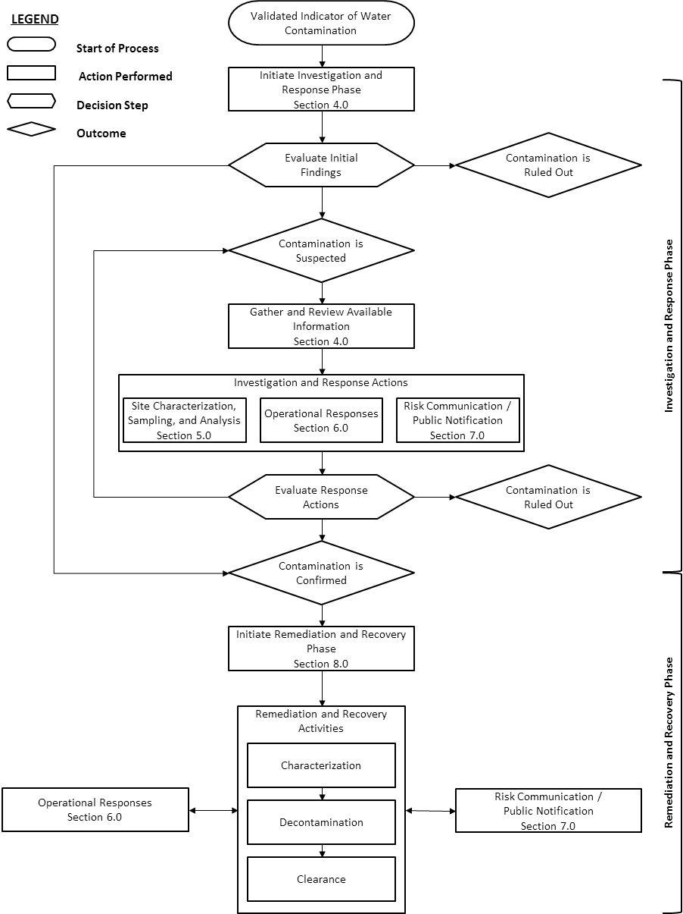

Figure 3-1. Response Procedure Overview

# Section 4: Investigation and Response Phase

This section details investigation and response activities to perform when contamination is suspected in the distribution system.

[*Insert investigation and response phase description*]

[*Insert investigation and response phase decision tree*]

[*Insert a description for each step in the investigation and response phase decision tree*]

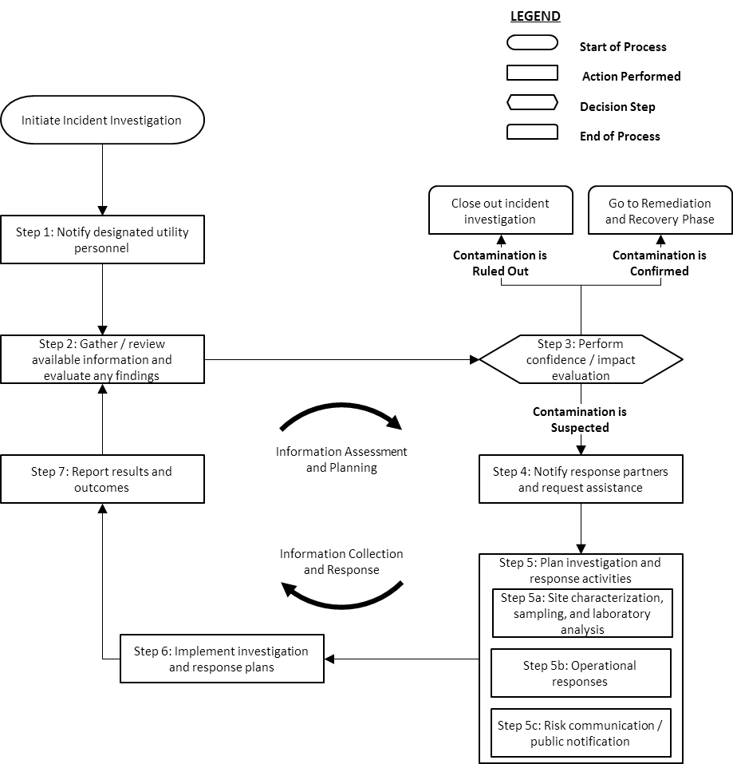

Figure 4-1. Investigation and Response Phase Decision Tree

Table 4-1. Information Useful During an Investigation

[*Modify the list of information and indicator the source / access instructions*]

|  |  |
| --- | --- |
| **Information** | **Source / Accessing Instructions** |
| *Instrument maintenance records* | *Instrument logbooks or digital management system* |
| *Online monitoring data* | *SCADA or water quality information management system* |
| *Flow and pressure data* | *SCADA or distribution operations department* |
| *Pump/tank operating status* | *SCADA or distribution operations department* |
| *Treatment operations information* | *SCADA or treatment plant operations department* |
| *Distribution System modeling results* | *Distribution operations or engineering department* |
| *Sampling results* | *Laboratory information management system (LIMS) or water quality database* |
| *Customer complaints records* | *Customer service department* |
| *Maintenance and repair work orders* | *Distribution and treatment plant operations department* |
| *Reports of drinking water-related illness* | *Local public health agency* |
| *Region/state-wide water advisories* | *State environmental agency* |
| *Recent chemical spills* | *Spill reporting hotline* |
| *Calendar of regional events* | *City/County events calendars* |
|  |  |

Table 4-2. Confidence and Impact Level Descriptions

[*Modify the confidence and impact levels and descriptions*]

|  |  |  |
| --- | --- | --- |
| ***Confidence*** | ***Possible*** | *An indicator has signaled contamination may be present in the distribution system* |
| ***Credible*** | *Evidence has been found to corroborate the initial indicator or the indicator provides strong evidence that contamination has occurred* |
| ***Confirmed*** | *Direct evidence has been found that proves contamination has occurred or a preponderance of evidence overwhelmingly demonstrates it has occurred* |
| ***Impact*** | ***Low*** | *May effect water aesthetics (e.g., taste/odor), but no known effect on public health, no known effect on utility or premise infrastructure, and minimal known extent (e.g., a single block)* |
| ***Medium*** | *Minor acute effect on public health (e.g., minor illness, skin irritation) and/or chronic health concerns and/or minimal effect on utility or premise infrastructure (e.g., requires flushing) and/or moderate extent (e.g., pressure zone, area)* |
| ***High*** | *Moderate to severe acute effect on public health (e.g., major illness, hospitalizations) and/or chronic health and/or moderate to severe effect on utility or premise infrastructure (e.g., requires decontamination/replacement) and/or significant extent (e.g., multiple pressure zones, entire system)* |

# Section 5: Site Characterization, Sampling, and Analysis

This section details the planning and implementation of site characterization, sampling, and analysis activities for a distribution system contamination incident.

[*Insert site characterization, sampling, and analysis description*]

[*Insert a site characterization process figure*]

[*Insert a description for each step in the site characterization process figure*]

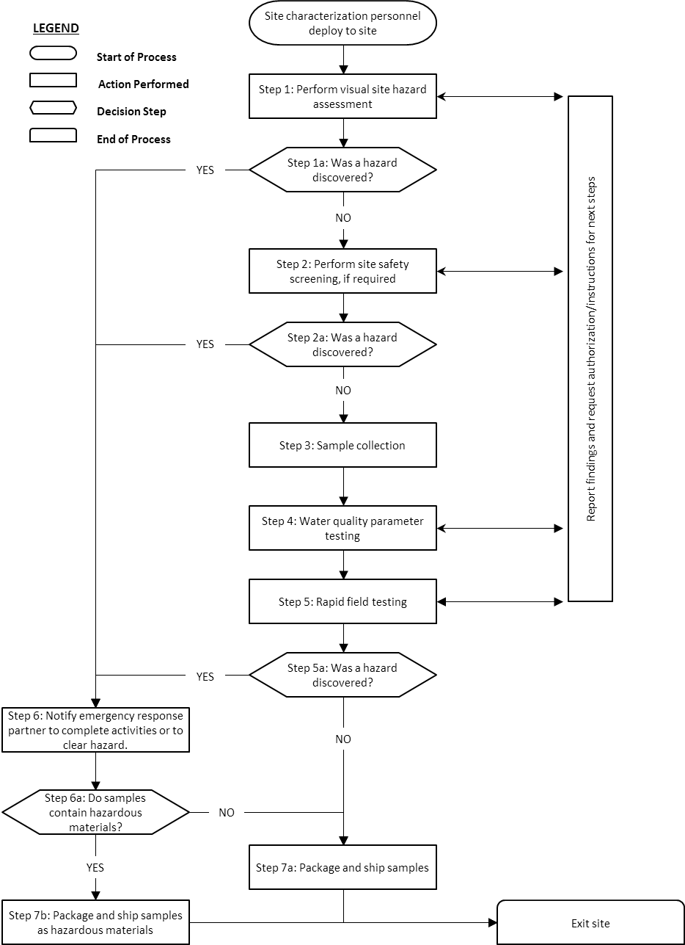

Figure 5-1. Site-characterization and Sampling Process

Table 5-1. Field Sampling and Analysis Capabilities

[*Modify the following table with your utility’s/partner’s capabilities*]

| **Parameter/Contaminant/Class** | **Testing Method/Application** | **In-House/Response Partner** |
| --- | --- | --- |
| **Water Quality Parameter Testing Methods/Capabilities - Field** | | |
| *pH* | *Standard Method 4500-H+B* | *In-House* |
|  |  |  |
|  |  |  |
| **Rapid Field Testing Methods/Capabilities** | | |
| *Arsenic* | *Colorimetric, Test strips* | *In-House, Local HazMat Team* |
|  |  |  |
|  |  |  |

Table 5-2. Laboratory Sampling and Analysis Capabilities

[Modify the following table with your utility’s/partner’s capabilities]

| **Parameter/Contaminant/Class** | **Testing Method/Application** | **In-House/Response Partner** |
| --- | --- | --- |
| **Water Quality Parameter Testing Capabilities/Methods** | | |
| *Anions* | *EPA 300.1* | *In-House, Laboratory B* |
|  |  |  |
|  |  |  |
| **Biological Testing Capabilities/Methods** | | |
| *Coliforms/E. coli* | *Standard Method 9223 (Colilert-18®)* | *In-House, Laboratory B* |
|  |  |  |
|  |  |  |
| **Chemical Testing Capabilities/Methods** | | |
| *Volatiles* | *EPA 502.2, 8021B* | *In-House, Laboratory A* |
|  |  |  |
|  |  |  |
| **Radiological Testing Capabilities/Methods** | | |
| *Radiochemical – gross alpha and beta* | *EPA 900.0* | *State Department of Public Health* |
|  |  |  |
|  |  |  |

Table 5-3. Potential Sampling Locations

[*Modify the following table with your sampling locations*]

| **Sampling Location ID** | **Type of Facility** | **Location Description/Address** | **Significance of Location** |
| --- | --- | --- | --- |
| *H115* | *Hydrant* | *Second hydrant on Main Street, north of 10th Street* | *Cross-connection to chemical manufacturer* |
| *T1043* | *Tap* | *[City Name] maintenance building, 321 Main Street.* | *Main pressure zone* |
|  |  |  |  |
|  |  |  |  |

# Section 6: Operational Responses

This section details the planning and implementation of operational responses for a distribution system contamination incident response.

[*Insert operational response description*]

[*Insert an operational response planning decision tree*]

[*Insert a description for each step in the operational response planning decision tree*]

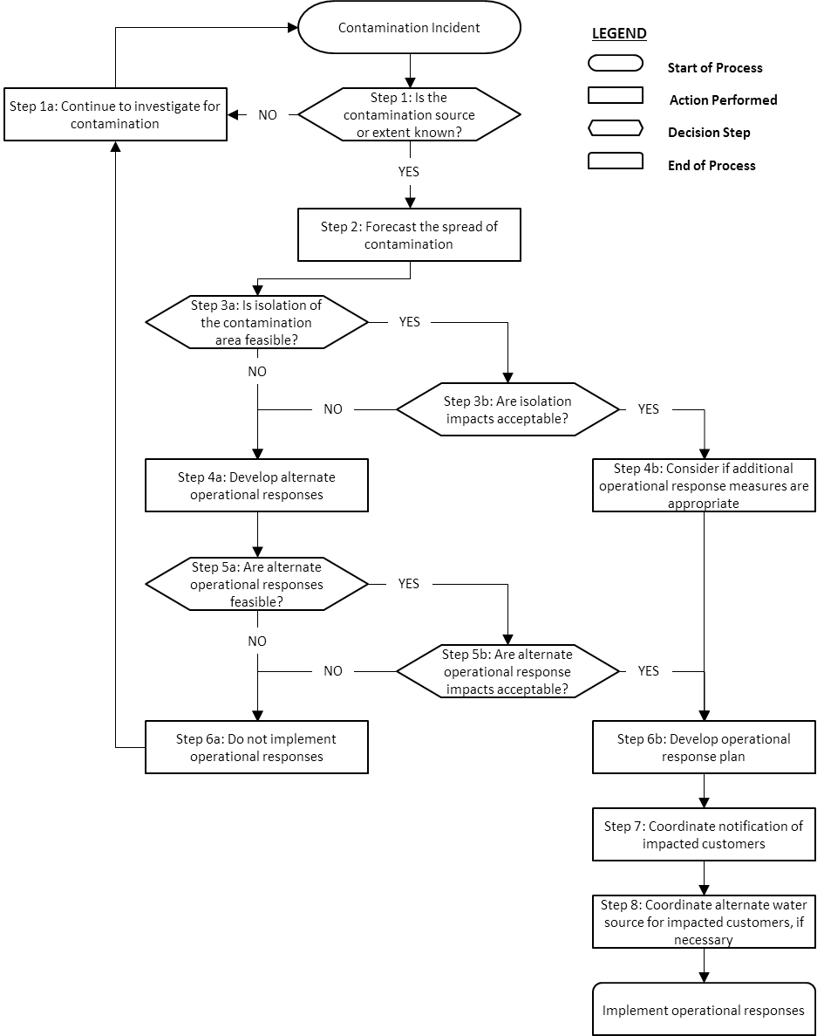

Figure 6-1. Operational Response Planning Decision Tree

Table 6-1. Preplanned Operational Responses

[*Modify the following table*]

| **Operational Response** | **Instructions for implementing the response** | **Potential impacts to customers/system** |
| --- | --- | --- |
| *Isolate pressure zone 3* | *Close valves…*  *Open Tank…* | *Isolation can only be maintained while Tank is above…*  *Prevents flow to west side* |
|  |  |  |
|  |  |  |
|  |  |  |
|  |  |  |

# Section 7: Risk Communication / Public Notification

This section details the planning and implementation of risk communication and public notification for a distribution system contamination incident response.

[*Insert risk communication / public notification description*]

[*Insert risk communication process figure*]

[*Insert a description for each step in the risk communication process figure*]

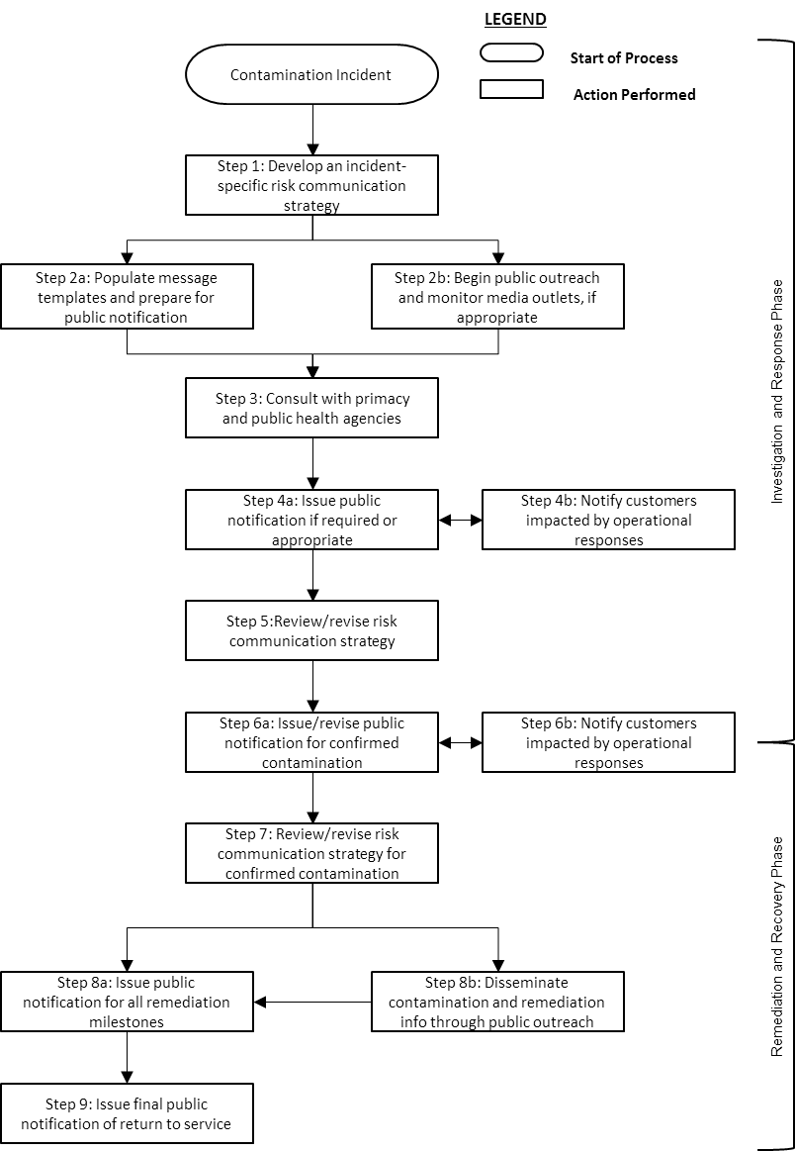

Figure 7-1. Risk Communication Overview

[*Insert public notification decision tree*]

[*Insert a description for each step in the public notification decision tree*]

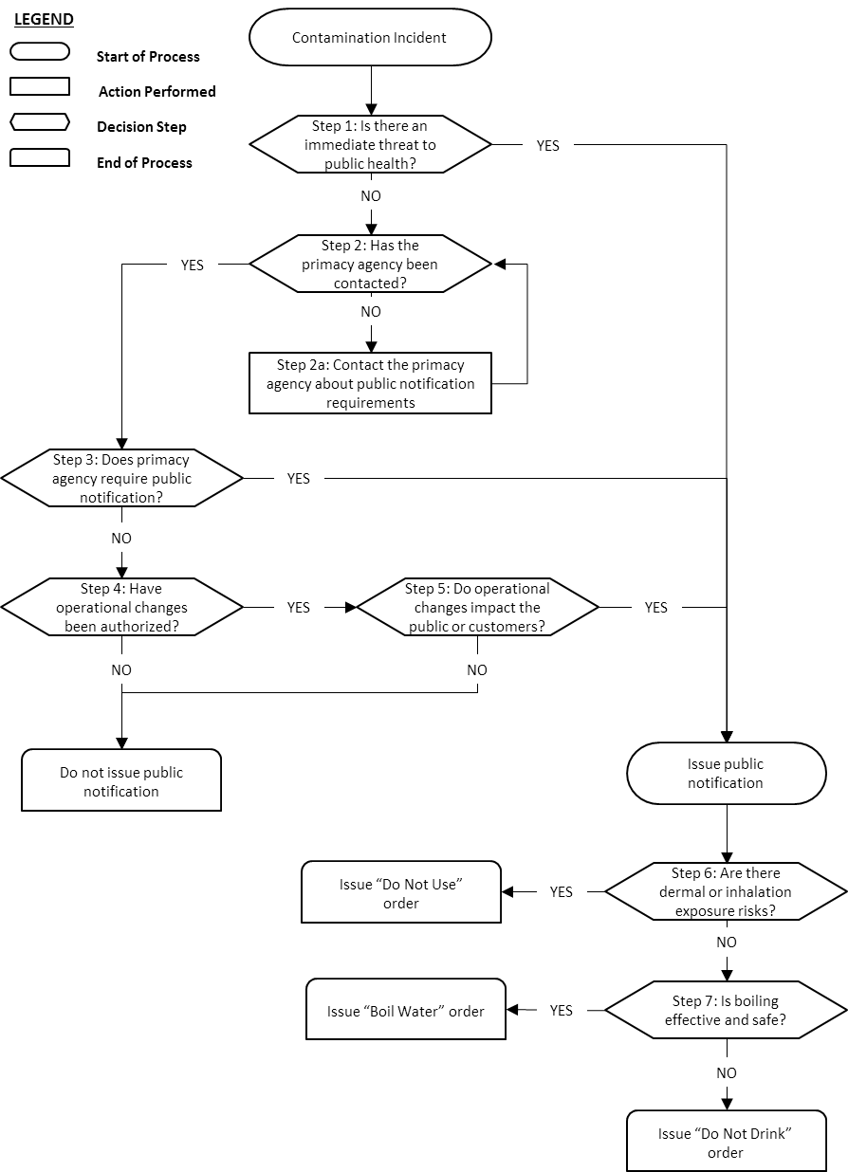

Figure 3-2. Public Notification Decision Tree

# Section 8: Remediation and Recovery Phase

This section details the remediation and recovery process for a distribution system contamination incident response.

[*Insert remediation and recovery phase description*]

[*Insert remediation and recovery decision tree*]

[*Insert decision tree step details*]

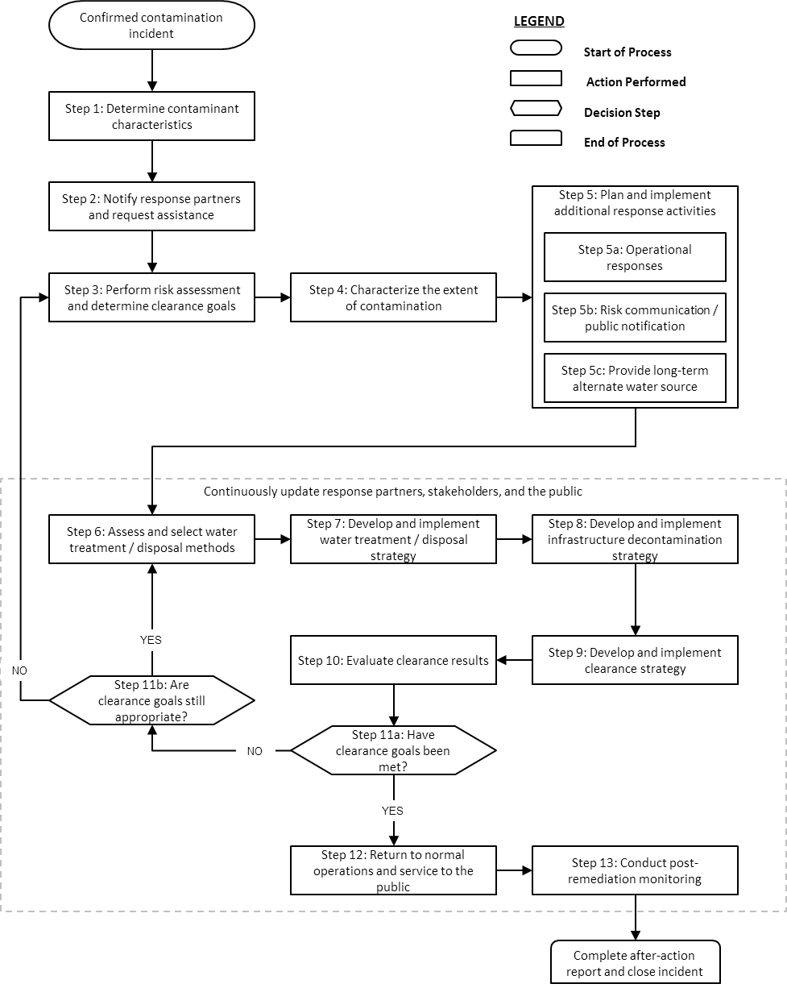

Figure 8-1. Remediation and Recovery Phase Decision Tree

# Section 9: Incident Close-Out and After-Action Report/Improvement Plan

[*Insert incident close-out description*]

# Appendix: Template Forms

**Record of Decisions**

[*Use this form to document all decisions and actions (the “what”) taken during the incident, including the reasoning and the information considered (the “why”). Use the Confidence scale to record your utility’s confidence that contamination is present. Use the Impact scale to record your utility’s assessment of the potential impact of the incident on customers and utility operations/infrastructure.*]

**Record of Decisions**

| **Time/Date** | **Confidence** | | **Impact** | | **Decision / Action** | **Reasoning / Considerations** |
| --- | --- | --- | --- | --- | --- | --- |
| *9:30 am 1/1/18* | **Possible**  **Credible**  **Confirmed** |  | **Low** **Medium** **High** |  | *Sampling team sent to location A to investigate complaints and collect samples.* | *Number of odor complaints above standard threshold requires investigation. Location A selected due to proximity to complaints and ease of access.* |
| *11:00 am 1/1/18* | **Possible**  **Credible**  **Confirmed** |  | **Low** **Medium** **High** |  | *Sampling team authorized to collect samples for VOC and SVOC analysis.* | *Personnel confirmed odor complaints warranting sample collection and analysis.* |
|  | **Possible**  **Credible**  **Confirmed** |  | **Low** **Medium** **High** |  |  |  |
|  | **Possible**  **Credible**  **Confirmed** |  | **Low** **Medium** **High** |  |  |  |
|  | **Possible**  **Credible**  **Confirmed** |  | **Low** **Medium** **High** |  |  |  |
|  | **Possible**  **Credible**  **Confirmed** |  | **Low** **Medium** **High** |  |  |  |
|  | **Possible**  **Credible**  **Confirmed** |  | **Low** **Medium** **High** |  |  |  |
|  | **Possible**  **Credible**  **Confirmed** |  | **Low** **Medium** **High** |  |  |  |

**Confidence/Impact Evaluation Record**

[*This Confidence/Impact Evaluation Record should be used to record any indicators or findings that suggest contamination is present in the distribution system along with the time and date and any pertinent notes or explanation. With each entry, determine the utility’s confidence that contamination is present and evaluate the potential impact on customers and the system. This evaluation will inform decision-making for appropriate responses to the situation and serve as a summary of information collected.*]

**Confidence / Impact Evaluation Record**

|  |  |  |
| --- | --- | --- |
| **Confidence and Impact Level Descriptions** | | |
| *Confidence* | *Possible* | *An indicator has signaled contamination may be present in the distribution system* |
| *Credible* | *Evidence has been found to corroborate the initial indicator or the indicator provides strong evidence that contamination has occurred* |
| *Confirmed* | *Direct evidence has been found that proves contamination has occurred or a preponderance of evidence overwhelmingly demonstrates it has occurred* |
| *Impact* | *Low* | *May effect water aesthetics (e.g., taste/odor), but no known effect on public health, no known effect on utility or premise infrastructure, and minimal known extent (e.g., a single block)* |
| *Medium* | *Minor acute effect on public health (e.g., minor illness, skin irritation) and/or chronic health concerns and/or minimal effect on utility or premise infrastructure (e.g., requires flushing) and/or moderate extent (e.g., pressure zone, area)* |
| *High* | *Moderate to severe acute effect on public health (e.g., major illness, hospitalizations) and/or chronic health and/or moderate to severe effect on utility or premise infrastructure (e.g., requires decontamination/replacement) and/or significant extent (e.g., multiple pressure zones, entire system)* |

| **Time / Date** | **Indicator / Findings of Contamination** | **Notes and Explanation** | **Confidence** | | **Impact** | |
| --- | --- | --- | --- | --- | --- | --- |
| *9:00 am 1/1/18* | *Odor complaints from several customers* | *Odor described as gasoline-like. Poor taste was noted, but no illness reported in complaints.* | **Possible**  **Credible**  **Confirmed** |  | **Low** **Medium** **High** |  |
| *11:00 am 1/1/18* | *Odor confirmed by utility personnel* | *During sample collection in area of odor complaints, sampling personnel noted a similar gasoline-like odor.* | **Possible**  **Credible**  **Confirmed** |  | **Low** **Medium** **High** |  |
| *1:30 pm 1/18/18* | *Multiple gasoline range organics (BTEX/etc.) via lab analysis* | *VOC method 524.2 was used. Source likely gasoline or oil contamination.* | **Possible**  **Credible**  **Confirmed** |  | **Low** **Medium** **High** |  |
|  |  |  | **Possible**  **Credible**  **Confirmed** |  | **Low** **Medium** **High** |  |
|  |  |  | **Possible**  **Credible**  **Confirmed** |  | **Low** **Medium** **High** |  |
|  |  |  | **Possible**  **Credible**  **Confirmed** |  | **Low** **Medium** **High** |  |
|  |  |  | **Possible**  **Credible**  **Confirmed** |  | **Low** **Medium** **High** |  |
|  |  |  | **Possible**  **Credible**  **Confirmed** |  | **Low** **Medium** **High** |  |
|  |  |  | **Possible**  **Credible**  **Confirmed** |  | **Low** **Medium** **High** |  |
|  |  |  | **Possible**  **Credible**  **Confirmed** |  | **Low** **Medium** **High** |  |
|  |  |  | **Possible**  **Credible**  **Confirmed** |  | **Low** **Medium** **High** |  |
|  |  |  | **Possible**  **Credible**  **Confirmed** |  | **Low** **Medium** **High** |  |
|  |  |  | **Possible**  **Credible**  **Confirmed** |  | **Low** **Medium** **High** |  |
|  |  |  | **Possible**  **Credible**  **Confirmed** |  | **Low** **Medium** **High** |  |
|  |  |  | **Possible**  **Credible**  **Confirmed** |  | **Low** **Medium** **High** |  |
|  |  |  | **Possible**  **Credible**  **Confirmed** |  | **Low** **Medium** **High** |  |
|  |  |  | **Possible**  **Credible**  **Confirmed** |  | **Low** **Medium** **High** |  |

**Site Characterization and Sampling Plan**

|  |  |  |  |  |  |  |  |  |  |  |  |  |  |  |  |  |  |  |  |  |  |
| --- | --- | --- | --- | --- | --- | --- | --- | --- | --- | --- | --- | --- | --- | --- | --- | --- | --- | --- | --- | --- | --- |
| **Investigation Site** | | | | | | | | | | | | | | | | | | | | | |
| **Site Name:** | | | | | | | | | | | | | | | | | | **Additional Site Information:** | | | |
| **Site Address:** | | | | | | | | | | | | | | | | | |
| **Type of Facility:** | | | 🞎 Source water  🞎 Ground storage tank  🞎 Tap | | | | | | | | 🞎 Treatment plant  🞎 Elevated storage tank  🞎 Hydrant | | | | | | | | 🞎 Pump station  🞎 Finished water reservoir  🞎 Service connection | | |
| 🞎 Water quality monitoring station | | | | | | | | | | | | | | | |
| 🞎 Other: ___________________________________________________ | | | | | | | | | | | | | | | | | | |
| **Initial Information Known:** | | | 🞎 Customer complaints  🞎 Water quality anomaly | | | | | | | | | | | | | | 🞎 Reported illnesses  🞎 Security alert | | | | |
| 🞎 Other: ___________________________________________________ | | | | | | | | | | | | | | | | | | |
| **Field Activities** | | | | | | | | | | | | | | | | | | | | | |
| 🞎 Visual site hazard assessment  🞎 Site safety screening  🞎 Water quality parameter testing | | | | | | | | | | | | | | 🞎 Rapid field testing  🞎 Sample collection for laboratory analysis | | | | | | | |
| **Site Safety Screening** | | | | | | | | | | | | | | | | | | | | | |
| **✓** | | **Parameter** | | | | | | | | **✓** | | **Parameter** | | | | | | | | | |
|  | |  | | | | | | | |  | |  | | | | | | | | | |
|  | |  | | | | | | | |  | |  | | | | | | | | | |
| **Water Quality Parameters** | | | | | | | | | | | | | | | | | | | | | |
| **✓** | | **Parameter** | | | | | | | | **✓** | | **Parameter** | | | | | | | | | |
|  | |  | | | | | | | |  | |  | | | | | | | | | |
|  | |  | | | | | | | |  | |  | | | | | | | | | |
| **Rapid Field Testing** | | | | | | | | | | | | | | | | | | | | | |
| **✓** | | **Parameter** | | | | | | | | **✓** | | **Parameter** | | | | | | | | | |
|  | |  | | | | | | | |  | |  | | | | | | | | | |
|  | |  | | | | | | | |  | |  | | | | | | | | | |
| **Sampling Plan** | | | | | | | | | | | | | | | | | | | | | |
| 🞎 Distribution main  🞎 Service line  🞎 Premise  🞎 Other: ________________________________ | | | | | | | | | | | | 🞎 Composite sample  🞎 Grab sample  🞎 Large volume sample collection without sub-sampling  🞎 Large volume sample collection with sub-sampling  🞎 Contaminant or class listed below  🞎 Contaminant or class described in attached plan | | | | | | | | | |
| **✓** | **Contaminant or Contaminant Class** | | | | | | | | | | **✓** | **Contaminant or Contaminant Class** | | | | | | | | | |
|  |  | | | | | | | | | |  |  | | | | | | | | | |
|  |  | | | | | | | | | |  |  | | | | | | | | | |
|  |  | | | | | | | | | |  |  | | | | | | | | | |
|  |  | | | | | | | | | |  |  | | | | | | | | | |
|  |  | | | | | | | | | |  |  | | | | | | | | | |
|  |  | | | | | | | | | |  |  | | | | | | | | | |
| **Sample Delivery:** | | | | 🞎 Return samples to utility | | | | | 🞎 Ship samples to pre-arranged laboratories | | | | | | | | | | | | 🞎 Recipient listed below |
| **Name:** | | | | | | | | | | | | | | | | | | | | | |
| **Address:** | | | | | | | | | | | | | | | | | | | | | |
| **Phone No.:** | | | | | | | | | | | | | | | | | | | | | |
| **Field Response Personnel** | | | | | | | | | | | | | | | | | | | | | | |
| **Utility** | | | | | 🞎 Site Characterization Team:____________________________________________  🞎 Water quality technician:_______________________________________________  🞎 Field samplers:______________________________________________________  🞎 Security officer:______________________________________________________  🞎 Distribution system operator:____________________________________________  🞎 Other: _____________________________________________________________ | | | | | | | | | | | | | | | | | |
| **Participating Agencies** | | | | | 🞎 Local law enforcement  🞎 HazMat  🞎 Fire department  🞎 FBI  🞎 Civil Support Team  🞎 Primacy Agency  🞎 EPA Response Team  🞎 Other: ____________________ | | | | | | | | | | **Participating Agency will:**  🞎 Deploy with utility personnel  🞎 Meet at location site at (specify time) | | | | | | | |
| **Communications** | | | | | | | | | | | | | | | | | | | | | | |
| **Mode of Communication:** | | | | | 🞎 Phone | | | | 🞎 2-way radio | | | | | | | | | | 🞎 Digital | | | | |
| 🞎 Other: _____________________________________________________ | | | | | | | | | | | | | | | | | | |
| **Reporting Events:** | | | | | 🞎 Upon arrival at site  🞎 During approach  🞎 Site entry | | | | | | | | | | | 🞎 Site exit  🞎 After field testing  🞎 Other: __________________________ | | | | | | |
| **Report To:** | | | | | | | | | | | | | **Phone No.:** | | | | | | | | | |
| **Health and Safety** | | | | | | | | | | | | | | | | | | | | | | | |
| **Health and Safety Plan:** | | | | | | 🞎 Reviewed  🞎 Modified | | If modified, describe:______________________________ | | | | | | | | | | | | | | | |
| **✓** | **Personal Protective Equipment** | | | | | | | | | | **✓** | **Personal Protective Equipment** | | | | | | | | | | | |
|  |  | | | | | | | | | |  |  | | | | | | | | | | | |
|  |  | | | | | | | | | |  |  | | | | | | | | | | | |
|  |  | | | | | | | | | |  |  | | | | | | | | | | | |
| **Approvals** | | | | | | | | | | | | | | | | | | | | | | | |
| **Health and Safety Officer** | | | | | | | Name (PRINT): | | | | | | | | | | | | | | | | |
| Signature: | | | | | | | | | | | | | Date: | | | |
| **Utility Manager or Incident Commander** | | | | | | | Name (PRINT): | | | | | | | | | | | | | | | | |
| Signature: | | | | | | | | | | | | | Date: | | | |

**Visual Site Hazard Assessment Form**

| **General Information** | | | | | | | | | |
| --- | --- | --- | --- | --- | --- | --- | --- | --- | --- |
| **Site Name or ID:** | | | | | | | **Date:** | | |
| **Site Address:** | | | | | | | **Time of Arrival:** | | |
| **Type of Facility:** | 🞎 Source water  🞎 Ground storage tank  🞎 Distribution main | | | | 🞎 Treatment plant  🞎 Elevated storage tank  🞎 Hydrant | | | | 🞎 Pump station  🞎 Finished water reservoir  🞎 Service connection |
| 🞎 Other: _____________________________________________________ | | | | | | | | |
| **Weather Conditions at Site:** | | | | | | | | | |
| **Additional Site Information:** | | | | | | | | | |
| **Designated Contact (Name, Title, and Phone Number):** | | | | | | | | | |
| **Communication Check:** 🞎 Phone 🞎 2-way radio 🞎 Digital 🞎 Other:___________________ | | | | | | | | | |
| Contact Time: ______________ | | | Individual(s) Contacted:_________________________ | | | | | | |
| **Site Approach** | | | | | | | | | |
| **Immediate Hazards:** | 🞎 None  🞎 Fire  🞎 Signs of a potential explosive hazard (e.g., devices with exposed wires)  🞎 Hazardous materials release  🞎 Unauthorized personnel/intruder onsite  🞎 Other________________________________________ | | | | | **Time of Approach to Site:** | | | |
|  | | | |
| \*\*\*\**If hazards are discovered* STOP *and* WITHDRAW****  *Notify Designated Contact and await further instructions* | | | | | | | | | |
| **Signs of Chemical Hazards:** | 🞎 None  🞎 Dead or stressed vegetation  🞎 Unexplained liquids  🞎 Dead animals  🞎 Clouds or vapors  🞎 Odors | | | | | | | | |
|  | 🞎 None  🞎 Sulfur  🞎 Sweet/fruity | | 🞎 Irritating  🞎 Pungent  🞎 Skunky | | | | 🞎 New mown hay  🞎 Bitter almond  🞎 Other____________ | |
| **Unusual Vehicle Found at the Site:** | 🞎 None  🞎 Car/sedan | | | 🞎 Flatbed truck  🞎 SUV | | | | 🞎 Construction vehicle  🞎 Pickup truck | |
| 🞎 Other_____________________ | | | | | | | | |
| Describe make/model/year/color, license plate #, and logos or markings: | | | | | | | | |

| **Site Approach (continued)** | | | | | | | | | |
| --- | --- | --- | --- | --- | --- | --- | --- | --- | --- |
| **Signs of Intrusion or Tampering:** | 🞎 None  🞎 Open/damaged gates, doors, or windows  🞎 Missing/damaged equipment  🞎 Cut locks/fences | | | 🞎 Open/damaged access hatches  🞎 Facility in disarray  🞎 Other: ______________  ______________________ | | Signs of sequential intrusion (e.g., locks removed from a gate and hatch)? | | | |
| 🞎 Yes | | | 🞎 No |
| Describe signs of tampering: | | | | | | | | |
| **Unusual Equipment:** | 🞎 None  🞎 Tools (e.g., wrenches, bolt cutters)  🞎 Lab equipment (e.g., beakers, tubing) | | | 🞎 Discarded PPE (e.g., gloves, masks)  🞎 Hardware (e.g., valves, pipe)  🞎 Pumping equipment | | 🞎 Other: ______________  ______________________ | | | |
| Describe equipment: | | | | | | | | |
| **Unusual Containers:** | Type of container: | |  | | Condition of container: | | |  | |
| 🞎 None  🞎 Plastic bag  🞎 Test tube  🞎 Drum/barrel  🞎 Box/bin  🞎 Bulk container | | 🞎 Bottle/jar  🞎 Pressurized cylinder  🞎 Other:  ____________  ____________ | | 🞎 Opened  🞎 Unopened  🞎 New  🞎 Old | | | 🞎 Damaged/leaking  🞎 Intact/dry | |
| Describe container size, labeling/placards, and visible contents: | | | | | | | | |
| ****STOP and REPORT****  *Report to Designated Contact* | | | | | | | | | |
| **Approval granted to proceed with sample collection?** | | 🞎 Yes  🞎 No | | | | | **Time of Site Exit:** | | |

**Visual Site Hazard Assessment Form Instructions**

| **General Information** | |
| --- | --- |
| **Site Name or ID** | Provide the site name or ID where the visual site hazard assessment is being conducted. This form is for a single site. |
| **Site Address** | Provide the full street address of the site. If a street address is not available, the physical location of the site should be recorded in a clear manner. |
| **Date** | Enter the date that the site is being assessed. |
| **Time of Arrival** | Enter the time of arrival to the site. |
| **Type of Facility** | Select the appropriate box to indicate the type of facility being assessed. If the type of facility being assessed is not listed, select the box marked “Other” and describe the type of facility. |
| **Weather Conditions at Site** | Enter a description of the weather conditions at the site. Examples of conditions to describe include: temperature, wind speed, wind direction, and precipitation. |
| **Additional Site Information** | Enter any other information pertinent to the site not included in the “General Information” section. |
| **Designated Contact** | Enter the name, title, and phone number of the person to whom results should be reported from the field. |
| **Communication Check** | Select the method(s) used for communication, time contact established, and individual(s) contacted. |
| **Site Approach** | |
| **Immediate Hazards** | If an immediate hazard is observed during site approach, select the appropriate box to indicate the hazard. If the type of hazard observed is not listed, select the box marked “Other” and describe the hazard. |
| **Time of Approach to Site** | Enter the time of approach to the site. |
| **Signs of Chemical Hazards** | If signs of a chemical hazard are observed during the site assessment, select the appropriate box to indicate the hazard. |
| **Unusual Vehicle Found at the Site** | If an unusual vehicle is observed during the site assessment, select the appropriate box to indicate the type of vehicle. If the type of vehicle is not listed, select the box marked “Other” and describe the vehicle. Enter the make/model/year/color and license plate number of the vehicle in the space provided. |
| **Signs of Intrusion or Tampering** | If signs of intrusion or tampering are observed during the site assessment, select the appropriate box. Provide a description of the signs of intrusion or tampering. |
| **Unusual Equipment** | If unusual equipment is observed during the site assessment, select the appropriate box. Provide a description of the equipment. |
| **Unusual Containers** | If unusual containers are observed during the site assessment, select the appropriate box to indicate the type of container and condition of the container. Provide a description of the container. |
| **Approval granted to proceed with sample collection?** | Select “Yes” or “No” to indicate whether approval has been granted to proceed with sample collection. |
| **Time of Site Exit** | Enter the time of exit from the site. |

**Site Safety Screening Report Form**

| **General Information** | | | | | | | | | | | | |
| --- | --- | --- | --- | --- | --- | --- | --- | --- | --- | --- | --- | --- |
| **Site Name or ID:** | | | | | | | | | | **Date:** | | |
| **Site Address:** | | | | | | | | | | **Time of Arrival:** | | |
| **Team Members:** | | | | | | | | | | **Report Form ID:** | | |
| **Designated Contact (Name, Title, and Phone Number):** | | | | | | | | | | | | |
| **Meter/Kit IDs** | | | | | | | | | | | | |
|  | | | | | |  | | | | | | |
|  | | | | | |  | | | | | | |
|  | | | | | |
| **Instrument Checks** | | | | | | | | | | | | |
| **Parameter** | **Blank or Background Result** | | | **Instrument Checks Performed** | | | **Instrument Check Reference Value** | | **Instrument Check Result** | | | **Acceptance Range** |
|  |  | | |  | | |  | |  | | |  |
|  |  | | |  | | |  | |  | | |  |
|  |  | | |  | | |  | |  | | |  |
| ****STOP and REPORT****  *If an instrument check result is outside of acceptance range, report the result to the Designated Contact before proceeding.* | | | | | | | | | | | | |
| **Sample Results** | | | | | | | | | | | | |
| **Parameter** | **Units** | **Expected Range** | | | **Action Level** | | | **Action Level Exceeded? (Y/N)** | | | **Recorded Result** | |
|  |  |  | | |  | | |  | | |  | |
|  |  |  | | |  | | |  | | |  | |
|  |  |  | | |  | | |  | | |  | |
| ****STOP and REPORT****  *Verbally report results to the Designated Contact.* | | | | | | | | | | | | |
| **Deviations from Standard Operating Procedures (SOPs) and Other Notes** | | | | | | | | | | | | |
|  | | | | | | | | | | | | |
| **Submitted By** | | | | | | | | | | | | |
| Report Submitted By (PRINT): | | |  | | | | | | | | | |
| Report Submitted By (Signature): | | |  | | | | | | | | | |
| Date: | | |  | | | | | | | | | |

**Site Safety Screening Report Form Instructions**

| **General Information** | |
| --- | --- |
| **Site Name or ID** | Provide the site name or ID where site safety screening is being conducted. This form is for a single site. |
| **Site Address** | Provide the full street address of the site. If a street address is not available the physical location of the site should be recorded in a clear manner. |
| **Team Members** | Record the names of team members performing site safety screening. |
| **Designated Contact** | Enter the name, title, and phone number of the person to whom results should be reported from the field. |
| **Date** | Enter the date that the site safety screening is performed. |
| **Time of Arrival** | Enter the time the team arrives at the site and begins site safety screening. |
| **Report Form ID** | Enter a unique ID number for this form. |
| **Meter/Kit IDs** | |
| Enter the ID for the meter or kit used to measure the site safety screening parameters. | |
| **Instrument Checks** | |
| **Parameter** | List the parameters that are being measured. Instrument checks are typically conducted in the field before entering the site. |
| **Blank or Background Result** | Enter the result(s) for blank or background sample(s), if taken. |
| **Instrument Checks Performed** | Enter the instrument checks that are performed to ensure instrumentation is operational and ready for use. |
| **Instrument Check Reference Value** | Enter the reference value(s) for the instrument check(s), if applicable. |
| **Instrument Check Result** | Enter the result(s) for the instrument check(s). |
| **Acceptance Range** | Enter the acceptance range for instrument check(s). |
| **Sample Results** | |
| **Parameter** | List the parameters that are being measured. |
| **Units** | Enter the units for the parameter result(s). |
| **Expected Range** | Enter the expected range for the site safety screening parameter(s) based on baseline/historical data for the site. |
| **Action Level** | Enter the action level set by the utility for each site safety screening parameter. |
| **Action Level Exceeded? (Y/N)** | Enter Y if action level is exceeded and N if the action level is not exceeded. |
| **Recorded Result** | The highest observed result should be recorded for each parameter. If results are within the normal range, they may be recorded as “Normal.” If the action level is exceeded, this result should be recorded. |
| **Deviations from SOP(s) and Other Notes** | |
| Document any deviations or changes to SOP(s) or other notes related to site safety screening. | |
| **Submitted By** | |
| **Report Submitted By (PRINT)** | The printed name of the individual recording results and submitting the report to the utility manager or Incident Commander. |
| **Report Submitted By (Signature)** | The signature of the individual recording results and submitting the report to the utility manager or Incident Commander. |
| **Date** | The date the results are submitted to the utility manager or Incident Commander. |

**Water Quality Parameter Report Form**

| **General Information** | | | | | | | | | | | | |
| --- | --- | --- | --- | --- | --- | --- | --- | --- | --- | --- | --- | --- |
| **Site Name or ID:** | | | | | | | | | | **Date:** | | |
| **Site Address:** | | | | | | | | | | **Sample Collection Time:** | | |
| **Team Members:** | | | | | | | | | | **Report Form ID:** | | |
| **Designated Contact (Name, Title, and Phone Number):** | | | | | | | | | | | | |
| **Meter/Kit IDs** | | | | | | | | | | | | |
|  | | | | | |  | | | | | | |
| **Field Point-of-Use Quality Control (QC)** | | | | | | | | | | | | |
| **Parameter** | **Blank or Background Result** | | **QC Lot Number** | | | | **QC True Value** | | **QC Result** | | | **Acceptance Range** |
|  |  | |  | | | |  | |  | | |  |
|  |  | |  | | | |  | |  | | |  |
|  |  | |  | | | |  | |  | | |  |
| ****STOP and REPORT****  *If a field point-of-use QC result is outside of acceptance range, report the result to the Designated Contact before proceeding.* | | | | | | | | | | | | |
| **Sample Results** | | | | | | | | | | | | |
| **Parameter** | | **Units** | | | **Sample Result** | | | **Duplicate Result** | | | **Expected Range** | |
|  | |  | | |  | | |  | | |  | |
|  | |  | | |  | | |  | | |  | |
|  | |  | | |  | | |  | | |  | |
| *****STOP and REPORT****  *Verbally report results to Designated Contact.* | | | | | | | | | | | | |
| **Deviations from Standard Operating Procedures (SOPs) and Other Notes** | | | | | | | | | | | | |
|  | | | | | | | | | | | | |
| **Submitted By** | | | | | | | | | | | | |
| Report Submitted By (PRINT): | | | |  | | | | | | | | |
| Report Submitted By (Signature): | | | |  | | | | | | | | |
| Date: | | | |  | | | | | | | | |

**Water Quality Parameter Report Form Instructions**

| **General Information** | |
| --- | --- |
| **Site Name or ID** | Provide the site name or ID where water quality parameters are being measured. This form is for a single sample location. |
| **Site Address** | Provide the full street address of the site. If a street address is not available the physical location of the site should be recorded in a clear manner. |
| **Team Members** | Record the names of team members performing water quality parameter testing. |
| **Designated Contact** | Enter the name, title, and phone number of the person to whom results should be reported from the field. |
| **Date** | Enter the date that the water quality parameters are measured. |
| **Sample Collection Time** | Enter the collection time for the sample. |
| **Report Form ID** | Enter a unique ID number for the form. This number will be used to link water quality parameter results to samples on the chain of custody form. |
| **Meter/Kit IDs** | |
| Enter the ID for the meter or kit used to measure the water quality parameters. | |
| **Field Point-of-Use QC** | |
| **Parameter** | List the parameters that are being measured. Field point-of-use QC samples are analyzed in the field before analyzing collected samples. |
| **Blank or Background Result** | Enter the result(s) for blank or background sample(s), if taken. |
| **QC Lot Number** | Enter the lot number(s) for the point-of-use QC sample(s). Point-of-use QC samples may not be analyzed at every sample location. |
| **QC True Value** | Enter the true value(s) for the point-of-use QC sample(s). |
| **QC Result** | Enter the result(s) for the point-of-use QC sample(s). |
| **Acceptance Range** | Enter the acceptance range for the point-of-use QC sample(s). |
| **Sample Results** | |
| **Units** | Enter the units for the sample result(s). |
| **Sample Result** | Enter the result(s) for the sample(s). |
| **Duplicate Result** | Enter the result(s) for the duplicate measurement(s), if taken. |
| **Expected Range** | Enter the expected range for the water quality parameter(s) based on current expected values for location. The expected range should be known before water quality parameter testing. |
| **Deviations from SOP(s) and Other Notes** | |
| Document any deviations or changes to SOP(s) or other notes related to water quality parameter testing. | |
| **Submitted By** | |
| **Report Submitted By (PRINT)** | The printed name of the individual recording results and submitting the report to the utility manager or Incident Commander. |
| **Report Submitted By (Signature)** | The signature of the individual recording results and submitting the report to the utility manager or Incident Commander. |
| **Date** | The date the results are submitted to the utility manager or Incident Commander. |

**Rapid Field Testing Report Form**

| **General Information** | | | | | | | |
| --- | --- | --- | --- | --- | --- | --- | --- |
| **Site Name or ID:** | | | | | | **Date:** | |
| **Site Address:** | | | | | | **Sample Collection Time:** | |
| **Team Members:** | | | | | | **Report Form ID:** | |
| **Designated Contact (Name, Title, and Phone Number):** | | | | | | | |
| **Meter/Kit IDs** | | | | | | | |
|  | | |  | | | | |
| **Field Quality Control (QC) Samples** | | | | | | | |
| **Parameter** | **Blank or Background Result** | **QC Lot Number** | | **QC True Value** | **QC Result** | | **Acceptance Range** |
|  |  |  | |  |  | |  |
|  |  |  | |  |  | |  |
|  |  |  | |  |  | |  |
| ****STOP and REPORT****  *If a field QC result is outside of acceptance range, report the result to the Designated Contact before proceeding.* | | | | | | | |
| **Sample Results** | | | | | | | |

| **Parameter** | **Units** | | **Sample Result** | **Duplicate Result** | **Expected Range** |
| --- | --- | --- | --- | --- | --- |
|  |  | |  |  |  |
|  |  | |  |  |  |
|  |  | |  |  |  |
| ****STOP and REPORT****  *Verbally report results the Designated Contact.* | | | | | |
| **Deviations from Standard Operating Procedures (SOPs) and Other Notes** | | | | | |
|  | | | | | |
| **Submitted By** | | | | | |
| Report Submitted By (PRINT): | |  | | | |
| Report Submitted By (Signature): | |  | | | |
| Date: | |  | | | |

**Rapid Field Testing Report Form Instructions**

| **General Information** | |
| --- | --- |
| **Site Name or ID** | Provide the site name or ID where rapid field testing is being conducted. This form is for a single sample location. |
| **Site Address** | Provide the full street address of the site. If a street address is not available the physical location of the site should be recorded in a clear manner. |
| **Team Members** | Record the names of team members performing rapid field testing. |
| **Designated Contact** | Enter the name, title, and phone number of the person to whom results should be reported from the field. |
| **Date** | Enter the date that the rapid field testing is performed. |
| **Sample Collection Time** | Enter the collection time for the sample. |
| **Report Form ID** | Enter a unique ID number for this form. This number will be used to link rapid field testing results to samples on the chain of custody form. |
| **Meter/Kit IDs** | |
| Enter the ID for the meter or kit used to measure the rapid field testing parameters. | |
| **Field QC Samples** | |
| **Parameter** | List the parameters that are being measured. Field QC samples are analyzed in the field before analyzing collected samples. |
| **Blank or Background Result** | Enter the result(s) for blank or background sample(s), if taken. |
| **QC Lot Number** | Enter the lot number(s) for the field QC sample(s). Field QC samples may not be analyzed at every sample location. |
| **QC True Value** | Enter the true value(s) for the field QC sample(s). |
| **QC Result** | Enter the result(s) for the field QC sample(s). |
| **Acceptance Range** | Enter the acceptance range for the field QC sample(s). |
| **Sample Results** | |
| **Parameter** | List the parameters that are being measured. |
| **Units** | Enter the units for the sample result(s). |
| **Sample Result** | Enter the result(s) for the sample(s). |
| **Duplicate Result** | Enter the result(s) for the duplicate measurement(s), if taken. |
| **Expected Range** | Enter the expected range for the rapid field testing parameters based on baseline/historical data. |
| **Deviations from SOP(s) and Other Notes** | |
| Document any deviations or changes to SOP(s) or other notes related to rapid field testing. | |
| **Submitted By** | |
| **Report Submitted By (PRINT)** | The printed name of the individual recording results and submitting the report to the utility manager or Incident Commander. |
| **Report Submitted By (Signature)** | The signature of the individual recording results and submitting the report to the utility manager or Incident Commander. |
| **Date** | The date the results are submitted to the utility manager or Incident Commander. |

**Emergency Response Chain of Custody Form**

|  |  |  |  |  |  |  |  |  |  |  |  |  |  |  |  |  |  |  |  |  |  |  |  |  |  |  |  |  |  |  |  |  |  |  |  |  |  |  |  |  |  |  |  |  |  |  |  |  |  |  |  |  |  |  |  |  |  |  |  |  |  |  |  |  |  |  |  |  |  |  |  |  |  |  |  |  |  |  |  |  |  |  |  |  |  |  |  |  |  |  |  |  |  |  |  |  |  |  |  |  |  |  |  |  |  |  |  |  |  |  |  |  |  |  |  |  |  |  |
| --- | --- | --- | --- | --- | --- | --- | --- | --- | --- | --- | --- | --- | --- | --- | --- | --- | --- | --- | --- | --- | --- | --- | --- | --- | --- | --- | --- | --- | --- | --- | --- | --- | --- | --- | --- | --- | --- | --- | --- | --- | --- | --- | --- | --- | --- | --- | --- | --- | --- | --- | --- | --- | --- | --- | --- | --- | --- | --- | --- | --- | --- | --- | --- | --- | --- | --- | --- | --- | --- | --- | --- | --- | --- | --- | --- | --- | --- | --- | --- | --- | --- | --- | --- | --- | --- | --- | --- | --- | --- | --- | --- | --- | --- | --- | --- | --- | --- | --- | --- | --- | --- | --- | --- | --- | --- | --- | --- | --- | --- | --- | --- | --- | --- | --- | --- | --- | --- | --- |
| |  |  |  |  |  |  |  | | --- | --- | --- | --- | --- | --- | --- | | Utility Name: |  | | | | | | | Street Address: | |  | | | | | | City, State, Zip Code: | | | | |  | | | Point-of-Contact: | | |  | | | | | Point-of-Contact Phone #: | | | | | |  | | *Recipient laboratory if different from above:* | | | | | | | | Laboratory Name: | | | |  | | | | Shipping Address: | | | |  | | | | City, State, Zip Code: | | | | |  | | | Point-of-Contact: | | |  | | | | | Point-of-Contact Phone #: | | | | | |  | | | | | | | | Analysis Request | | | | | | | | | | | | | | | | | | | | | | | | | | | | Utility Project ID #: | | | | | | |
|  | |  | |  | |  | | | | |  | | |  | | |  | | |  | | |  | | |  | | COC ID #: | | | | | | Page ____ of _____ |
| Cooler ID #: | | | | | | Total # Bottles in Cooler: |
| Field Samplers: | | | | | | Requested Turnaround Time: |
| COC Completed by: | | | | | | |
| ****Laboratory Use Only**** | | | | | | |
| Laboratory Project ID #: | | | | Samples Received Temp.: | | |
| Samples Received  Date and Time: | | | | Cooler Custody Seal Intact?  Yes 🞏 No 🞏 None 🞏 | | |
| Samples Checked Against COC by: | | | | Sample Custody Seals Intact?  Yes 🞏 No 🞏 None 🞏 | | |
| Sample ID | G, C, or S2 | If Sub-sampled,  Large Bottle ID | Location ID3 | Collected | | | Enter Preservation Code1 | | | | | | | | | | | | | | | | | | | | | | | | | | | |
|  | | |  | |  | |  | | | | |  | | |  | | |  | | |  | | |  | |  | | Water Quality Parameter  Report ID | Rapid Field  Testing  Report ID | | Remarks | | | |
| Date | | Time | Check Below for Requested Analysis | | | | | | | | | | | | | | | | | | | | | | | | | | | |
|  |  |  |  |  | |  |  | | |  | |  | | |  | | | | |  | | |  | | |  | | |  | | |  | |  |  |  | |  | | | |
|  |  |  |  |  | |  |  | | |  | |  | | |  | | | | |  | | |  | | |  | | |  | | |  | |  |  |  | |  | | | |
|  |  |  |  |  | |  |  | | |  | |  | | |  | | | | |  | | |  | | |  | | |  | | |  | |  |  |  | |  | | | |
|  |  |  |  |  | |  |  | | |  | |  | | |  | | | | |  | | |  | | |  | | |  | | |  | |  |  |  | |  | | | |
|  |  |  |  |  | |  |  | | |  | |  | | |  | | | | |  | | |  | | |  | | |  | | |  | |  |  |  | |  | | | |
|  |  |  |  |  | |  |  | | |  | |  | | |  | | | | |  | | |  | | |  | | |  | | |  | |  |  |  | |  | | | |
|  |  |  |  |  | |  |  | | |  | |  | | |  | | | | |  | | |  | | |  | | |  | | |  | |  |  |  | |  | | | |
|  |  |  |  |  | |  |  | | |  | |  | | |  | | | | |  | | |  | | |  | | |  | | |  | |  |  |  | |  | | | |
|  |  |  |  |  | |  |  | | |  | |  | | |  | | | | |  | | |  | | |  | | |  | | |  | |  |  |  | |  | | | |
|  |  |  |  |  | |  |  | | |  | |  | | |  | | | | |  | | |  | | |  | | |  | | |  | |  |  |  | |  | | | |
| 1**Preservation Codes**: *1*=Ice; *2*=HCI; *3*=H2SO4; *4*=HNO3; *5*=NaOH; *6*=Ascorbic Acid; *7*=Sodium Sulfite; *8*=Sodium Thiosulfate; *9*=Potassium Dihydrogen Citrate. **Other Codes:** | | | | | | | | | | | | | | | | | **Special Instructions:** | | | | | | | | | | | | | | | | | | | | | | | | |
| 2**G**=Grab, **C**=Composite, **S**=Sub-sampled | | | 3**If all samples are from the same location, enter address here:** | | | | | | | | | | | | | | | | | | | | | | | | | | | | | | | | | | | | | | |
| Signature | | | | | Affiliation | | | Date and Time | | | | | | | | Signature | | | | | | | | | | | | | | | | | | | | | Affiliation | | | Date and Time | | |
| Relinquished by: | | | | |  | | |  | | | | | | | | Received by: | | | | | | | | | | | | | | | | | | | | |  | | |  | | |
| Relinquished by: | | | | |  | | |  | | | | | | | | Received by: | | | | | | | | | | | | | | | | | | | | |  | | |  | | |
| Relinquished by: | | | | |  | | |  | | | | | | | | Received by: | | | | | | | | | | | | | | | | | | | | |  | | |  | | |

**Emergency Response Chain of Custody Form Instructions**

|  |  |
| --- | --- |
| **Address Field** | |
| Enter the utility name, address, and point-of-contact information. Enter the laboratory address and point-of-contact information, if different from the utility. | |
| **Analysis Request** | |
| In each column enter a specific analysis that will be requested. | |
| **Enter Preservation Code** | |
| Enter the preservation code if preservative is added to the sample bottle in the field, or is provided in the bottle from the laboratory. For convenience, common preservatives are footnoted below. | |
| **COC Information** | |
| **Utility Project ID #** | Enter the utility project ID number if assigned. |
| **COC ID #** | Enter the ID number for the COC. |
| **Page _____ of ______** | If multiple COCs will be grouped together, enter the number of the current COC out of the total number of COCs in the group. |
| **Cooler ID #** | Enter the ID number for the cooler associated with the COC. |
| **Total # Bottles in Cooler** | Enter the total number of bottles included in the shipping cooler. |
| **Field Samplers** | Enter the names, or IDs, of the field samplers who collected samples. |
| **Requested Turn Around Time** | If a specific turnaround time is requested, it should be entered here. Leave this field blank if it is not applicable. |
| **COC completed by** | Enter the name, or ID, of the individual who completed the COC. |
| **\*\*\*\*Laboratory Use Only\*\*\*\*** | |
| **Laboratory Project ID #** | Enter the laboratory project ID number if assigned. |
| **Samples Received Temp.** | Record the temperature of the samples when received at the laboratory. |
| **Samples Received Date and Time** | Enter the date and time of receipt of samples at the laboratory. |
| **Cooler Custody Seal Intact?** | Record if the custody seal was intact when received at the laboratory. |
| **Sample Custody Seals Intact?** | Record if the custody seals were intact when the samples were received at the laboratory. |
| **Samples Checked Against COC by** | Enter the name of the individual who checks the samples against the COC. |
| **Sample Information** | |
| **Sample ID** | Enter the sample ID for each bottle. Each sample bottle should be entered on a different row and have a unique ID. |
| **G, C, or S** | Enter the appropriate code for the sample: G for a grab sample, C for a composite sample, or S for a sub-sample from a large volume container. |
| **If Sub-Sampled, Large Bottle ID** | Enter the ID of the large bottle from which sample was sub-sampled. |
| **Location ID** | Provide the location ID for each sample. If all samples are from same location, enter the address below. |
| **Collected Date/Time** | Enter the date and time the sample was collected. Use 24 hour military time. |
| **Check Below For Analysis Requested** | Enter a check mark at the intersection of the “Sample ID” row and “Analysis Request” column for the analysis that is requested. |
| **Water Quality Parameter Report ID** | Enter the Water Quality Parameter Report ID for the sample. If none performed, enter “none”. |
| **Rapid Field Testing Report ID** | Enter the Rapid Field Testing Report ID for the sample. If none performed, enter “none”. |
| **Remarks** | Enter any remarks related to the sample. |
| **Special Instructions** | |
| Enter any special instructions that relate to all of the samples listed on the COC in this area. | |
| **Sample Transfer Documentation** | |
| Individuals who relinquish or receive the samples should sign the COC form, enter their affiliation, and enter the date and time of each transfer of samples. Use 24 hour military time. | |