**IEIC 2019 Mobile App Guide**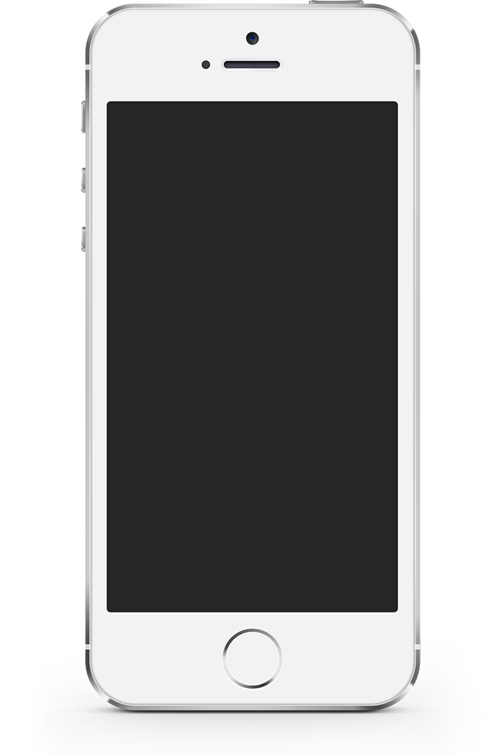





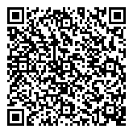

Optional: Use a QR Reader to scan this QR code for iOS and Android devices

**For an HTML5 web version** (to use on a laptop, Windows phone, or Blackberry), direct your browser to:

<https://www.confpal.com/m/ieic/>

**2. Log In**

Username: Your **email address**

Password (if prompted): ieic  
(You may change your password in Settings)

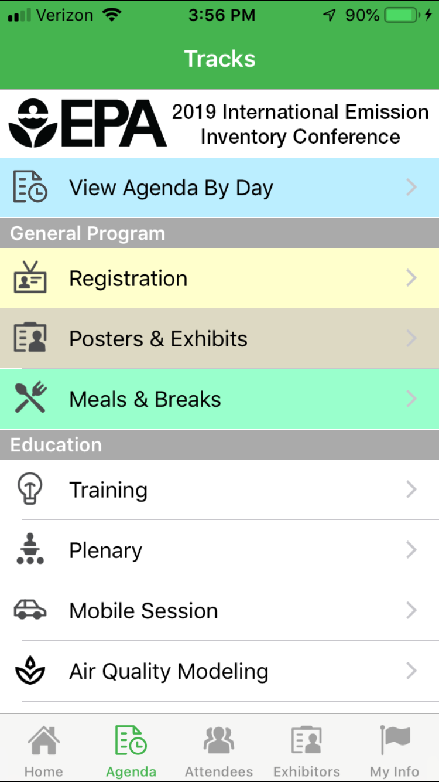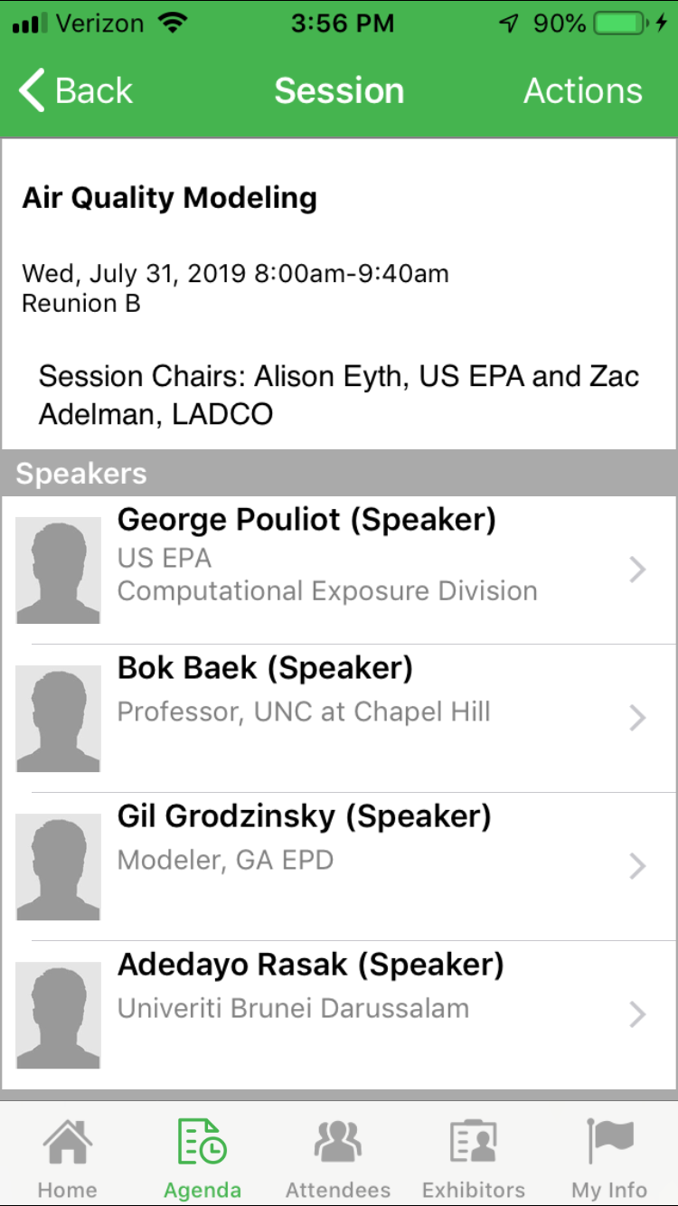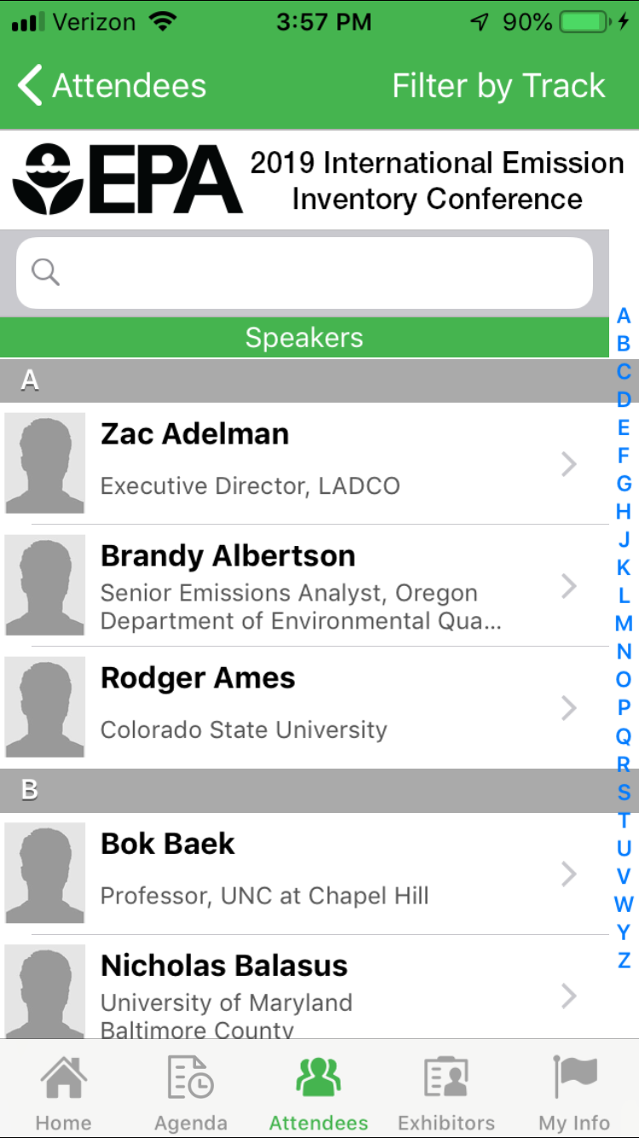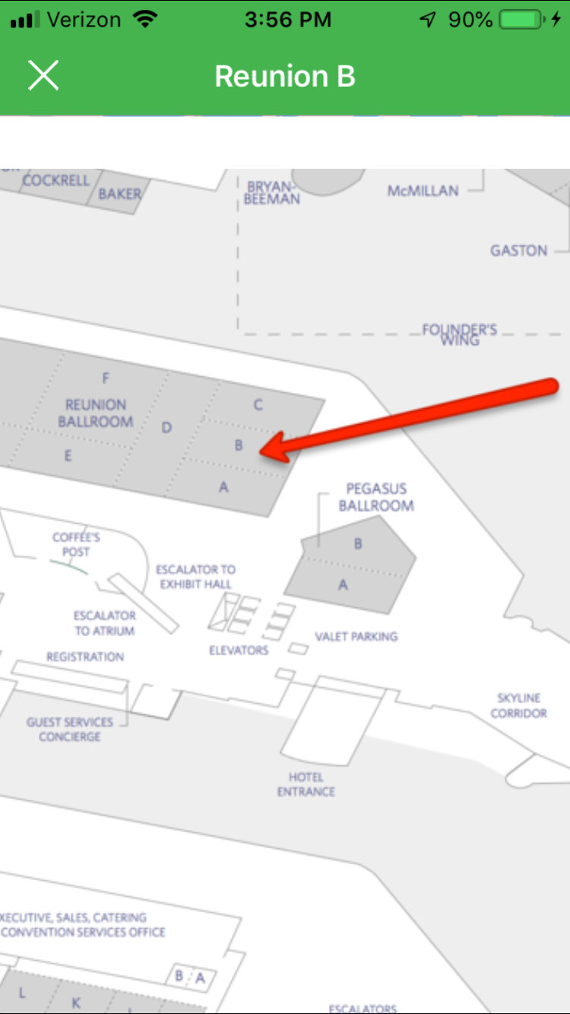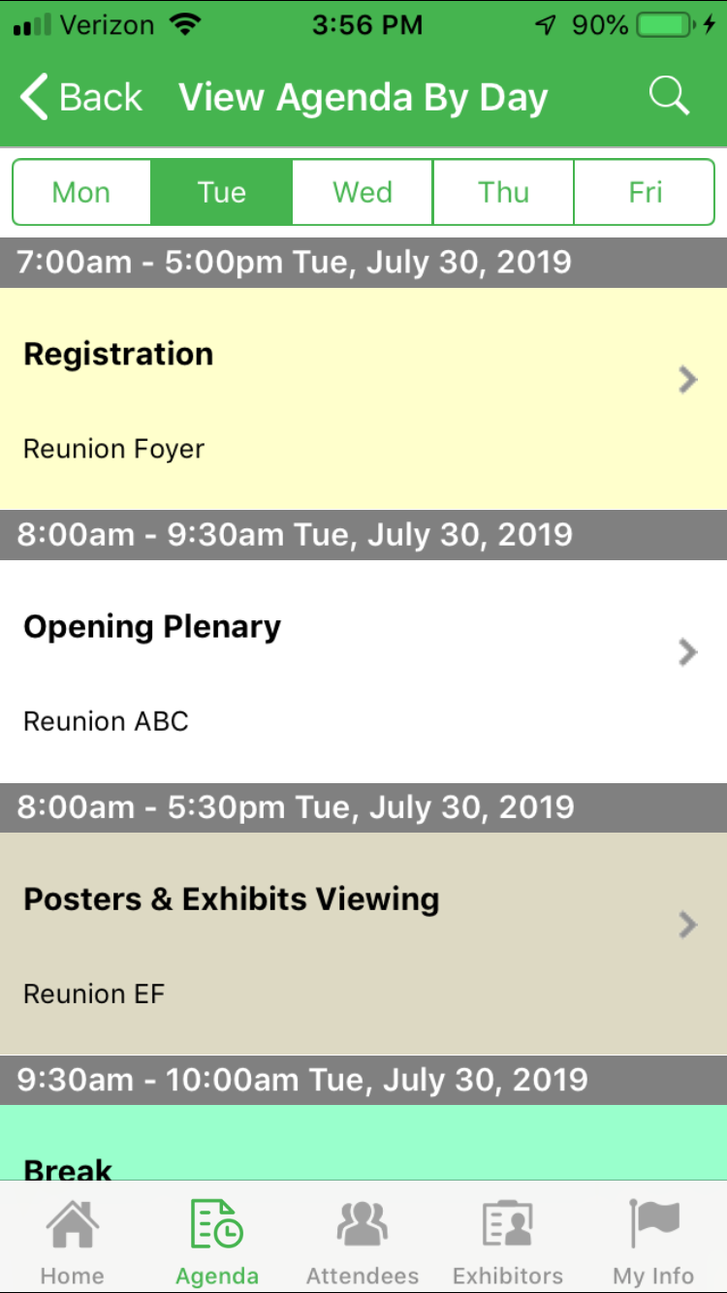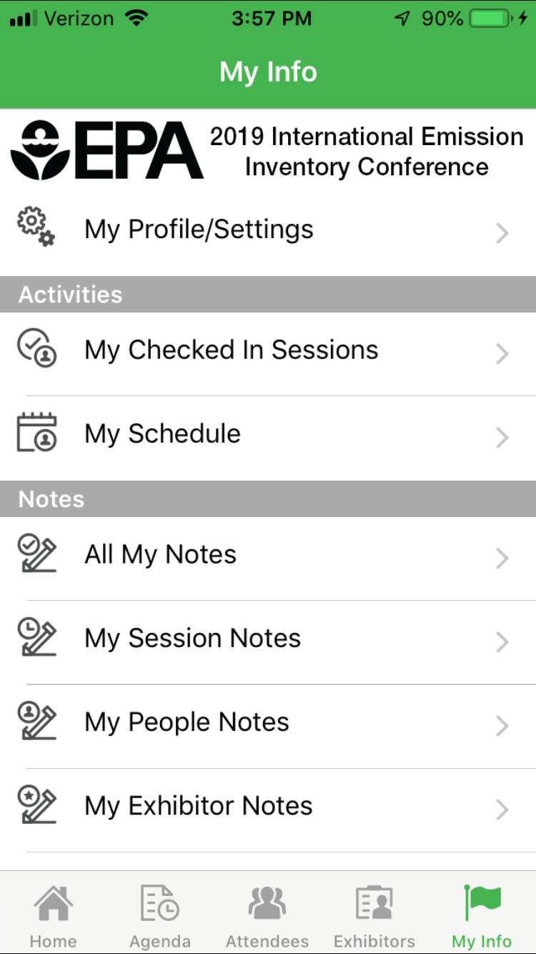

**AgendaPop.com**

703-793-4955

App questions?

Ask the event staff

or email: [help@agendapop.com](mailto:help@agendapop.com)

The **EPA International Emission Inventory Conference 2019 Mobile App from AgendaPop** is an easy and convenient way to navigate the trade show on your Apple (iOS) and Android smartphones and tablets. It contains all of the event information that you’ll need to make the most out of your experience.

**1. Download the native app** from the App Store or Google Play Store. Search **“AgendaPop”** — then download and install. Tap the AgendaPop icon on your device.Organizer Code: type **IEIC**

**3. Key Features**

* Connect with **Attendees and Speakers** (locate the “Attendees” tab on the bottom menu)
* Navigate to **Sessions** by the Tracks menu, select “View Agenda by Day” and **personalize your daily calendar**
* Create your own **Notes** about fellow attendees, sessions, or sponsors: select **“Write Notes”** on the attendee or sponsor profile page (locate the “My Info” tab on the bottom menu to view all your notes)
* **Update your profile**, bio, and headshot — tap “Settings” at the top of the Main Menu, then tap View / Edit Profile.
* Locate **Maps** of meeting rooms at the Dallas Hyatt Regency

Program and Session Details

Navigate using Tracks

Attendee and Speaker Directories

Keep Track

of Your Notes

Meeting Room Maps

Daily Agenda

Hour by Hour Listing

