SPECIATE Browser Help Guide
The SPECIATE Data Browser is an easy-to-use dashboard that provides access to the data in EPA's SPECIATE database through a web interface. The SPECIATE Data Browser allows you to browse information, customize charts and tables, as well as select and download the data of interest. The SPECIATE Data Browser is accessible on your device through your web browser and was built using the Qlik Sense® platform. The SPECIATE Data Browser always contains the most recent SPECIATE data publicly available.
The SPECIATE Data Browser enables you to search or sort on any field in the database. See web links below for searching features. Right click to export your selection to Excel.

The browser provides 6 main features as briefly explained below
- Profile - Detail - contains the complete database of all profiles with weight percent by species in SPECIATE
- Profile – Basic – contains selected fields for the profiles – includes weight percent by species but only a subset of the profile metadata
- Species Properties - provides species properties information
- Weight % Bar - allows you to visualize one or more the profiles in a bar chart
- Weight % Pie - allows you to graphically view one profile or more profiles in a hollow pie chart (most effective when only one profile is selected)
- Revisions - shows changes made to the data during SPECIATE development

Making Selections

Understanding How to Select Data

Color-Coding
Selected: green and checkmark
Alternative: light gray
Possible: white
Excluded: dark gray
Selected Excluded: dark gray and checkmark
By default, the dataset included in a Qlik Sense® application is the entire dataset. By making a selection on the dataset, you can begin to focus in on a subset of the data and drill down to insights and narratives that might not be as apparent when looking at the entire dataset. For example, trends in analytical methods, test year, or normalization basis might not be visible until you narrow down the selection of your dataset to a specific region or category level. Qlik Sense® is based on an associative model, which means that any selections on the dataset will output the subset of data that is possible based on the selections. Qlik Sense® uses green and red color-coding to differentiate between different selection states and possible options for filtering the data.

For example, “CATEGORY_LEVEL_1_Generation_Mechanism”, selecting “Combustion” will update to display only the rows where CATEGORY_LEVEL_1_Generation_Mechanism is “Combustion” and all other generation mechanisms will be hidden. The profile code and row counts (Note: row counts is on the far right side of the table and not shown in the screen shot below) will update to demonstrate the new values.
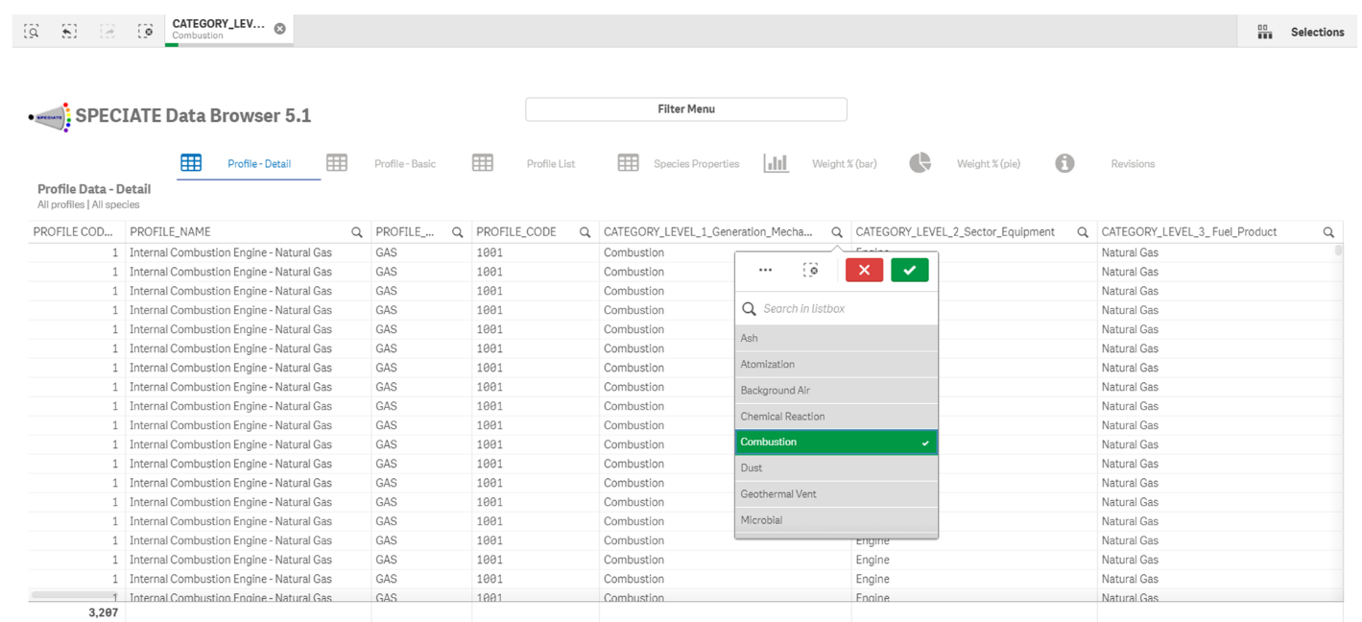

Users can select CATEGORY_LEVEL_2_Sector_Equipment “Boiler” by clicking the green checkmark to confirm selection. The browser will then display all combustion profiles that utilize boiler equipment. Again, the row and profile code totals will update to demonstrate the diminished number of observable data.

Each selection made will show in the overhead bar. To de-select a variable, either select that variable in the table and press the red “X” to de-select, or click the grey “X” in the overhead bar next to the variable you would like to deselect.

How to Filter Data

Using a Filter Pane

One of the objects used in Qlik Sense® applications is the filter pane. Filter panes can be used to provide additional flexibility in how values are selected from a given field. As shown below, filter panes can be used to search directly on all of the values using an open text field. In this example we typed “Dust” in the filter pane and selected the green checkmark.

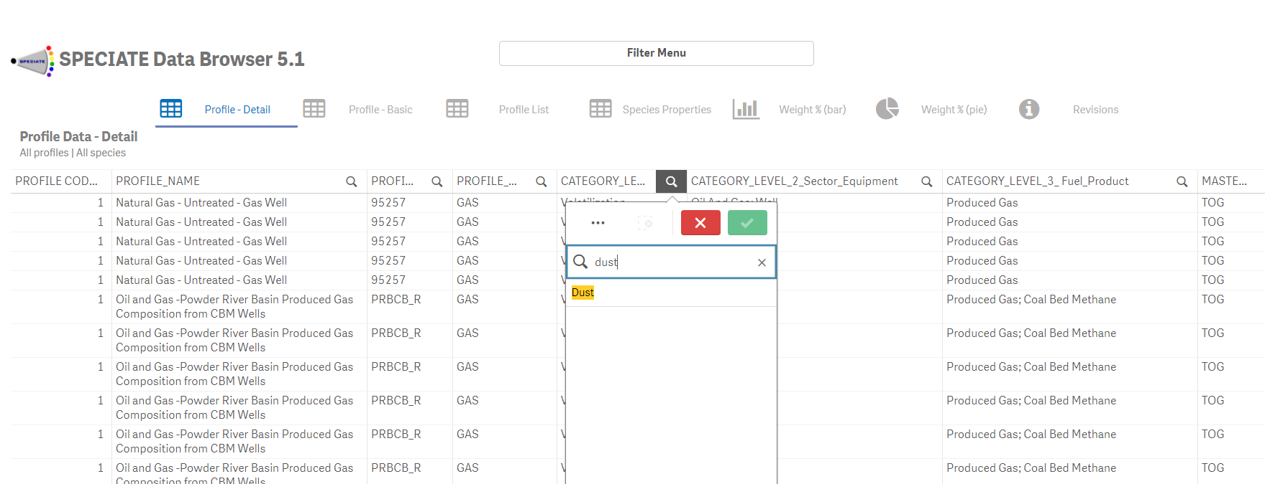

Types of Selection Methods
You can interact with any Qlik visualization (chart, map, table, etc.) to make selections.
- Click: Click on at least one value or data point to include them in the current selection. For example, you can click on a pie chart slice to select the dimension associated with that slice.
- Range: Click on a range of values in either the x- or y-axis of a chart to select those values.
Searching for Data

Qlik Sense® provides many search options to help you find specific subsets of the data included in a dashboard.

To search, type a search string into the search bar that opens by clicking on the magnifying glass in the top left corner above the SPECIATE table or by clicking “Selections” in the top right corner and search dimensions and fields of the data. After typing in the search string, select the green checkmark (or enter on your keyboard) to make the selection.

Types of Searches
Qlik Sense ® allows for several different search methods, described below.

Text search
Text search allows for searching by string(s). Additional options include using quotation marks to combine strings and search for only the entire string rather than individually, or using plus or minus signs to include or exclude certain strings. Wildcards may also be used. For example, "*" can be a placeholder for any number of characters, whereas "?" is a placeholder for a single character.

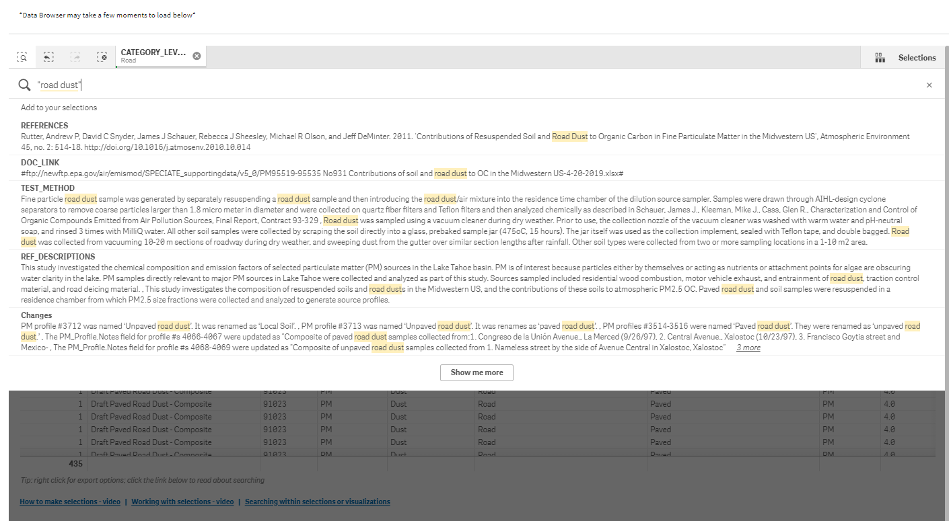

Fuzzy search
Placing a “~” character at the beginning of search string allows for fuzzy matching, which displays results that are similar to the search string(s) but not necessarily exact matches.

Using Weight % (Bar), and Weight % (Pie)

Weight % (Bar):
The Weight % (Bar) is a profile comparison by weight percent. Again, previous selections will be demonstrated here, or alternatively, you can choose from listed species names on the right-hand panel. To make multiple selections, click all desired species names before clicking the green check mark to confirm your selection.

Weight % (Pie):
Weight % (Pie) displays the weight percents of profiles in a pie chart. It is most appropriate to select a single profile for viewing in pie chart format. Again, previous selections will be displayed in the chart and in the overhead bar. You may make alternative selections by de-selecting previous parameters, and/or make additional selections by selecting species names from the right-hand panel. To make multiple selections, click all desired species names before clicking the green check mark to confirm your selection.

