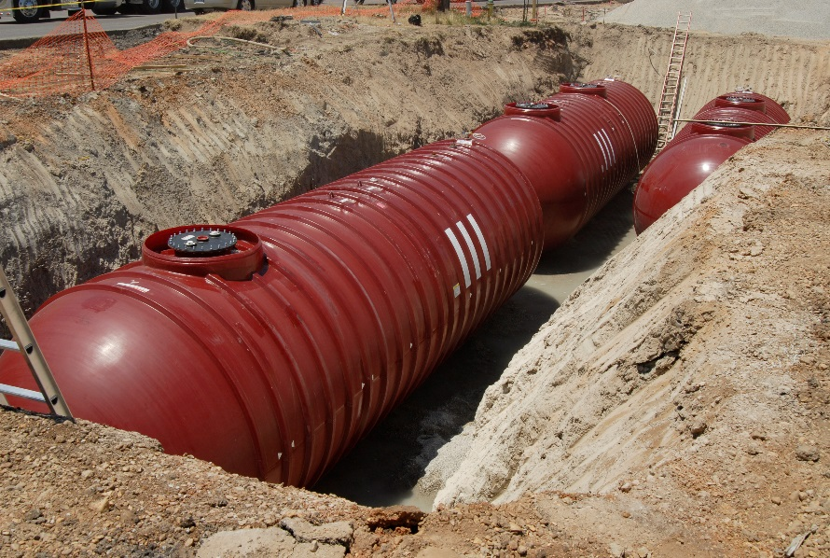
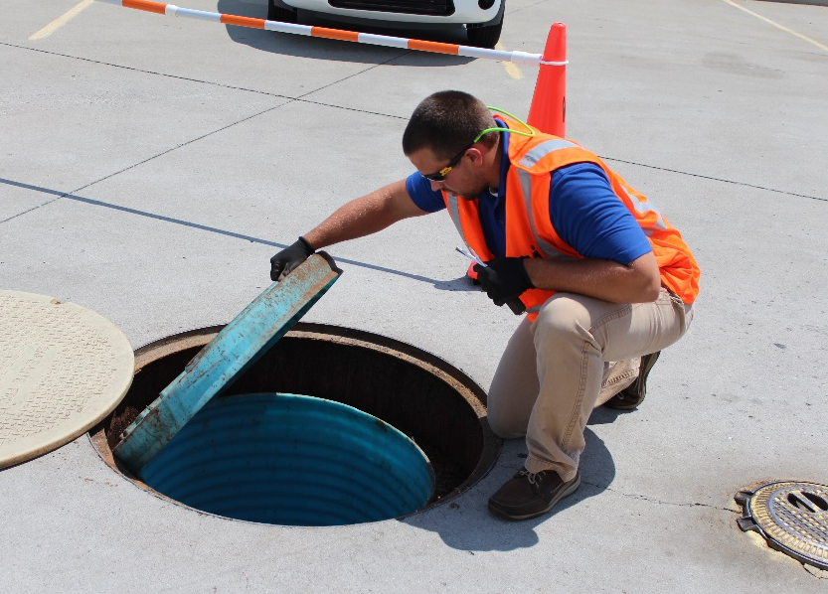
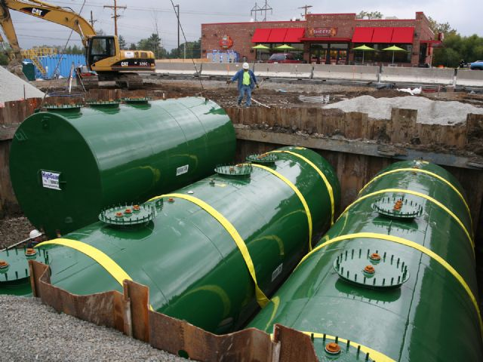
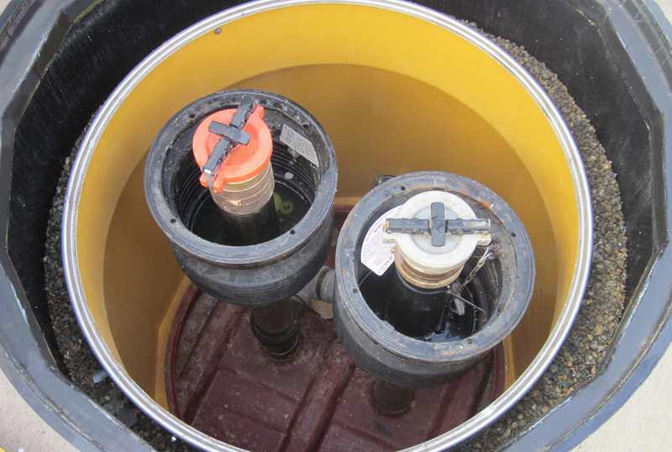
EPA 510-K-20-001
July 2020

UST System Compatibility With Biofuels

Printed on Recycled Paper

UST System Compatibility With Biofuels

Printed on Recycled Paper

UST System Compatibility With Biofuels

Printed on Recycled Paper

UST System Compatibility With Biofuels

Printed on Recycled Paper

EPA wrote this booklet for owners and operators of underground storage tanks (USTs).
This booklet describes the 2015 revised federal UST regulation. Many states and territories (referred to as states in this booklet) have state program approval from EPA. To find a list of states with state program approval, see www.epa.gov/ust/state-underground-storage-tank-ust-programs.
If your UST systems are located in a state with state program approval, your requirements may be different from those identified in this booklet. To find information about your state’s UST regulation, contact your implementing agency or visit its website. You can find links to state UST websites at www.epa.gov/ust/underground-storage-tank-ust-contacts#states.
If your UST systems are located in a state without state program approval, both the requirements in this booklet and the state requirements apply to you.
If your UST systems are located in Indian country, the requirements in this booklet apply to you.

EPA wrote this booklet for owners and operators of underground storage tanks (USTs).
This booklet describes the 2015 revised federal UST regulation. Many states and territories (referred to as states in this booklet) have state program approval from EPA. To find a list of states with state program approval, see www.epa.gov/ust/state-underground-storage-tank-ust-programs.
If your UST systems are located in a state with state program approval, your requirements may be different from those identified in this booklet. To find information about your state’s UST regulation, contact your implementing agency or visit its website. You can find links to state UST websites at www.epa.gov/ust/underground-storage-tank-ust-contacts#states.
If your UST systems are located in a state without state program approval, both the requirements in this booklet and the state requirements apply to you.
If your UST systems are located in Indian country, the requirements in this booklet apply to you.

EPA wrote this booklet for owners and operators of underground storage tanks (USTs).
This booklet describes the 2015 revised federal UST regulation. Many states and territories (referred to as states in this booklet) have state program approval from EPA. To find a list of states with state program approval, see www.epa.gov/ust/state-underground-storage-tank-ust-programs.
If your UST systems are located in a state with state program approval, your requirements may be different from those identified in this booklet. To find information about your state’s UST regulation, contact your implementing agency or visit its website. You can find links to state UST websites at www.epa.gov/ust/underground-storage-tank-ust-contacts#states.
If your UST systems are located in a state without state program approval, both the requirements in this booklet and the state requirements apply to you.
If your UST systems are located in Indian country, the requirements in this booklet apply to you.

EPA wrote this booklet for owners and operators of underground storage tanks (USTs).
This booklet describes the 2015 revised federal UST regulation. Many states and territories (referred to as states in this booklet) have state program approval from EPA. To find a list of states with state program approval, see www.epa.gov/ust/state-underground-storage-tank-ust-programs.
If your UST systems are located in a state with state program approval, your requirements may be different from those identified in this booklet. To find information about your state’s UST regulation, contact your implementing agency or visit its website. You can find links to state UST websites at www.epa.gov/ust/underground-storage-tank-ust-contacts#states.
If your UST systems are located in a state without state program approval, both the requirements in this booklet and the state requirements apply to you.
If your UST systems are located in Indian country, the requirements in this booklet apply to you.

Image credits:

MVI Field Services (inspector on cover)
Highland Tank & Manufacturing Company (steel tanks on cover and in headers)
OPW (fill sump on cover)

Publications About UST Requirements
Download or read UST System Compatibility With Biofuels and other UST documents on EPA’s underground storage tank website at www.epa.gov/ust/publications-related-underground-storage-tanks. Also download and read online UST documents on the National Service Center for Environmental Publications (NSCEP) website at www.epa.gov/nscep.

Free Publications About UST Requirements
Download or read UST System Compatibility With Biofuels and other UST documents on EPA’s underground storage tank website at www.epa.gov/ust. Also download and read online UST documents on the National Service Center for Environmental Publications (NSCEP) website at www.epa.gov/nscep.

Free Publications About UST Requirements
Download or read UST System Compatibility With Biofuels and other UST documents on EPA’s underground storage tank website at www.epa.gov/ust. Also download and read online UST documents on the National Service Center for Environmental Publications (NSCEP) website at www.epa.gov/nscep.

Free Publications About UST Requirements
Download or read UST System Compatibility With Biofuels and other UST documents on EPA’s underground storage tank website at www.epa.gov/ust. Also download and read online UST documents on the National Service Center for Environmental Publications (NSCEP) website at www.epa.gov/nscep.

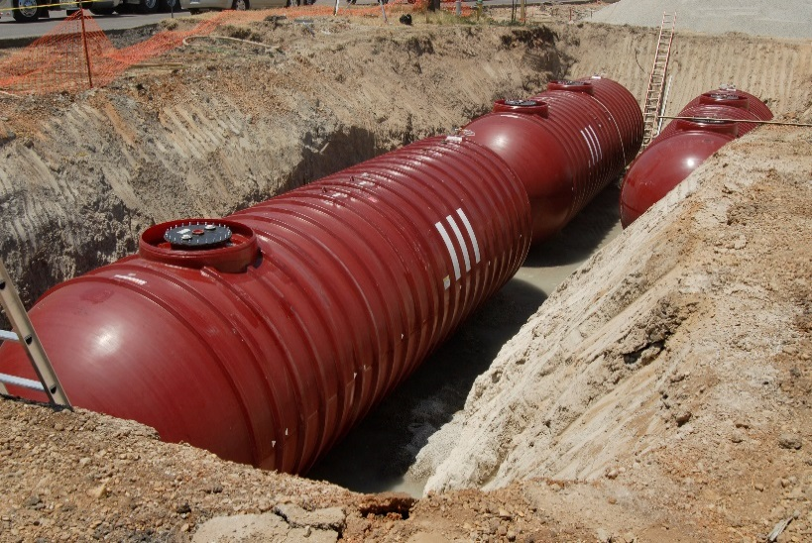

Contents

Contents

Contents

Contents
Contents

Contents

Contents

Contents

What Is This Booklet About? 1
How Do You Meet The 2015 Compatibility Requirements? 11
Upgrading Equipment To Meet Compatibility Requirements For Storing Biofuels 16
Resources For More Information 17
Appendices A-1

Disclaimer

This booklet provides information about underground storage tank (UST) system compatibility. The booklet is not a substitute for U.S. Environmental Protection Agency regulations nor is it a regulation itself—it does not impose legally binding requirements.

For regulatory requirements regarding UST systems, refer to the federal regulation governing UST systems (40 CFR part 280).

What Is This Booklet About?

As of 2020, the U.S. Environmental Protection Agency (EPA) regulates over one-half million underground storage tank (UST) systems that contain petroleum or hazardous substances. EPA’s Office of Underground Storage Tanks was formed in response to the discovery in the early 1980s that thousands of USTs had leaked and contaminated groundwater supplies in the United States. While the number of annual releases since that time has gone down significantly, releases of petroleum from USTs into the environment are still a significant concern today. Underground storage tanks form a crucial part of our country’s fueling infrastructure. It is important for USTs to be constructed, maintained, and operated in a manner such that petroleum and other regulated substances are stored safely. EPA developed the UST regulation to help owners and operators meet those goals.

Releases from USTs can threaten human health and the environment, contaminating both soil and groundwater. As of 2020, more than 557,000 UST releases have been confirmed.

Ensuring UST systems are compatible with the substances they store is essential to preventing releases of regulated substances to the environment.

How EPA Defines Biofuels In This Booklet

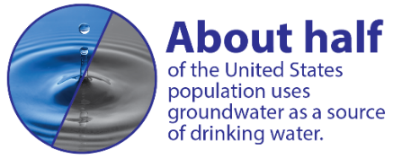
Ethanol and biodiesel are commonly called biofuels in the fuel industry. Ethanol is routinely mixed and stored with gasoline in concentrations of 10 percent ethanol (E10). Biodiesel is routinely mixed and stored with diesel in concentrations up to 20 percent biodiesel (B20). E10 is sold at nearly every gas station in the United States.

Throughout this booklet, however, EPA uses the term biofuel to refer only to substances listed in the 2015 UST regulation that require additional actions of owners and operators pertaining to compatibility. Those substances are:

- gasoline blends containing greater than 10 percent ethanol;
- diesel blends containing greater than 20 percent biodiesel;
- or any other substance identified by the implementing agency now or in the future.

Ethanol and biodiesel have significantly increased their volume share of the total national vehicle fuel market over the last 15 years. Other new fuels made from renewable sources, including renewable diesel and isobutanol, have entered the market in limited quantities. More biofuels and other new renewable fuels are likely to enter the market in the next decade.

All UST systems must be compatible with the regulated substances they store. EPA’s June 2019 compliance advisory alerts UST facility owners and operators about compatibility requirements at 40 CFR 280.32 in the 2015 UST regulation:
www.epa.gov/ust/compliance-advisories-about-2015-underground-storage-tank-regulation.

Ensuring compatibility of UST systems with the fuel stored—knowing the materials that make up the UST system will maintain their respective chemical and physical properties when in contact with the substance they are storing—is essential. Storing fuel in an incompatible UST system may jeopardize the integrity of the UST system and cause a release to the environment.

This booklet will help you understand what you need to do in order to meet the 2015 UST compatibility requirements when storing biofuels and petroleum-biofuel blends and minimize the risk of a release from your UST system due to incompatibility.
Remember, compatibility with the substance stored is required for all UST systems. Equipment incompatible with the fuel stored could harden, soften, swell, or shrink and could lead to a release of fuel to the environment.

Why Is Compatibility Important?

In an UST system, the regulated substances stored must not interact with the materials comprising the system in any way that would cause the material to change its performance. USTs contain many components made of different materials. If any of these materials are incompatible with the regulated substance stored and even temporarily lose their manufactured properties such as shape or flexibility, the UST system may fail to contain the substance. This could lead to a release to the environment and possibly a failure to detect the release. Examples of observed incompatibility between fuels stored and UST materials include equipment or components such as tanks, piping, or gaskets and seals that have become brittle, elongated, thinner, or swollen when compared with their as-installed conditions. Sealants or pipe dope used to hold UST connections together could dissolve or become leaky when in contact with incompatible fuel blends.
The 2015 UST regulation clarifies methods for demonstrating compatibility for fuels containing greater than 10 percent ethanol or greater than 20 percent biodiesel. However, implementing agencies may have different compatibility requirements for storing biofuels, so it is important to contact them before storing higher blends of biofuels.

Compatibility In The 1988 UST Regulation

EPA has required UST systems to be compatible with the substance stored in them since the 1988 UST regulation. Compatibility is required for as long as the UST system is used to store regulated substances. From the 1988 UST regulation:

- You must use an UST system made of or lined with materials compatible with the regulated substance stored in the UST system.
Most currently installed UST systems have at least some components that may not be compatible with fuel blends containing more than 10 percent ethanol or more than 20 percent biodiesel. However, components compatible with higher blends are now available. If you choose to upgrade your UST system, remember to require that your installer use compatible equipment.

However, the United States’ fuel supply has changed significantly since 1988 and there has been an exponential growth of the use of biobased fuels. All biobased fuels are made from some type of renewable resource. But these renewable resources can be processed through a variety of fuel production processes and result in many types of finished fuels that have different chemical characteristics. One category of biobased fuels—biofuels—are the main focus of this booklet.

Biodiesel is commonly blended into diesel and ethanol into gasoline. The resulting blended fuels stored in USTs usually contain 20 percent biodiesel (B20) or less or 10 percent ethanol (E10) or less of the petroleum based fuel volume. However, in certain percentages, diesel-biodiesel or gasoline-ethanol blends are more aggressive toward certain materials used in UST system construction than petroleum based fuel with biodiesel or ethanol in lesser amounts. Most UST components are compatible with E10 or B20. But some older, existing UST components are incompatible with any blends of ethanol, and some are incompatible with biodiesel blends above B5. In addition to the compatibility requirement above, the 2015 UST regulation includes requirements for owners and operators of certain UST systems to help ensure UST systems are compatible with biofuels prior to storing them.
Adding any amount of ethanol to petroleum based fuels changes how the fuel interacts with materials. Blends greater than 10 percent ethanol by volume show the most ability to affect the performance of some materials in older UST systems. Equipment made with only materials that are compatible with these fuels are available, but sometimes cost more.

Why EPA Updated The Compatibility Requirements In The 2015 UST Regulation

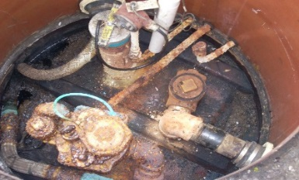
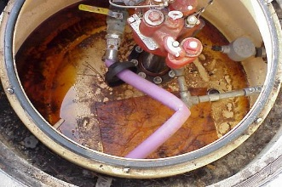
The fuel supply in the United States is constantly evolving. Ensuring compatibility prior to storing any regulated substance in an existing or new UST system is important, because your UST system may have been built with components that were not intended for use with the biofuel you wish to store today.
These photos of UST system material incompatibility were not caused by biofuels, but provide good examples of incompatibility. Top to bottom are pipe elongation, cracking of the internal tank lining, and delamination of product piping (in top left of the picture.)

One example that demonstrates the importance of knowing the compatibility of your UST system involves ethanol, an oxygenate commonly blended into fuel to improve engine efficiency and emissions. Ethanol became widely used in the United States in blends up to 10 percent by volume in the mid-2000s when methyl tertiary butyl ether (MTBE), an oxygenate introduced to enhance octane as lead was phased out of gasoline, was itself phased out due to environmental concerns.

Research has shown that some materials, such as some polymers and elastomers commonly used in UST system construction prior to ethanol becoming widely used, may swell and lose their shape when in contact with ethanol. In an UST system, these materials may be intended to create a seal between components, but if damaged, may not perform correctly and could lead to a release of a regulated substance to the environment. These materials may show the most swelling in gasoline blended with ethanol greater than 10 percent by volume. Other regulated substances, such as higher concentrations of biodiesel, may also present compatibility considerations for these or other UST components.

UST systems are designed for long lifespans and are normally not frequently replaced. As the fuel supply changed to incorporate more ethanol, UST and fuels stakeholders found that some installed UST systems were incompatible with lower level ethanol blends. The UST system equipment industry responded to the increasing use of biofuels and the risks identified by creating equipment compatible with lower blends of these fuels. Over time, the industry also began producing equipment compatible with higher blends of ethanol and biodiesel—those that are generally more aggressive toward more commonly used UST system materials. Generally, all new tanks and piping produced today are compatible with blends of up to 100 percent ethanol and biodiesel.

However, many of the ancillary components available in the market may still be available in versions not compatible with up to 100 percent biodiesel or 100 percent ethanol. The whole UST system (which includes but is not limited to tanks, pumps, ancillary equipment, lines, gaskets, and sealants) needs to be compatible with the fuel stored to prevent releases to the environment.
This booklet describes EPA’s requirements for compatibility, but your implementing agency may have requirements that are somewhat different or more stringent than the federal requirements. Contact your implementing agency for its specific compatibility requirements. Many agencies may require owners who store biofuels follow different requirements, which could include submitting documents that differ from the examples provided in this booklet.

Generally, most older and even some newer existing UST systems are not fully compatible with biofuels and require modification before storing them. For example, the actual tank is often compatible with E15, but some of the connectors and pump components may not be, and that can lead to leaks. EPA updated the compatibility requirements in the 2015 UST regulation to ensure higher blends of biofuels are stored only in compatible UST systems.

The 2015 UST regulation describes the steps UST owners and operators must take to help protect our health and environment from potential UST releases due to incompatibility. These steps will also help you avoid the high cost of cleaning up releases and possible legal actions that can result if your UST system releases product to the environment.

Compatibility Of Fuel Dispensers

By EPA’s definition, dispensers are not part of the UST system, but face the same compatibility concerns and are a critical part of the fueling system. The 2015 UST regulation does not require owners and operators to demonstrate the compatibility of dispensers or associated aboveground equipment. However, compatibility requirements for these components may exist in other local regulations, such as the fire code. Owners and operators should check for these requirements with their implementing agencies. You will see some discussion of dispensers in this booklet.
Remember, compatibility for fuel dispensers and fuel hoses is important. Compatibility requirements for these components may exist in other local regulations, such as the
fire code.

Check With Your Implementing Agency

Many states, territories, and the District of Columbia (referred to collectively as states) have state program approval from EPA. To find a list of states with state program approval, see www.epa.gov/ust/state-underground-storage-tank-ust-programs.

If your UST systems are located in a state with state program approval, your requirements may be different from those identified in this booklet. Check with the state UST program in the state where your USTs are located.

If your UST systems are located in a state without state program approval, both the requirements in this booklet and the state requirements apply to you.

If your UST systems are located in Indian country, the requirements in this booklet apply to you.

Compatibility Requirements In The 2015 UST Regulation
The 2015 UST regulation maintains the requirement that all UST systems must be made of or lined with materials compatible with the substance stored in the UST system. Remember that compatibility extends beyond the fuel tank to the entire system.
A list of contacts
is available at

www.epa.gov/ust/
underground-storage-tank-
ust-contacts#states.

The 2015 UST regulation provides clarity to the 1988 compatibility requirement by specifying additional compatibility requirements for owners and operators wishing to store certain regulated substances, including gasoline containing more than 10 percent ethanol and diesel containing greater than 20 percent biodiesel. Research has identified these substances as having a higher likelihood of incompatibility with many existing UST systems. By targeting the additional compatibility requirements toward the specific subset of the UST operating universe with the highest risk of failure due to incompatibility, the overall risk of releases will be minimized.

Beginning October 2015, in addition to the 1988 requirement of ensuring that the UST system is compatible, UST owners and operators intending to store regulated substances must also meet these additional compatibility requirements:

Notification

- You must notify your implementing agency at least 30 days before switching to any of the following products:

  - Regulated substances containing greater than 10 percent ethanol
  - Regulated substances containing greater than 20 percent biodiesel
  - Any other regulated substance identified by your implementing agency

See Appendix 1 for a sample letter for notifying your implementing agency that you plan to switch to store a biofuel.

Additionally, owners and operators storing one or more of these regulated substances must meet the compatibility requirement by demonstrating compatibility of the system with the fuel or by using an alternative allowed by the implementing agency.

Meeting The Compatibility Requirement

- If you store any of these substances, you must either:

  - Demonstrate that the following UST system components are compatible with the regulated substance: tank, piping, containment sumps, pumping equipment, release detection equipment, spill prevention equipment, and overfill prevention equipment
Note: In this list, pumping equipment refers to the equipment used to move the fuel from the underground storage tank to the fuel dispenser. The 2015 UST regulation does not address the fuel dispenser itself because the regulation only covers equipment at or under the surface of the ground. Although not covered in the regulation or this booklet, you should make sure your dispenser is also compatible with the substance stored. Check with your implementing agency to find out which department or agency regulates fuel dispensers in your area and ensure you meet all requirements for fuel dispenser compatibility.
  - Use an alternative determined by the implementing agency to be no less protective of human health and the environment than demonstrating that those components are compatible

An owner and operator may meet the compatibility requirement in the 2015 UST regulation by showing that each component listed is approved for use with the biofuel stored.

Some implementing agencies may allow an alternative to demonstrating compatibility of the components to meet the compatibility requirement. Although alternatives are available, they are uncommon. Contact your implementing agency for the compatibility requirements that apply to your USTs.

Refer to How Do You Meet The 2015 Compatibility Requirements section beginning on page 11 for more details on these alternatives.

Recordkeeping

- Beginning October 2015, if you store regulated substances containing greater than 10 percent ethanol, greater than 20 percent biodiesel, or other substances identified by your implementing agency, you must keep records showing that your UST system is compatible with those substances. If you choose to follow an alternative determined to be no less protective of human health and the environment established by your implementing agency, then you must keep documentation of adherence to this requirement as required by the implementing agency’s rules. You must keep these records for as long as you store these regulated substances.

B100

The 2015 UST regulation requires these additional steps for any regulated substance containing more than 10 percent ethanol or 20 percent biodiesel. Pure B100 contains 100 percent biodiesel, which is more than 20 percent biodiesel; but it is not a regulated substance and thus is not covered by the regulation.

To be regulated, a substance must be petroleum or a CERCLA-listed hazardous substance. Petroleum is defined to be a complex blend of hydrocarbons. B100 is 100 percent biodiesel and it is not a hydrocarbon; that means B100 stored in an UST does not meet the definition of petroleum. In addition, B100 is not on the CERCLA list of hazardous substances. Therefore, USTs storing 100 percent biodiesel are not regulated under the 2015 UST regulation.

EPA understands that most biodiesel is blended with some regular diesel. If the biodiesel is blended with even a small amount of diesel, then USTs storing that blend are regulated as petroleum USTs under the 2015 UST regulation.

Renewable Diesel Fuel

Renewable diesel fuel, which is also called green diesel, is a biomass-derived transportation fuel suitable for use in diesel engines. Renewable diesel is distinct from biodiesel. The 2015 UST regulation revised the regulated substance definition to clarify that UST systems containing petroleum derived from non-crude oil products are regulated. Although B100 is not a regulated substance, renewable diesel fuel is.

While renewable diesel is chemically similar to petroleum diesel, biodiesel is a mono-alkyl ester, which has different physical properties and hence different fuel specifications. The two fuels are also produced through very different processes. B100 meets the requirements of the ASTM International (ASTM) Standard D6751, Standard Specification for Biodiesel Fuel Blend Stock (B100) for Middle Distillate Fuels. Renewable diesel, on the other hand, meets the ASTM D975 specification for diesel fuel, even though it is produced from biomass.

Renewable diesel does not on its own contain biodiesel. Sometimes, however, renewable diesel fuel may be blended with biodiesel and stored at a gas station or other fuel distribution facility, just as diesel fuel from crude oil is often blended with biodiesel. An owner or operator storing renewable diesel does not need to meet the additional requirements for compatibility outlined in this section, unless that renewable diesel is blended with other fuels in any formulation with more than 20 percent biodiesel.

Renewable Jet Fuel

Also called biojet or aviation biofuel, renewable jet fuel is a biomass-derived fuel that can be used interchangeably with petroleum-based aviation fuel. Certain biojet fuel can be blended up to 50 percent with conventional commercial and military jet (or aviation turbine) fuel by following requirements in ASTM’s D7566 specification. Both commercial and military aviation fuel and renewable jet fuel are regulated substances under the 2015 UST regulation. But an owner or operator storing conventional or renewable jet fuel need not meet the additional requirements for compatibility in this section unless they are blended with ethanol or biodiesel. EPA understands this is unlikely due to technical requirements of aviation fuels.

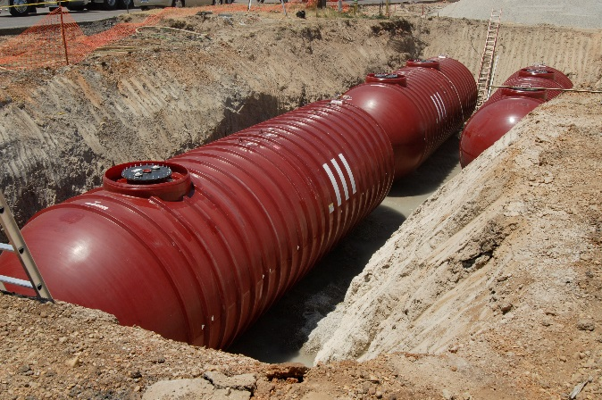
How Do You Meet

The 2015 Compatibility Requirements?

This section explains how to meet the requirements for compatibility when storing biofuels. Below is a chart of the requirements for the vehicle fuels most commonly stored in UST systems. The chart is not a complete list of regulated substances which must meet the additional compatibility requirements in the 2015 UST regulation. The chart is a quick guide to help owners and operators storing regulated vehicle fuels understand which compatibility requirements they must meet.

Type of regulated substance | Must be compatible with UST system | Must notify implementing agency before switching to store this fuel | Must demonstrate compatibility of UST system with the substance being stored | Must keep these records for as long as the substance is stored | *Must keep records of leak detection performance claims
Regulated substances containing up to 10 percent ethanol. This includes the fuel commonly referred to as E10.
Regulated substances containing up to 20 percent biodiesel. This includes fuels such as diesel fuel, B5, B10, B20, and renewable diesel.
Regulated substances containing greater than 10 percent ethanol. This includes fuels such as E15 or E85.
Regulated substances containing greater than 20 percent diesel, including fuels such as B50 or B99.
Other regulated substances identified by implementing agency.

*Leak detection performance claims are associated with equipment functionality in biofuels. See page 15 for more information.

How Do You Meet The Compatibility Requirements?
Owners and operators must meet the compatibility requirement in the 2015 UST regulation by demonstrating compatibility of their UST systems, or by using an alternative that is no less protective than demonstrating compatibility. An alternative must be allowed by the implementing agency.
EPA’s January 2020 statement discusses the growth of E15 fuel and its compatibility with
UST systems: www.epa.gov/ust/e15-compatibility-ust-systems-statement.

Demonstrating That Your UST System Is Compatible With Biofuels

Two options are available to demonstrate that your UST system is compatible with fuels containing greater than 10 percent ethanol or greater than 20 percent biodiesel.

- Certification or listing of UST system equipment or components by a nationally recognized, independent testing laboratory for use with the regulated substance stored; or

- Equipment or component manufacturer approval. This manufacturer’s approval must:
  - be in writing,
  - indicate an affirmative statement of compatibility,
  - specify the range of biofuel blends the component is compatible with, and
  - be from the equipment or component manufacturer

See Appendix 2 for a sample checklist to help owners and operators determine compatibility of UST systems.

Demonstrating compatibility of an UST system requires first identifying what equipment is installed as part of your UST system. Equipment manufacturers should be able to provide information on the substances for which their equipment is compatible. Determining the compatibility status of some older UST equipment or components for which paperwork has been lost could be challenging, so remember to keep your documentation. If you cannot determine a component’s manufacturer and year or model of production, you will not be able to demonstrate compatibility.

In addition to your UST implementing agency, the resources on page 17 may help identify the compatibility status of your installed UST system components. EPA anticipates that most older UST systems will require retrofitting of some equipment with compatible equipment, if the owners or operators choose to store higher level biofuel blends in these systems.

Meeting The Compatibility Requirement Through Use Of An Alternative Allowed By The Implementing Agency
The 2015 UST regulation allows implementing agencies to determine alternatives to meet the compatibility requirement for regulated substances containing greater than 10 percent ethanol, greater than 20 percent biodiesel, or other substances identified by the agency.

Although alternatives are available, they are uncommon. Before allowing an alternative for owners and operators to meet the requirements in 40 CFR 280.32, implementing agencies must ensure the alternative is at least as protective of human health and the environment as the manufacturer’s approvals or certifications or listings by a nationally recognized, independent testing laboratory for components that demonstrate your UST system is compatible. Contact your implementing agency for the compatibility requirements that apply to your USTs.

What Records Must You Keep?

Generally follow this useful rule of thumb for recordkeeping: When in doubt, keep it.
The 2015 UST regulation requires you keep documentation showing that your system is compatible when storing certain biofuels:

- Beginning October 2015, if you store regulated substances containing greater than 10 percent ethanol, greater than 20 percent biodiesel, or any other substances identified by your implementing agency, you must keep records showing that your UST system is compatible with those substances. You must keep these records for as long as you store these regulated substances.
If you repair any component of your UST system, you must ensure it is repaired only with components compatible with the fuel you store. Keep repair records because they help demonstrate compatibility of your UST system.

- If you choose to follow an alternative that the implementing agency determined is no less protective of human health and the environment, then you must keep documentation demonstrating compliance with this requirement as required by the implementing agency’s rules. You must keep these records for as long as you store these regulated substances.

You should also contact your implementing agency about the particular recordkeeping requirements that apply to your USTs.

Compatibility Of Pipe Dope And Sealants

Pipe dope or sealants used anywhere in an UST system must be compatible with the regulated substance stored in the system. Pipe dope is used to seal together threaded connections. Sealants are generally used to seal together non-threaded joints. The 1988 UST regulation required compatibility for all components of the UST system and the 2015 UST regulation reiterated that requirement.

EPA did not include pipe dope on the 2015 UST regulation list of UST system components that owners and operators must demonstrate to be compatible when storing regulated substances containing greater than 10 percent ethanol or greater than 20 percent biodiesel. Nonetheless, all components and all pipe dope in all UST systems must be compatible with substances stored.

Pipe dope that is compatible with ethanol blends higher than E10 is available, but much of the pipe dope on the market is not. If storing or considering storing greater than E10, owners and operators should explicitly check to ensure the pipe dope on their UST system connections is compatible; installers and installation records are sources for that information. Ensuring UST systems are compatible with the pipe dope and sealant used is critical because EPA thinks that pipe dope used prior to 2007 is probably not compatible with ethanol blends greater than 10 percent. Most older pipe dope was soft set pipe dope and not intended to be used with ethanol blends over 10 percent.

Higher-ethanol compatible pipe dope was available beginning around 2007. Despite that, UST systems installed then and since to store lower levels of ethanol, such as E0 or E10, probably have pipe dope compatible only with lower levels of ethanol. Storing greater than 10 percent ethanol in those UST systems means the pipe dope is incompatible. Because higher-ethanol compatible pipe dope is more expensive, pipe dope compatible only with lower levels of ethanol may have been used, rather than higher-ethanol compatible pipe dope.

Compatibility Versus Functionality For Release Detection Equipment
Remember, compatibility is different from functionality. You can use testing protocols to evaluate the functionality of various release detection technologies in different regulated substances.
Compatibility of equipment, or the ability of two or more substances to maintain their respective chemical and physical properties when in contact with one another, is different from functionality of equipment. Functionality is the ability of equipment to perform the job it was designed to do.

Some biofuels could potentially affect both the compatibility and functionality of UST equipment. Biofuels containing ethanol can affect the amount of water absorbed or retained in fuel. Some types of release detection equipment rely on sophisticated technologies to evaluate product levels in underground storage tanks. These methods for leak detection could be adversely affected by ethanol’s ability to dissolve and mix with water, which could prevent them from functioning as designed as a release detection device in fuels blended with ethanol. Owners and operators should ensure that their release detection equipment is both compatible with the biofuel stored and meets EPA’s release detection performance standards for use with the biofuel.

EPA released in May 2019 updated protocols, Standard Test Procedures for Evaluating Various Leak Detection Methods; these help manufacturers verify that their leak detection equipment meets federal performance standards for functionality. The updated protocols account for new fuels and technologies. You can access the protocols at www.epa.gov/ust/standard-test-procedures-evaluating-various-leak-detection-methods. The National Work Group on Leak Detection Evaluations (NWGLDE) reviews leak detection equipment that was third-party evaluated using EPA’s test protocols or equivalent protocols. Owners and operators may wish to check if their leak detection method meets performance requirements for use in biofuels at NWGLDE’s website: www.nwglde.org/.

Upgrading Equipment To Meet Compatibility Requirements For Storing Biofuels

Remember, keeping records of equipment or components installed or repaired now may help to determine compatibility of that equipment at a later date, even if you aren’t currently storing biofuels. If you are already storing biofuels, you may already be required to keep such documentation to demonstrate compatibility of the UST system.

Owners and operators having a new UST system installed may wish to choose equipment that will be compatible with gasoline containing greater than 10 percent ethanol or diesel containing greater than 20 percent biodiesel. This provides owners with the option of storing biofuels later, even if they do not store them now.

Remember that you must specifically request equipment that is compatible with higher biofuel blends from the installer prior to the installation or the installer may install less expensive equipment that may not be compatible with biofuels.

It is possible that many owners and operators of existing UST systems wishing to store biofuels will find, after evaluating their systems and documentation, they are not able to demonstrate compatibility for their entire UST system. These owners have three options.

One option is to use targeted retrofits of specific equipment to upgrade their existing UST systems. Many owners may already be able to demonstrate compatibility for the tanks and piping in their UST systems. These components are often the largest expenses associated with an UST system installation and owners may have documentation available for this equipment. In this situation, owners may be able to upgrade other components of their UST system with less operational downtime and less cost because they will not need to break the concrete pad over the UST system to replace tanks or piping.

Another option is to install a new UST system that can be demonstrated compatible with the substance to be stored. When installing a new system for this purpose, an owner should specifically request equipment that is compatible with regulated substances containing greater than 10 percent ethanol and greater than 20 percent biodiesel. The marginal upgrade cost for equipment that is compatible with ethanol or biodiesel blends up to 100 percent is a small percentage increase compared with the overall cost of a new system. However, owners must ensure they request such equipment prior to equipment installation.

The other option is to not store the substance. This will ensure no releases occur due to incompatibility of the substance and the UST system. This could prevent an owner from being out of compliance with the compatibility requirements or becoming responsible for cleaning up a release to the environment from an incompatible system.

Owners and operators can explore options for upgrading their UST systems to meet compatibility requirements by consulting with their implementing agency, UST servicing contractor, or the resources listed on page 17.

Resources For More Information

Government

- EPA’s emerging fuels and USTs: www.epa.gov/ust/emerging-fuels-and-underground-storage-tanks-usts
- EPA’s January 2020 statement about E15’s compatibility with UST systems: www.epa.gov/ust/e15-compatibility-ust-systems-statement
- EPA’s June 2019 compliance advisory about compatibility requirements in the 2015 UST regulation: www.epa.gov/ust/compliance-advisories-about-2015-underground-storage-tank-regulation
- EPA’s industry codes and standards for USTs: www.epa.gov/ust/underground-storage-tanks-usts-laws-and-regulations#code
- Association of State and Territorial Solid Waste Management Officials’ Compatibility Tool: astswmo.org/ust-compatibility-tool/
- New England Interstate Water Pollution Control Commission: www.neiwpcc.org

Industry Organizations And Resources

- UL (formerly Underwriters Laboratories) Fuel Compatibility Tool: www.ul.com/apps/ul-fuel-compatibility-tool
- Petroleum Equipment Institute’s UST Component Compatibility Library: www.pei.org/ust-component-compatibility-library
- Fiberglass Tank & Pipe Institute: www.fiberglasstankandpipe.com
- Steel Tank Institute: www.steeltank.com
- Fuels Institute’s Retailing Biofuels: A Guide to Reading Applicable Federal Regulations: www.fuelsinstitute.org/Research/Retailing-Biofuels
- American Petroleum Institute’s Recommended Practice 1626, Storing and Handling Ethanol and Gasoline-Ethanol Blends at Distribution Terminals and Filling Stations: www.apiwebstore.org/publications/item.cgi?27892088-2705-44bc-8244-4fd6454b8018

- National Workgroup on Leak Detection Evaluations (NWGLDE): www.nwglde.org/index.html

Publications About USTs

You can access EPA’s publications about USTs by downloading or reading documents on EPA’s website at www.epa.gov/ust/publications-related-underground-storage-tanks.

You can also access, read, and download online versions of our documents on the National Service Center for Environmental Publications (NSCEP) website at www.epa.gov/nscep. NSCEP is EPA’s publication distributor.

Appendices

Remember, you must notify the implementing agency 30 days before you switch to store a regulated substance containing greater than 10 percent ethanol or greater than 20 percent biodiesel.

Appendix 1: Sample Notification Letter

Below is a sample letter that you can use as a template for notifying your implementing agency at least 30 days before you switch to regulated substances containing greater than 10 percent ethanol, greater than 20 percent biodiesel, or any other substance identified by your implementing agency. You may also call or email the implementing agency, but you should include the same information described in this sample letter. [Date]

[Name of UST Implementing Agency
Street Address
City, State, Zip Code]

Dear Sir or Madam:

This letter is notifying you that pursuant to the federal underground storage tank (UST) regulation at 40 CFR 280.32, I intend to store [type of regulated substance] beginning on [date] in my underground storage tank system, which is uniquely identified as [UST system identification number; compartment number, if applicable]. My underground storage tank facility is located at [facility address]. I understand my UST system must be fully compatible with [type of regulated substance]. If you have questions, please contact me at [phone number].

Sincerely,
[signature]
[owner or operator name]

Appendix 2: Sample Checklist For Determining UST System Compatibility
This sample checklist can help owners and operators determine and document the compatibility of their UST systems. Be sure to check with your implementing agency for their specific compatibility requirements. They may require you submit a compatibility documentation checklist that differs from the sample checklist provided below.

Sample Checklist For Determining And Demonstrating
UST System Compatibility
Completing all sections in this checklist will help you determine if you possess the required information to demonstrate compatibility of your underground storage tank (UST) system with regulated substances containing more than 10 percent ethanol or more than 20 percent biodiesel (hereafter referred to as biofuels).

Owners and operators may meet the compatibility requirement in the 2015 UST regulation by either demonstrating compatibility of their UST system with biofuels or by using an alternative. Demonstrating compatibility is most common, and can be performed by using one of these two options:
- an independent laboratory certification or listing of component approval for use with the fuel you intend to store; or,
- a manufacturer statement of approval to use the component with the fuel you intend to store.
You must demonstrate compatibility for these parts of the UST system: tank, piping, containment sumps, pumping equipment, release detection equipment, spill equipment, and overfill equipment.

Some implementing agencies may allow an alternative to demonstrating compatibility to meet the compatibility requirement. Although alternatives are available, they are uncommon. Contact your implementing agency for the compatibility requirements that apply to your USTs.

Background: 40 CFR 280.32 states that UST owners and operators must use an UST system made of or lined with materials that are compatible with the substance stored in the system. In the 2015 UST regulation, EPA defines an UST system as an underground storage tank, connected underground piping, underground ancillary equipment, and containment system, if any. Owners and operators who store regulated substances that contain more than 20 percent biodiesel or more than 10 percent ethanol, such as 15 percent ethanol or E15, must notify their implementing agency 30 days before storing the fuel. Owners and operators must also keep records demonstrating that their UST system is compatible with the substance stored.

The 2015 UST regulation:

- does not require owners and operators to demonstrate the compatibility of dispensers or associated above ground equipment. But local regulations, such as fire codes, may require compatibility for these components. Always check with your implementing agency for requirements applicable to your UST system and to other above ground components of your fueling system that are not part of your UST system.

- does not require owners and operators to demonstrate the compatibility of pipe dope or sealants used in UST system construction. But pipe dope or sealants used anywhere in your UST system must be compatible with the regulated substance stored in the UST system, according to 40 CFR 280.32(a). If pipe dope or sealant is incompatible with the regulated substance, owners and operators may not use that UST system to store the incompatible substance. Pipe dope is used to seal together threaded connections. Sealants are generally used to seal together non-threaded joints.

UST system owners and operators may find American Petroleum Institute’s Recommended Practice 1626, Storing and Handling Ethanol and Gasoline-Ethanol Blends at Distribution Terminals and Filling Stations useful in complying with compatibility requirements.

Facility Owner:  Facility Name:  Facility Number:  Facility Street Address, City, State, Zip Code: | UST System Identifier:
 | Type Of Regulated Substance You Intend To Store, Including The Biofuel Percentage:
 | UST Capacity In Gallons:
Instructions: Complete the checklist on the next page. Support all answers with a sufficient description or documentation to show that your system meets the compatibly requirement for the biofuels you intend to store.

To comply with the 2015 UST regulation compatibility requirements for storing biofuels:
- document how you meet the requirement by demonstrating compatibility or using an alternative, and
- keep the documentation as long as you store the substance.

You should update this checklist each time you repair or replace components of your UST system to ensure you have all the required compatibility documentation while storing biofuels.
A = demonstration using an independent laboratory certification or listing of component approval for use with the fuel you intend to store.

A valid demonstration of compatibility from an independent lab must:
- be a certification or listing that specifically includes analysis and testing of the component applicable to use with the type and blend of regulated substance you listed at the top of this page.

Many independent laboratory certifications or listings for UST system components do not include testing for use with biofuels. You may find your system’s component is listed or certified by an organization, such as UL, and the listing or certification states the component meets certain performance criteria. But if that listing or certification criteria does not specifically reference the component’s performance with the substance you intend to store, then it does not meet the criteria necessary to demonstrate the component is compatible with the regulated substance you intend to store. Many components have UL listings or certifications that are applicable for use only with gasoline-ethanol blends containing from 0 to 10 percent ethanol.

You can find more information on UL Fuel Compatibility Tool; www.ul.com/apps/ul-fuel-compatibility-tool. If you cannot locate an appropriate listing or certification, a manufacturer’s statement of compatibility may be available.
B = demonstration is a manufacturer statement of approval to use the component with the fuel you intend to store.

A valid manufacturer statement of compatibility must:
- be an affirmative statement in writing;
- be from the equipment or component manufacturer; and
- state the range of blends (for example, 0-30 percent ethanol; 0-85 percent ethanol; 0-100 percent biodiesel) the equipment or component is compatible with.

A manufacturer’s written statement and compatibility claim are the responsibility of the manufacturer; EPA does not review them. An inspector may accept them as adequate demonstration of compatibility of the component for use with a regulated substance, if they meet the criteria above.

You can find many manufacturer statements at:
- Petroleum Equipment Institute’s UST Component Compatibility Library: www.pei.org/ust-component-compatibility-library
- ASTSWMO Emerging Fuels Task Force Fuel Compatibility Tool: astswmo.org/ust-compatibility-tool/
C = use only if your implementing agency allows an alternative and has determined it is at least as protective of human health and the environment as A or B. If using C, list your implementing agency and describe their allowed alternative to meet the compatibility requirement at the end of the checklist.

UST System Components | Documentation Demonstrating Compatibility With The Substance Listed Above? |  | A, B, Or C* | Description Of Component Type, Model Number, And National Laboratory Certification, Listing Or Manufacturer Approval
Tank | No | Yes
Piping  (carries product from the tank including flex connectors and shear valves) | No | Yes
Containment Sumps  (a sump the product piping enters, including entry boots) | No | Yes
Pumping Equipment  (includes the submersible pump or suction pump, depending on the type of system) | No | Yes
Release Detection Equipment—Tank  (includes, but not limited to, automatic tank gauging probes and float sensors) | No | Yes
Release Detection Equipment—Piping  (includes line leak detectors; and if using interstitial monitoring, secondary containment and sump sensors) | No | Yes
Spill Equipment  (for example, spill buckets) | No | Yes
Overfill Prevention Equipment  (includes, but not limited to, ball float valves, flapper valves or automatic shutoff devices, and probes for high-level alarms, if not listed elsewhere on this form) | No | Yes
A and B demonstrate compatibility.

*C: If your implementing agency determined this alternative is as protective of human health and the environment as A or B, then below list your implementing agency and describe the allowed alternative for meeting the compatibility requirement for each component, as applicable. Attach additional pages if needed.

Implementing Agency:

C Description:

United States Environmental Protection Agency
5401R
Washington, DC 20460

EPA 510-K-20-001
July 2020

