Introduction: U.S. EPA Toolkit for Building National GHG Inventory Systems

Purpose
This toolkit is designed to help the national greenhouse gas (GHG) inventory coordination team (i.e., National GHG Inventory Coordinator (NIC) and key inventory team members) develop and advance their country’s national GHG inventory management system. Establishing a system to compile and improve the national GHG inventory may seem difficult and complex; however, it does not need to be. This toolkit aims to make the process easier and clearer. It is an iterative and learning-by-doing process. When the inventory compilers maximize the use of supporting resources, each new inventory will build on and improve in quality from previous inventories.

GHG Inventory Management Systems and the Inventory Compilation Cycle
The National GHG Inventory System is a way to organize and structure all the steps and elements needed to estimate, report, review, archive, and improve estimates of GHG emissions and removals. It includes institutional, legal, and procedural arrangements that facilitate management of key inventory tasks during the inventory compilation process like planning, collecting and documenting information about data, documenting steps, reviewing, reporting, archiving, and planning improvements. Your national GHG inventory system will allow you to transition from a project-based approach to an ongoing, institutional approach. Instead of recreating the inventory preparation process and arrangements for each new inventory, you will be able to begin each one with a more transparent, accurate, complete, consistent and comparable previous inventory, and a proven system that saves you time and resources and helps you produce future GHG inventories on a more continuous basis.

The GHG Inventory Compilation Cycle
The GHG Inventory management system helps inventory compilers manage the seven stages of the GHG inventory compilation cycle:
- Plan
- Collect
- Estimate
- Write
- Review
- Finalize and submit report
- Archive

The Figure 1 below shows how these seven stages form a cycle, and presents the main activities associated with each of its stages.
Figure 1. National GHG Inventory Cycle

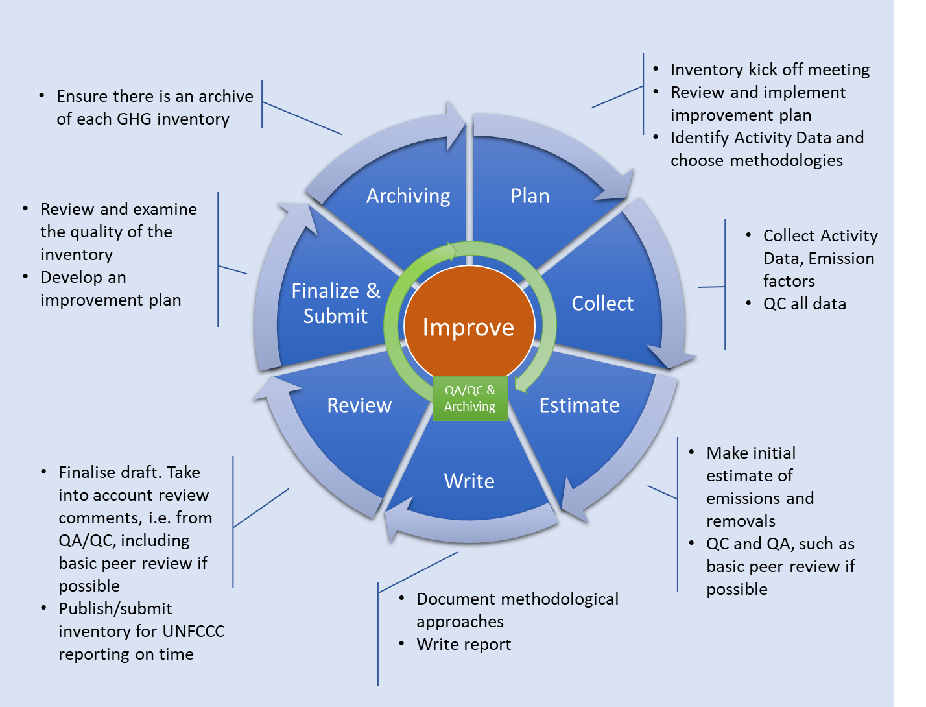

The inventory compilation stages rotate around the central, unifying theme of continuous improvement (noted by orange color in Figure 1). Almost every country has compiled at least one inventory, and many countries have completed multiple inventories. Thus, the focus of national GHG inventory compilation now is for countries to institutionalize and continually improve their compilation processes, and in turn improve their inventory reports.
Tip: The 2006 IPCC Guidelines will help you plan the GHG inventory cycle.
The 2006 IPCC Guidelines for National Greenhouse Gas Inventories (2006 IPCC Guidelines) encourage continuous improvement and rigor through QA/QC and verification activities. The concepts and tools in Chapter 6 of Volume 1 of the 2006 IPCC Guidelines support efficient inventory management, checking, and continuous improvement. By following these Guidelines, you should be able to make the best use of limited resources and produce an inventory of a quality consistent with IPCC good practice principles. Additional useful guidance and good practices in developing inventory arrangements and applying QA/QC that complement this Toolkit are also provided in Volume 1 of the 2019 Refinement to the 2006 IPCC Guidelines (e.g., Chapter 1: Introduction to National GHG Inventories).

The length of your inventory cycle depends on your national circumstances and reporting requirements. The inventory cycle pictured above can be applied to annual or biennial cycles. Based on current Biennial Update Report reporting requirements, and future reporting under the Enhanced Transparency Framework (ETF), that require reporting to the United Nations Framework Convention on Climate Change (UNFCCC) every two years, most developing countries should plan for an inventory cycle of two years.
The inventory compilation cycle has two core underpinning and distinct processes: quality assurance/quality control (QA/QC) activities, and archiving. Effective and efficient QA/QC should happen at every stage of inventory compilation, and a complete archive of all electronic and written materials relevant to the compilation cycle should be created for each completed GHG inventory so future users can reproduce the estimates.

How This Toolkit Can Help
This toolkit includes templates, tools, and guides describing the steps of designing and building a national GHG inventory management system that you will apply over an inventory compilation cycle. The resources in this toolkit are consistent with Intergovernmental Panel on Climate Change (IPCC) “good practices” and UNFCCC guidelines for national GHG inventory development, including the modalities, procedures, and guidelines for future reporting of national greenhouse gas inventories under the ETF. The toolkit’s “learning-by-doing” approach will help you incrementally build and document a national GHG inventory system that suits your national context.
When you have applied and completed the toolkit’s materials that you find helpful, you may collate them into your own “National GHG Inventory Management System Manual” that documents your schedule, institutional arrangements, methods and data, key category analysis, QA/QC procedures, inventory improvement plan, and archiving system. This manual may be very useful to future key inventory staff or team members when they prepare subsequent national inventories for reporting to the UNFCCC or for other purposes.
There are four types of resources in this toolkit:
- National GHG inventory system templates and supporting templates (e.g., an example of a supporting template includes composing a memorandum of cooperation for data collection or scope of work to engage external support for inventory compilation)
- Guides (e.g., references for understanding sector roles and responsibilities to inform position descriptions)
- Key Category Analysis tool and tutorial series
- Inventory Progress Indicator (IPI) tool
The purpose of each of these resources is to facilitate the development of key elements of your national GHG inventory system. Detailed information on each of the four types of resources is provided below.

Templates for Creating a National GHG Inventory System Manual, and Supporting Templates
A template is a model for a plan, procedure, or other resource to which inventory team members may refer for guidance as needed. It offers you a starting point that you may customize according to your needs.
The U.S. EPA’s Templates for Creating a National GHG Inventory System Manual are not designed to replace a GHG inventory report, or the GHG inventory information that should be included in reporting to the UNFCCC (e.g., Biennial Update Report, National Communication, or future Biennial Transparency Report) or a domestic GHG inventory. Rather, these templates are meant to help you gather and compile the information you will need to include in these reports, consistent with the 2006 IPCC Guidelines and good practices, and build or improve the various components of your national GHG inventory system (e.g., institutional arrangements).
These templates will help you establish and maintain a system that enables continuous inventory improvement. They will do this by helping you identify the strengths and limitations of your current GHG inventory system, specifically its institutional arrangements, documentation of methods and data collection, key category analyses, QA/QC procedures, archiving practices, and improvement planning. They are intended to help you think through the challenges to improving the inventory, record those challenges, and plan how to overcome them.
This toolkit contains seven Templates for Creating a National GHG Inventory System Manual, and four supporting templates that supplement the seven Inventory System Templates, as the following Table 1 shows:
Table 1. Templates for Creating a National GHG Inventory System Manual, and Supporting Templates
Inventory System Templates | Purpose
1. How to Use the Templates (HUT) | Explain how to use the National GHG Inventory System templates, and provide the National GHG Inventory Coordinator (NIC) with a table in which to record due dates for key compilation stages and another table in which to track progress with completing the other templates.
2. Institutional Arrangements (IA) | Assess and document existing arrangements for compilation, including data collection and review to ensure continuity.
3. Methods and Data Documentation (MDD) | Help inventory teams ensure estimates are transparent and reproducible by providing tables in which to record information related to methods, assumptions, activity datasets, and emission factors used to estimate emissions or removals.
4. QA/QC Procedures (QA/QC) | Develop a cost-effective QA/QC plan to improve accuracy, transparency, consistency, comparability, and completeness, and establish the roles and responsibilities of the QA/QC Coordinator in relation to the NIC and sector leads.
5. Key Category Analysis (KCA) | Identify most significant emissions and sink categories to focus improvement efforts.
6. Archiving System (AS) | Develop an archiving plan to facilitate preparation of subsequent inventories, providing clear roles to the NIC and sector leads and safeguard against data and information loss.
7. National Inventory Improvement Plan (NIIP) | Develop a National Inventory Improvement Plan that identifies the steps or projects the country should prioritize to improve the transparency, consistency, comparability, completeness, and accuracy of future inventories.
Supporting Templates | Purpose
National GHG Inventory Inception Memorandum | Assist the NIC with providing guidance to a country’s inventory compilers (i.e., staff responsible for preparing emissions or removals estimates and associated text for the sectors included in the national GHG inventory). The NIC may complete this template to outline the goals, expectations, and roles and responsibilities of team members during the inventory development cycle, based on existing institutional arrangements and national circumstances. It also includes a draft national GHG inventory work plan that the NIC may customize.  This supplements the HUT, IA, MDD, QA/QC, and AS templates listed above.
Memorandum of Cooperation (MoC) | To establish an agreement between two organizations, typically a data provider to the National GHG Inventory and the organization developing the Inventory.  This supplements the IA and MDD templates above.
Scope of Work | To assist with drafting a Scope of Work or Terms of Reference that the lead GHG inventory entity may use as the basis of a request for proposals to hire a consultant to develop emission or removal estimates for the national GHG inventory. Within it, the entity may define the goals, expectations, roles and responsibilities, work plan, and anticipated cost of consultants for the inventory.  This supplements the IA template above.
Confidentiality Agreement | To establish an agreement between a data provider that is supplying confidential information for the development of national GHG inventory emission or removal estimates.  This supplements the MDD template above.

How the templates can help you improve your inventory and build your inventory system
By customizing or completing the tables in the templates and adding any relevant supporting information, as shown in Figure 2 below, you will be creating several useful resources for your current and future national GHG inventory teams to use. Specifically, you will be:
- Compiling and organizing information (i.e., preparing plans and procedures) that is essential and specific to developing your national GHG inventory system and preparing your country’s national GHG inventory reports, and ensuring they are transparent;
- Clearly and efficiently outlining inventory tasks;
- Ensuring that individuals and institutions involved in your inventory know what their roles and responsibilities are;
- Identifying priorities for future inventory improvements;
- Providing future inventory teams with an instruction manual for your country’s inventories;
- Applying IPCC good practices and other UN guidance documents for preparing national inventories (e.g., these templates refer in places to the methodological details in the 2006 IPCC Guidelines).
At times, you may find it useful to keep the templates assembled in groups because of how they build upon or relate to each other, or you may use them independently of one another. You may also copy and paste them into your own documents as needed. To store the templates, consider archiving them with other materials relevant to your inventory, and backing up these files regularly to prevent loss.
Figure 2. Progressing from the Templates to the National GHG Inventory System Manual
Add Country-Specific
Information to template tables
Repeat with other templates and compile to create your GHG Inventory System Manual

Country X GHG Inventory System Manual
Template
Produce Country X Plan, Procedures, or Guide

Additional materials in the toolkit
In addition to the templates described above, the toolkit includes guides, a Key Category Analysis tool (including a series of key category tutorials on their use), and an Inventory Progress Indicator (IPI) tool. The following Table 2 describes each of these:
Table 2 Additional Resources
Guides and Tools | Purpose
National Greenhouse Gas Inventory Coordinator: Responsibilities and Qualifications | Describes the responsibilities of the National GHG Inventory Coordinator (NIC), and the qualifications that the NIC ideally would possess in order to effectively manage and coordinate development of a National GHG Inventory.
Sector Roles and Responsibilities | Describes the typical roles and responsibilities of each sector lead for the national GHG inventory. The sectors are Energy; Industrial Processes and Product Use; Agriculture; Land Use, Land-Use Change, and Forestry; and Waste.
Key Category Analysis tool and tutorials | To enable a country to determine its key source or sink categories from its GHG inventory emission and removal estimates, in a manner that is consistent with the 2006 IPCC Guidelines. Tutorials can be used to train new inventory team members on this important concept.
Inventory Progress Indicator (IPI) tool | To assess progress with improving national GHG inventories, or similarly, to evaluate the effectiveness of activities that aim to improve GHG inventories and inventory management systems.

Aligning the stages of the inventory cycle with the toolkit’s resources
The following Table 3 shows how the various resources in the toolkit align with the stages of the national GHG inventory cycle.
Table 3. Inventory Cycle Stages and the Toolkit Materials that Support them
Stage | Templates | Tools | Guides
Plan | HUT, IA, MDD, Inception Memo, MoC, Scope of Work, KCA and NIIP from previous inventory | IPI | NIC Responsibilities and Qualification,  Sector Roles and Responsibilities
Collect | MDD, QC, AS, Confidentiality Agreement
Estimate | MDD, QA/QC, KCA | KCA Tool | KCA Tutorials
Write | MDD, KCA, AS | KCA Tool | KCA Tutorials
Review | QA/QC, KCA | IPI
Finalize and report | NIIP, QA/QC
Archive | QA/QC, AS | IPI

UNDP’s Managing the National GHG Inventory Process (2005); UNFCCC Consultative Group of Experts Handbook on Building Sustainable National GHG Inventory Management Systems.
Flexibility is given to Least Developed Countries (LDCs) and Small Island Developing States (SIDS).
“QA” refers to a planned system of review and sometimes audit procedures that personnel not involved in the inventory development process conduct. “QC” is a system of planned, routine technical activities the inventory development team implements to measure and control the quality of the inventory as it is being prepared.

