National GHG Inventory Inception Memorandum Template

Description
This document provides a template for drafting a National Inventory Inception Memorandum (Memo). This memo, when customized to your national circumstances, can be distributed by the National Inventory Coordinator (NIC) to provide guidance and convey the schedule to those working on the National GHG inventory. This document is part of EPA’s Toolkit for Building National GHG Inventory Systems (“Toolkit”), which key members of a national inventory team (such as full time staff, part time staff, or consultants ) may use to design and develop a sustainable inventory system, and which complements EPA’s Templates for Creating a National GHG Inventory System Manual, also within the Toolkit. Specifically, the NIC is encouraged to use this template with Template 1. How to Use the Templates, Template 2. Institutional Arrangements, Template 3, Methods and Data Documentation, Template 4, Quality Assurance and Quality Control, and Template 6, Archiving. Additional guidance on developing GHG inventory arrangements and inventory management that complement this Toolkit are also provided in the 2019 Refinement to the 2006 IPCC Guidelines, Volume 1, Chapter 1: Introduction to National GHG Inventories.

Purpose
The purpose of this memo is to assist the National Inventory Coordinator (NIC) in providing guidance to a country’s inventory compilers - those responsible for preparing emissions/removals estimates and associated text for the sectors included in the National Inventory. This template can be used as a guide to outline the goals, expectations, and roles and responsibilities of team members during the inventory development cycle, based on existing institutional arrangements and national circumstances. The memo should specify the inventory team’s expected work plan and schedule (including key milestones for interim and final products), documentation procedures, spreadsheet and data management practices, and QA/QC and uncertainty estimation procedures. The document should also reference methodological guidelines for the National Inventory, and identify planned improvements compared to the previous inventory. This memo should be completed and distributed by the NIC.
Throughout the memo, instructions are provided in GREEN, and example text is provided in each section. This template is provided as an example; each NIC is strongly encouraged to modify text as required to reflect their country’s national circumstances and inventory compilation process.
This template provides examples of content for the following memo sections:
- Introduction
- Work Plan and Schedule
- Inventory Structure and Team Member Responsibilities
- Documentation Procedures
- Data Management
- Narrative Text Instructions
- QA/QC Requirements
- Uncertainty Analysis
MEMORANDUM
DATE | [Add Date]
TO: | Sector Leads, QA/QC Coordinator, Uncertainty Coordinator, and other relevant staff and consultants.
FROM: | National Inventory Coordinator and [other relevant inventory staff]
SUBJECT: | Inventory Preparation Procedures for [add year]

Introduction
In the section below, you should briefly introduce this memorandum and the National Inventory reporting process, including important considerations and prioritized items.

Purpose of the Memorandum
Example text:
The purpose of this memorandum is to provide guidance to those responsible for preparing emissions/removals estimates and associated text for [country]’s National Inventory. The United Nations Framework Convention on Climate Change (UNFCCC) requires most developing countries to submit a National GHG Inventory every two years consistent with current reporting under the Convention (e.g., Biennial Updates Reports and future reporting under the Enhanced Transparency Framework (ETF)) (e.g., with biennial transparency report or as standalone national GHG Inventory report). This memo includes a work plan and schedule for the next inventory report submission, as well as the planned documentation procedures, spreadsheet and data management practices, and QA/QC and uncertainty estimation procedures. It also references the methodological guidelines for the National Inventory and identifies significant planned improvements for this Inventory.

Overview Prioritized Items
Example text:
The National Inventory Coordinator (NIC) has recommended several areas of the National Inventory development process to be prioritized and/or improved for this inventory. Below is a list of areas for focus and improvement. If anything is unclear from this memo, please contact the NIC as early as possible to avoid misinterpretations or misunderstandings.
GHG Estimate Years to be Included:
- This inventory should include GHG estimates for [year – year]2005-2016. Calculation, report, and documentation files should include all of these years.

Inventory Software
- Sector leads are encouraged to use National GHG Inventory software tools to help them implement accurate methodologies for calculating GHG emissions. The IPCC Inventory software is also a useful tool to facilitate data collection, documentation, and archiving. The 2006 IPCC Guidelines Inventory Software (https://www.ipcc-nggip.iges.or.jp/software/index.html) and ALU Software are GHG calculation tools and exported GHG estimates from these tools can facilitate preparing reporting tables.
- The ALU Software (http://www.nrel.colostate.edu/projects/ALUsoftware/) is a calculation and data management tool that can be used to estimate emissions/removals using Tier 2 methods from Agriculture and Forestry related activities consistent with the 2006 IPCC Guidelines. FAO has developed estimates of Agriculture and Forestry emissions using Tier 1 methods from the 2006 Guidelines available in FAOSTAT at http://www.fao.org/faostat/en/#data to fill gaps and use for comparison.
- In addition to these software options, the Methods and Data Documentation template should be used to facilitate and supplement documentation.

Use of the U.S. EPA’s Templates for Creating a National GHG Inventory System Manual and other resources in EPA’s Toolkit for Building National GHG Inventory Systems (“Toolkit”)
- The U.S. EPA developed the Templates for Creating a National GHG Inventory System Manual to assist countries to produce high quality and sustainable national inventory management systems. Once complete, the templates will provide comprehensive documentation of each component for managing the development of the GHG inventory. Application of the templates has been integrated into the procedures described through this memo. Take note of particular sections of the templates listed below, which should be completed and submitted to the NIC at the same time you submit your sector estimates. This will support the production of a more transparent, accurate, consistent, comparable, and complete GHG inventory.
  - How to Use the Templates [Overview] (All tables are applicable to every sector)
  - Institutional Arrangements (Applicable sector tables include 2-2, 2-3, and 2-4)
  - Methods and Data Documentation (All tables are applicable to every sector)
  - Quality Assurance and Quality Control (Table 4-4 for category-specific QC, and Table 4-5 if an external review is conducted)
  - Archiving Systems (Review archiving recommendations in Tables 6-2 and 6-3)
  - National Inventory Improvement Plan (Review and contribute to Section 7-1 on potential category improvements)

Documentation
- National Inventory archive materials should be provided to the NIC along with your sector estimates and should include documentation of methods and data used in the inventory. Refer to Sections 4 and 5 of this memo, as well as the US EPA Archiving Template mentioned above.

Inventory Resources
- Reference Manual for the Enhanced Transparency Framework
- Consultative Group of Experts (CGE) Technical handbook for developing country Parties on Preparing for implementation of the enhanced transparency framework, in particular the Addendum to the handbook
- Modalities, Procedures, and Guidelines under the Enhanced Transparency Framework (see 18/CMA.1)
- UNFCCC resource guide for preparing National Communications of developing countries
- Selected training materials and methodological documents
- Relevant guidelines and manuals for National Communications and Biennial Update Reports (BUR)2019 Refinement to the 2006 IPCC Guidelines, Volume 1, Chapter 1: Introduction to National GHG Inventories

Work Plan and Schedule
The NIC should list the major milestones and deliverables for the National Inventory in the table provided below. This table identifies the main activities; the lead team member for each activity; example due dates (e.g., based on a 24-month cycle starting in January 2020), which the NIC should replace with actual due dates; and helpful resources. The NIC should modify this table to account for national circumstances. The example inventory cycle diagram below the table provides a visual overview of the tasks involved in inventory development. These tasks, and others, should be specified in the table below.
Example text:
The following table is the work plan and schedule for developing and improving the national GHG inventory. It is based on a [indicate the duration of the inventory compilation cycle in months or years, e.g., 24-month or 2-year] cycle, beginning on [date the cycle begins]. It includes major milestones and deliverables/products/outputs, and lists the main activities and associated tasks, the lead team member for each activity, the due date for each activity, and helpful resources. Wherever the table refers to a template, tool, or guide, it is referring to resources in the U.S. EPA’s Toolkit for Building a National GHG Inventory System. Templates are abbreviated as follows:
- How to Use the Templates: HUT
- Institutional Arrangements: IA
- Methods and Data Documentation: MDD
- Quality Control and Quality Assurance: QA/QC
- Key Category Analysis: KCA
- Archiving Systems: AS
- National Inventory Improvement Planning: NIIP
Work Plan and Schedule for GHG Inventory Development and Improvement
Activity no. | Stage | Activities and Tasks | Staffing | Month Due | Relevant resource(s)
1 | Plan | Finalize and document Institutional Arrangements  - Review existing IA  - Review and implement the existing improvement plan for IA  - Confirm experts for sector working groups and inventory peer review  - Complete Template 2. Institutional Arrangements  - Identify arrangements/process necessary to obtain approval to publish/submit inventory when completed | NIC,  Sector leads | Feb 2019 | IA template,  Sector Lead Roles and Responsibilities Guides
2 | Plan | Determine methods and tools to use  Confirm which methodologies the team used for the most recent inventory.  Note: The 2006 IPCC Guidelines software can facilitate developing the inventory and manage data, especially if you are applying mostly Tier 1 methods. | NIC,  Sector leads | Mar 2019 | 2006 IPCC Guidelines,  UNFCCC Consultative Group of Experts Training Materials for Each Sector
3 | Plan | Complete the Inception Memo  Prior to your inception meeting – the meeting at which you will initiate the inventory cycle – complete the Inception Memo. Also complete the HUT, QA/QC and AS templates, and additional tables in other templates that will apply to all sectors. | NIC,  Sector leads | Apr 2019 | EPA Toolkit
4 | Plan | Inception meeting  Hold an inception meeting with key inventory team members and all sector leads to:  - Confirm the team’s readiness to begin  - Discuss/identify any missing categories to include from previous inventory  - Discuss which improvements to make  - Specify the years to include, e.g., 2005-2018  - Specify the guidelines to use (for example, the 2006 IPCC Guidelines)  - Specify the software to use (for example, for calculations)  - Discuss tasks, schedule, and deliverables (i.e., the materials the team will submit to the NIC and when)  - Distribute and review the inception memo and any additional general inventory guidance  - Distribute and review category preparation instructions and any additional supporting materials (i.e., the completed Methods and Data Documentation Template)  - Discuss how the inventory could help track the impacts of GHG-related policies and measures | NIC,  Sector leads | May 2019 | National GHG Inventory Inception Memo  2006 IPCC Guidelines
5 | Plan | Read and review previous documentation  Work with sector leads to find and distribute useful materials from the most recent inventory (from a National Communication, Biennial Update Report, or other inventory report) | NIC | Jun 2019 | Sector Lead Roles and Responsibilities Guides
6 | Plan, Collect | Prepare to collect data  - Read the most recent inventory to determine priorities for this inventory, focusing on discussions of problems or potential future improvements  - Review the KCA and uncertainty analysis, if available, from the most recent inventory  - Review spreadsheets and other files relevant to the most recent inventory  - Assign staff responsibilities as appropriate per institutional arrangements (i.e., collecting data, developing estimates, coordinating consultant(s), working with ministries providing data, etc.)  - Determine data availability, quality, and barriers to collection  - Choose methods, activity data, emission factors, and conversion factors  Note: If the GHG inventory team is replacing a prior team, it should try to meet with the prior team to learn how it compiled the previous inventory. | Sector leads and sector working groups | Sep 2019 | MDD Template  Sector Lead Roles and Responsibilities Guides  2006 IPCC Guidelines
7 | Plan, Collect, Review | Review methodology and confirm parameters selected  - Determine which methods to use (i.e. Tier 1, etc.)  - Request data from data providers  - Compile activity data, emission factors, and relevant uncertainty parameters  - Identify gaps  - Determine how to fill data gaps  - Use tables in the MDD template to document methods and data | Sector leads | Dec 2019 | MDD Template  Review reporting and documentation sections of 2006 IPCC Guidelines for each emission or removal category
8 | Estimate, Write | Estimate emissions and removals, and write draft explanatory text  - Use the results of the review of the most recent inventory (step 6, above) to guide improvements  - Estimate emissions and removals for the years to be included in the inventory  - For the inventory report, draft a text that summarizes the methodology and interprets the results  - Consider using the 2006 IPCC Guidelines software (request capacity building and training support if needed) | Sector leads | Feb 2020 | Sector Lead Roles and Responsibilities Guides
9 | Estimate, Write | Recalculate estimates for previous inventory years  - If methodologies have changed, recalculate emission or removal estimates for previous inventory years (if applicable)  - Draft text to explain the recalculations.  Note: Use IPCC good practice to ensure time series consistency of recalculations. Try to provide estimates for the years that are most relevant to GHG mitigation targets, for example, reference or base years. Consistency ensures that differences in estimates between years reflect real changes in emissions, not differences in measurements or calculations. According to the 2006 IPCC Guidelines, "Because of the importance of tracking emissions trends over time, countries should ensure that a time series of estimates is as consistent as possible.” | Sector leads | Feb 2020 | Sector Lead Roles and Responsibilities Guides  2006 IPCC Guidelines, Vol. 1, Chap. 5
10 | Estimate/QC | Perform Quality Control  - Perform internal quality control (QC) procedures and other internal reviews as described in the QA/QC plan  - Brief inventory agency management on results | Sector leads,  QA/QC Coordinator | Mar 2020 | QA/QC Template  Review QA/QC sections of 2006 IPCC Guidelines for each emission or removal category (in addition to general provisions in each)
11 | Estimate/QA | Perform Quality Assurance  - Review the instructions to expert reviewers concerning how and when to conduct their review and provide feedback  - Oversee quality assurance (QA) procedures, i.e., external reviews by independent experts or an inventory advisory committee, as described in the QA/QC plan | Sector leads,  QA/QC Coordinator | May 2020 | QA/QC Template  Review QA guidance in 2006 IPCC Guidelines
12 | Estimate, Review | Update GHG estimates based on the results of QA/QC reviews  - Update GHG estimates and sector narrative text based upon QA/QC reviews  - Build the findings of the QA/QC reviews into the improvement plan (using the NIIP Template), and ensure the GHG inventory team is aware of the plan  - Track the changes made as a result of the improvement plan, and describe them in the inventory report (see Activity 16) | Sector leads | Jun 2020 | Sector Lead Roles and Responsibilities Guides  QA/QC Template  NIIP Template
13 | Estimate | Perform uncertainty analysis  - Perform uncertainty analysis (if a quantitative uncertainty analysis is not possible, perform a qualitative assessment)  - Use the analysis to identify sectors the GHG estimates of which should be improved to reduce uncertainty  - Describe the method used for the uncertainty analysis in the MDD chapter | Sector leads,  Uncertainty Coordinator | Jul 2020 | MDD Template  2006 IPCC Guidelines, Uncertainty Chapter
14 | Write | Assemble the methodology document  Compile sector narratives into one complete and transparent document that describes the methods used to estimate emissions and removals (additional material for the inventory report are the subject of Activity 16) | NIC | Jul 2020 | NIC Responsibilities and Qualifications Guide
15 | Estimate | Perform Key Category Analysis (KCA)  - Conduct Key Category Analysis (KCA) on GHG estimates using at least a Level Assessment; if multiple years of data are available, also conduct a Trend Assessment  - Use the EPA materials listed in the two rightmost columns to learn about KCA (the webinar and IPCC Guidelines), conduct the KCA (the KCA tool), and document the results (the KCA Template)  - Improve the estimates for emission or removal categories based on their contributions to magnitude and trend  Note: The output of KCA is essential to prioritizing inventory improvements. Concentrate on improvements to the top 5 categories in terms of magnitude of contribution. | NIC | Aug 2020 | KCA Tool  KCA Template  EPA KCA Webinar Part 1  EPA KCA Webinar Part 2  2006 IPCC Guidelines Key Category Analysis Chapter
16 | Write | Prepare the draft inventory chapter or report  - Decide what improvements in completeness or transparency could be made, and update the QC check list as appropriate  - Perform internal QC checks  - Brief the inventory agency management on results. | NIC,  QA/QC Coordinator | Sep 2020 | QA/QC Template  2006 IPCC Guidelines on QA/QC of inventory systems
17 | Finalize | Finalize the inventory report  - Address comments from QC review when finalizing the inventory  - Distribute the draft report and obtain the necessary approval(s) to submit the inventory (or the report of which the inventory is a part) | NIC | Oct 2020
18 | Submit | Submit the inventory  If the inventory is within a National Communication or Biennial Update Report, then submit it to the UNFCCC (after confirming the report’s consistency with the latest UNFCCC reporting requirements) | NIC | Nov 2020
19 | Plan, Write | Archive all relevant material  Implement the archiving plan you develop using the tables in the AS Template.  - Archive all inventory files both electronically and physically (i.e., archive both digital and printed files)  - Compile all the finished templates from this workbook to have complete documentation of inventory processes, methods, data, etc.  At a minimum, the archive should include:  - A description of institutional arrangements  - Descriptions of the data assessment and manipulation processes, including the sources of data that were evaluated  - An explanation of how data sources were selected  - A list of the assumptions made when selecting data or estimating emission or removals  - Data references  - A description of the recalculations performed, and why they were performed  - Responses to internal and external reviewers’ comments  - Major draft and final versions of estimation spreadsheets and the inventory report | NIC | Nov 2020 | EPA Toolkit (especially the MDD and AS Templates)  2006 IPCC Guidelines, Vol. 1, Chap. 6
20 | Review, Improve | Improvement plan  - Review the quality of the inventory  - Create a plan consisting of potential improvements for the next inventory, noting who would make the improvements and how | NIC with input from relevant inventory team members | Dec 2020 | NIIP Template  KCA video tutorials

Example Inventory Cycle 1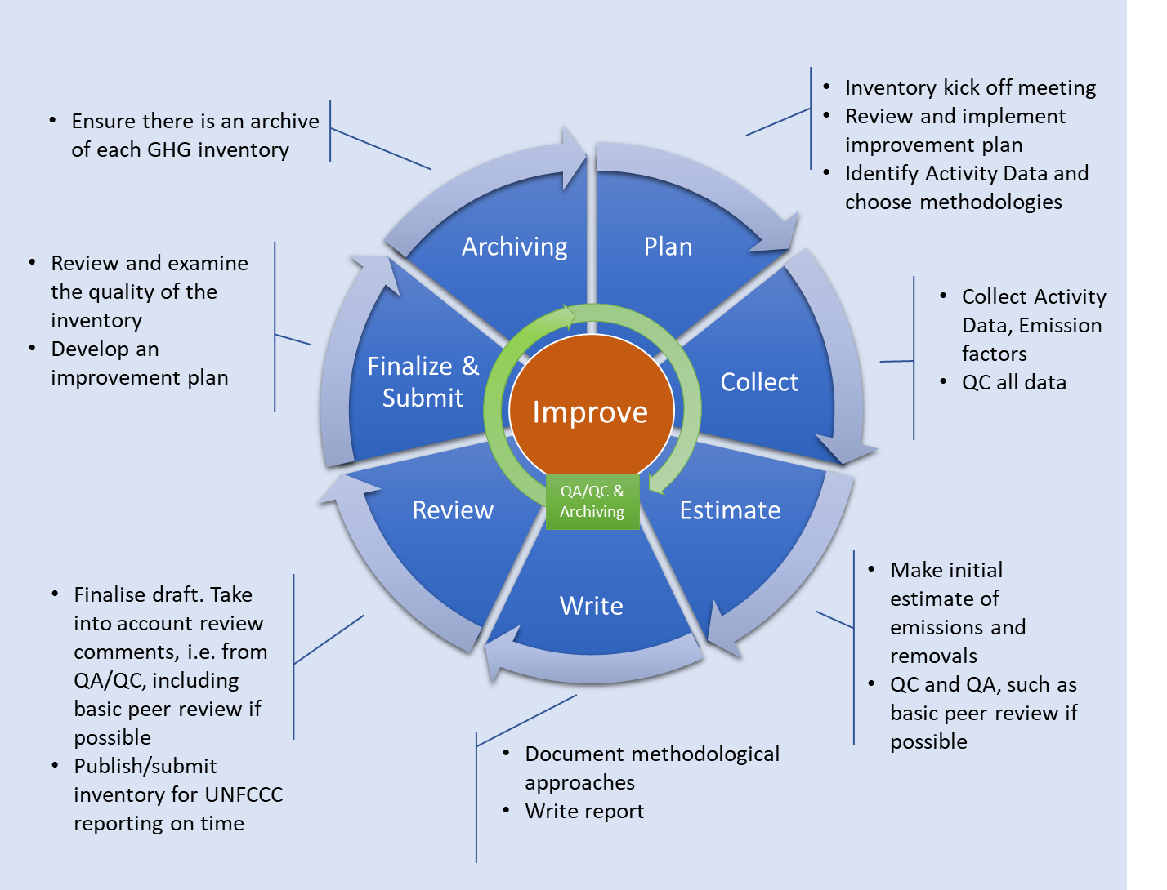

Example Inventory Cycle 2 from Chile (customized)
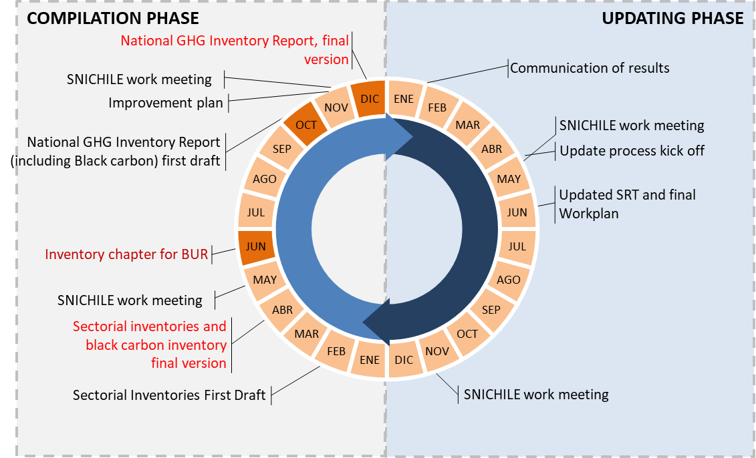
Source: Technical Team Coordinator, Ministry of Environment (Ministerio del Medio Ambiente (MMA))

Inventory Structure and Team Member Responsibilities
This section provides a potential outline of the National Inventory organization and provides a place for the NIC to identify the key team members responsible for compiling estimates for each sector. The purpose of this section is to clarify to your inventory team which person and/or ministry is responsible for developing GHG estimates for each sector. Two expanded options are provided in Appendix I at the end of this memorandum (for 2006 IPCC Guidelines) if the NIC provides more detailed assignments within each sector (that table can then replace this basic structure). The NIC should also complete the Institutional Arrangements template and use it as a reference in identifying/designating the Sector Leads.
Example Inventory Structure according to 2006 IPCC Guidelines (Basic)
Sector | Lead
Energy
Industrial Processes and Product Use (IPPU)
Agriculture, Forestry, and Other Land Use (AFOLU)
Waste
Other Sections (fill in if applicable)
QA/QC
Uncertainty
Archiving
Location of Institutional Arrangements Template: include reference to completed Institutional Arrangements Template for your country (where this information is documented), including location of completed template, version, date, etc.

Documentation Procedures
Comprehensive documentation is crucial to the long-term sustainability of regular high-quality National Inventories. In this section, provide instructions for inventory staff on how to document the National Inventory. This section can summarize the responsibilities based on procedures and plans you have developed through application of the Archiving System template. For example, you can adapt and distribute the Methods and Data Documentation template to identify what elements should be documented for each category in your National Inventory and reference its application below.

General Responsibilities
Example Text:
Comprehensive and detailed documentation will ensure that the National Inventory is transparent and reproducible, and that high quality inventories can continue to be developed in future years.
- Every primary data element (e.g., activity data, emission factors, carbon coefficients, etc.) should have a reference⎯published or unpublished⎯for the source of the data. All non-calculated values in the spreadsheets other than unit conversion factors and constants should be referenced.
- Everything should have a date of completion, especially all spreadsheet printouts.
- Each Sector Lead should ensure that the Methods and Data Documentation Template is completed for its sector (attached to this memo).
- Additional details are in the Archiving plan.

Inventory Archive
The Inventory archive is a comprehensive collection of all references/sources of information used to produce the National Inventory. This collection includes activity data sources, websites, online databases, email correspondence, and telephone conversations, among others. It is good practice to compile and safeguard the archive. The archive should be kept in physical and/or electronic form and completed when the National Inventory estimates are finalized. Use the Archiving Systems template to define tasks, responsibilities, and a schedule for archive development for the archiving coordinator as well as Sector Leads. The plan developed in the template can then be summarized in this section.
Example Text:
In addition, we will be preparing an electronic archive, which will include all references used to estimate emissions from categories and to produce the Inventory. The archive will serve as a repository for additional documentation and explanation of your categories. The e-archive is located on the shared drive, in the folder titled “GHG Inventory for [Country’s Inventory for TNC or BUR1].” Key archive materials should include the items listed below; a comprehensive list of materials to be submitted is in the Archiving Plan [Refer to the Archiving System Template 6]:
- Documentation of institutional arrangements.
- A list of all citations/references used.
- A copy of each reference should be submitted to the NIC with a narrative describing each reference, and an internet link if available.
  - For a report: copies of the cover page and most relevant pages may be sufficient. If the entire report was used extensively, then a copy of the cover page will suffice.
  - For an online database: PDF or Excel files with the relevant data tables are ideal. If it is too time-intensive to collect or if there are a large number of spreadsheets, it may be sufficient to provide a link to the database along with the appropriate search criteria and your contact information.
  - For personal communication: documenting personal communications where information was exchanged or collected (activity data, emission factors, methodologies), such as email correspondence, telephone conversations, or personal communication via in-person meetings.
    - For email correspondence: a copy of the email is sufficient.
    - For phone conversations: If a phone conversation is held where data are received or decisions on data are discussed, the contact information of the person contacted is needed, including the date contacted, the contact’s name, title, organization, phone number, email address, location address, and a description of the purpose or subject of conversation, and a brief summary of the conversation itself including any outcomes of the meeting. [Complete the contact report attached to this memo]
    - For in-person meetings: a short memorandum including the relevant information or data and the contact information of both parties will be necessary. [Complete contact report attached]
  - For confidential business information: submit a placeholder for this information including your contact information. The placeholder should provide a reference but acknowledge that the physical data are confidential and not to be shared or included in the archive. Also submit any confidential business information agreements.
- Any additional discussion about uncertainty analyses and recalculations.

Data Management
In this section, you should provide requirements and suggestions for managing inventory compilation data and calculation files (e.g. MS Excel spreadsheets). The data and calculation files (e.g. MS Excel spreadsheets) should be designed so that new team members with little to no previous inventory experience can easily update category emission or removal estimates. Please list your requirements/suggestions below.
The summary provided here should be consistent with your Archiving Plan, specifically the Archive Procedures section of the template that includes information on the management of files, data and document retention, and storage mechanisms. All relevant plans developed from use of the templates (Archiving, QA/QC, etc.) should be referenced in this section as resources for more information.
If your country does not use spreadsheets to perform the main National Inventory calculations, this section should be re-written to be relevant to the inventory software and/or calculation files used.
Example Text:
The following points are guidelines for managing inventory spreadsheets. If any of these guidelines are unclear, please contact the NIC. Complete guidelines for data management are in the Archiving Plan (specific archiving procedures are in the Archiving System template)
- If available, all Sector Leads will use spreadsheets from the previous Inventory. These have been provided to you by the NIC. Each Sector Lead will be asked to submit the sector/category spreadsheet once estimates are finalized. If historical estimates are revised, then the spreadsheet estimates should reflect those revised numbers.
- Every primary data element (e.g., activity data, emission factors, carbon coefficients, etc.) should have a reference⎯published or unpublished⎯for the source of the data, and this reference should be identified in the spreadsheet, as well as documented in the Methods and Data Documentation Template. There should not be values in the spreadsheets that are not referenced (i.e., no hard wired values), other than unit conversion factors and constants either through an Excel comment or cell note. The data sources will be provided as part of each sector’s archive submission.
- Do not enter values such as conversion factors or other numbers inside cell formulas. You should enter each value in separate cells and perform calculations using formulas that refer to those cells. Users should be able to understand the parameters for each value (e.g., units). Such practices are more transparent to others viewing and using the spreadsheets in the future.
- Create automatic look-up tables or pull down menus that limit permissible entries, or in some cases, automatically enter data.
- Use cell protection in spreadsheets so that fixed data cannot accidentally be changed, and build in electronic checks to highlight possible problems.
- When the estimates have been completed, electronic copies of each sector or category’s spreadsheet(s) must be sent to the NIC and [insert Archiving Coordinator, if applicable]. Once the spreadsheet(s) have been transferred, these spreadsheets become the official version to which any future changes should be made. If changes are required after the spreadsheet has been submitted, contact the Inventory Coordinator so that changes can be made to the official version. Please provide every “linked” supporting spreadsheet that is used.
- Make efforts to label and “organize” the spreadsheets where possible, keeping it in mind that they should be as transparent as possible (i.e., someone unfamiliar with it should be able to open it and quickly extract information and understand the estimation procedures).

Narrative Text Instructions
Provide instructions to your inventory team for drafting the National Inventory text. Below is some example text, although country circumstances will vary greatly depending on whether previous narrative text is available and if portions can be used, or whether all new text is needed.
Example Text:
These instructions provide a framework for preparing the text for the National Inventory.
Option 1: If previous text is available and still mostly relevant, the following text might be appropriate.
Example Text:
Text from the previous National Inventory will be provided to each sector lead to update for the current inventory. If these files are not received, please contact the NIC.
- Everyone must use the MS Word versions of the write-ups and annexes provided at the beginning of the Inventory cycle after the inception meeting via the NIC. If there are any questions regarding the files, please contact the NIC immediately. Each text section will have been edited to fit into a standard and consistent format and writing style. No changes should be made to the formatting, styles, margins, etc. currently in the MS Word documents. Sector leads can simply revise the text and add columns to tables for the most recent data.
Option 2: If previous text is not available (or will not be used), the following text might be appropriate.
Example Text:
The NIC will provide a template for preparing text. Sector leads should develop their own content and report the appropriate sector or category discussion as well as a description of the data received; arrangements to collect and archive data; methodology for preparing estimates; the results themselves; and any additional information available, including, but not limited to, efforts to make these actions a continuous process or information on the roles of the institutions involved.
All text should be written to correspond to the structure described below in “Sector Reporting.” Contact the NIC if you have any questions regarding the narrative.

Sector Reporting
This section provides instructions to Sector Leads for developing their inventory chapters. For the inventory chapter or report, Sector Leads should include text that briefly describes each category, the institutional arrangements involved in activity data collection, the methodology for estimating emissions, and the documentation and archiving procedures for the data. It is important to note that if the U.S. EPA’s Templates for Creating a National GHG Inventory System Manual is completed during the inventory cycle, the resulting documentation will contain most of the information necessary to complete the narrative for describing institutional arrangements and for the sector chapters for the National Inventory text. The Methods and Data Documentation template is particularly useful here. Suggestions on additional information to provide in the text that is not included in the templates are listed below.
Example Text:
The following list provides suggestions for additional information that may be included in category chapter text.
- Discussion of the national circumstances specific to the emission/removal category (e.g., characteristics of the category, relevant GHGs, or how the emissions/removals occur).
- Description of the national trend in emissions and removals over the reported time period (e.g., rate of change), if available, with a brief explanation of why this trend is and any other notable year-to-year trends are occurring.
- A simple trend and current emissions table with estimates of GHGs (i.e., carbon dioxide (CO₂), methane (CH₄) and nitrous oxide (N₂O), etc. by emissions/removals in units of mass (gigagrams or Gg).
- Description of methods and data sources, including indication if category is key.
- Simple data tables for relevant years with activity data, emission factors and other key estimate input parameters).
- Description of QA/QC, uncertainty, and uncertainty analysis (if performed).
- Description of recalculations from the previous inventory.
- Any additional tables and/or graphics to be included with the text in addition to basic emission estimates are also welcome (confer with the NIC prior to including).

QA/QC Requirements
This section should explain the requirements for the QA/QC activities for the Inventory. The completed QA/QC Procedures template will provide information on QA/QC requirements that can be summarized and referenced here.
Example Text:
As part of QA/QC for the inventory, all sector leads must:
- Conduct a Tier 1 QA/QC analysis on all categories within your sector. At a minimum, each Sector Lead should complete Table 4-3: General QC Activities within the QA/QC Template, including supplying all documentation used in the checks (e.g., contact reports, supplemental reports, or other comments). If a QA/QC Plan has already been developed, refer to the QA/QC Plan.
- Submit completed Tier 1 QA/QC checklist to [insert QA/QC coordinator].
- Depending on resource availability, conduct a Tier 2 QA/QC. Refer to Table 4-4: Category-specific QC Procedures within the QA/QC Template, which is recommended for key categories. However, Tier 2 checks may not be possible to for all key categories due to resource constraints. Sector leads should continue to implement a multiyear plan to conduct a Tier 2 analysis on key categories.
- Additional details are in the QA/QC plan provided as an attachment to this memo.
Continue to review the 2006 IPCC Guidelines, data management, and other recommendations for good practices for each category. Contact the QA/QC and Uncertainty Coordinator for any questions regarding data collection for uncertainty or QA/QC.

Uncertainty Analysis
This section should explain the requirements for the Uncertainty Analysis activities for the Inventory. Uncertainty estimates are encouraged for developing countries, but not required.
Example Text:
The inventory system is designed and operated to ensure the quality of the inventory through planning, preparation, and management of inventory activities. As part of this approach, quality assurance (QA) and quality control (QC) procedures, coupled with uncertainty analysis (if applicable), are designed to enhance and continually improve inventory quality over time. Sector leads should continue to build on past efforts for the current GHG Inventory, while ensuring compliance with the UNFCCC reporting guidelines.

Uncertainty
Example Text:
- Optional: Conduct a Tier 1 uncertainty analysis on all sources. If an uncertainty tab is not included in the sector or category spreadsheets, see the Tier 1 uncertainty formulae attachment for details on required data. Default uncertainty values are provided in Chapters 2 through 5 of the 2006 IPCC Guidelines for many emission and removal categories as well as the IPCC Emission Factor Database; however, country-specific parameters for activity factors and emission factors can be used based on expert judgment, published references, periodic emissions measurements, and continuous emissions monitoring. Document all sources of uncertainty estimates; where expert judgment is used, please document the expert elicitation process.
- Optional: Where possible, a Tier 2 Monte Carlo analysis is the preferred approach to quantifying uncertainty and should be undertaken, particularly for key categories, or where a Tier 1 uncertainty analysis is not possible (e.g., a correlation exists between data points, or the data are not normally distributed). A Tier 2 analysis can be very resource intensive, and may not be possible to complete for all key categories for the current Inventory. Sector leads should continue to implement a multiyear plan to conduct a Tier 2 analysis on key categories. Tier 2 Monte Carlo analyses should include all sources/sinks and sub-sources/sinks included in the emission estimate, and should report information per IPCC Guidelines, (e.g. Table. 3.3 in Volume 1, Chapter 3 of 2006 IPCC Guidelines). If a Tier 2 Monte Carlo analysis is performed, then for the archives please also provide the Inventory Coordinator with all relevant uncertainty Excel spreadsheets, raw data on model variables used to develop the Monte Carlo analysis for all model simulations, and/or the @RISK software data files.
- If additional analyses are undertaken or a more detailed written discussion of the uncertainty analysis and findings is required consistent with reporting and documentation guidance in 2006 IPCC Guidelines, please consider including such additional information as reference sources in the report and associated technical annexes. Retained the detailed documentation as readily accessible supplemental documentation in the inventory archive. The archive should be considered a useful tool to retain this additional information for interested parties and future inventory compilers that may update this analysis.
Appendix I: UNFCCC Greenhouse Gas Emission/Removal Categories
Option 1: List of GHG categories from 2006 IPCC Guidelines, by sector and category lead
Greenhouse Gas Categories
1 | Energy | Category Lead
1.A | Fuel combustion activities
1.A.1 | Energy industries
1.A.2 | Manufacturing industries and construction
1.A.3 | Transport
1.A.4 | Other sectors
1.A.5 | Non-specified
1.B | Fugitive emissions from fuels
1.B.1 | Solid fuels
1.B.2 | Oil and natural gas
1.B.3 | Other emissions from energy production
1.C | Carbon dioxide transport and storage
1.C.1 | Transport of CO₂
1.C.2  1.C.3 | Injection and storage  Other
2 | Industrial processes and product use
2.A | Mineral industry
2.A.1 | Cement production
2.A.2 | Lime production
2.A.3 | Glass production
2.A.4 | Other process uses of carbonates
2.A.5 | Other (please specify)
2.B | Chemical industry
2.B.1 | Ammonia production
2.B.2 | Nitric acid production
2.B.3 | Adipic acid production
2.B.4 | Caprolactam, Glyoxal and Glyoxylic acid production
2.B.5 | Carbide production
2.B.6 | Titanium dioxide production
2.B.7 | Soda ash production
2.B.8 | Petrochemical and carbon black production
2.B.9 | Fluorochemical production
2.B.10 | Other (please specify)
2.C | Metal production
2.C.1 | Iron and steel production
2.C.2 | Ferroalloys production
2.C.3 | Aluminum production
2.C.4 | Magnesium production
2.C.5 | Lead production
2.C.6 | Zinc production
2.C.7 | Other (please specify)
2.D | Non-energy products from fuels and solvent use
2.D.1 | Lubricant use
2.D.2 | Paraffin wax use
2.D.3 | Solvent use
2.D.4 | Other (please specify)
2.E | Electronics industry
2.E.1 | Integrated circuit or semiconductor
2.E.2 | TFT flat panel display
2.E.3 | Photovoltaics
2.E.4 | Heat transfer fluid
2.E.5 | Other (please specify)
2.F | Product uses as substitutes for ozone depleting substances
2.F.1 | Refrigeration and air conditioning
2.F.2 | Foam blowing agents
2.F.3 | Fire protection
2.F.4 | Aerosols
2.F.5 | Solvents
2.F.6 | Other applications (please specify)
2.G | Other product manufacture and use
2.G.1 | Electrical equipment
2.G.2 | SF₆ and PFCs from other product uses
2.G.3 | N₂O from product uses
2.G.4 | Other (please specify)
2.H | Other
2.H.1 | Pulp and paper industry
2.H.2 | Food and beverages industry
2.H.3 | Other (please specify)
3 | Agriculture, forestry, and other land use
3.A | Livestock
3.A.1 | Enteric fermentation
3.A.2 | Manure management
3.B | Land
3.B.1 | Forest land
3.B.2 | Cropland
3.B.3 | Grassland
3.B.4 | Wetlands
3.B.5 | Settlements
3.B.6 | Other land
3.C | Aggregate sources of non-CO₂ emissions sources on land
3.C.1 | Emissions from biomass burning
3.C.2 | Liming
3.C.3 | Urea application
3.C.4 | Direct N₂O emissions from managed soils
3.C.5 | Indirect N₂O emissions from managed soils
3.C.6 | Indirect N₂O emissions from manure management
3.C.7 | Rice cultivations
3.C.8 | Other (please specify)
3.D | Other
3.D.1 | Harvested wood products
3.D.2 | Other (please specify)
4 | Waste
4.A | Solid waste disposal
4.A.1 | Managed waste disposal sites
4.A.2 | Unmanaged waste disposal sites
4.A.3 | Uncategorized waste disposal sites
4.B | Biological treatment of solid waste
4.C | Incineration and open burning of waste
4.C.1 | Waste incineration
4.C.2 | Open burning of waste
4.D | Wastewater treatment and discharge
4.D.1 | Domestic wastewater treatment and discharge
4.D.2 | Industrial wastewater treatment and discharge
4.E | Other (please specify)
5 | Other
5.A | Indirect N₂O emissions from atmospheric deposition of nitrogen in NO_{x} and NH₃
5.B | Other (please specify)

Option 2: List of GHG categories from 1996 IPCC Guidelines, by sector and category lead
Greenhouse Gas Categories
1 | Energy | Category Lead
1.a | Fuel combustion (sectoral approach)
1.a.1 | Energy industries
1.a.2 | Manufacturing industries and construction
1.a.3 | Transport
1.a.4 | Other sectors
1.a.5 | Other (please specify)
1.b | Fugitive emissions from fuels
1.b.1 | Solid fuels
1.b.2 | Oil and natural gas
2 | Industrial processes
2.a | Mineral products
2.b | Chemical industry
2.c | Metal production
2.d | Other production
2.e | Production of halocarbons and sulphur hexafluoride
2.f | Consumption of halocarbons and sulphur hexafluoride
2.g | Other (please specify)
3 | Solvent and other product use
3.a | Product Use
4 | Agriculture
4.a | Enteric fermentation
4.b | Manure management
4.c | Rice cultivation
4.d | Agricultural soils
4.e | Prescribed burning of savannahs
4.f | Field burning of agricultural residues
4.g | Other (please specify)
5 | Land-use change and forestry
5.a | Changes in forest and other woody biomass stocks
5.b | Forest and grassland conversion
5.c | Abandonment of managed lands
5.d | CO₂ emissions/removals from soil
5.e | Other (please specify)
6 | Waste
6.a | Solid waste disposal on land
6.b | Waste-water handling
6.c | Waste incineration
6.d | Other (please specify)
7 | Other (please specify)
 | Memo items
 | International bunkers
 | Aviation
 | Marine
 | CO₂ emissions from biomass

Default emission factors in the IPCC’s Emission Factor Database are available online at: http://www.ipcc-nggip.iges.or.jp/EFDB/main.php
This is the person responsible for developing the GHG estimates for each category.
This is the person responsible for developing the GHG estimates for each category.

