Standard Operating Procedure
for
the Vaisala CL51 Ceilometer

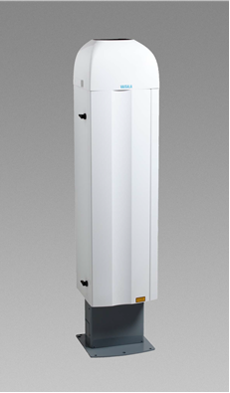

Prepared by

T&B Systems
3739 Pleasant Valley Road, Unit C
Placerville, CA

Table of Contents
Table of Contents 2
1.0 Abbreviations and Acronyms 4
2.0 General Information 5
2.1 Principals and Applicability 5
2.2 Description of the Method 5
2.2.1 Basic Operating Principles 6
2.2.2 BL-View Software Package 6
2.3 Instrument Components 8
2.4 Health & Safety Warnings 9
2.5 Cautions 11
2.6 Interferences 11
2.7 Personnel Qualifications 11
3.0 Procedures 12
3.1 Apparatus and Materials 12
3.2 Installation 12
3.2.1 The CL51 Assembly 12
3.2.2 Setup and Installation 13
3.2.3 Power Requirements 13
3.2.4 Instrument Mount 13
3.2.5 Unpacking the CL51 14
3.2.6 Mounting the CL51 15
3.2.7 Connecting the CL51 Backup Battery 17
3.2.8 Connecting External Cables 17
3.3 Initial Startup 18
3.4 Instrument Operation 19
3.5 Data Acquisition 19
3.6 Computer Hardware & Software 19
3.7 Data Management and Records Management 20
3.8 Maintenance Procedure 21
3.8.1 Checking Alarms and Warnings 21
3.8.2 Cleaning the CL51 Window 21
3.8.3 Checking the Door Gasket 22
3.8.4 Checking the Backup Battery 22
3.8.5 Window Contamination Measurement Calibration 22
3.9 Troubleshooting 22
4.0 Quality Assurance and Quality Control 23
4.1 Instrument or Method Calibration 23
4.2 Quality Assurance 23
4.2.1 Performance Audit 23
4.2.2 Systems Audit 24
4.2.3 Data Quality and Data Validation 24
4.3 Routine Checks 24
5.0 References and Additional Resources 25
5.1 Technical Materials 25
5.2 Additional Resources 25
6.0 References 26
Appendix A. Vaisala CL51 Technical Datasheet 27
Appendix B. CL51 Warning and Alarm Messages 28
Appendix C. CL51 Component Diagram 29
Appendix D. CL51 Spare Parts List 31
Appendix E. Troubleshooting through the Service Connection 32

Abbreviations and Acronyms

A ampere(s)
AC alternating current
AQS Air Quality System
ASCII American Standard Code for Information Interchange
BL boundary layer
BL-View Boundary Layer View software - Vaisala
CFR Code of Federal Regulations
DAS data acquisition system
EPA Environmental Protection Agency
ESD electrostatic discharge
ft foot/feet
hr hour
IEC/EN International Electrotechnical Commission Euro Norm
LAN local area network
LED light emitting diode
LIDAR light detection and ranging
m meter
min minute(s)
MLH mixing layer height
mm millimeter(s)
µs microsecond(s), 10⁻⁶ second
netCDF network common data form
nm nanometer(s)
ns nanosecond(s), 10⁻⁹ second
PAMS Photochemical Assessment Monitoring Station
PC personal computer
ps picosecond(s), 10⁻¹² second
QA quality assurance
QAPP quality assurance project plan
QC quality control
SOP standard operating procedure
V volt(s)
VAC volt(s) alternating current

General Information
2.1 Principles and Applicability
This SOP describes procedures for the setup, commissioning and routine operation of the Vaisala Ceilometer CL51 which is used to measure the local atmospheric boundary layer (BL) depth. The instrument is employed to measure the mixing layer height (MLH) as required for the U.S. Environmental Protection Agency (EPA) Photochemical Assessment Monitoring Stations (PAMS) Required Site network. The ceilometer is supplied with a laptop personal computer (PC) equipped with the Vaisala BL-View software package which produces the local MLH measurement. Note that the CL51 may also be accessed and operated through Vaisala’s
CL-View software program installed on the support PC. CL-View does not support MLH determination as the algorithm and MLH functions are native to the BL-View software.
This document is intended to summarize the Vaisala Ceilometer CL51 User’s Guide. It is recommended that this SOP be used in conjunction with the user guide during installation, commissioning, and operation of the instrument.
The operational and physical specifications for the CL51 ceilometer are listed in Appendix A.
Instrument users can access Vaisala’s customer support through their website (www.vaisala.com) or their customer service line at 800-408-9456.

Description of the Method
The Vaisala Ceilometer CL51 measures cloud height and atmospheric visibility as part of its internal processing. The addition of the laptop computer executing the BL-View software package enables the detection of up to three (3) independent local BL heights per profile. The lowest of these BL heights is typically considered the mixed layer or mixing layer.
The CL51 utilizes pulsed diode laser technology (LIDAR = Light Detection and Ranging), where short, powerful laser pulses are emitted into a vertical or near-vertical direction. The reflection or backscatter of the LIDAR pulse is the consequence of the interaction of the light signal with local atmospheric-borne particulates such as air pollution, haze, fog, mist, virga, precipitation, and clouds. The backscatter profile, that is, the signal strength versus sample time (related to the altitude), is stored and processed, after which it is used by BL-View to determine the local BLs/mixing height(s). The time interval between the emission of the laser pulse and the reception of the backscatter signal is directly related to the altitude from which the signal is reflected.
The CL51, with the BL-View software package, is able to identify the cloud layers and the BLs/mixing heights simultaneously. The CL51 firmware supports several service and maintenance functions.
2.2.1 Basic Operating Principles
The CL51 employs a pulsed InGaAs (Indium Gallium Arsenic) diode laser operating at a wavelength of 910 nm. The CL51 functions as a monostatic and monochromatic, pulsed LIDAR source by emitting a pulse of light and then recording and processing the received signal produced by the interaction of the light energy with the particles carried by the atmosphere. At any given altitude, the measured signal intensity is proportional to the number of particles at that altitude.
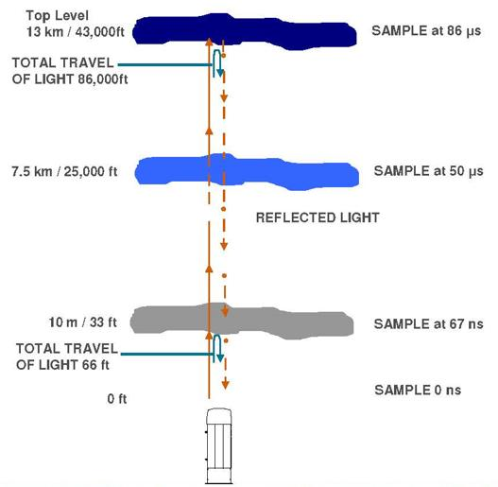
Figure 1. The CL51 LIDAR sampling process detailing the transmission and reflection of a laser pulse

When in operation, a 100-nanosecond (ns) pulse (equivalent to a 15-meter depth) is emitted every 150 microseconds (μs). The ceilometer measures profiles 6500 times per minute and uses 32,768 of these profiles for each measurement cycle. A schematic diagram of the LIDAR measurement process is shown in the Figure 1.

The time history (corresponding to sampling heights) of the signal intensity is recorded by the instrument. BL-View uses this to identify the BL heights, one of which correlates to the local mixed layer at any given point in time.

    - BL-View Software Package
The CL51 is supplied with the Vaisala BL-View software package and a personal laptop computer that is pre-configured to communicate with the CL51 for configuring the ceilometer, data collection (backscatter and BLs/mixing heights), and real time data display. The computer comes with the software pre-installed and ready for use, requiring no user adjustments. The software records the pulse profiles through the network connection and then uses this information to compute the MLH estimate(s). The BL-View software can detect up to three (3) BLs/MLHs simultaneously. Coupled with the embedded CL51 cloud detection algorithm, the software also reports up to three (3) cloud heights. However, as cloud heights are outside the scope of the PAMS network, the cloud detection techniques and applications will not be discussed further in this document.
The CL51 signal profile detection is based on the profile of the size and number of the particles distributed vertically in the atmosphere above the unit. A sample of this signal profile is shown below in Figure 2.
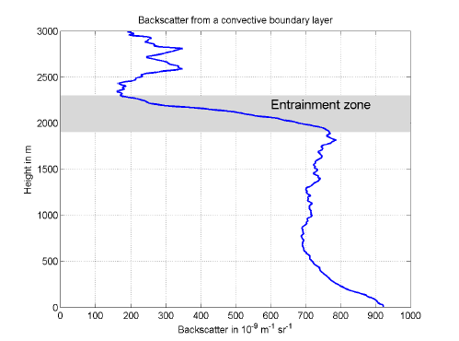
Figure 2. Backscatter signal intensity profile demonstrating the entrainment zone
This profile shows the well mixed layer (region beginning at the ground (altitude 0 m) and extending upward to the entrainment zone – starting at approximately 1900 m. This is the region where the backscattered signal is nearly constant in amplitude with increasing altitude. The entrainment layer is the interface between the mixed layer and the free atmosphere, which demonstrates fewer particles with a correspondingly lower signal level.
The BL-View program processes the history of these profiles to identify and report up to 3 mixing layers (if detected) for each hour. The signal processing techniques are described in the BL-View manual available from through the Vaisala product support department as referenced in Section 2.1. A sample time-height presentation of the aerosol scattered signal profile is shown in Figure 3.

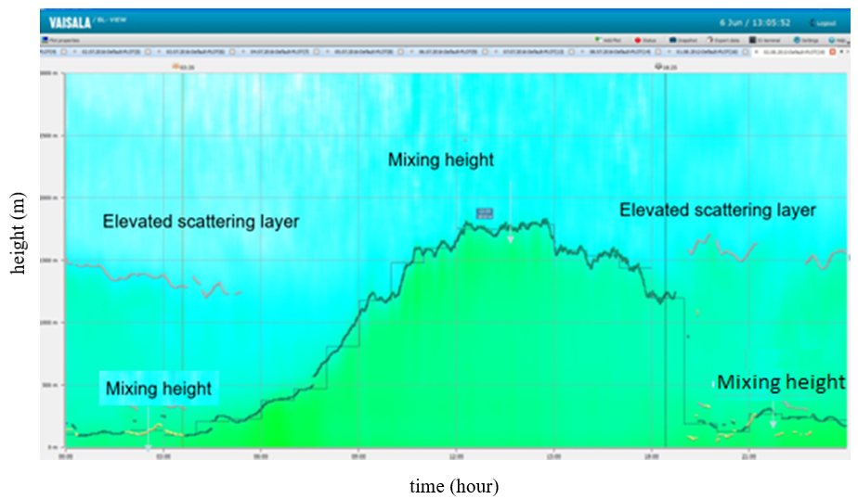

Figure 3. Diurnal variation of the ceilometer backscattered signal intensity
In Figure 3, the time of day increases from left to right on the x-axis and the altitude associated with the signal intensity at each point in time is scaled on the vertical axis. The signal intensity is then color encoded at each point. Greater backscatter intensity is shown in green and lower backscatter intensity is shown in blue. The resulting diurnal pattern illustrates the mixing height changes during the day. In general the mixing height is at a lower altitudes in the morning and evening. The morning solar insolation heats the ground with the result that ground formed thermals initiate a vertical mixing process that mixes the particulate matter upward which causes the mixing layer to grow upward until early afternoon. Solar heating decreases in the afternoon with the result that the mixing layer begins to collapse in the afternoon and results in disconnnected elevated scattering layers in the late afternoon which sometimes continues into the next day. The nocturnal mixing layer reforms close to the ground near and after sunset due to the cooling of the earth’s surface. In effect, the scattering intensity time-height cross-section is a powerful visualization of the diurnal evolution of the atmospheric BL.

2.3 Instrument Components
Ceilometer interior parts and components referenced in this SOP are identified in Figure 4 and detailed in Appendix C.

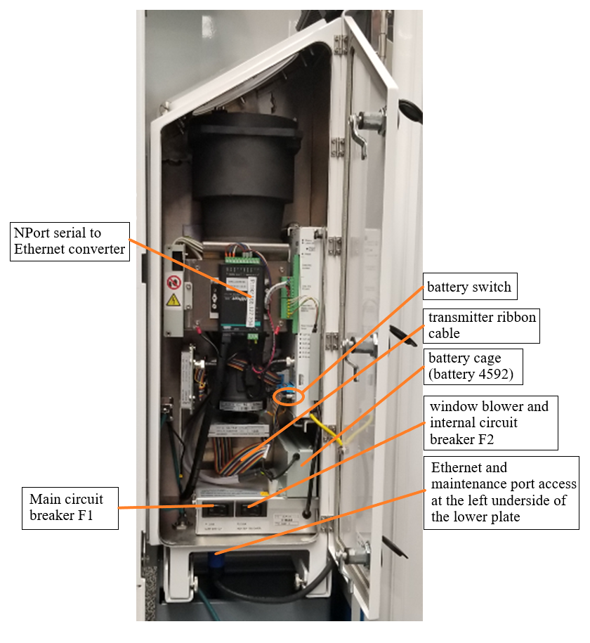

Figure 4. CL51 Measurement Unit Interior

2.4 Health & Safety Warnings
The CL51 has been tested for safety and approved prior to shipment from the factory. Safety precautions must be observed during all phases of setup, commissioning, operation, service, and repair. Users must not modify the unit as improper modification can damage the instrument and may lead to a malfunction. Questions should be directed to the Vaisala product support department referenced in Section 2.1.

The CL51 is classified as a Class 1M laser device in accordance with international standard IEC/EN 60 825-1. The CL51 complies with 21 CFR 1040.10 and 1040.11 except for deviations pursuant to the Laser Notice No. 50 dated 26 July 2001. When the CL51 is installed in a field environment, configured with instrument covers, and pointed vertically or near-vertically, it poses no established biological hazard to humans.
The CL51 is delivered with the following label:

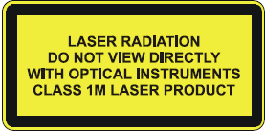

The CL51 is intended for operation in an area restricted from public access. It is to be pointed vertically or at a shallow zenith angle. Invisible laser radiation is emitted through the aperture, depicted in Figure 5, on the top of the ceilometer.

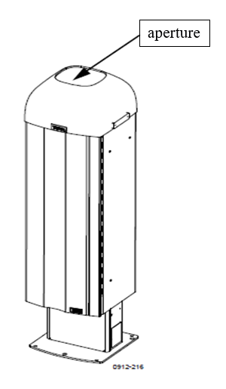

Figure 5. Ceilometer CL51 Laser Aperture

Do not look directly into the ceilometer transmitter (aperture) or ceilometer optics with magnifying optics (e.g., glasses, binoculars, or telescopes). Never remove the ceilometer transmitter from its normal position without first switching off the AC power line voltage, switching off the battery power, and detaching the transmitter ribbon cable from the ceilometer engine board. When operating the CL51, avoid looking at the ceilometer unit from the beam direction or aperture. If the unit is tilted, ensure that it is not being viewed from the beam direction with magnifying optics.
Finally, as a precaution, only trained personnel should perform maintenance functions. Access to the work area by unauthorized persons during service operations must be prevented.

2.5 Cautions
The CL51 and accessories contain parts and assemblies sensitive to damage by electrostatic discharge (ESD). Use ESD precautionary procedures when touching, removing, or inserting any objects inside the equipment housing. ESD can cause immediate or latent damage to electronic circuits. To protect against ESD, the unit must be properly electrically grounded.

2.6 Interferences
When siting the CL51, make sure the laser has a clear view of the sky with no obstructions (e.g., trees, powerlines, buildings, fences, guy wires, flag poles, etc.). The ceilometer must be installed so that the light beam points vertically with a clear view of the sky above it. As a rule of thumb, the vertically pointing ceilometer should be installed at a minimum distance of 1 foot away from a two-story building to allow for an unobstructed viewing cone of 2 degrees above the ceilometer. The higher the building the greater the distance that the ceilometer needs to be separated from the building or structure to allow for a minimum 2-degree viewing cone.
Avoid installation adjacent to tall trees, bushes, overhead lines, antennas or other obstructions within the 2-degree viewing cone. Care should be taken that no obstructions can be blown into the ceilometer’s field of view, such as tree limbs, loose metal covers, etc., as they will interfere with measurements.
Falling snow, rain, hail, fog, fire smoke plumes and flying birds will interfere with the ceilometer performance. Their presence is identified by significantly higher signal levels compared to normal unobstructed view signal levels as displayed in the BL-View software backscatter presentation.
Birds may land on the ceilometer window. Bird droppings, feathers, and associated debris will degrade ceilometer performance. If birds are expected to be frequently around the ceilometer, the optional bird deterrent kit (CL51BIRDKITSP) can be installed to prevent them from landing on the ceilometer.

2.7 Personnel Qualifications
This SOP, in addition to the CL51 User Guide, is sufficient to inform field technicians to commission, operate, and maintain the ceilometer. All trained personnel should be familiar with the methodology behind the BL measurement and the monitoring goal.

Procedures

Apparatus and Materials
The CL51, as delivered by Vaisala, is pre-configured and tested prior to shipment. The system is delivered with the following components and accessories:
- Vaisala CL51 ceilometer
- PC type laptop computer with pre-installed BL-View software
- Ethernet switch
- Interconnecting cables, power supplies and cords
- Mounting plate and mounting hardware
Upon unpacking, verify these items have been delivered per the packing list. If any are missing, contact Vaisala directly as described in Section 2.1.
For installation and commissioning, the following tools and materials may be required depending upon the conditions at the proposed site:
- Concrete, any commercially available type
- Six-foot (6’) grounding rod with terminal connector
- Copper grounding wire (at least a 4’ section)
- Shovel
- Tool kit including flathead and Phillips type screw drivers
At the field site, the CL51 instrument installation also requires the following:
- Standard commercial service electrical power (120 volts AC, 20 ampere) is required to operate the instrument and its internal fan and heater (if needed). A three conductor AC power connector must be employed to supply instrument ground.
- A weather protective enclosure or shelter is necessary to house the PC.
- Conduit is to be employed to route the Ethernet cables from the CL51 to the PC.
- Approval may be required to install the grounding rod or to ground the CL51 instrument. An appropriate ground is required to minimize shock hazards.
3.2 Installation
3.2.1 The CL51 Assembly
The CL51 is designed for outdoor operation in all weather conditions and employs an external shield to protect the measurement unit as shown in Figure 6. The external shield comprises the mounting base which is to be secured to a mounting platform.

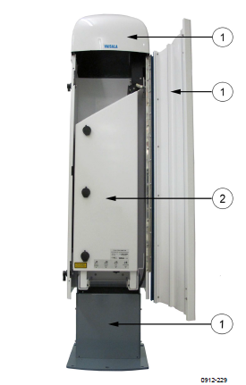

Figure 6. CL51 External Shield (1) and Measurement Unit (2)

3.2.2 Setup and Installation
When choosing an installation site, install the instrument in an open location where there are no tall trees, overhead power lines, nearby antennas, or other potential obstructions to the laser pathway to the open sky. The instrument should not be installed near powerful radars or radio transmitters through which electromagnetic interference could degrade the CL51 performance. See also the siting restrictions and interferences noted in the Section 2.6.

3.2.3 Power Requirements
The CL51 operates on standard 120 VAC, 60 Hz electrical power through a standard 120 VAC, 20 A service connection.
3.2.4 Instrument Mount
The CL51 may be installed on an existing foundation such as a wooden deck or concrete pad. If a suitable mounting location is not available, a newly poured concrete base is recommended to accommodate the CL51 mounting plate as shown in Figure 7. Align the CL51 base to the four cardinal reference points as shown in the Figure 7.
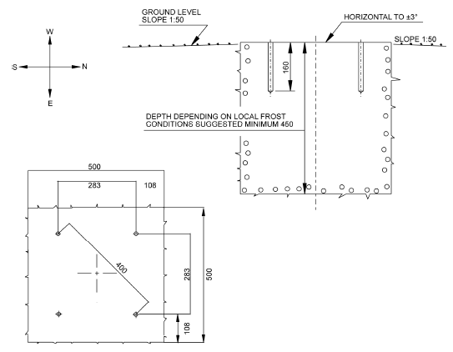

Figure 7. Compass orientation, top view (lower left), and side view (upper right) of recommended CL51 mount

Referring to Figure 7, the mounting base is approximately 2´x 2´x 2´ – approximately 8 ft³ (0.3 cubic yards) and would require approximately 1100 pounds of concrete. For constructing concrete mounts of other sizes, users can calculate the amount of concrete needed using the concrete calculation tool at calculator.net.
Dig a properly sized hole to accommodate the chosen concrete base size (normally 2´x 2´x 2´), mix the concrete, pour the foundation, and level the pad prior to the concrete hardening. Allow the concrete to cure before installing the ceilometer.
3.2.5 Unpacking the CL51
To unpack the shipment, place the shipping box on a flat surface with the indicated top side oriented upward. Open the top of the box and carefully remove the ceilometer and all other equipment, observing the following precautions:
- Wear gloves while handling the equipment to protect against sharp edges.
- Avoid touching the window and lens surfaces. Do not remove the protective sheet from the measurement unit window.
- Do not remove the integral protective caps from the unused external connectors (J4 Maintenance line).
- Use the measurement unit handle (indicated in Figure 8) for lifting and carrying the measurement unit.

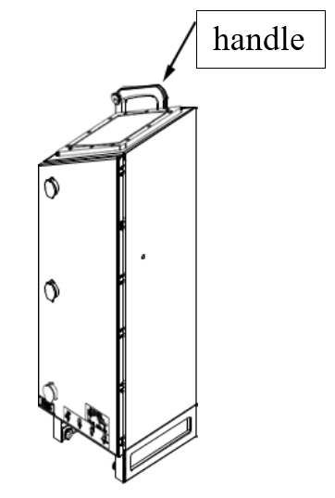
Figure 8. CL51 Measurement Unit Handle
3.2.6 Mounting the CL51
Install the ceilometer shield mounting hardware in the mounting surface as follows:
- Use the base plate supplied with the CL51 as the pattern to drill four (4) 12-mm diameter holes to secure it to the concrete pad (or other mounting surface). Orient the plate to the compass as shown in Figure 7.
- Drill the four (4) holes with a diameter of 0.5 inches (12 mm) to a depth of 6.5 inches (165 mm).
- Fasten the wedge bolts (M10 x 40) to the lower ends of the foundation screws (4 total).
- Place the wedge bolt-foundation screw combination into the holes with the wedge bolts downward and hammer the protruding bolt into the hole.
- Turn the foundation bolts several rotations to secure the wedge bolts to the walls of the holes.
Upon completion the base is prepared for installation of the ceilometer shield.
The CL51 is delivered with the measurement unit installed within the instrument shield. The shield can be mounted with the measurement unit installed, provided that the CL51 can be handled without damaging it. Note that handling the shield with measurement unit installed increases the weight of the unit for handling and may increase the likelihood of damage if the unit is subjected to shocks from tipping or dropping. In such cases, users are recommended to remove the measurement unit, mount the shield onto the foundation, and then re-install the measurement unit into the shield as follows:
- To remove the measurement unit from the shield, loosen the three attachment screws (labeled as A in Figure 9), disconnect the blower cable from connector J1, and pull the measurement unit sideways out of the shield.
- Orient the shield base on the foundation mounting screws so the shield door faces north in the northern hemisphere (or south in the southern hemisphere).
- Place the flat washers on the foundation screws, install the nuts, and finger tighten the nuts to the base. To ensure even tightening, securely tighten the nuts with a suitable wrench in a stepwise fashion.
- Reinstall the measurement unit inside the shield, connect the blower cable to connector J1, and tighten the three attachment screws.
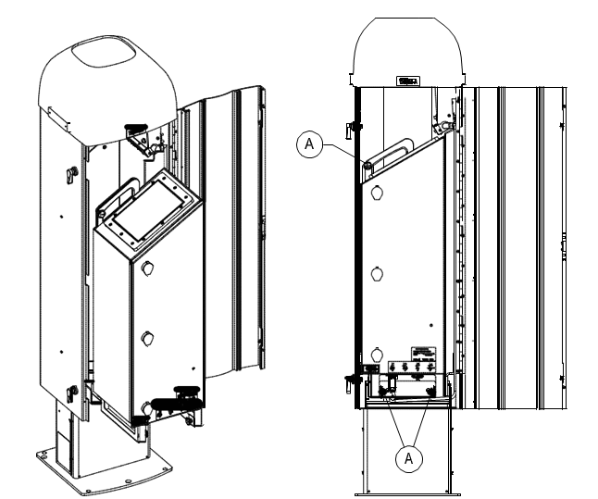
Figure 9. Measurement unit attachment screw locations (A)

3.2.7 Connecting the CL51 Backup Battery
The backup battery is delivered in the shipping box with the CL51, attached to the measurement unit. If the battery is not installed, a Phillips screwdriver and a 3-mm hex-key wrench are needed to complete the installation according to the following steps (Refer to Figure 4):
- Ensure the battery switch on the CL51 unit is in OFF position.
- Open the measurement unit door and remove the two locking screws on the lid of the backup battery cage.
- Connect the battery cables to the battery.
  - The red end of the cable connects to the positive (+) end terminal
  - The black end of the cable connects to the negative (-) end terminal.
- Open the battery cage lid and slide the battery into the battery cage.
- Close the battery cage lid and secure the lid with the two lock screws.
- Connect the backup battery cable to the CL51 board.
Leave the power switches in the OFF position until the cables are connected.
3.2.8 Connecting External Cables
External connectors are located in a connector plate at the bottom of the measurement unit. They are labeled as J1 through J4 as shown in Figure 10.
- J1: Connection for window blower
- J2: Connection for electrical power – with ground connection for instrument chassis
- J3: Connections for remote communication (normal use)
- J4: Connection for computer for local maintenance. A protective cap is included for this port when not in use.
Prior to connecting the electrical power cable to port J2, turn the main circuit breaker F1 to the OFF position. Check the voltage of the power supply cable connector and plug in the line supply cable to connector J2.
The instrument includes external mating connectors with 2-m (7-ft) cables for ports J2 and J3. The power plug can be removed from the J2 cable when the unit is permanently installed.
The Ethernet cable connection to the measurement unit base is on the underside of the measurement unit as show in Figure 4. This connection includes a screw connector cap to secure the Ethernet cable in place.

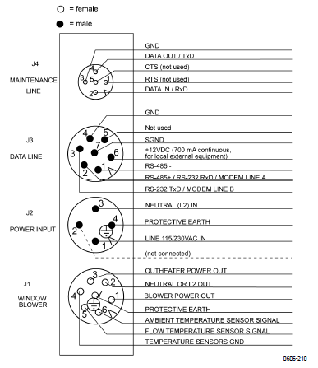
Figure 10. External CL51 connection ports (bottom view)

3.3 Initial Startup
Perform the following steps to prepare the CL51 for measurement operation (refer to Figure 4 and Figure 11):
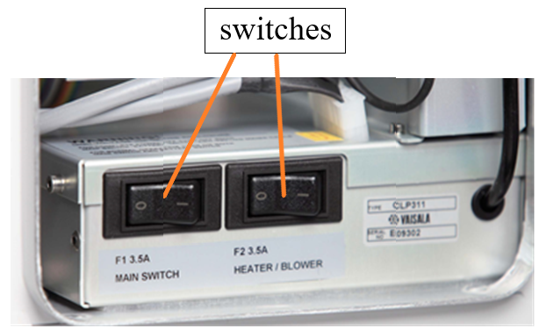
Figure 11. CL51 power switches (Main Switch F1 and Heater/Blower Switch F2) located at the bottom of the measurement unit

- Open the unit door and visually check the condition of the internal connectors.
- Turn ON Main Switch F1 and the Heater/Blower Switch F2 (refer to Figure 11).
- Turn the Battery Switch to the ON position. After the initialization routines, the “Laser On” LED on the ceilometer engine board will begin flashing at 6-second intervals. The six diagnostic LEDs on the ceilometer engine board will also light up.
- Ensure that no one is viewing the laser output (beam direction) with magnifying optics.
- The switch settings for normal operation are as follows:
- Main circuit breaker F1 ON
- Heater/Blower circuit breaker F2 ON
- Battery switch ON
- The configuration of the data message, interface, measuring interval, and transmission speed are set to standard factory settings which can be changed through commands entered in the terminal.
- Instrument optics are carefully adjusted at the factory and require no adjustment in the field.
- To switch the CL51 fully off, turn off the battery switch and the line power switch. The battery will become drained if the line power is switched off and the battery switch remains on.
3.4 Instrument Operation
There are two operation modes for the CL51, normal and standby. In the normal mode, continuous measurement and message transmission are active and occur according to defined parameters. In standby mode components of the instrument are powered off to limit operational wear during periods when active measurement is not needed. The ceilometer should be kept in normal mode during active measurement. The instrument is delivered with normal mode as the default upon powering up and data are transferred from the CL51 to the BL-View software on the controlling PC. Users can control the operation modes through the BL-View software interface as indicated in the user manuals. The associated controlling computer is delivered pre-configured with BL-View software installed.
3.5 Data Acquisition
The provided laptop computer provides both a means of accessing instrument controls and storing and processing the backscatter data available through BL-View.

3.6 Computer Hardware & Software
The CL51 includes the components listed in Section 3.1. The ceilometer and computer are connected through a local area network (LAN) consisting of an Ethernet switch for transfer of data from the CL51 to the computer (refer to Figure 12). An additional serial connection of the CL51 to the computer permit execution of operational commands (note that this communication pathway is not shown in Figure 12).
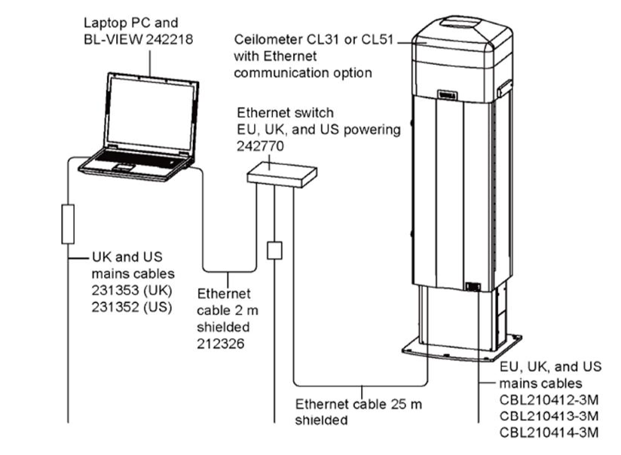
Figure 12. Data connections from the CL51 to the controlling computer
The CL51, computer, and BL-View software are delivered pre-configured and are “plug and play.” Contact Vaisala support if problems are encountered when connecting and powering on the instrument and computer. Do not change software settings or substitute physical components delivered with the instrument.

3.7 Data Management and Records Management
BL-View is a dual function software package that provides control of the CL51 and logs and analyzes data from the CL51. BL-View archives raw signal data files which can be accessed manually at a later date. BL-View creates three file types: image, netCDF, and ASCII text files.
Image files capture the raw laser pulse data as a height vs. time plot figure similar to that shown in Figure 3. Image files include timestamped received signal intensity information from each laser pulse and are archived for users to evaluate offline.
The BL/mixing height measurements produced by the BL-View software package from the image files are recorded simultaneously in both netCDF and text file formats. The structure of and information contained within the netCDF files are discussed in the Vaisala technical reference document entitled “netCDF example file”.
Vaisala has recommended PAMS monitoring agencies extract MLH data from the ASCII file format, which includes both the BL/mixing height and cloud height information (in meters) in a compact form (refer to Figure 13 below).

History file
CREATEDATE, UNIXTIME, CEILOMETER, PERIOD, SAMPLE_COUNT, BL_HEIGHT_1, BL_INDEX_1, BL_HEIGHT_2, BL_INDEX_2, BL_HEIGHT_3, BL_INDEX_3, CLOUD_STATUS, CLOUD_1, CLOUD_2, CLOUD_3, PARAMETERS
2010-06-01 00:00:00, 1275350400, DEVICE_1, 16, 187, 150, 3, -999, -999, -999,
-999, 0, -999, -999, -999, 1_360_0_3000_10_30_4000_3

Figure 13. Sample of the ASCII file format output by the BL-View program
Information and data contained within the ASCII files have been processed through an automated quality control (QC) process described in the BL-View user manual. The resulting data outputs include a factor to indicate the quality of the data as described in Section 4.2.3.
3.8 Maintenance Procedure
The CL51 comprises few moving parts and requires little routine maintenance. In general, the most important maintenance function is to ensure an unobstructed view and a clean window for the laser beam. The ceilometer performs best (strongest signal transmission and reception) with a clean window. Routine frequent maintenance includes checking for operational alarms and warnings, cleaning the window, and checking the door gasket. The backup battery should be checked annually, and the laser window contamination system should be recalibrated after five years of use. These procedures are described below.
3.8.1 Checking Alarms and Warnings
Users must check the instrument data messages routinely for alarms and warnings. Warning and alarm information is communicated as the second character in line two of the data message with the following three characters:
0 Self-check OK
W At least one warning active, no alarms
A At least one alarm active
When there is an active alarm or warning, more information is given at the end of the second line in the data message as a binary code indicating the cause. The status message provides detailed information about the failure.
Refer to Appendix B for details of warning and alarm messages.
Contact Vaisala product support (as listed in Section 2.1) for warnings or alarms that require repair or servicing of the CL51. Repair and service must be done according to the instructions in the CL51 Users Guide.
3.8.2 Cleaning the CL51 Window
The CL51 checks the window blower hourly and will notify the user of a contaminated window or operational error with an alarm in the data messages. The system will activate the window blow if contamination is detected, to remove light contaminants and dry water droplets. If the blower is unable to sufficiently remove contamination, the CL51 will issue a “Window Contaminated” warning to notify the operator that the window must be manually cleaned per the following steps:
1. Keep the enclosure door closed and gently flush the window with clean water to remove coarse grains. Do not use a pressure cleaner to clean the window.
2. Clean the window with a soft, lint-free cloth moistened with a mild detergent. Be careful not to scratch the window surface.
The window blower operation should be verified while cleaning the window. Unless already running, the blower should start when you block the laser beam (cover the laser window) with the cleaning cloth for approximately 15 seconds or more. The blower should stop after the window is cleaned unless there are low clouds, precipitation, or fog present. If the window blower does not activate or properly cease to run, the blower may be defective and require replacement. Contact Vaisala customer support (as listed in Section 2.1) for further troubleshooting on the window blower.
    - Checking the Door Gasket
The measurement unit door utilizes an electrically conductive gasket to suppress electromagnetic radiation. Routinely open the door to check that the gasket and the opposite contact surfaces are clean and in good condition (uniform and free of obvious damage or debris). If necessary, use a wet cloth to gently clean the gasket.
    - Checking the Backup Battery
Operators should visually inspect the battery condition annually. If any signs of battery aging such as a bulging battery case, white powder or residue near the battery vent, leaking electrolyte, or corroded terminals are observed, the battery must be replaced. The lead acid battery may show these signs of age in approximately 3 to 5 years and, if not replaced, could result in a rupture, loss of electrolyte, and damage to the ceilometer.
    - Window Contamination Measurement Calibration
After 5 years of operation, the CL51 may more frequently issue window contamination warnings as the result of window contamination measurement drift or wearing of the laser window, requiring replacement. Users should first recalibrate the window contamination measurement before replacing the window. Calibration is described in detail in the CL51 user manual.
After attempting a calibration, if the window contamination warnings continue to be issued, contact the Vaisala product support staff for further guidance on replacing the window.
  - Troubleshooting
The BL-View software interface has an icon adjacent to the ceilometer icon in the upper left side of the main screen that indicates the system status or operational alerts.
To view the active alerts, select the alerts menu option in the main window. The active alerts will be listed in a table along with their severity and the time at which the condition alert was detected. For each alert there is a corresponding identifier and a help option to assist the operator to address the alert. An example of the alert table is shown in the figure below.
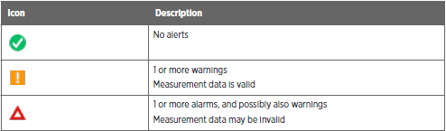
A complete discussion of each alert, their corresponding meanings and the recommendation to correct the alert is found in Chapter 11 of the BL-View user manual³. To summarize, these alerts are used to monitor the following system functions:
- BL-View software operational status
- Ceilometer hardware status
- Communications status with the Ceilometer
- System errors
In addition to the system warnings provided through the alert feature within the BL-View software, more detailed inspection of the system components is available outside the BL-View interface by using a terminal program such as TeraTerm⁵ coupled with a serial connection to the Ceilometer maintenance port (J4) at the bottom cable entrance to the ceilometer using a terminal connection to the ceilometer (see Figure 4 of this document). Since most modern computers do not have serial port connections, a USB to serial connection cable may be needed for this connection. Vaisala customer support should be contacted before attempting to use this feature. Please refer to the Vaisala BL-View manual when using this feature.
- Quality Assurance and Quality Control

4.1 Instrument or Method Calibration
No calibrations of the CL51 or algorithms for determining MLH are required by the user.

  - Quality Assurance
    - Performance Audit
Performance audits are conducted on the CL51 to verify the altitude/height/distance measurement reported by the ceilometer is accurate to within the specified tolerance of ±5 m or ±1%, whichever is greater. A performance audit involves measuring the distance to a hard target as described in Step 9 of Section 3.9. The hard target will be at a known standardized distance from the ceilometer measurement unit. The measurement is read from the instrument output through BL-View software and compared to the known standard distance. The frequency required for performance audits will be defined in the program QAPP.
Further work is required to develop auditing methods for MLH determination, such as comparison to another independent MLH measurement made with a radiosonde (refer to Section 5.2), radar wind profiler (RWP), or other suitable measurement method. Such developments will be included in future revisions of this SOP.
    - Systems Audit
A system audit comprises review of instrument siting, calibration, data handling, maintenance, and quality control checks to ensure they comply with the prescribed policies and procedures. Instrument siting assessments for the CL51 will ensure the ceilometer has an unobstructed view of the sky and is not installed in close proximity to powerful radar systems. The auditor will also review quality control checks and maintenance records to ensure that they are performed at the proper frequency, that quality checks meet acceptance criteria, and that problems or issues are remedied in a timely manner. Lastly, the auditor will review the collected data to ensure that collected data and any data transformations are accurate and result in proper reporting of data.
    - Data Quality and Data Validation
The BL/mixing height measurements and hourly average MLHs BL-View reports include associated data quality indexes to indicate the level of associated quality. These indexes range from 1 to 3, with “1” indicating poor quality, “2” indicating marginal quality, and “3” indicating good quality. Vaisala recommends that data with a quality index of 2 or 3 are considered valid, whereas data with a quality index of 1 should not be considered valid without further review. Users can view the backscatter profile graphically in BL-View and examine the suitability of the assigned hourly MLHs to verify whether data with poor quality are valid. Note that for hours where there is substantial precipitation and/or fog, there will not be a reportable MLH.
It is anticipated that hourly MLH data will be reported to EPA’s Air Quality System (AQS) database or other similar central database including the associated quality index. Subsequent use of the data can be determined based on the data quality. As of publication of this draft SOP, the convention for data validation and reporting hourly MLH data to AQS was still under development. EPA intends to communicate with monitoring agencies regarding future establishment of data verification, data validation, and data reporting routines, which may involve automated or semi-automated upload of backscatter data to a central database from which the hourly MLH data can be extracted and available for reporting to AQS or other database accessible to ozone prediction modelers.
  - Routine Checks
Users should perform periodic routine checks of the ceilometer for proper function as described in Section 3.8 and 3.9. Users should check for alarms and warnings routinely at a specified frequency (e.g., daily on active working days), which can be performed remotely for instruments connected to an accessible network. Users should inspect the window for cleanliness with each site visit, cleaning the window on an established frequency (e.g., weekly) and additionally as needed based on inspection or notification of alarm or warning.

5.0 Technical Materials and Additional Resources
5.1 Technical Materials
The following references expand on the information presented in this SOP. The intent of the SOP is to familiarize the user with the installation and commissioning of the CL51 and associated computer connections and controls. For advanced features, please refer to the following documents:
- Vaisala Ceilometer CL51 User’s Guide
- Boundary Layer View Software (BL-View) User Guide (v 2.1)
- NetCDF Example File, Technical reference
- Vaisala CL51 Quick Start Guide
The most recent versions of these documents are available from Vaisala by contacting their technical support division (800-408-9456 US customers). Additional information can be found on their website http://www.vaisala.com/.
5.2 Additional Resources
For those interested in comparisons between ceilometer derived BLs/MLHs with radiosonde measurements as well as a technical discussion of the measurement technique, please refer to the publication by Lotteraner (reference 6).
Users of this document should exercise caution when comparing MLH data generated with ceilometers (or other LIDAR instruments) and other methods, such as radiosondes. Measuring MLH with LIDAR instruments relies on fundamentally different physical phenomena than radiosonde measurements and that while the MLH measurements estimated by the two different conventions are expected to correlate well, the resulting MLH estimates may be quite different depending on the atmospheric and measurement conditions. Radiosondes measure thermal gradients by recording temperature as a function of altitude whereas LIDAR measures the amount of reflected light associated with specific altitudes and characterizes the BL based on the gradient of the backscatter intensity change. In addition to the differences in physical phenomena measured to derive the MLH, LIDAR instrument measurements are essentially instantaneous whereas radiosonde instruments are more temporally spaced due to the much slower physical transport of the instrument by balloon. LIDAR also permits continual measurements whereas radiosondes allow one discrete measurement per sounding, which require a discrete instrument launch for each sounding. Comparison of MLH measurements generated by the two different methods should take these fundamental differences in measurement methodology into account.
6.0 References
- Ceilometer CL51 Datasheet B210861EN. Vaisala 2018. Available at (accessed February 2020): https://www.vaisala.com/sites/default/files/documents/CL51-Datasheet-B210861EN.pdf
- Vaisala Ceilometer CL51 User’s Guide. M210801EN-A. Vaisala Oyi, 2010.
- Vaisala Boundary Layer View (BL-View) User Guide, N211185EN-B. Vaisala Oyi, 2017.
- Vaisala BL-View Datasheet B210919EN-C. Vaisala 2018. Available at (accessed February 2020): https://www.vaisala.com/sites/default/files/documents/BL-View-Datasheet-B210919EN.pdf
- TeraTerm terminal emulator interface program. Available at (accessed April 2020): https://tera-term.en.lo4d.com/windows
- Lotteraner, Christopher and Martin Piringer, Mixing Height Time Series from Operational Ceilometer Aerosol-Layer Heights, 2016, Boundary-Layer Meteorology, 161:265-287. Available at (accessed February 2020):
https://rd.springer.com/article/10.1007/s10546-016-0169-2
Appendix A. Vaisala CL51 Technical Datasheet
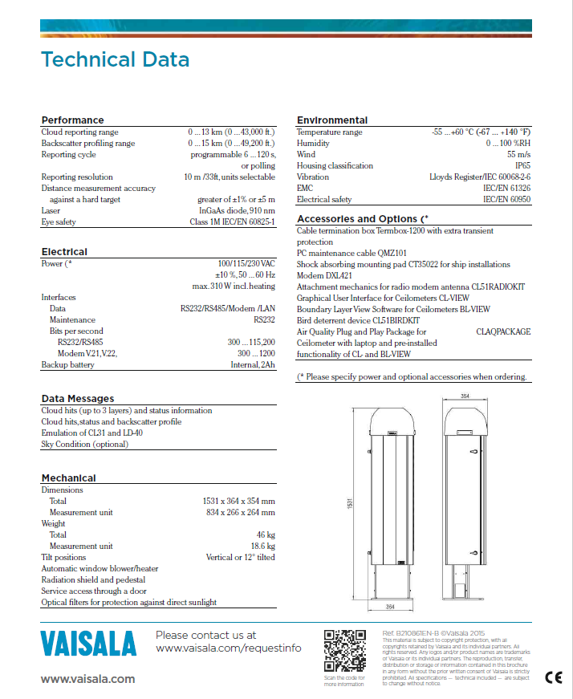
Appendix B. CL51 Warning and Alarm Messages

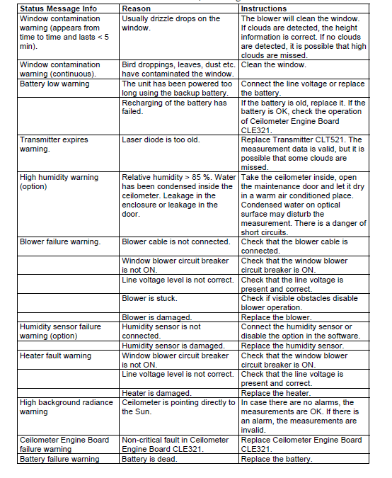
Appendix B. CL51 Warning and Alarm Messages
(continued)
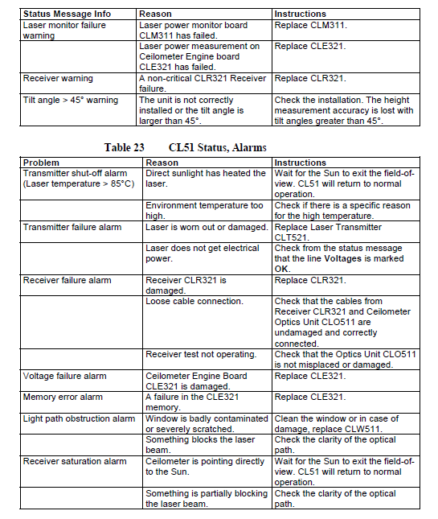

Appendix C. CL51 Component Diagram

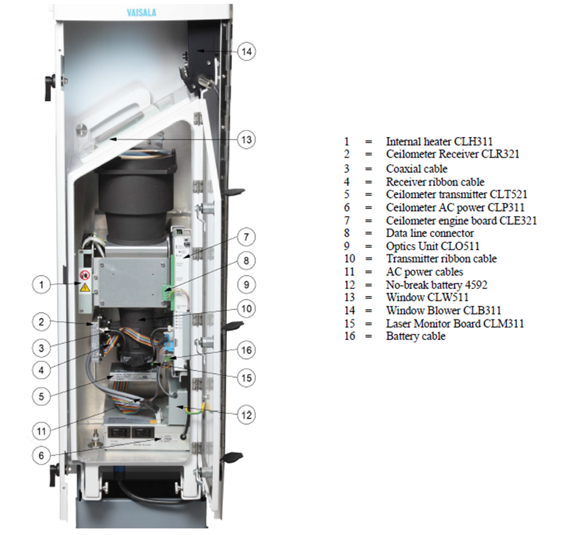

Appendix D. CL51 Spare Parts List

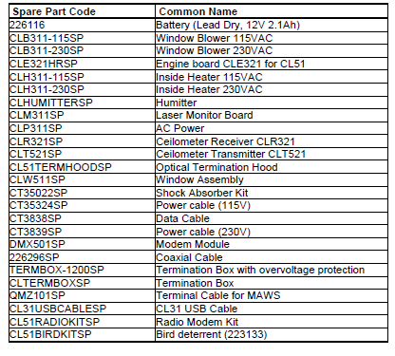

Appendix E. Troubleshooting through the Service Connection

To establish a service connection to the CL51 you need to have a maintenance terminal which can be a palmtop computer with an RS-232 Interface or a PC with serial interface, maintenance cable QMZ101, and any terminal program (such as TeraTerm). The CL-View software may also be used for this purpose.

If you perform the operation check indoors, you need to have an Optical Termination Hood (see accessory CL51TERMHOOD) which absorbs the laser light that would otherwise reflect from the ceiling and possibly saturate the receiver.

If the ceilometer is not operating, a maintenance connection may also be established through the data line. This will interrupt the data flow for as long as the command line is kept open.

Accessing Diagnostic Information
Basic troubleshooting instructions can be found in the troubleshooting section of the Vaisala CL51 user guide. In the event that the recommended actions do not resolve the reported issues, it is important to contact the Vaisala product support staff to discuss this warning and receive guidance on how to proceed.

Equipment for Troubleshooting
Contact the Vaisala product support staff prior to proceeding with any troubleshooting effort.
Troubleshooting Instructions
Refer to the CL51 user guide for trouble shooting instructions. To check the normal operation of the CL51, proceed as follows:

- Clean the window carefully with a soft, lint-free cloth moistened with a mild detergent. Be careful not to scratch the window surface.

- If you are indoors, put the optical termination hood (CL51TERMHOOD) on the ceilometer window. To the ceilometer, this represents a clear, nighttime sky.

- Connect the maintenance terminal to the maintenance port at the bottom of the CL51 (see Figure 4, page 10 of this document). Turn on both the CL51 and the maintenance terminal. If you are using the palmtop or the CL-VIEW program for the first time, make the necessary installations according to the manuals of these products.

- Verify that the ceilometer starts operating properly. A quick status check can be made by looking at the LEDs on the CLE321 board (see Figure 26 on page 99 of the hardware manual). After the initialization routines, the LASER ON LED should start blinking at 6-second intervals. If all the key modules are ok, all six diagnostic LEDs should light up.

- A blower check is done during the first 5 minutes, during which the blower is running. The automatic check also verifies the functioning of the blower heater. The result of this check is available 5 minutes after starting the unit and it is indicated by the CLB OK LED. It also is displayed in the status message.

- To get the failure status message, type the OPEN command and press ENTER on the maintenance terminal (PC) keyboard.

The CEILO > prompt should appear. Enter the command GET FAILURE STATUS and press ENTER.

An example of the response is as follows:

Alarms
Tmit Shutoff OK Transmitter ALRM
Receiver OK Voltages OK
Ext Memory OK Light Pth Obs OK
Rec Saturat OK Coaxial Cable OK
Engine OK

Warnings
Window Contam OK Battery Low OK
Transm Expire OK Humid High OK
Blower OK Humid Sensor OK
Int Heater OK High Rad OK
Engine OK Battery OK
Laser Monitor OK Receiver OK
Tilt Angle OK

System Status: FAIL
Suspect Module: CLT

The two last lines in the status message will indicate if there are warnings or alarms present. The SUSPECT MODULE line indicates the sub unit that is suspected to be faulty. In this example, it is the ceilometer transmitter CLT521. Notice the ALRM status for the transmitter and the corresponding SYSTEM STATUS message.

- Wait until the 5-minute blower check is over and check the result from the status message. After this, place a piece of white paper on the ceilometer window. The blower should start within 1 minute. Remove the paper. The blower should stop within 8 minutes. 8. If there are clouds present, compare the ceilometer measurement with a qualified weather observer's height approximation.

- In case there are no clouds present and if the site is suitable, do a hard target test. Turn the measurement unit 90 degrees and aim it on a fixed target (such as a wall or a forest front).

This completes the troubleshooting sequence through the maintenance terminal interface. Contact Vaisala Service Department to discuss any unresolved conditions.

