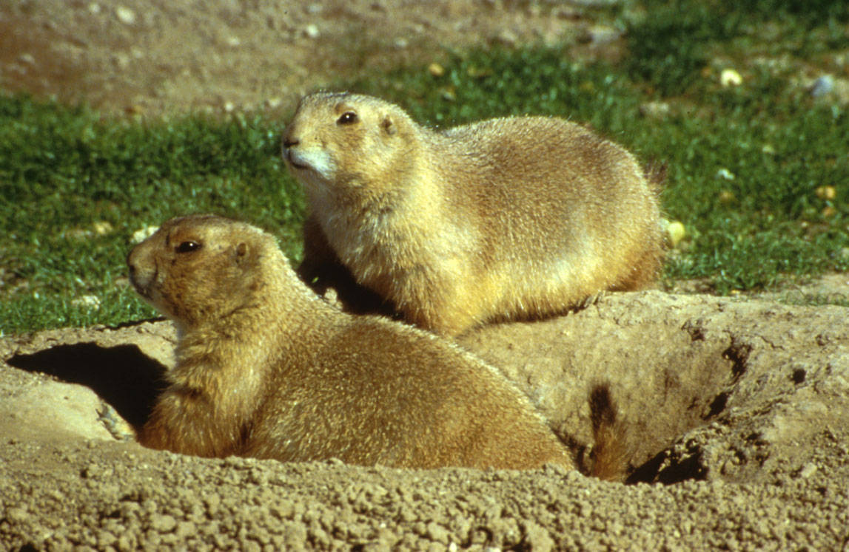
<Data layer name, capitalize; 24 pt or smaller if long>

Overview (< 60 words), no heading Begin this section with “This EnviroAtlas national map” or “This EnviroAtlas community map” and follow with a description of the individual map layer. You can use verbs such as displays, portrays, estimates, etc. Include proper units, extent, and any definitions created for the metric. <photo should relate to layer directly>
EXAMPLE: This EnviroAtlas national map displays the mean number of mammal species with potential habitat within each 12-digit HUC in the southwestern United States (Arizona, Colorado, Nevada, New Mexico, and Utah). These data are based on habitat models rather than wildlife counts. The potential habitat may be specific to wintering, breeding, or year-round activities depending on the species.
Photo: Short description, Person, Agency OR Agency, Location

Why is <this layer> important?
(300 – 500 words) This section should explain to a non-technical user the importance of including this metric in EnviroAtlas.
- Please begin this section with a brief summary paragraph of what you will be talking about in this section, so that users will still get important information even if they only read the first paragraph.
- Main paragraphs/points in this section should directly address the layer’s relationship to its specified associated benefit categories. Use the EnviroAtlas data matrix as your guide for this. For example, Percent rare ecosystem is linked to Recreation, Culture, and Aesthetics and Biodiversity Conservation. It is okay to mention other linkages based on your existing knowledge, but this should not be the focus of information you provide. If you feel strongly that a layer should be linked to additional benefit categories, discuss with the EnviroAtlas Development Team.
- Please cite information where appropriate. This is especially important if you provide specific numbers, details, or information. Use your discretion in this. When directly citing, please use an endnote citation style (i.e., a superscript number goes at the end of the sentence after the period), but please do not use the endnote function in word. If you do not think you need to directly cite a source but use a resource in your fact sheet, please include it in the Selected Publications section (more info about this below).

- If you use words that need to be included in the glossary, please also provide the definition of that word and the source in a comment. You are welcome to provide the definition in text if you are not pressed for space. Refer to the glossary for help on what types of words we have included thus far.

How can I use this information?
(~150 words) Begin this section with “The map, <layer title>” followed by a one line description of the map. EXAMPLE: The map, Mean Mammal Species, is one of three EnviroAtlas maps that illustrate indicators of mammal species richness.
This section should include potential uses for the data. What does this map help the EnviroAtlas user (e.g., interested layperson, student, scientist, public health practitioner, city planner) to do? Is this map layer grouped with any other metrics that should be mentioned here? (Ex: mean, max, NIB species richness sheets a related group). Are there other metrics or groups of metrics in EnviroAtlas that will add to the information gained from this one (e.g., at-risk species)? Or, if metrics are summarized by HUC, one might suggest using an aerial imagery basemap to see underlying topography, drainage, or landscape stressors.
<<Put a column/page break here. Use this overall format for the two pages: Put the first three sections on the first page and the remaining six sections on the second page. We will make every effort to make all relevant information fit, but we want to keep consistency across fact sheets. >>
How were the data for this map created?
(100 - 200 words) This section should include links to source data and tools when possible. Content should be basic and focused on helping a user unable to read an xml file understand the map data and what toolboxes, programs, or resources were used to generate the metric. Feel free to borrow relevant text from current fact sheets.
EXAMPLE: This data layer is based on data generated by the U.S. Geological Survey (USGS) National Gap Analysis Program (GAP). The USGS GAP project maps the distribution of natural vegetation communities and potential habitat for individual terrestrial vertebrate species. These models utilize predictive environmental variables (e.g., GAP land cover, elevation, distance to water) to predict habitat for each species. GAP modeled habitat for 365 terrestrial mammal species that reside, breed, or use the habitat within the U.S. for a significant portion of their life history. The mean and maximum numbers of mammal species in each 30-meter pixel were calculated for each 12-digit HUC. The mean species richness value by HUC was divided by the maximum mean value within all HUCs to calculate the NIB.

What are the limitations of these data?
(100 - 200 words) This section should include specific limitations that users should keep in mind when using the data. Again, think of a user who won’t read xml and isn’t going to repeat the process. Feel free to borrow relevant text from current fact sheets.
EXAMPLE: EnviroAtlas uses the best data available, but there are still limitations associated with these data. The data, based on models and large national geospatial databases of predicted habitat, are estimations of reality that may overestimate actual mammal species presence. Modeled data are intended to complement rather than replace monitoring data. Habitat models do not predict the actual occurrence of species, but rather their potential occurrence based on their known associations with certain habitat types. Habitat is only one factor that determines the actual presence of a species. Other factors include habitat quality, predators, prey, competing species, and fine scale habitat features such as woody debris. Other essential species information in addition to species richness includes the types of species and their functional groups, whether they are rare or common, native or non-native, tolerant or intolerant of disturbance.

How can I access these data?
You can use this text for this section. Please replace the second sentence with any links to download any relevant foundational data sets such as NLCD, GAP, NHD, etc.
EnviroAtlas data can be viewed in the interactive map, accessed through web services, or downloaded. Metric values for individual pixels may be obtained from the New Mexico State University Center for Applied Spatial Ecology. GAP data can be accessed through their respective websites.

Where can I get more information?
If you know of any key websites or tools for more information on the topic of the metric, list them here.
A selection of resources related to mammals and biodiversity is listed below. Information on the models and data used in the GAP project is available on their website. For additional information on how the data were created, access the metadata for the data layer from the layer list drop down menu. To ask specific questions about this data layer, please contact the EnviroAtlas Team.

Acknowledgments
This section should include acknowledgment information along with credits for contributors for “Data Generation” and “Fact Sheet” if applicable. EXAMPLE: EnviroAtlas is a collaborative effort led by EPA. The data for Mammal Species Richness were created through a collaborative effort between the EPA and USGS GAP. The data were generated by Kenneth Boykin and graduate students from New Mexico State University. The fact sheet was written by Kenneth Boykin, New Mexico State University, and Anne Neale and William Kepner, EPA.
Overall, try to fill the space so that two pages are filled as closely as possible, that is, try to avoid leaving a large open space at the bottom of this page.

Selected Publications
1. Kremen, C. 2005. Managing ecosystem services: What do we need to know about their ecology? Ecology Letters 8:468–479.
2. Miller, B., R. Reading, J. Hoogland, T. Clark, G. Ceballos, R. List, S. Forrest, L. Hanebury, P. Manzano, J. Pacheco, and D. Uresk. 2000. The role of prairie dogs as a keystone species: Response to Stapp. Conservation Biology 14:318–21.
Boykin, K.G., W.G. Kepner, D.F. Bradford, R.K. Guy, D.A. Kopp, A. Leimer, E. Samson, F. East, A. Neale, and K. Gergely. 2013. A national approach for mapping and quantifying habitat-based biodiversity metrics across multiple spatial scales. Ecological Indicators 33:139–147.
Kepner, W.G., K.G. Boykin, D.F. Bradford, A.C. Neale, A.K. Leimer, and K.J. Gergely. 2011. Biodiversity Metrics Fact Sheet. U.S. Environmental Protection Agency, Washington, DC, EPA/600/F-11/006. Accessed March 2016.

