DRAFT

Standard Operating Procedure for the Analysis of Photochemical Assessment Monitoring Station (PAMS) Volatile Organic Compounds (VOCs) in Ambient Air via the Markes UNITY-xr Thermal Desorber with Agilent 7890B Auto-Gas Chromatograph with Flame Ionization Detection (Auto-GC-FID)

EPA Document Number [TBD]

Effective Date: [DRAFT]

**TABLE OF CONTENTS**

I. SCOPE AND APPLICABILITY 4

II. SUMMARY OF METHOD 4

III. ABBREVIATIONS AND DEFINITIONS 6

IV. INTERFERENCES AND CAUTIONS 11

V. SAFETY 13

VI. APPARATUS AND MATERIALS 13

VII. REAGENTS AND CHEMICALS 15

VIII. SAMPLE COLLECTION AND HANDLING 16

IX. QUALITY CONTROL 17

X. PROCEDURE 19

XI. CALCULATIONS 29

XII. DATA VERIFICATION 31

XIII. DATA VALIDATION 42

XIV. DATA REPORTING 45

XV. RESOURCES 48

XVI. REFERENCES 48

**TABLES**

Table 1. Priority and Optional VOCs for the PAMS Program 5

Table 2. Thermal Desorber Trap Conditioning Method 20

Table 3. Elution Order of Target Analytes in the 59-Component RTS 21

Table 4. Commonly Misidentified Target Compounds 35

Table 5. Common Rationales for Manual Peak Integration 37

Table 6. Description and Assignment of Data Qualifiers 38

Table 7. Quality Control Parameters and Acceptance Criteria 45

**FIGURES**

Figure 1. Screen Capture of MIC “Trap Heat” Method Settings 21

Figure 2. Example Sampling Schedule for a 7-day Period Including Approximately Daily and Weekly QC Samples 26

Figure 3. Example Overlay of Chromatograms for Ambient Air (Green), Retention Time Standard (Red), and a System Blank (Blue) 28

Figure 4. Example Retention Time (RT) Window for Cyclopentane 29

Figure 5. Flowchart of Site Operator Data Verification Checks 32

Figure 6. Example Plot of Compound Retention Times 35

Figure 7. Flowchart of Peer Review Verification Steps 40

Figure 8. Diurnal Profile Illustrating Daytime Increase of Isoprene 45

Appendix A – Agilent GC Method Parameters 51

Appendix B – Basics of Chromatography 54

1. SCOPE AND APPLICABILITY

This standard operating procedure (SOP) describes the operation of the Markes UNITY-xr thermal desorber (TD) equipped with the Kori-xr and CIA Advantage-xr sampling inlet systems with Agilent 7890B gas chromatograph (GC) system for the analysis of volatile organic compounds (VOCs) identified under the Environmental Protection Agency’s (EPA’s) Photochemical Assessment Monitoring Stations (PAMS) Program to be ozone precursors or relevant to atmospheric ozone formation. This complement of instrument components is configured to operate continually as an automated gas chromatograph, or auto-GC. Procedures for the setup, calibration, operation, and data handling are described herein. This SOP is intended to provide instruction for properly trained instrument operators and is not intended as a comprehensive manual to address all operational aspects.

Monitoring requirements, training requirements, and data reporting to EPA’s Air Quality System (AQS) database are outside the scope of this SOP. Users of this SOP are encouraged to seek additional supplemental training on the chromatography data system (CDS) software package employed to control the GC and process the collected data. Basic functions of the CDS are addressed; however, users will need to consult the CDS user manual to optimize the software functions. An illustrated guide to GC chromatographic peak integration is included in Appendix B.

This SOP is intended to be a comprehensive starting point for monitoring agencies to modify for their specific application. Due to the complexity of the instrument components and the variety of equipment, equipment configurations, and software options available, monitoring agencies should edit this document to describe and prescribe their specific equipment and associated procedures. Monitoring agencies may make revisions to this SOP provided the acceptance criteria and measurement aspects comply with those specified in the governing PAMS Quality Assurance Program Plan (QAPP). Users of the SOP are prompted to modify this document in green-highlighted text.

1. SUMMARY OF METHOD

On an hourly cycle, the Markes UNITY-xr TD-Agilent 7890B GC system draws in ambient air from the inlet probe to collect and preconcentrate VOCs from the sampled atmosphere and subsequently separate the VOCs for detection via a flame ionization detector (FID). Collection of a new sample commences at the top of each hour. Ambient air is drawn into the sampling inlet by the vacuum supplied by the system’s sampling pump into the CIA Advantage-xr sample selection device, routed through the Kori-xr for dehydration, and routed to the UNITY-xr containing a two-phase sorbent trap maintained at -30ºC by Peltier cooling. Sample collection occurs for 40 minutes and flow is controlled at 20 milliliters (mL) per minute by a mass flow controller (MFC) to acquire 800 mL of air. Sampled atmosphere is routed through the Kori-xr to remove moisture by water abstraction at approximately -30ºC prior to passing the sampled atmosphere to the preconcentration trap. Bulk atmospheric gases (oxygen, nitrogen, carbon dioxide, and argon) are unretained and VOCs of interest are captured within the sorbent trap. At the end of the collection period, the trap is flushed (dry purge) for a minimum of 1 minute with dry carrier gas to remove any remaining bulk gases and/or residual moisture prior to being desorbed by quickly heating (up to 100ºC/second) to 325ºC.

During desorption, the trap is backflushed with dry carrier gas to sweep the desorbed VOCs from the trap to the analytical column for separation. The target analyte compounds elute from the   
DB-1 separation column and are routed through a Deans switch, which directs the lighter hydrocarbons (C2-C6) through a subsequent alumina porous layer open tubular (PLOT) analytical separation column and the heavier compounds (C6-C12) directly to an FID. Because the lighter hydrocarbons (C2-C6) are not appropriately separated by the DB-1 column, they must be subsequently routed through the PLOT column for separation. These lower molecular weight volatile species are detected by a separate FID as they elute from the PLOT column. The GC CDS contains the instructions for the timing of the Deans switch. The Deans switch is used to direct the eluent of the DB-1 column away from the PLOT column to the second FID following the elution of 1-hexene. Thus, all of the light VOC target compounds will continue to separate on the PLOT column connected to one FID while the remainder of VOC targets from hexane through undecane will separate on the DB-1 column for simultaneous detection on the second FID. Compounds are identified by their retention time (RT) as they exit the appropriate separation column and are detected by the FID. The resulting FID picoampere responses are plotted against the observed chromatographic RT and the resulting peak areas are integrated and converted to a concentration in parts per billion carbon (ppbC) based on the response factor (RF) according to the calibration. The RFs are based on the FID integrated area response of propane (C2-C6) or benzene (C6-C12), respectively. System functions are controlled by a connected personal computer (PC) running the Agilent OpenLab CDS EZChrom software or OpenLab CDS ChemStation software. The Markes UNITY-xr with Agilent 7890B auto-GC requires additional supplies and support equipment including a zero air generator (ZAG) with support compressor, source of helium carrier gas, source of hydrogen (hydrogen generator or cylinder gas) for FID fuel, and a method of providing the system with diluted stock standard gases for calibration and ongoing quality control (QC) checks.

PAMS target VOCs are listed below in Table 1. Priority compounds are those VOCs for which all PAMS sites must report concentrations to AQS. Optional compounds are those VOCs that are of interest to the PAMS program but are not required to be reported. Note there are two compounds (1-hexene and n-dodecane) in Table 1 that are not assigned by the PAMS program either as priority or optional compounds, but are nonetheless included in the 59-component retention time standard (RTS) VOC mix typically analyzed for the PAMS program. These additional compounds are incorporated into the PAMS standard for reference purposes for determination of Deans switch cut times and definition of unknown VOC totals.

Table 1. Priority and Optional VOCs for the PAMS Program

| **Priority or Optional \*** | **Compound Name** | **Number of Carbons** |  | **Priority or Optional \*** | **Compound Name** | **Number of Carbons** |
| --- | --- | --- | --- | --- | --- | --- |
| o | carbon tetrachloride | 1 |  | o | 2,3-dimethylpentane | 7 |
| p | ethane | 2 |  | o | 2,4-dimethylpentane | 7 |
| p | ethylene | 2 |  | o | n-heptane | 7 |
| o | tetrachloroethylene | 2 |  | o | methylcyclohexane | 7 |
| o | acetylene | 2 |  | o | 2-methylhexane | 7 |
| o | ethanol | 2 |  | o | 3-methylhexane | 7 |
| p | propane | 3 |  | p | 2,2,4-trimethylpentane | 8 |
| p | propylene | 3 |  | p | ethylbenzene | 8 |
| o | 1,3-butadiene | 4 |  | p | m-/p-xylene | 8 |
| p | 1-butene | 4 |  | p | o-xylene | 8 |
| p | cis-2-Butene | 4 |  | p | styrene | 8 |
| p | isobutane | 4 |  | o | 2-methylheptane | 8 |
| p | n-butane | 4 |  | o | 3-methylheptane | 8 |
| p | trans-2-butene | 4 |  | o | n-octane | 8 |
| p | isopentane | 5 |  | o | 2,3,4-trimethylpentane | 8 |
| p | isoprene | 5 |  | p | 1,2,3-trimethylbenzene | 9 |
| o | cyclopentane | 5 |  | p | 1,2,4-trimethylbenzene | 9 |
| p | n-pentane | 5 |  | p | m-ethyltoluene | 9 |
| o | 1-pentene | 5 |  | p | o-ethyltoluene | 9 |
| o | cis-2-pentene | 5 |  | p | p-ethyltoluene | 9 |
| o | trans-2-pentene | 5 |  | o | isopropylbenzene | 9 |
| p | benzene | 6 |  | o | n-nonane | 9 |
| p | n-hexane | 6 |  | o | n-propylbenzene | 9 |
| o | cyclohexane | 6 |  | o | 1,3,5-trimethylbenzene | 9 |
| o | 2,2-dimethylbutane | 6 |  | o | n-decane | 10 |
| o | 2,3-dimethylbutane | 6 |  | o | m-diethylbenzene | 10 |
| x | 1-hexene | 6 |  | o | p-diethylbenzene | 10 |
| o | 2-methylpentane | 6 |  | o | a-pinene | 10 |
| o | 3-methylpentane | 6 |  | o | b-pinene | 10 |
| o | methylcyclopentane | 6 |  | o | n-undecane | 11 |
| p | toluene | 7 |  | x | n-dodecane | 12 |

* o = optional; p = priority; x = VOC contained in RTS but neither priority nor optional compounds (concentrations not reported to AQS)

1. ABBREVIATIONS AND DEFINITIONS

AC alternating current

ADQ audit of data quality

AGL above ground level

APD absolute percent difference

AQS Air Quality System

atm atmosphere

BOA back of analyzer

CCV continuing calibration verification

CDS chromatography data system

cps counts per second

CPU central processing unit

DF dilution factor

DI deionized

DQO data quality objective

DTS date-time stamp

EPA Environmental Protection Agency

FEP fluorinated ethylene propylene

FID flame ionization detector

GC gas chromatograph

HCF hydrocarbon free

HVAC heating ventilation and air conditioning

ICAL initial calibration

ID inner diameter

inHg inch(es) of mercury

kPa kilopascal(s)

MDL method detection limit

MFC mass flow controller

MIC Markes Instrument Control (software)

mL milliliter(s)

mmHg millimeter(s) of mercury

MQO measurement quality objective

MUR method update rule

mV millivolt

NIST National Institute of Standards and Technology

OD outer diameter

pA picoampere

PAMS Photochemical Assessment Monitoring Stations

PC personal computer

PDMS polydimethylsiloxane

PEEK polyetheretherketone

PFA perfluoroalkoxy

PLOT porous layer open tubular

ppb part per billion

ppbC part per billion carbon

ppbV part per billion volume

PPE personal protective equipment

ppmC part per million carbon

psia pound(s) per square inch absolute

PT proficiency test

PTFE polytetrafluoroethylene

QAPP quality assurance project plan

QC quality control

r2 correlation coefficient

RF response factor

RPD relative percent difference

RSD relative standard deviation

RT retention time

RTS retention time standard

SB system blank

S:N signal-to-noise ratio

SOP standard operating procedure

SSCV second source calibration verification

STP standard temperature and pressure

TAD technical assistance document

TD thermal desorber

THC total hydrocarbons

TNMOC total non-methane organic carbon

TNMTC total non-methane target compounds

TSA technical systems audit

UHP ultra-high purity

UPS uninterrupted power supply

VOC volatile organic compound

ZAG zero air generator

**Absolute pressure**: Pressure relative to absolute vacuum, typically expressed in units of: psia, atm, mm Hg, kPa, or in Hg.

**Acquisition time**: Portion of the GC program during which the CDS records detector responses. To reduce data file size, the first few minutes of a chromatogram when no target analytes are eluting from the column(s) are not recorded.

**Analytical sequence**: List of sample analyses programmed into a sequence table within the CDS.

**Auto-GC**: Automatic gas chromatograph. GC capable of autonomous operation to collect an ambient air sample and to trap, separate chromatographically, identify, and quantitate the VOCs of interest.

**Baseline**: The instrument’s detector background signal in the absence of a substance.

**Carrier gas**: The mobile phase in gas chromatography; the carrier gas is non-reactive to the target analytes. Carrier gas flows at a constant rate through the GC column to carry analytes to the detector. For the Markes UNITY-xr TD and Agilent 7890B GC, the carrier gas is helium. [*note: Hydrogen may be employed as a carrier gas in lieu of helium; however, such is outside the scope of this SOP.*]

**Chromatogram:** A graphical record of a chromatographic separation plotting detector response (generally represented in mV or pA) on the y-axis as substances elute from the separation column against elapsed time from GC injection on the x-axis.

**Chromatographic peak**: The portion of a chromatogram representing the increase and subsequent decrease in detector response during which a compound elutes from the separation column. To be considered a true peak for identification purposes, the signal-to-noise ratio (S:N) must be ≥ 3:1. A completely resolved peak will start and end at the baseline.

**Chromatography data system (CDS)**: The software program that controls the operation of the GC, acquires raw instrument data, and permits processing of collected data. The CDS allows programming of analytical sampling sequences, generation of instrument calibration curves for target analytes, calculation of target analyte concentrations, and post-collection processing of raw instrument data. The CDS for the Agilent 7890B system is Agilent OpenLab EZChrom or OpenLab ChemStation. The Markes UNITY-xr TD is operated through the Markes Instrument Control (MIC) software.

**Coelution:** Simultaneous elution of two or more substances from the separation column whereby their chromatographic peaks overlap and the chromatogram does not return to baseline between the substances. Coelutions can be partial or complete and can interfere with the ability of the CDS and/or analyst to properly identify and/or integrate the peak(s).

**Continuing calibration verification (CCV)**: QC sample consisting of a known concentration of target analytes analyzed to assess the ongoing suitability of the instrument calibration. CCVs are prepared by diluting a stock standard gas to a concentration within the calibration curve range (preferably within the lower one-third of the calibration curve range) and analyzed approximately every 24 hours of analysis. The CCV must demonstrate the measured concentrations for propane and benzene, each of which is separately detected on the two different FID channels, are within ±30% of their theoretical concentrations. The CCV is to be sourced from a certified standard.

**Date-time-stamp (DTS):** The date-time stamp is appended to a digital file as a result of saving the contents of the file. The DTS will change each time the file is changed or accessed.

**Data quality objective (DQO)**: Metric defined for a project or program that describes or quantifies the desired acceptance criteria for collected data.

**Deans switch**: Gas routing device that operates by controlling the flows of subject gas (e.g., column effluent) by adjusting flows of said gas through increasing or decreasing the flow rate of an auxiliary gas.

**Dilution factor (DF)**: The ratio of a standard gas to the corresponding diluent. Such is needed to calculate the concentration of diluted standard gases.

**Dynamic dilution**: Dilution of a standard gas or gases with a diluent gas by mixing gases together at known flow rates in an inert plenum.

**Flame ionization detector (FID)**: Detection device that responds to ions formed during combustion of organic compounds in a hydrogen flame. The production of ions and associated response within the FID is proportional to the concentration of carbon atoms in the sample gas stream introduced to the detector. FIDs require a source of both hydrogen (fuel) and oxygen to produce the hydrogen flame.

**Gas chromatograph (GC)**: Analytical instrument utilized to separate vaporized compounds according to physical or chemical properties by passing the sample through a separation column, which serves as the stationary phase, with a carrier gas acting as the mobile phase.

**Gauge pressure**: Pressure relative to ambient atmospheric pressure. Typically expressed in pounds per square inch gauge (psig). A measurement of 0 psig indicates ambient atmospheric pressure.

**Initial calibration (ICAL)**: Standardization of the instrument response to known concentrations of a target analyte. Generation of an ICAL typically involves fitting response factors of analyses of several concentration levels via linear regression. The concentration of the target analyte can then be determined by translating its measured chromatographic peak area response into a concentration via inversion of the linear regression equation determined from the ICAL.

**Inlet probe**: The opening of the analytical system inlet to the ambient atmosphere. The materials comprising, siting, and configuration of the inlet probe must comply with 40 CFR Part 58 Appendix E.

**Make-up gas**: Inert gas (such as nitrogen or helium) added to the FID to maintain the linear velocity of column eluent and maintain appropriate chromatographic response.

**Mass flow controller (MFC)**: Device that controls the flow of a specific gas by adjusting a flow control valve based on thermal differences within a capillary tube between temperature sensors upstream and downstream from a heater. The difference in temperature between the sensors is translated to set the gas flow to a calibrated known flow rate via the flow control valve.

**Measurement quality objective (MQO)**: Acceptance criteria prescribed for a given data quality indicator such as bias, precision, completeness, frequency, and sensitivity.

**NCore:** EPA’s National Core ambient air monitoring network.

**PAMS hydrocarbons (PAMSHC)**: Those priority and optional compounds listed in the PAMS target list.

**Part per billion carbon (ppbC)**: Concentration unit of measurement equivalent to a ppbv (defined below) multiplied by the number of carbon atoms in the molecule.

**Part per billion volume (ppbv)**: Concentration unit of measurement equivalent to a mixing ratio of 10-9 L (or moles) of a trace gas in 1 L (or mole) of diluent. One ppbv is equivalent to 2.46·1010 molecules cm-3 at 760 mm Hg pressure and 25°C.

**Precision**: The reproducibility of a measurement. Auto-GC precision is determined by evaluating the similarity of the measured concentrations of successive analyses of a CCV on a weekly basis. The relative percent difference of the measurement pair is calculated by taking the absolute difference of the two measurements and dividing by the measurement pair average, expressed as a percentage.

**Raw instrument data**: Time-based signals generated and recorded by the instrument in the process of making measurements. Such data may include instrument detector responses, time stamps, flow rates, and other associated recorded instrument events such as valve switching, temperature changes, etc.

**Recovery**: The measured concentration of a target analyte divided by its theoretical nominal concentration, expressed as a percentage.

**Relative standard deviation (RSD)**: The standard deviation of a given number of measurements divided by the mean of the measurements, expressed as a percentage.

**Response factor (RF)**: The ratio of the instrument response in area units to a known concentration of a target analyte. The concentration of a given unknown target analyte can be calculated by multiplying or dividing (as appropriate) the measured area response by the RF determined in the initial calibration.

**Retention time (RT)**: Duration of time it takes for a given target analyte to reach the detector following initiation of the desorption of the VOCs on the sorbent trap onto the GC column. RTs are assigned as the apex of the chromatographic peak.

**Retention time window**: Assigned time range during which a given target analyte is expected to elute from the separation column and reach the detector. Compound identification is determined by whether it elutes within a specified RT window, which is set by analysis of a known standard of the target analyte.

**Retention time standard (RTS)**: A 56- to 59-component VOC mixture containing target analytes. This standard is analyzed to establish and confirm the RT of target analytes.

**Sample**: Aliquot of atmosphere introduced to the inlet of the GC system that is trapped for subsequent separation by the GC. The volume of sample is determined by multiplying the sampling flow rate by the duration of sample collection.

**Second source calibration verification (SSCV) standard**: A standard gas purchased from a supplier different than the primary standard from which the ICAL is prepared (a different lot from the same supplier as the primary standard is acceptable if the standard is unavailable from a different supplier). The SSCV standard gas is diluted to within the calibration curve and analyzed immediately following the establishment of the ICAL. The SSCV independently verifies the quality of the calibration curve(s).

**Signal-to-noise**: The ratio of the peak height or integrated area of the detector responses to a known substance to that of the detector response in the absence of the substance.

**Standard temperature and pressure (STP)**: 25ºC and 760 mm Hg absolute pressure.

**Static dilution**: Preparation of a standard gas dilution by addition of a standard gas or gases and diluent gas to an evacuated vessel. The absolute pressure of the vessel is measured before and after the addition of each gas and the dilution factor calculated by dividing the final vessel pressure by the partial pressure of each standard gas.

**System blank (SB)**: Analysis of a humidified zero air blank provided to the instrument through the instrument sampling inlet to ensure the instrument is sufficiently free of contamination.

**Theoretical nominal concentration**: The concentration of a target analyte sourced from a certified concentration standard gas after adjustment for dilution, as applicable.

**Thermal desorption (TD)**: The freeing of molecules from a sorbent by heating the sorbent to a temperature sufficient to release the molecules of interest from the sorbent.

**Total non-methane organic carbon (TNMOC):** Sum of carbon species responses on both FIDs eluting between ethane and dodecane.

**Total non-methane target compounds (TNMTC)**: Total of the speciated, identified, and quantitated compounds in the FID analyses.

**Ultra-high purity (UHP):** Gas purity ≥ 99.999%.

**Volatile organic compound (VOC)**: Carbon-containing compounds with vapor pressure greater than 10-1 Torr at 25ºC and 1 atmosphere pressure.

**Wetted surfaces**: Interior surfaces of the sampling flow path that contact the sample gas.

**Zero air**: Atmospheric air or synthetic mixture of minimally nitrogen and oxygen from which hydrocarbons have been removed to achieve a total hydrocarbon content of nominally ≤ 0.01 ppmC.

**Zero air generator (ZAG):** Device employed to scrub ambient air of hydrocarbons, water, and other gases that may interfere with the analysis of hydrocarbon VOCs. ZAG units typically employ sorbent materials, desiccants, and thermal and/or catalytic oxidation to produce air meeting the cleanliness acceptance criterion for zero air.

1. INTERFERENCES AND CAUTIONS

**Planning:** The auto-GC instrument system is complex and incorporates numerous components that can fail and halt continuous operation. Extended instrument downtime may occur if failures impact multiple components or major components that require a technician visit to repair. Instrument operators are encouraged to have a ready supply of common spare parts (typically recommended by the manufacturer and may include preconcentrator traps, Kori-xr traps, silica-lined stainless steel tubing, FID components, etc.) in the event of instrument failure. Routine maintenance on the instrument system and support equipment should be performed well in advance, recommended to minimally be eight (8) weeks, of the intended monitoring period to ensure that new components can be properly conditioned. Prior to each PAMS season, analysts should replace the separation columns, preconcentrator trap, and Kori-xr dehydration trap, and inspect and replace as necessary the associated o-rings. Additional maintenance items to address well in advance of the beginning of monitoring include preventive maintenance to gas purifier/generator systems, including changing the deionization resin, electrolyte substrate, and catalyst in H2 generators, and coalescing filters, membrane filters, sorbent scrubbing and/or charcoal cartridges, and catalyst beds in ZAG systems. Following maintenance on these systems, they should be operated for several days to ensure sufficient time to purge contaminants.

Planning for acquiring, storing, processing, and handling the amount of data collected is likewise critical. Ensuring the availability of sufficient hard drive space, that back-up/archive drives and folders are mapped, and proper access permissions are assigned will ensure data are properly captured and move smoothly through the data handling processes. Once the data are acquired and processed, planning roles for staff to verify and validate the data to ensure timely entry into AQS is also imperative. If these processes are not well-defined and established in advance of beginning measurements, the amount of data generated will be difficult to properly process and handle in a timely manner. The auto-GC generates a concentration data point for approximately 60 parameters per hour and the volume of data can quickly become overwhelming if proper data collection, storage, and handling practices are not in place.

**Equipment Conditioning and Storage:** Prior to beginning collection of data with the auto-GC system for data reporting, it is strongly recommended that the system be installed and operated for a minimum of two months to ensure contaminants have been purged, all equipment operates properly, stable operation is achieved, the instrument has been properly calibrated, and that operators are familiarized with the functions and troubleshooting of the instrument. Insufficient conditioning may result in interfering chromatographic artifacts, inability to successfully calibrate the instrument, and/or poor target analyte recovery. PAMS requirements for Required Network sites as of the time this SOP was written require reporting of PAMS data to AQS for a three-month period annually, starting June 1 and ending August 31. If instruments experience significant downtime between PAMS seasons, there is potential for degradation or failure of components (e.g., failures of o-rings and seals). If instruments are shut down between active monitoring periods, it is imperative to have appropriate shut-down and storage procedures for all equipment as some equipment (e.g., hydrogen generator) requires special attention for long storage periods.

**Co-elution:** GC/FID identifies compounds solely by RT and can be subject to compound misidentification or incomplete chromatographic separation when chromatograms exhibit unknown substances co-eluting with target analyte peaks. Insufficient separation of target analytes between each other and/or unknown compounds can confound automated integration routines and will require substantial resources to address in acquired data.

**RT Shifting and Peak Misidentification:** In general, the C6-C12 channel chromatography is stable for RTs when the system is functioning properly, as changes in relative humidity of the sampled gas/atmosphere do not typically result in RT shifts. However, for the C2-C6 channel, the PLOT column is hygroscopic and readily absorbs water, which occupies active sites on the column and results in decreasing target analyte RTs. The Kori-xr water abstraction device, when operating properly, dries gas streams consistently regardless of starting humidity levels, and therefore maintains a constant humidity level on the PLOT column to accomplish stable target analyte RTs. If the Kori-xr dehydrator is not functioning properly (e.g., insufficient purge flow or purge time when purging moisture from the Kori-xr dehydration trap, resulting in retention of residual water), excess water may be transferred to the PLOT column and result in decreased RTs for target analytes – which may make it difficult or impossible for the CDS or analyst to identify compounds appropriately.

**Compound Loss and Quantitative Transfer:** Higher molecular weight (lower volatility) VOCs are susceptible to losses to wetted surfaces of the flow path, whether for sample introduction or connections to standard gases. Where possible, materials comprising the flow path for sample atmospheres and standard gases should consist of chromatographic-grade stainless steel. Where available, it is recommended that the chromatographic-grade stainless steel tubing be deactivated by silicon ceramic lining. Heating sampling lines and gas transfer lines aids in the quantitative transfer of low volatility VOCs.

**Quantity of Data:** Operators should be aware of the large amount of data produced by the auto-GC system and the need for frequent contact with the instrument to ensure proper operation. QC sample failure and system failure due to malfunction or power outage, etc., can jeopardize the validity of large amounts of data, which could lead to the inability to meet the completeness MQO. Operators/analysts are encouraged to check in on the system frequently, daily if possible, whether on site or via remote login. Operators should verify that the system is online and collecting data properly, that QC samples have been analyzed and meet acceptance criteria, and that future sample collections are scheduled and queued properly. Additionally, analysts are strongly encouraged to optimize the automated CDS identification and integration routines, as poorly configured data processing methods require substantial analyst resources to reprocess analyte misidentifications and to correct improper peak integrations. Properly configured instruments and automated data processing routines will reduce the frequency with which data qualifiers must be appended to reported data or for which data invalidation is necessary.

1. SAFETY

Refer to the instrument operator manuals for specific safety information for the Markes UNITY-xr TD, Kori-xr, CIA Advantage-xr, Agilent 7890B GC, and ancillary support equipment.

The ZAG system includes an air compressor, which stores air at high pressure in a ballast tank. Ruptures to the tank or connection lines can result in injury to persons in close proximity to the instrument.

Standard gases and support gases are contained within high pressure cylinders. Staff working with high pressure cylinders must be trained on their proper handling. Steel-toed shoes and leather gloves are recommended personal protection equipment (PPE) when moving and changing support gases.

The FIDs utilize hydrogen gas as fuel. Leaks in the hydrogen delivery system may result in hydrogen buildup, which can cause fire or explosion. Instruments should not be operated near open flame and sources of sparks should be eliminated. The shelter in which the instrument is installed should have a hydrogen gas detection/warning system.

Operators should exercise caution when working on interior components of the instruments as internal components operate at both high temperatures (GC oven, FID, trap during desorption) and low temperature (Peltier cooled trap) which can damage unprotected skin. Operators should allow internal parts to return to room temperature before handling.

System components are heavy so individuals should exercise caution when moving components. Many of the components (e.g., the GC) require two people to move.

1. APPARATUS AND MATERIALS

The Markes system includes the UNITY-xr TD, Kori-xr water abstraction device and the CIA Advantage-xr gas sampling inlet. The Markes components and Agilent 7890B GC with dual FID comprise the auto-GC system, along with several other pieces of support equipment. The instrument footprint is approximately 38 inches wide by 24 inches deep; however additional space is required behind and beside the unit for gas and electrical connections, ventilation, and communications connections to the computer controlling the CDS.

1. Agilent 7890B GC
   1. Transfer line – 0.25 mm inner diameter (ID) silica lined capillary tubing – approximately 2 m
   2. Microfluidics Deans switch
   3. FID – two discrete FIDs for capillary column connection
   4. Polydimethylsiloxane (PDMS) (DB-1 style) Column: 50-m x 0.32 mm ID with 1.05-µm film thickness, P/N 123-105F, or equivalent
   5. PLOT Column: Al2O3/Na2SO4, 50 m length, 0.32 mm ID, 8 µm film thickness, P/N 19091P-S15, or equivalent
2. Markes UNITY-xr TD system
   1. Preconcentrator trap – 2 mm x 60 mm sorbent bed within an 89 mm x 6.4 mm quartz tube (one of the following):
      1. Ozone pre-cursor trap - Markes P/N U-T17O3P-2S (this trap is optimized for hydrocarbon trapping and analysis but is not designed for terpene compounds such as the pinene isomers)
      2. PAMS trap - Markes P/N U-T20PAM-2S (this trap is designed to quantitatively trap the pinene isomers)
   2. GC interface harness P/N SERUTE-5142
   3. Sample pump – KNF model N86KN.18
3. Markes Kori-xr water abstraction system
   1. Single empty glass trap P/N MKI-U-T1KORI, 3-mm ID
   2. Heated transfer line
4. Markes CIA Advantage-xr gas sampling inlet or UNITY-Air Server-xr Inlet System
   1. Sample input ports and sample switching valves
   2. Heated interface
5. ZAG capable of providing air scrubbed to contain ≤ 10 part per billion (ppb) of total hydrocarbons with a recommended dewpoint of ≤ -50°C. The ZAG must have sufficient capacity to provide air minimally for the FID air and dilution gas needs (recommended flow of minimally 1000 cc/minute unless HCF is only employed for FID supply). If another source of dry gas (e.g., ultra-high purity [UHP] N2 or compressed cylinder air) is not employed for pneumatics operation and purging of the Peltier cooling boxes, additional ZAG capacity will be necessary and subsequent additional drying may be necessary to achieve a dewpoint of -50 and -70°C. Note that the UNITY-xr pneumatic gas requires pressure of 50 to 60 psig in addition to a dewpoint ≤ -50°C.
6. Air compressor capable of maintaining output pressures of 100 psig and sustained flow of minimally 1.5 L/minute.
7. Hydrogen gas generator: capable of providing UHP hydrogen with sustained flow to meet system demands, minimally 100 cc/minute (higher capacity recommended to provide sufficient reserve capacity). Alternatively, hydrogen gas may be sourced from high pressure cylinders.
8. Agilent OpenLab EZChrom software, Revision A04.07 SR2 or higher, or Agilent OpenLab CDS ChemStation software, Revision A.01.12 or higher.
9. Windows PC: Minimum hardware configuration: 3 GHz dual core processor speed (CPU), 4 GB physical memory (RAM), 160 GB hard drive space, compatible monitor (1280x1024 SXGA), Microsoft® Windows compatible mouse, USB 2.0 port, 100/1000 LAN.
10. Gas Clean Carrier Gas filter kit: for additional cleanup and drying of the helium carrier gas, FID zero air, and FID make-up gas – includes four moisture filters (P/N CP17971) and two hydrocarbon filters (P/N CP17972).
11. Gas regulators
    1. High purity regulator – stainless steel construction with CGA350 connection fitting. Each standard cylinder will require such a regulator.
    2. CGA350 regulator(s) for connection to hydrogen cylinder(s)
    3. CGA580 regulator(s) for connection to helium cylinder(s) and nitrogen cylinder(s)
12. Gas dilution system – Standard gases may be diluted by either dynamic dilution or static dilution. Standard gas dilutions may also be accomplished by altering the flow and duration of sampling to prepare an effective dilution (refer to Section X.4.c)
    1. The dynamic dilution or gas blending system should be capable of providing a dilution factor (DF) of approximately 1000-fold (note this assumes a source gas concentration of approximately 1 ppmC). This DF can be achieved with MFCs capable of flowing at 1 L/minute and 1 mL/minute, respectively, or via a set of flow restrictions that permit flow calculations based on calibrated partial pressures that can provide such dilution factors. Calibrations for MFCs and/or pressure transducers employed for metering standard and diluent gases will have been established within the previous 12 months and verified in the previous three months.
    2. Static dilutions require a clean, evacuated (absolute pressure < 100 mTorr) vessel in which to prepare the dilution and an accurate, highly sensitive calibrated pressure gauge or pressure transducer to measure the partial pressures of the added standard and diluent gases. Calibrations for pressure gauges or transducers employed for static dilution will have been established or verified in the previous 12 months.
13. Stainless steel sampling canister(s) – Silicon ceramic-lined canisters are recommended over canisters with unlined (e.g., electropolished or SUMMA) interior surfaces due to the latter’s greater retention of higher molecular weight (lower volatility) VOCs. Depending on need, silicon ceramic-lined canisters and electropolished canisters are available in 6-L and 15-L sizes from various suppliers.
14. Various lengths of 1/4 inch, 1/8 inch, and 1/16 inch outer diameter (OD) chromatographic-grade stainless steel tubing and associated appropriate compression (Swagelok™) fittings. It is recommended that all such stainless steel tubing be silicon ceramic lined. Additionally, connections to standard cylinders or canisters should consist of 1/16 inch OD tubing to minimize dead volume (and internal surface area) and potential losses of higher molecular weight (lower volatility) VOCs.
15. REAGENTS AND CHEMICALS
16. Zero air – Zero air, or hydrocarbon-free (HCF) air, containing nominally ≤ 0.01 ppmC total hydrocarbons (THC), is provided by the ZAG to supply air for FIDs and may also be employed for purge gas for Peltier cooler boxes on the Kori-xr and UNITY-xr TD. The HCF may also be employed for diluting standard gases for standards preparation. HCF employed for purging Peltier cooler boxes must be dried to contain below 1 ppmv (dewpoint ≤ -76°C) of water to ensure proper TD operation.
17. Calibration stock standard gas – National Institute of Standards and Technology (NIST)-certified or NIST-traceable certified multi-component blend standard gas minimally containing the two calibration compounds (typically propane and benzene) and may also contain additional target compounds listed in Table 1. Typically, this standard gas is purchased at a concentration of approximately 200 to 1000 ppbC for each target compound in a balance of UHP nitrogen.
18. Second source stock standard gas – NIST-certified or NIST-traceable certified multi-component blend standard gas containing minimally the two calibration compounds, and preferably containing 15 or more of the target compounds of interest (to represent the molecular weight and volatility range of the target compounds) listed in Table 1. Typically, this standard gas is purchased at a concentration of approximately 200 to 1000 ppbC for each target compound in a balance of UHP nitrogen.
19. Retention time standard (RTS) – Gas mixture containing the target compounds of interest listed in Table 1. Concentrations of the target compounds range from approximately 8 ppbC to 60 ppbC in a balance of UHP nitrogen. While not required, concentrations of propane and benzene and other compounds may be NIST-traceably certified so this standard can be employed for calibration or calibration verification.
20. Deionized (DI) water – For use in the hydrogen generator and for humidifying standard gases. Typical laboratory-grade water polishing units provide ASTM Type I water with resistivity ≥ 18 MΩ·cm, which meets specifications for most hydrogen generators.
21. Hydrogen (H2) gas: Hydrogen generator or cylinder gas – minimally UHP grade,   
    ≥ 99.9999% purity is recommended – for FID fuel.
22. Helium (He) gas: Cylinder gas – UHP grade – for carrier gas and optionally as FID make-up gas.
23. Nitrogen (N2) gas: Cylinder gas or provided by a nitrogen generator – UHP grade. The N2 may be employed for FID make-up gas, pneumatic valve actuation, and purge gas for UNITY-xr and Kori-xr Peltier coolers.
24. SAMPLE COLLECTION AND HANDLING
    * + 1. Sampling Train Materials Construction

All portions of the inlet pathway to the instrument inlet (inlet port on the CIA Advantage-xr), the back of the analyzer (BOA), etc. must consist of chromatographic-grade stainless steel, glass, or equivalent. Use of fluorinated ethylene propylene (FEP) Teflon®, rubber, Tygon®, or similar materials are prohibited as these materials may behave as sorbents or sources for VOCs, resulting in the loss of VOCs in the sampling train or off-gassing VOCs which can contaminate the sampled air stream. The use of copper, brass, or non-chromatographic-grade stainless steel is also prohibited, as such materials comprise active sites that act as catalysts for destructive reactions of target analytes. Use of polytetrafluoroethylene (PTFE) and perfluoroalkoxy (PFA) Teflon® is discouraged, as these materials similarly exhibit adsorptive/desorptive properties for VOCs. Sample inlet lines should be cleaned or replaced on a prescribed frequency as particulate matter buildup on the wetted surfaces may also behave as a sink or source of VOCs, biasing measured concentrations.

The inlet probe should be configured such that entrainment of precipitation is minimized; such can be accomplished by inverting the inlet and installing an inverted glass or stainless steel funnel. Protection from insects is also recommended such as by installing stainless steel mesh screen into or around the inlet.

Within the instrument, the UNITY-xr TD employs polyetheretherketone (PEEK) tubing for gas transfer and incorporates a PTFE Teflon® valve for selecting gas streams during sample collection and desorption. These materials within the instrument have not been shown to impact the operation of the unit to quantitatively transfer target analytes to the GC.

The auto-GC permits near real-time analysis of ambient air. Ambient atmosphere is routed through either a standalone inlet dedicated to the auto-GC or to a manifold inlet to which the auto-GC sampling inlet is connected.

* + - * 1. Standalone Inlet: For the standalone inlet, no other instruments are connected to the inlet probe. A length of chromatographic-grade stainless steel tubing (e.g., 1/8 inch or 1/16 inch ID) extends from the CIA Advantage-xr (or AirServer-xr) sampling inlet through the shelter wall or roof to the inlet probe.
        2. Manifold Inlet: One or more instruments may be connected to a manifold plenum comprising multiple ports for instrument connections. Configurations for manifolds are discussed within Appendix F of the EPA QA Handbook Volume II.1 The manifold inlet configuration will consist of a glass or stainless steel inlet probe outside the shelter extending inside the shelter and connecting to a glass or stainless steel manifold plenum. A blower fan or vacuum pump is connected to the manifold to pull ambient air into the manifold at a known rate exceeding two-fold the combined flow demand of all connected instruments. The blower exhaust should be routed outside the shelter away from the inlet probe to ensure air is not re-entrained in the sampling probe. The auto-GC sample inlet is connected to the manifold plenum via a short length of 1/8 inch or 1/16 inch OD chromatographic-grade stainless steel tubing. It is recommended that manifolds and inlet tubing be heated or insulated to prevent condensation inside the inlet lines as the warm humid ambient air is cooled within the sampling line inside the shelter. A legend of the instrument connections to the sampling manifold must be maintained in the site records.
      1. Sampling Residence Time

The length and ID of the stainless steel tubing is selected to ensure the residence time of the sampled atmosphere is ≤ 20 seconds from the inlet probe to the inlet of the CIA Advantage-xr. The total sampling demand of the Markes UNITY-xr TD instrument is approximately 20 mL/minute. To maintain a residence time of 20 seconds or less at this sampling rate, the lengths of 1/18 inch or 1/16 inch OD tubing (internal diameters of 1.4 and 1.02 mm, respectively) must be no more than 4.3 m or 8.1 m (based on 20 mL/minute), respectively, to an inlet probe or laminar flow manifold. Documentation demonstrating that this residence time criterion is satisfied must be kept within site records.

Note that for instruments connected to a manifold inlet, if the blower motor power is interrupted during an electrical outage, the auto-GC will be sampling stale air from the manifold, and not fresh ambient air. In such cases, the associated data must be invalidated with a NULL code with reporting to AQS.

* + - 1. Sampling Inlet Probe Siting

Sampling inlet probe siting must comply with the siting criteria listed in the governing PAMS QAPP. Briefly, the inlet probe must be 2 to 15 m above ground level (AGL) and minimally 1 m horizontally or vertically from any supporting structure. Further details on spacing from trees, obstructions, and roadways are listed in the governing PAMS QAPP.

* + - 1. Sample Timing and Schedule

Ambient air samples are to be collected continuously hourly for the duration of the PAMS season as defined in the governing QAPP, except when the instrument is sampling and analyzing QC samples. Ideally, sample collection begins at the beginning of the hour. Sample collection must commence no earlier than 10 minutes before the top of the hour and no later than 30 minutes after the top of the hour. For example, for sample collection of the 10:00 hour, sample collection must commence between 9:50 and 10:30 for the sample to be valid for that hour. This ensures that at least 30 of the 40 minutes, or 75%, of sample collection occurs during the hour. Samples collected outside this timing window or for less than 40 total minutes are invalid.

1. QUALITY CONTROL

QC requirements and acceptance criteria are summarized in Table 7 and described in Revision 2 of the PAMS Technical Assistance Document (TAD).2

Initial Calibration (ICAL)

Once the conditioning of the instrument is completed (refer to Section X.1.2), and the Deans switch timing established, the instrument can be calibrated by establishing the carbon-based response of both FID channels with a certified standard (typically this is accomplished with propane for the light HC [PLOT] channel and benzene for the heavy HC [PDMS] channel). Instructions for completing the ICAL are detailed in Section X.1.4.

Method Detection Limits (MDLs)

When initially placed into service and prior to reporting data from the auto-GC system, the MDL must be determined for each PAMS priority compound and should be determined for optional compounds. The MDL is determined following the procedure described in the PAMS TAD, which is an adaptation of the method update rule (MUR) to the 40 CFR Part 136 Appendix B procedure3 whereby the analyst performs a series of measurements of a low concentration standard and measurements of blanks over minimally three different dates. The MDL is an estimate of the concentration at which a given analyte can be detected above background 99% of the time. The MDL must be determined when the instrument is placed into service initially and following maintenance or changes to the instrument or method that can reasonably be expected to significantly change the sensitivity of the instrument or method, such as: replacement of the FID, replacement of the preconcentrator trap(s), or change of carrier gas (i.e., from He to H2). Determined MDLs are to meet the measurement quality objective (MQO) criteria (MDL ≤ 0.5 ppbC) specified in the governing PAMS QAPP. To ensure MDLs are representative of the typical measurement conditions, MDLs should be determined once the instrument has been conditioned, calibrated, and readied for ambient air analysis (i.e., the MDLs should not be determined when the instrument conditions are changing and contaminants are being purged from the measurement system). Refer to the PAMS TAD for further instruction for determining MDLs.

Routine QC Samples

Once the ICAL is established, QC samples are to be analyzed routinely to demonstrate continued suitability of the instrument calibration, acceptable levels of target analyte contamination, acceptable reproducibility of measurements, and proper identification of analytes. Additional information on the required QC checks is detailed in Table 7. The frequency for QC sample measurements will be either approximately daily or weekly, depending on the check.

**Daily QC Checks**: The most frequent QC checks consist of a system blank (SB) and continuing calibration verification (CCV), which are to be analyzed approximately daily (every 24 ± 4 hours of operation). These QC checks should be scheduled in the analytical sequence to occur successively (CCV followed by SB) to begin nightly between the hours of 20:00 and 02:00.

a. System blank (SB): This blank sample consists of humidified zero air and is analyzed to demonstrate contamination levels of target analytes are sufficiently low. All target analytes must analyze less than the determined MDL or 0.5 ppbC, whichever is lower.

b. Continuing calibration verification (CCV): The CCV is analyzed to demonstrate the instrument calibration remains within specification. Calibration compound (e.g., propane and benzene) response must be within ±30% difference from the expected theoretical nominal concentration to ensure proper carbon-based instrument calibration response. Additional target compounds in the CCV analysis must also be within ±30% of the theoretical nominal concentration.

**Weekly QC Checks**: In addition to the daily QC checks, a precision check, second source calibration verification (SSCV), and RTS check are required minimally weekly. Note that if the RTS contains the appropriate target compounds at certified concentrations, this may be analyzed as the SSCV or the CCV.

c. Retention time standard (RTS): The RTS is analyzed minimally weekly to verify the RT windows assigned to each target analyte are appropriate. If there are shifts in RTs that result in the CDS misidentifying or missing peaks, the RT window(s) must be adjusted.

d. Second Source Calibration Verification (SSCV): The SSCV is analyzed immediately following the ICAL and weekly thereafter to independently verify the quality of the calibration. Calibration compound (e.g., propane and benzene) response must be within   
±30% difference from the expected theoretical nominal concentration to ensure proper carbon-based instrument calibration response. Additional target compounds in the CCV analysis must also be within ±30% of the theoretical nominal concentration.

1. Precision check: A replicate (back-to-back analysis) of the CCV is analyzed weekly to assess the precision of replicate measurements. Replicate measurements must show precision of ≤ 25% relative percent difference (RPD).
2. PROCEDURE
   * + 1. Installation of the Auto-GC System

The instrument vendor or qualified representative will typically install the instrument and perform setup when newly purchased.

* + - * 1. Environmental Conditions: The auto-GC instrument system is to be installed in a shelter maintained between 15 and 30ºC and the temperature should ideally not exceed 24°C. This temperature range overlaps the allowable range for shelters that also house criteria pollutant gas monitoring equipment for the NCore network, for which the shelter must be maintained within 20 to 30ºC. A separate climate zone may be necessary within the shelter to ensure sufficient cooling for the auto-GC. Analysts are not required to record shelter temperatures for auto-GC operation; however, monitoring shelter temperatures is recommended as fluctuations or extended excursions beyond 24°C may lead to RT shifts or potential extended GC oven cooling times. Extended cooling times may result in failure to begin a sampling sequence at the assigned time and failure to capture subsequent sample hours. Users are strongly recommended to route GC oven exhausts outside the shelter. Additional heating, ventilation, and air conditioning (HVAC) capacity and/or shelter ventilation may be necessary to ensure proper cycling of the TD and GC.
        2. Electrical Power: The required power supply for the Markes UNITY-xr TD/Kori-xr/CIA Advantage-xr and Agilent 7890B GC instrument is a 20A 110V alternating current (AC) circuit. Additional circuits are necessary to supply power to the ZAG, compressor, computer, and other support equipment such as a hydrogen generator. Components may be connected to an uninterrupted power supply (UPS) unit to ensure power is conditioned to 110V and is continually available (note that Agilent does not recommend using a UPS for the GC). Power conditioning is recommended for hydrogen generators as voltage fluctuations can damage the components. The UPS permits instrument components to run uninterrupted during short power outages, the duration of which is dependent on the UPS unit capacity.
        3. Gas Supply and Connections: Provision within the monitoring shelter must be made for providing support gases for the auto-GC. Monitoring agencies have several options for sourcing and providing support gases to the instrument suite and should thoroughly plan the installation and configuration prior to installing equipment. Minimally, a high pressure cylinder of helium is needed for carrier gas, but additional space may be required if hydrogen or nitrogen are sourced from high pressure cylinders. Cylinders must be readily accessible for analysts to observe the pressure of each cylinder and replace cylinders as needed. Additionally, the ZAG system and, if employed, H2 generator require installation space in addition to inline gas scrubbers and water removal cartridges. Lastly, the compressor supplying air to the ZAG is noisy and analysts may consider installation in a sound-reducing cabinet or other provision to reduce noise in the shelter. High pressure cylinders must be properly secured and should be properly purged when regulators are installed. Due to the need for H2 as FID fuel, it is strongly recommended that monitoring shelters include a hydrogen detector/alarm to notify staff when there is a H2 leak, as buildup of H2 can create explosive conditions.
        4. Exhausting GC Oven Heat: To reduce the burden on HVAC systems and their ability to deal with high temperatures, the GC oven heat should be exhausted outside the shelter, as practical. Materials for exhausting heat outside the shelter include 4 inch OD steel ducting suitable for woodburning stoves, gas water heaters, or similar materials suitable for exposure to temperatures of approximately 200°C. These are typically available at home improvement and hardware stores in 3-feet sections with compatible elbows and flanges for routing to and through the shelter wall or ceiling. Care should be taken to avoid the ingress of precipitation in the GC exhaust by angling the outlet downward or installing louvers or other rain shield on the outlet. The use of plastic materials or similar materials that are not heat resistant, such as foil-lined plastic clothes dryer ducting, should be avoided as they are not rated for such high temperatures and will melt and/or cause fire.
      1. Initial Startup

The initial startup steps are described in detail in the instruments’ user manuals. Refer to the instrument manuals for further information, diagrams, and instructions for connections and operations.

Support Gases: Analysts are encouraged to have compressed cylinder gases for HCF air, hydrogen, and nitrogen available for initial startup to troubleshoot potential issues with the system that may occur with support equipment. It is important to ensure that zero air purifiers and H2 and/or N2 generators are powered on and running for an approximately 24-hour conditioning period and performing according to manufacturer specifications prior to connection to and the power up of the TD components and GC. Direct connection of equipment prior to completing a conditioning period risks introducing contaminants into the instrument that may be difficult and time-consuming to eliminate. Compressed gas cylinders are useful in tracing potential contamination in ZAG systems and H2 generators as well ensuring dry gases (HCF zero air and UHP N2) employed for purging Peltier cooler boxes are sufficiently dry.

Preconcentrator Trap Installation: When installing a new preconcentrator trap (whether initially or as a replacement) in the UNITY-xr TD, the system should be set to perform the following trap conditioning method shown in Table 2 (“Trap Heat” method in Markes Instrument Control [MIC] software) involving staged intervals of incremental heating, while flowing carrier gas to eliminate contaminants and moisture without damaging trap sorbents:

Table 2. Thermal Desorber Trap Conditioning Method

|  |  |  |
| --- | --- | --- |
| **Stage** | **Temperature (°C)** | **Duration (minutes)** |
| Trap desorb 1 | 100 | 10 |
| Trap desorb 2 | 200 | 10 |
| Trap desorb 3 | 320 | 30 |

The MIC settings configuration for the “Trap Heat” method for conditioning new traps is shown below in Figure 1.

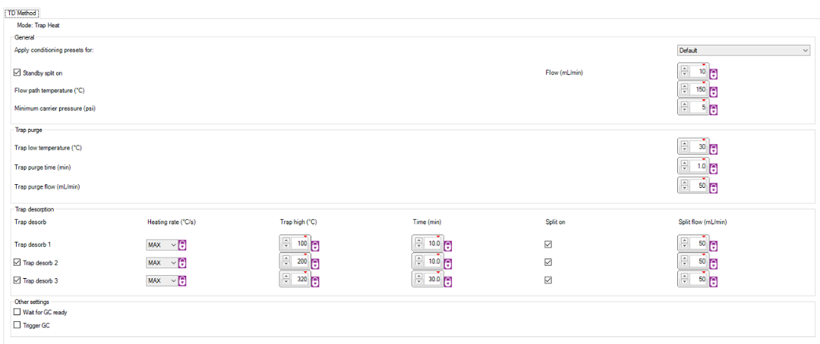

Figure 1. Screen Capture of MIC “Trap Heat” Method Settings

Once the instrument is set up and the trap conditioning program is completed, the analyst should perform subsequent test runs of SB (humidified HCF zero air) analyses to evaluate whether artifacts have been successfully purged from the new preconcentrator trap. Review acquired chromatograms for contaminants and artifacts, which should decrease with repeated SB analyses. Once the SB chromatograms appear to be stabilizing in contaminant levels, set the Deans switch timing according to Section 3.b below and analyze an RTS (recommended concentration range is to dilute the RTS to < 25 ppbC to ensure instrument is not contaminated with high concentration standard) and establish rough retention windows for the target analytes per the elution order shown in Table 3. Prepare overlay chromatograms of the RTS with recent SBs to determine whether any remaining residual contaminants in the SBs are target analytes. At this point, a period of several days of analyzing ambient air is helpful to further condition the instrument, establish repeatable RTs, and make fine adjustments to split and purge flows, and GC oven program to optimize peak separation.

Table 3. Elution Order of Target Analytes in the 59-Component RTS

| **Compound Name** | **# Carbons** | **Elution Order** | **FID Channel** |  | **Compound Name** | **# Carbons** | **Elution Order** | **FID Channel** |
| --- | --- | --- | --- | --- | --- | --- | --- | --- |
| ethane | 2 | 1 | PLOT |  | methylcyclopentane | 6 | 25 | PDMS |
| ethylene | 2 | 2 | PLOT |  | 2,4-dimethylpentane | 7 | 26 | PDMS |
| propane | 3 | 3 | PLOT |  | benzene | 6 | 27 | PDMS |
| propylene | 3 | 4 | PLOT |  | cyclohexane | 6 | 28 | PDMS |
| isobutane | 4 | 5 | PLOT |  | 2-methylhexane | 7 | 29 | PDMS |
| n-butane | 4 | 6 | PLOT |  | 2,3-dimethylpentane | 7 | 30 | PDMS |
| acetylene | 2 | 7 | PLOT |  | 3-methylhexane | 7 | 31 | PDMS |
| trans-2-butene | 4 | 8 | PLOT |  | 2,2,4-trimethylpentane | 8 | 32 | PDMS |
| 1-butene | 4 | 9 | PLOT |  | n-heptane | 7 | 33 | PDMS |
| cis-2-butene | 4 | 10 | PLOT |  | methylcyclohexane | 7 | 34 | PDMS |
| cyclopentane | 5 | 11 | PLOT |  | 2,3,4-trimethylpentane | 8 | 35 | PDMS |
| isopentane | 5 | 12 | PLOT |  | toluene | 7 | 36 | PDMS |
| n-pentane | 5 | 13 | PLOT |  | 2-methylheptane | 8 | 37 | PDMS |
| 1,3-butadiene | 4 | 14 | PLOT |  | 3-methylheptane | 8 | 38 | PDMS |
| trans-2-pentene | 5 | 15 | PLOT |  | n-octane | 8 | 39 | PDMS |
| 1-pentene | 5 | 16 | PLOT |  | ethylbenzene | 8 | 40 | PDMS |
| cis-2-pentene | 5 | 17 | PLOT |  | m-/p-xylene | 8 | 41 | PDMS |
| 2,2-dimethylbutane | 6 | 18 | PLOT |  | styrene | 8 | 42 | PDMS |
| 2,3-dimethylbutane | 6 | 19 | PLOT |  | o-xylene | 8 | 43 | PDMS |
| 2-methylpentane | 6 | 20 | PLOT |  | n-nonane | 9 | 44 | PDMS |
| 3-methylpentane | 6 | 21 | PLOT |  | isopropylbenzene | 9 | 45 | PDMS |
| n-hexane | 6 | 22 | PLOT |  | a-pinene | 10 | 46 | PDMS |
| isoprene | 5 | 23 | PLOT |  | n-propylbenzene | 9 | 47 | PDMS |
| 1-hexene | 6 | 24 | PLOT |  | m-ethyltoluene | 9 | 48 | PDMS |
|  |  |  |  |  | p-ethyltoluene | 9 | 49 | PDMS |
|  |  |  |  |  | 1,3,5-trimethylbenzene | 9 | 50 | PDMS |
|  |  |  |  |  | o-ethyltoluene | 9 | 51 | PDMS |
|  |  |  |  |  | b-pinene | 10 | 52 | PDMS |
|  |  |  |  |  | 1,2,4-trimethylbenzene | 9 | 53 | PDMS |
|  |  |  |  |  | n-decane | 10 | 54 | PDMS |
|  |  |  |  |  | 1,2,3-trimethylbenzene | 9 | 55 | PDMS |
|  |  |  |  |  | m-diethylbenzene | 10 | 56 | PDMS |
|  |  |  |  |  | p-diethylbenzene | 10 | 57 | PDMS |
|  |  |  |  |  | n-undecane | 11 | 58 | PDMS |
|  |  |  |  |  | n-dodecane | 12 | 59 | PDMS |

* + - 1. System Settings for Normal Operation:
         1. The CIA Advantage-xr should be set to sample the desired inlet port.
         2. The Kori-xr trap settings should be -30°C during the sampling phase and 300°C for the post-sampling purging phase.
         3. The following settings apply to routine operation of the UNITY-xr:
* Trap: U-T20PAM-2S
* Trap temperature setting during sampling: -30°C
* Trap desorb temperature: 300°C
* Trap hold time: 5 minutes
* Flow path temperature: 80°C
* Trap purge: 2 minutes at 50 mL/minute
* Split flow: 2 mL/minute
  + - * 1. Agilent 7890B GC Settings: The GC method program is shown in Appendix A.
        2. Setting Deans Switch Timing: Once the instrument conditioning period has been completed, the analyst will need to ensure the Deans switch timing is properly set. Initially, the Deans switch should be set to “on” for approximately 15 minutes which routes the BP-1 column eluent to the PLOT column for subsequent further separation of the light hydrocarbons. The time at which the Deans switch is to be turned “off” should

be adjusted to occur immediately after 1-hexene has completely eluted from the C2-C6 channel (identify the target analytes according to the elution order listed in Table 3). Incorrect timing will result in incomplete separation of C2-C6 compounds on the BP-1 channel or the routing of higher molecular weight compounds to the PLOT column, which can contaminate the PLOT column and result in ghost peaks in subsequent chromatograms (high molecular weight compounds have a high affinity for the PLOT stationary phase). Analyze several replicates of the RTS and observe stable RTs to ensure the Deans switch timing is correct.

* + - 1. Initial Calibration (ICAL) and Calibration Verification
         1. ICAL Timing: The ICAL is established prior to performing sample analysis for data reporting, following instrument maintenance that would reasonably impact the instrument response (preconcentrator trap change, detector change, changes in sampling flows or outlet split flows, etc.), and when CCVs fail acceptance criteria and indicate recalibration is necessary (e.g., CCV failures that cannot accurately be explained by a bad injection or other justifiable rationale). The analyst is strongly encouraged to conduct an ICAL at the end of the monitoring season prior to shutting down the system. This concluding ICAL demonstrates the calibration response remained appropriate over the monitoring season.
  1. ICAL Standard Levels: The Markes UNITY-xr TD and Agilent 7890B GC system is calibrated by analyzing minimally three separate concentration levels of a NIST-traceable certified standard gas diluted with humidified HCF zero air or humidified UHP N2. Instrument calibration is established using a carbon-based response where concentrations of light hydrocarbons (C2-C6) are determined according to the response of propane and concentrations of heavier hydrocarbons (C6-C12) are determined according to the response of benzene. Calibration curves will include a minimum of three concentration levels covering approximately 1 ppbC to 25 ppbC (e.g., 1, 5, and 25 ppbC). Calibration curves are established separately on each FID channel and are modeled by least-squares linear regression.
  2. Establishing the ICAL: The ICAL can be established by one of two conventions: direct introduction of diluted standard gases prepared at the desired concentration or effective dilution of standard gases. Monitoring agencies will specify the convention employed for establishing the ICAL at their monitoring station and specify the equipment employed for accomplishing the ICAL.
     1. Direct introduction of diluted standard gases (*Preferred Method*): The auto-GC is operated in its normal sampling program and the preconcentrator samples the gas stream under the typical sampling duration and flow settings (20 mL/minute for 40 minutes). To introduce standard gases to the auto-GC for this convention, the analyst employs a separate process for diluting stock standard VOC gases with humidified HCF or humidified UHP N2. Analysts may perform dilution into a series of canisters, each at the desired concentration, or may dynamically dilute the stock standard which is introduced to the auto-GC as it is diluted in a mixing chamber. Canister dilutions can be prepared by dynamic dilution or static dilution methods.
     2. Effective dilution of standard gases: For this convention, the auto-GC preconcentrator is not operated at the typical flow and duration settings but rather these parameters are altered to mimic the relative amount of target analyte mass that would be trapped based on the typical sampling duration and flow settings (20 mL/minute and 40 minutes). Users can adjust the sampling flow settings and duration of sampling in the MIC software for effective standard dilution. For example, if the stock standard gas is 100 ppbC and the analyst intends to prepare an effective 25 ppbC standard, the analyst can adjust the flow from 20 mL/minute to 5 mL/minute but maintain the 40-minute sampling time, or can maintain the sampling flow rate of 20 mL/minute but reduce the sampling time from 40 to 10 minutes. Both conventions provide 25% of the target analyte mass that would be provided if the 100 ppbC standard was introduced under normal sampling conditions. Users should note that this method may lead to errors in the ICAL if the MFC in the UNITY-xr is not properly calibrated to cover the flow range of use (UNITY-xr manual indicates 2 to 50 mL/minute) or if the sampling duration is very short (e.g., ≤ 2 minutes).
  3. ICAL Acceptance Criteria: The linear least-squares regression calibration curve generated within the OpenLab software for each FID channel is evaluated separately and must demonstrate linearity with a correlation coefficient (r2) ≥ 0.995 and have an x-intercept (equivalent to the absolute value of the y-intercept/slope) ≤ 0.5 ppbC. The determined concentration (the resulting concentration when inputting the area response into the generated calibration curve) at each ICAL level must be within ±20% difference from the theoretical nominal concentration and the RSD of determined RFs must be ≤10%.

Note that analysts may employ weighted regression (e.g., 1/amount or 1/amount2) when modeling the standard responses to give lower concentration standards more emphasis in determining the regression fit. Calibration curve regressions must not be forced through the origin, as this eliminates the intercept term and does not permit evaluation of the curve behavior at zero concentration.

If these three criteria (correlation coefficient, intercept, and backcalculated concentration) are met, the analyst may employ the average RF for quantitation of target analytes.

*Note for SOP users employing Agilent OpenLab ChemStation*: Analysts should treat the curve origin using the Ignore option and not employ calibration curve origin treatment options such as Connect, Include, or Force in the regression.

* + 1. The Connect option effectively draws two separate linear curves, one covering the introduced standard concentration points (e.g., 1 to 25 ppbC) and another covering the 0 ppbC concentration (origin) to the lowest calibration standard level (e.g., 0 to 1 ppbC). Sample concentrations less than the lowest calibration point are then quantitated against a separate equation than those above the lowest calibration point.
    2. The Include option includes the origin (0,0) as an additional virtual point in the regression which influences the regression even though a zero concentration point was not analyzed.
    3. The Force option forces the resulting regression equation through the origin and eliminates the intercept term of the linear equation, which is not appropriate for this application.
  1. Immediately following establishment of the ICAL, a SSCV standard must be analyzed within the calibration curve range to verify the calibration. Quantitation of the SSCV against the established calibration curve or average RF must show the calibration compounds are within ±30% of the expected theoretical nominal concentration.

1. Creating Methods and Sequences within Agilent OpenLab EZChrom and Markes MIC Software

*NOTE: If different methods are defined to enable sampling from different sources (ports on the CIA Advantage-xr) for the purpose of introduction of QC samples, it is important that both the Markes and EZChrom sample introduction and data processing method parameters remain identical for all sampling methods whether the method is for ambient air or QC sample analysis.*

Please refer to the Markes UNITY-xr and Agilent OpenLab user manuals for generating methods and sequences. The UNITY-xr, Kori-xr, and CIA Advantage-xr or AirServer are all controlled from the MIC software interface. The GC is controlled through the Agilent OpenLab software package (EZChrom or ChemStation).

* 1. Creating Analysis Sequences

Sequences created within the Markes MIC software to control the introduction of different sample types are not linked to the EZChrom Sequence Wizard, therefore a separate sampling sequence must be created for both the preconcentrator (in MIC) and the GC (EZChrom). Each hourly sample within the MIC is a discrete line in the sequence table and defines the CIA Advantage-xr sampling port to be sampled. If analysis sequences originate (are generated) in the MIC software for sampling, the analyst must define a convention for identifying QC samples in the sequence generated in the EZChrom software either by utilization of date-time stamp (DTS) in a repeating single line EZChrom sequence or by generation of a matching sequence in EZChrom with sequence lines containing descriptive information about sample type corresponding to the MIC sequence table. Within the EZChrom sequence, the analyst prescribes the folder location for where the datafiles will be saved.

Note that the UNITY-xr TD and the EZChrom CDS do not communicate with one another apart from providing basic start and stop commands. If sample introduction is determined through the MIC (and not within EZChrom) the EZChrom filenames will be agnostic as to whether the analyzed sample was a QC sample or ambient air sample. When EZChrom data filenames do not readily permit distinguishing QC samples from ambient air samples, analysts must define which data files correspond to which samples – which can be accomplished through a separate table listing the MIC sampling table sequence and the associated EZChrom data filename.

* 1. Defining Sample Collection Methods within Markes MIC Software

The Markes system is run continuously using the instrument operation parameters defined in the generated sequence. These aspects include the sample collection parameters including: defining the sample port on the CIA Advantage-xr, sampling flow rate, collection duration, Kori-xr trapping and UNITY-xr trapping and desorbing temperatures, purge gas flows, and carrier gas flows for the Markes sample introduction and TD components. These default parameters are shown in Section X.3 and may require the analyst to update for their application to maximize response of the high volatility VOCs (e.g., C2 compounds) and minimize carryover of the low volatility VOCs (e.g., C9 and C10 compounds) (the monitoring agency will edit this SOP to include those revised settings, if needed).

In general, the instrument conditions for the TD method designations entered in the MIC sequence table will be identical in most respects with the exception of the CIA Advantage-xr sample port assigned to the various gas streams (whether ambient air, standard gas, SB, RTS, etc.).

* 1. Sequence Staggering (Optional): Please refer to Figure 2 for an example sampling schedule including QC samples for a one-week period. Here the starting times of the QC samples are staggered to be analyzed nightly starting between 20:00 and 02:00 hours (and are highlighted in blue). Ambient samples are noted as “amb” in the figure. This schedule can be repeated weekly and ensures that minimally each discrete daily hour will include ambient air samples for four samples per week. Note that such staggering is optional. It is recommended that the starting time for the CCV analysis rotate through the hours of 20:00 through 02:00. If the CCV/SB begins at the same time every night, for example, 22:00, no ambient sample data will be collected over the entire course of the PAMS monitoring season for the two-hour period between 22:00 and 0:00. An example rotation schedule is included in Figure 2, which demonstrates that rotation schedule.

Table showing daily sampling schedule for each hour of the day vertically for each day of the week horizontally. QC samples are shown highlighted.

Figure 2. Example Sampling Schedule for a 7-day Period Including Approximately Daily and Weekly QC Samples

* 1. EZChrom requires creation of an overall chromatographic method which outlines both the GC instrument parameters and the chromatographic processing parameters to define how a sample, blank, or standard is collected, analyzed, and quantitated.

The GC analysis instrument method parameters and data processing method parameters will be identical across methods employed for ambient air samples and QC samples.

* + 1. Instrument parameters define the sample collection parameters and the GC program parameters including carrier gas flows, timing for Deans switch actuation, and oven program, among others.
    2. Processing parameters define the settings for EZChrom to identify and quantitate the target compounds within the chromatograms. These settings prescribe the integration parameters, RT windows, target compound list, and maintain the RFs based on the established calibration, among other aspects of data processing.
    3. The EZChrom instrument method employed for this analysis is detailed in Appendix A and may be modified to optimize the separation, identification, and integration of the target analytes (monitoring agencies will update this SOP with their specific settings).

1. Analysis of Ambient Air

Sampling will occur at the top of each hour for 40 minutes as described in Section VIII.4.

Once the sequence tables have been created and saved for both the TD (in MIC) and the GC (in EZChrom), the TD sequence can be programmed to start at a desired date and time. The GC sequence can be initiated, which will place the GC sequence on hold until the TD triggers to start the associated GC run.

Once the sequences begin to run, datafiles are written to the analyst-specified folders. Chromatographic data files (.dat) should be named (Refer to PAMS TAD Table 4-2 for detailed filenaming convention2) and stored in a manner that allows ready identification and access. Analysts should not rely on datafile DTSs for determining collection date and time as the DTS will be updated if/when the datafile is reprocessed. The identification convention should allow the user to identify both the date and time of sample collection as well as the sample type (whether ambient or a specific type of QC sample). Additionally, to safeguard data due to the amount of data collected, the analyst should define a strategy for periodic (e.g., hourly or several times per day) automated (or verified manual) archival of data to ensure raw data integrity and reduce the likelihood of inadvertent data adulteration.

1. Collection of Data

The auto-GC instrument will run unattended to execute the prescribed sequences. The analyst will periodically verify that the instrument is operating appropriately per the defined sequences and will verify the sample data were collected and properly stored per the data verification steps in Section XII.

1. Processing and Evaluating Collected Data

Refer to the Agilent OpenLab EZChrom user manual for specific instructions for viewing and manipulating collected data. The CDS will identify target analyte peaks, integrate the associated area per the defined data processing method, and quantitate the concentration of each target analyte within each sample on both FID channels per the established calibration regressions. The analyst will review the processed data per the data verification processes in Section XII to ensure the data files were properly acquired, the target analytes were properly identified, chromatographic peaks were properly integrated, and QC samples met the acceptance criteria. The analyst will document adjustments needed to the processed data.

* 1. Viewing Chromatograms: Acquired chromatograms for collected samples may be viewed within the OpenLab EZChrom CDS or OpenLab CDS software. This software enables users to create overlays of chromatograms in several different viewing configurations. Ambient air sample chromatograms can be overlaid with standard (e.g., CCV, RTS, and/or SSCV) or SB chromatograms to investigate RT shifts, baseline behavior, or carryover of target compounds or interferences. An overlay of example chromatograms for ambient air (green), SB (blue), and RTS (red) is shown in Figure 3.

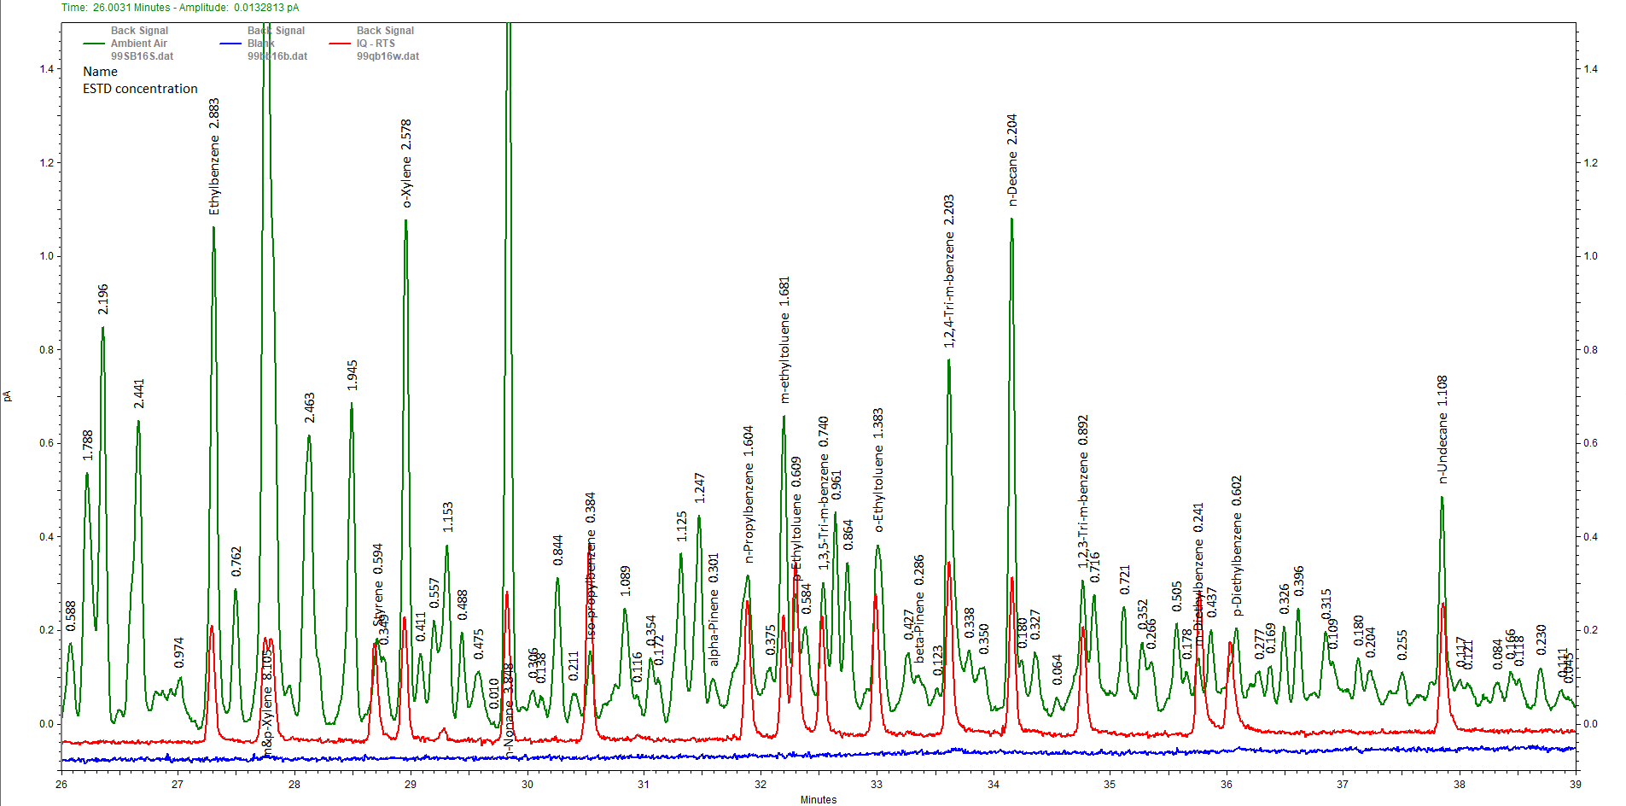

Figure 3. Example Overlay of Chromatograms for Ambient Air (Green), Retention Time Standard (Red), and a System Blank (Blue)

* 1. Processing Collected Data: Analysts perform post-processing of collected chromatographic data within the EZChrom software (or other compatible Agilent OpenLab software). To make adjustments to RT windows, the operator can adjust these within the processing method by clicking and dragging the RT window (refer to Figure 4 for an example of an RT window for cyclopentane) or within the parameters table. Similarly, the integration parameters can also be adjusted within the method to optimize the automated CDS integration. Once the RT window and/or integration parameters is/are satisfactorily updated, the data processing method is then saved and datafiles for affected samples are reprocessed to properly identify and/or integrate target compounds. The analyst will then review the reprocessed chromatograms to ensure proper identification and integration for the target analytes. If specific target analyte peaks do not lend themselves to adjusting the RT window and/or integration parameters, the analyst can manually adjust these. A guide to proper integration techniques is include in Appendix B. Refer to the CDS user manual for more information on making adjustments in the CDS.

Specific data reviewing procedures are described in the data verification section (Section XII).

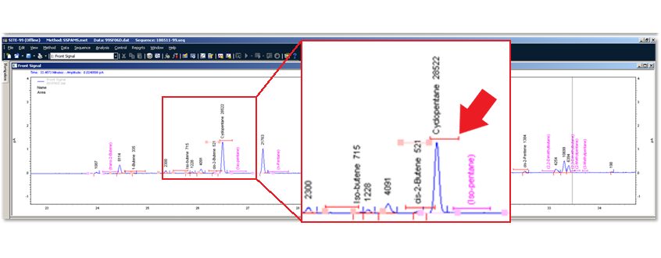

Figure 4. Example Retention Time (RT) Window for Cyclopentane

1. CALCULATIONS

Reporting Units: Measured concentrations are to be reported in units of ppbC. These are the units to be entered into the system for calibration, and therefore the instrument provides results in ppbC and reporting of the concentrations is straightforward. Consult the PAMS TAD and the AQS reporting guide for specific reporting parameters and conventions.

* + - 1. Calculations
         1. Conversion of ppbV to ppbC

$$C_{ppbC}= C_{ppbV}∙N_{C}$$

where: CppbC = concentration (ppbC)

CppbV = concentration (ppbV)

NC = number of carbon atoms in the molecule

* + - * 1. Standard dilution concentration via dynamic dilution:

$$C_{d}= \frac{(F_{s}∙C_{s})}{(F_{s}+F_{d})}$$

where: Cd = diluted concentration (ppbC)

Cs = stock standard concentration (ppbC)

Fs = flow of stock standard gas (standard mL/minute)

Fd = flow of diluent gas (standard mL/minute)

* + - * 1. Standard dilution concentration via static dilution:

$$C_{d}=\frac{(P_{s}∙C_{s})}{P_{f}}$$

where: Cd = diluted concentration (ppbC)

Cs = stock standard concentration (ppbC)

Ps = partial pressure of stock standard gas (mm Hg)

Pf = final pressure of vessel (mm Hg)

* 1. Standard dilution concentration by effective dilution:

$$C_{d}=C_{s}∙\frac{T_{d}}{T_{s}}∙\frac{F_{d}}{F_{s}}$$

where: Cd = effective diluted concentration (ppbC)

Cs = stock standard concentration (ppbC)

Td = sampled time of effective dilution (minutes)

Ts = standard sample time (minutes)

Fd = sampled flow of effective dilution (mL/minute)

Fs = standard sample flow (mL/minute)

* 1. Quantitation of Sample Using Calibration Response Factors:

$$C= \frac{A_{c}}{R_{fc}}$$

where: C = concentration of compound measured in ppbC

Ac = integrated peak area of the compound being measured in the sample

Rfc = response factor of the target compound based on the calibration (area/ppbC)

* 1. Quantitation of Sample Using Linear Regression:

$$C= \frac{{(A}_{c}-b)}{m}$$

where: C = concentration of compound measured in ppbC

Ac = integrated peak area of the compound being measured in the sample

m = slope of the linear regression (area/ppbC)

b = y-intercept of linear regression (area)

* 1. Relative Standard Deviation (RSD):

RSD = standard deviation x 100

mean

* 1. Absolute Relative Percent Difference (RPD) is calculated as:

RPD = |result A – result B| x 100

mean of results A & B

* 1. Absolute Percent Difference (APD) is calculated as:

APD = |result measured – result expected| x 100

result expected

* 1. Percent Recovery is calculated as:

% recovery = concentration measured x 100

concentration expected

* 1. Total collected sample volume

Vs = Fs·Ds·106

where: Vs = collected sample volume (m3)

Fs = sample flow rate (standard mL/minute)

Ds = duration of sampling (minutes)

1. DATA VERIFICATION

During review of the ambient concentration data, operators and data reviewers will invariably encounter situations where compounds exhibit interferences, QC checks fail acceptance criteria, and target compound and interference responses are questionable as to the presence or absence of the compound. Monitoring organizations must have prescribed procedures to address such issues to ensure they are handled consistently and the decisions are technically justifiable. Below are general procedures for performing data verification. Data are ready for validation once the verification processes are complete.

Data verification processes are intended to ensure that the generated data are true representations of the measurements produced by instruments that are calibrated, operating properly and within defined tolerances, and are accurately recorded. Verification activities involve active routine auto-GC operator checks to ensure the consistent and continuous proper operation of the instrument as well as subsequent review of collected data by the instrument operator and an independent individual intimately familiar with instrument operation and data collection.

* + - 1. Site Operator Routine Checks

It is critically important that the operator routinely ensures the auto-GC is operating properly and that instrument errors and QC sample failures, whether of an operational (e.g., instrument malfunction or performance degradation) or QC nature (contamination in an SB), are addressed in a timely manner to limit the impact of nonconformances on the ability to report valid ambient air concentrations. Instrument operators are encouraged to access the instrument CDS daily to verify the instrument is currently operating correctly (MIC permits viewing the Instrument Status dialogue box) and was operating correctly since the most recent operator check-in. Such daily instrument access allows the operator to access the most recent QC samples (e.g., CCV and SB) to ensure these checks met acceptance criteria and to take immediate corrective action when warranted. The complexity of auto-GCs makes them susceptible to failures resulting in instrument downtime.

Even if there are problems with the collected data such as RT shifts, blank contamination, or chromatography issues resulting in poor automated integration or missed peak identifications, provided the instrument is operating correctly, the data can most often be corrected in post-acquisition processing. If the instrument has entered a fault mode due to a power outage or other instrument failure and ceases to run each hour, those data cannot be salvaged and those sampling hours are lost. Therefore, it is of utmost importance to check the instrument status routinely to ensure the instrument is online and operating as expected.

Instrument operators will perform the data verification steps listed below and summarized in the flowchart shown in Figure 5.

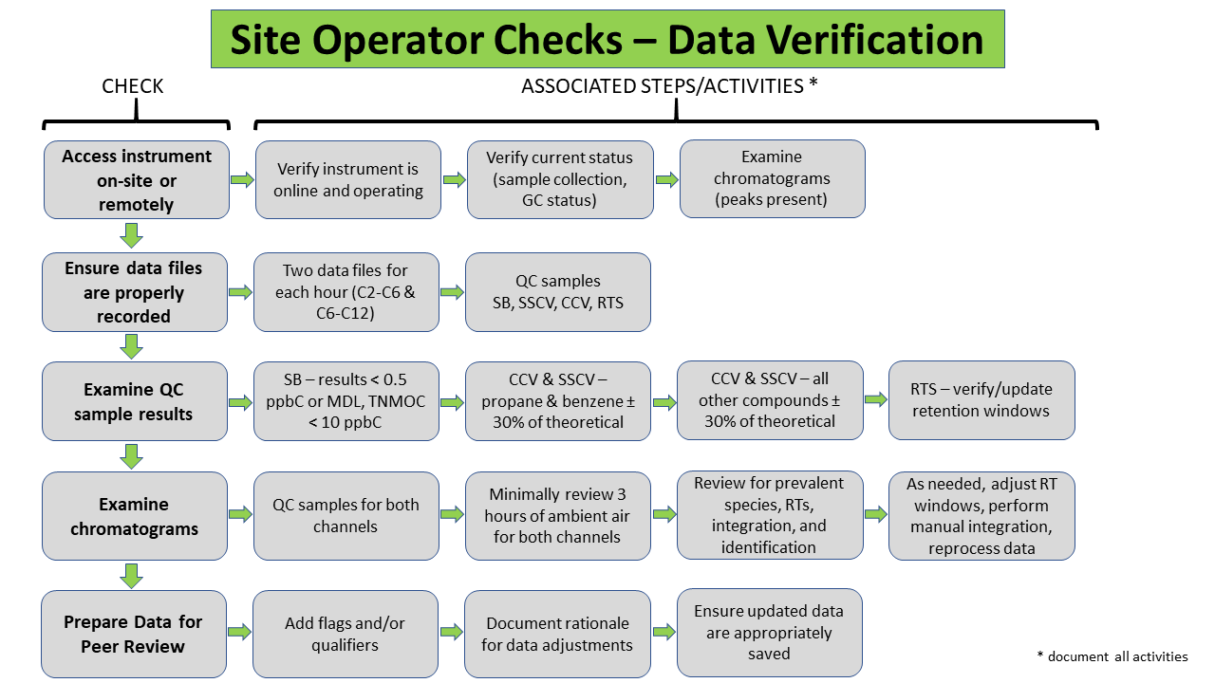Figure 5. Flowchart of Site Operator Data Verification Checks

* + - 1. **Verify Current Instrument Status**: Verify the instrument is operating properly (that there are no error messages or faults indicated by the CDS) and that the statuses in the sample collection and analysis cycles are as expected (e.g., that the instrument is collecting samples during the first 40 minutes of the hour). If there are faults/errors or any statuses are not as expected, take immediate corrective action. Errors and/or faults should be evident from the instrument software systems (Markes MIC software or Agilent OpenLab); however, operator understanding of the correct operation status should generally correspond to the following:
         1. If a QC sample is scheduled to run (note this will typically be scheduled for late overnight hours; approximately 22:00 to 02:00), ensure the instrument is sampling from the correct inlet stream/port.
         2. Between the top of the hour (e.g., 8:00 a.m.) and 40 minutes past the hour (e.g., 8:40), the preconcentrator should be actively sampling.
         3. At 40 minutes past the hour the GC injection should occur after which the GC should continue to run and be collecting data until the end of the GC run.

The signal on the C2-C6 (PLOT) FID should continue until the Deans switch occurs (occurs once 1-hexene elutes from the PLOT column)

Following the Deans switching, target compounds should be actively eluting on the C6-C12 (BP-1) channel.

* + - * 1. After injection to the GC, the preconcentrator suite of components should perform purges (Kori-xr should switch to purge mode to remove captured water) and should cool the sample dryer and preconcentration traps to be ready for collection of the next sample at the top of the hour.
        2. At the end of the GC program, the GC should cease data acquisition and begin cooling the oven to be ready for the next injection at approximately 40 minutes after the top of the hour.
      1. **Verify Data Files**: Review the data collected since the last operator check-in to ensure data files are saved and complete for each ambient air sampling hour and expected QC sample hour. Missing files may be indicative of an instrument failure (such as a stalled collection or GC run).
         1. For missing data files, examine data from nearby hours (at least one hour before and two hours after) for impact on the collected data. If missing files indicate an instrument failure, the sample immediately preceding a missing data hour will be invalidated.
         2. Failed sample collection events may result in contaminants remaining on the preconcentrator trap (due to incomplete desorption or purging of the preconcentrator trap) or within one or both separation columns which contaminate the following sample.
         3. Incomplete sample collection or leaks may permit the instrument to still collect a sample even though there is an error. These data should be reviewed closely to investigate for chromatographic changes that may relate to the error. Examples of conditions which may cause error messages but not interrupt the sample collection include small leaks in the inlet path or elsewhere in the system and flow or pressure criteria out of specification.
      2. **Review QC Data**: Examine the concentration data in the results summary files for the most recent SB, CCV, SSCV, and RTS and evaluate against the following acceptance criteria:

1. SBs must show that all target VOCs are < MDL or 0.5 ppbC, whichever is lower, and total non-methane organic carbon (TNMOC) is < 10 ppbC.
2. CCVs and SSCVs must show that the calibration compounds (e.g., propane and benzene) are within ±30% of the theoretical nominal concentration and should demonstrate that any other compounds in the CCV are also within ±30% of the theoretical nominal concentration.
3. RTSs do not have discrete acceptance criteria unless also serving as the CCV and/or SSCV. Analysts will evaluate the established RT windows against RTS analyses to ensure the Deans switch timing remains appropriate and will adjust RT windows as needed to ensure proper target analyte peak identification.
   * + 1. **Review/Examine Chromatograms and Prepare Data for Peer Review**: Site operators will examine chromatograms for each QC check as well as minimally three ambient air sample hours. Particular attention should be paid to examine chromatograms for failing QC checks to ensure that failing QC results are not due to improper peak identification, peak integration, and/or interference. SBs and/or CCVs following an ambient sample with relatively high concentrations may exhibit carryover from the high concentration sample which may lead to SB levels exceeding criteria or CCVs showing excessive recovery.

When reviewing chromatograms, examine the chromatogram baseline, accuracy of peak identification, and quality of peak integration. If corrections or changes are warranted, maintain the original automated output and record (e.g., annotate the chromatogram electronically or document in a separate log) the rationale for the change(s).

* + - * 1. Examine Baseline: Examine the baseline in the chosen chromatograms for excessive noise, uncharacteristic rises, dips, spikes, and/or other uncharacteristic behavior. When zooming in on the baseline, some noise will be evident; however, excessive/atypical noise may indicate degradation of that channel’s FID or system electronics. Rises and dips in the baseline may indicate pressure fluctuations resulting from cycling of the ZAG compressor, leaks or partial clogs in the support gas delivery, and/or excessive moisture or contamination in carrier gas streams. Practically, these perturbations in the baseline may, depending on their magnitude, complicate proper peak integration, requiring additional instrument operator efforts to properly identify and integrate adversely affected chromatograms.

*Note: Analysts should carefully consider the assignment of the peak area reject threshold setting. This parameter is useful to ensure that the CDS does not mistakenly identify detector noise as a chromatographic peak (whether target analyte or unknown peak). Setting this value too low will result in the CDS identifying noise responses as peaks and requiring the analyst to manually eliminate these noise responses as detections. The level of effort required to manually eliminate these responses may be considerable. However, setting this value too high will result in the CDS overlooking true chromatographic peaks and will require the analyst to review all chromatograms to manually identify target and non-target analytes.*

* + - * 1. Review Peak Identification: Examine the identification of target analyte peaks on both channels to ensure proper identification. Ambient air sample chromatograms should be examined to ensure that abundant species are present as expected and properly identified. RT shifts, particularly on the C2-C6 channel due to the PLOT column’s sensitivity to humidity changes, may occur and confound automated identification. A best practice is to prepare overlays of the reviewed chromatograms with the most recent RTS, or other multi-component standard, to confirm proper identification (Refer to Figure 3). Misidentifications by the CDS must be over-ridden and the correct peak identified, if possible. A useful tool is to plot the RTs of the target analytes (on the y-axis) against the chronological sample order to more easily identify peaks RTs that are out of the norm and may indicate there are chromatograms for which an RT shift has occurred or the peak(s) has been misidentified. Refer to the example in Figure 6 which shows the RT of   
           p-diethylbenzene moves slightly later for several hours (where no other compounds show a similar shift) on 6/4/2018 and 6/6/2018, indicating a possible misidentification for p-diethylbenzene.

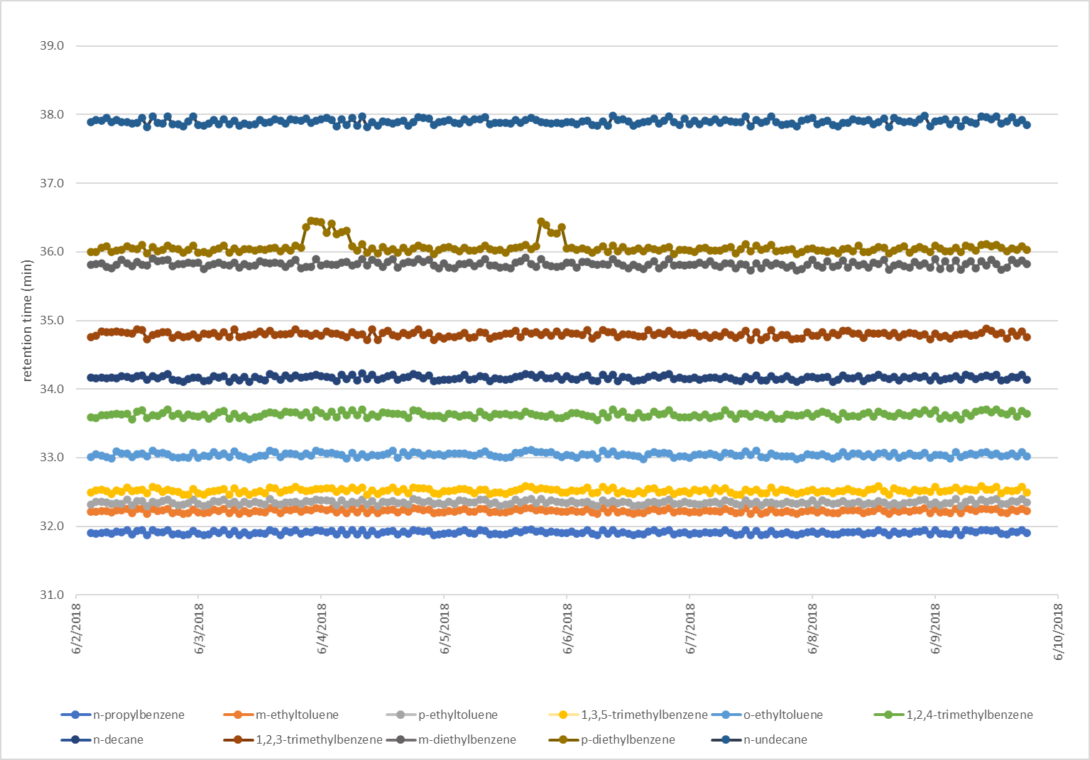

Figure 6. Example Plot of Compound Retention Times

Commonly misidentified target compounds are detailed in Table 4.

Table 4. Commonly Misidentified Target Compounds

| **FID Channel** | **Compound(s)** | **Interference** |
| --- | --- | --- |
| C2-C6 | acetylene | Acetylene requires a wide RT window - when not present automated routines may incorrectly identify a non-target peak as acetylene. |
| C2-C6 | cyclopentane and isopentane | These two compounds co-elute/elute closely together and may be misidentified when RTs shift. |
| C2-C6 | 2,3-dimethylbutane, 2-methylpentane, and  3-methylpentane | These “three sisters” partially co-elute and may be misidentified when concentrations are low and/or RTs shift. |
| C6-C12 | methylcyclopentane and  2,4-dimethylpentane | These two compounds co-elute/elute closely together and automated routines may incorrectly identify these compounds when one is absent in the chromatogram or an additional unknown compound co-elutes. |
| C6-C12 | 2-methylhexane and 2,3-dimethylpentane | These two compounds co-elute/elute closely together and automated routines may incorrectly identify these compounds when one is absent in the chromatogram or an additional unknown compound co-elutes. |
| C6-C12 | styrene | Styrene may exhibit poor peak shape and automated integration parameters may result in this compound being missed. |
| C6-C12 | m-ethyltoluene and  p-ethyltoluene | An unknown compound elutes/co-elutes just prior to m-ethyltoluene and p-ethyltoluene co-elutes on the backside of m-ethyltoluene which can confound automated identification routines. |
| C6-C12 | region of the chromatogram between alpha-pinene and  1,2,4-trimethylbenzene | This portion of the chromatogram is congested with target compounds and may show additional unknown peaks attributed to biogenic compounds (e.g., limonene, camphene, and other terpenes/terpenoids). These peaks may be large in relative magnitude and may co-elute or elute closely with target compounds, confounding identification. |

* + - * 1. Review Peak Integration: Examine target analyte peaks in the chosen chromatograms to ensure the integration is appropriate and consistent. Where possible, automated integration routines should be configured to properly integrate analyte peaks without analyst intervention. However, even when configured optimally for ambient air, the integration may require manual adjustment when unknown (non-target) compounds co-elute with target analytes, when RTs shift, or when standard or blank gases are analyzed. Conversely, when automated integration routines are optimized for standard or blank gases, integration for ambient air samples may require manual adjustment, particularly for peaks with co-elution interferences absent in the standard chromatogram. Therefore, peak integration should be examined closely in the CCV, RTS, and SB as well as in ambient air sample chromatograms.

A discussion of chromatographic peak integration practices is detailed in Appendix B. Agilent OpenLab CDS software packages permit analysts to drag and drop an integration baseline and perpendicular or employ more sophisticated peak integration regimes. When manually adjusting integration parameters, the CDS will flag the modified data (e.g., with an asterisk “*”) to indicate the peak(s) was manually integrated/modified.

Common rationales for modifying automated integration and recommended associated abbreviations are shown in Table 5.

When reviewing target analyte peak integration, analysts should review the integration of all peaks in the chromatograms undergoing review. When target analyte peaks show improper integration, analysts should review those peaks in adjacent sample hours and adjust integration as required in the subsequent sample hours.

Table 5. Common Rationales for Manual Peak Integration

|  |  |  |
| --- | --- | --- |
| **Rationale for Modification** | **Details and Examples** | **Suggested Abbreviation** |
| Not a peak | Peak or integrated portion of chromatogram is not a valid peak – e.g., integrated area has signal to noise ratio (S:N) < 3 | NP |
| Misidentification | Incorrect target analyte assignment | MI |
| Poor integration | Automated integration poorly reflects peak area – e.g., integration includes baseline noise or excludes appropriate peak area | PI |
| Co-elution | Integration adjusted to eliminate a co-eluting substance | CO |

**Integration Adjustment Priority**: Measured concentrations of many of the target analytes will likely be ≤ 1 ppbC. As analyte concentrations decrease and approach the MDL (note: the MDL MQO is ≤ 0.5 ppbC), peak S:N concomitantly decreases, increasing the difficulty for automated integration regimens to properly integrate these low concentration peaks. Manually adjusting those peaks which were improperly integrated may require substantial analyst time, therefore analysts should prioritize performing manual integrations in the following order of decreasing priority:

Priority compounds > 0.5 ppbC

Priority compounds ≤ 0.5 ppbC

Optional compounds > 0.5 ppbC

Optional compounds ≤ 0.5 ppbC

Unknown (non-target) compounds (sum for TNMOC)

For optional or priority compounds at low concentrations (i.e., < 0.5 ppbC or MDL) for which integrations are not reviewed, the associated concentration data will be flagged with QA qualifier LJ when reported to AQS.

* + - * 1. Reprocess Data, Add Qualifiers and Flags, and Confirm Changes are Saved: Once the acquired data have been reviewed and any needed adjustments made, the operator/analyst will ensure any data requiring adjustment have been properly reprocessed per the appropriate method, flags and qualifiers have been added as warranted, and documentation of changes and their rationale are recorded. The operator/analyst will also verify the updated data have been properly saved.

When preparing data for peer review, the analyst will flag data according to the scheme in Table 6. Listed flags are relevant QA qualifier codes or NULL codes. Data with QA qualifier codes are reported to AQS with the concentration value intact; however, data with NULL codes are invalid and the concentration value is not input into AQS.

Table 6. Description and Assignment of Data Qualifiers

| **Category** | **Description** | **Data to Flag** | **Flag to Append** | **Qualifier Type** |
| --- | --- | --- | --- | --- |
| Missing data | Intended data collection hour missing | Target analytes for missing ambient hours | AF | NULL qualifier |
| Missing data | Intended data collection hour missing | Target analytes for one hour following missing hours | AQ | NULL qualifier |
| Instrument malfunction or collection error | Collected data exhibit instrument malfunction or collection error | Target analytes for affected hours | AN (for malfunction)  AQ (for collection error) | NULL qualifiers |
| Data outside required time | Collected data do not comply with start time 10 minutes before or 30 minutes after the hour and/or do not comprise 40 minutes of sample collection | Target analytes for ambient hours not meeting timing requirements | AI | NULL qualifier |
| Chromatography Problems or Interferences | Collected sample shows severe chromatographic issue(s) (RT shift, artifacts, interferences) impacting the FID channel | Target analytes for the associated FID channel for the affected ambient hours | DA | NULL qualifier |
| Chromatography Problems or Interferences | Collected sample shows severe chromatographic problem (co-elution, RT shift) isolated to specific region in chromatogram | Target analytes with concentrations appearing to be biased by more than  ± 50% (based on analyst judgement) in affected ambient hours | BH | NULL qualifier |
| Chromatography Problems or Interferences | Target analyte identified with co-elution or interference | Target analytes with concentrations appearing to be biased high (bias not to exceed +50%) in affected ambient hours | LK | QA qualifier |
| Chromatography Problems or Interferences | Target analyte identified with co-elution or interference | Target analytes with concentrations appearing to be biased low (bias not to exceed -50%) in affected ambient hours | LL | QA qualifier |
| Chromatography Problems or Interferences | Target analyte identified with co-elution or interference | Affected target analytes for which the analyte concentration is an estimate (bias not to exceed ±50%) | LJ | QA qualifier |
| **Category** | **Description** | **Data to Flag** | **Flag to Append** | **Qualifier Type** |
| Analyte not detected | Target analyte not detected (not within RT window or S:N ≤ 3:1) | Target analytes not detected in affected ambient hours (0 ppbC) | ND | QA qualifier |
| Concentration below MDL | Target analyte detected but ≤ MDL | Target analytes detected in ambient hours at ≤ MDL | MD | QA qualifier |
| Concentration between MDL and sample quantitation limit | Target analyte detected between MDL and ≤ 3.18∙MDL | Target analytes detected in ambient hours at > MDL but ≤ 3.18∙MDL | SQ | QA qualifier |
| Exceeds calibration range | Target analyte in ambient hour exceeds upper range of calibration | Affected target analyte in affected ambient hours | EH | QA qualifier |
| QC Sample Failure – SB | Target analyte measured in SB at > 0.5 ppbC or MDL, whichever is lower | Ambient hours for that target analyte back to the most recent acceptable SB and forward to the next acceptable SB | FB and QX | QA qualifiers |
| QC Sample Failure – CCV or SSCV | Target analyte measured in CCV or SSCV < 70% recovery of nominal | Ambient hours for that target analyte (and associated target analytes*) back to the most recent acceptable CCV/SSCV and forward to the next acceptable CCV/SSCV | LL and QX | QA qualifiers |
| QC Sample Failure – CCV or SSCV | Target analyte measured in CCV or SSCV > 130% recovery of nominal | Ambient hours for that target analyte (and associated target analytes*) back to the most recent acceptable CCV/SSCV and forward to the next acceptable CCV/SSCV | LK and QX | QA qualifiers |
| QC Sample Failure – CCV or SSCV | Target analyte measured in CCV or SSCV < 50% or > 150% recovery of theoretical nominal | Ambient hours for that target analyte (and associated target analytes*) back to the most recent acceptable CCV/SSCV and forward to the next acceptable CCV/SSCV | AS | NULL qualifier |

* Associated target analytes refer to those analytes that are not included in the CCV and/or SSCV but are associated with the failing target analyte. For example, if the CCV does not include all target analytes (e.g., consists of 15 of 59 target compounds), the target analytes with similar molecular weights will be assigned to the closest target analyte in the CCV and/or SSCV – e.g., if 1,3,5-trimethylbenzene fails in the CCV and/or SSCV (which does not include other C9 target analytes), target analytes with nine carbon atoms will require flagging.

1. Peer Review

Once the operator has completed the routine self-checks and data review listed above in Section XII.1, the measurement data are to be reviewed by a separate individual who is knowledgeable with the auto-GC measurements and the instrument’s operation principles, the typical behavior of the target analytes, and common issues or problems that occur with VOC measurements. This independent review of the auto-GC data is intended to verify the site operator has properly completed the first level of data verification steps and to examine the data more completely. The peer reviewer will follow up with the site operator/instrument analyst for clarifications, missing information, or data that require correction. It is not intended for the peer reviewer to make changes to the data.

Peer reviewers will perform the following data verification steps listed below and summarized in the flowchart shown in Figure 7.

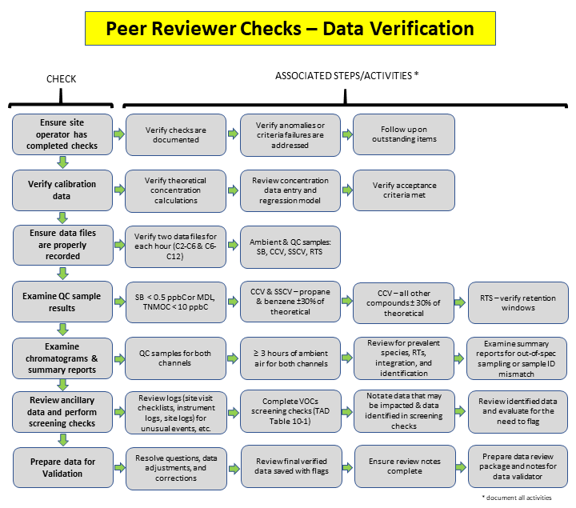

Figure 7. Flowchart of Peer Review Verification Steps

* + - 1. **Verify Site Operator/Analyst Checks**: Ensure the operator/analyst has completed the required review checks and documented data anomalies, acceptance criteria failures, manual changes to data, and the aspects of analysis reviewed (e.g., date ranges, filename ranges, etc.). Note where these items are incomplete and require follow up by the operator prior to performing peer review.
      2. **Verify Calibration Data**: Review the calibration records for the auto-GC to ensure that the calibration was properly established. This includes reviewing calculations for dilutions and ensuring that certified values for the target analytes have been entered properly for the theoretical concentrations into the calibration regression. Peer reviewers should then ensure that the correct regression models and options have been employed and that acceptance criteria have been met (refer to Table 7). Once reviewed, the calibration records need only be reviewed again if the calibration (or RFs) are updated.
      3. **Ensure Data Files are Properly Recorded**: Examine data storage folders for missing data files and ensure that the expected files are present, including all anticipated QC check files (e.g., CCV, SB, and RTS) and ambient air sample hours for both FID channels (C2-C6 and C6-C12) for 24 sampling hours of each day. Review the sample starting time for each to verify the sampling started within the proper time window. Verify that the sample type matches for the designated hour for both channels (i.e., both channels indicate that the same sample type was analyzed). Verify that the site operator/analyst has addressed any missing files and invalidated them and the preceding hour if the missing file is due to an instrument malfunction.
      4. **Examine QC Sample Results**: Examine the CCV and SB data for each day and the weekly SSCV and RTS to ensure acceptance criteria are met and note where failures occur (or verify that the operator has noted these failures) as the associated ambient data will need to be qualified or invalidated (i.e., flagged with a NULL qualifier) when reported. Review chromatography to ensure that target analyte peaks were identified properly, that RT windows remain valid, and that peak integration is consistent and appropriate. Review QC charts for trends indicating the instrument performance is approaching out of control status.
      5. **Examine Chromatograms and Data Summary Reports**: Review chromatograms for both channels for at least three (3) hours of each day’s ambient data. Chromatograms should be examined for misidentified compounds, suitable and consistent peak integration (whether with automated integration routines or through manual adjustment), interferences that impact data quality, abundant species expected in ambient air samples but that are missing, and target analytes with unexpected high concentrations exceeding the calibration range, particularly those that exceed the FID response range (this results in flat-topped peaks). Examine sample hours preceding and following high concentration samples to evaluate potential carryover. Prepare overlays with standard chromatograms, such as the RTS, to verify compound RT windows. If problems with compound identification are observed, additional ambient sampling hours should be reviewed to characterize the extent of the specific issue. Review data summary reports for insufficient collection durations (e.g., < 40 minutes), out-of-specification sample collection flows or volumes, and unexpected analyte concentrations indicative of a sample identifier mismatch (e.g., an ambient daytime sample that appears to be a blank).
      6. **Review Ancillary Data and Perform Screening Checks**: Review site logbooks, site visit checklists, instrument maintenance logbooks, and instrument audit trails for information that may indicate collected sample and/or QC data are impacted. Such aspects include: unusual events (e.g., wildfires), unscheduled maintenance, and large volumes of reprocessed sample data. Complete speciated VOC screening checks which assess whether ambient sample data exhibit characteristics such as presence/absence of target analytes, compare target species for expected relationships, and assess trends in target analyte concentration such as analytes exhibiting a diurnal pattern. These screening checks are detailed in Table 10-1 of the PAMS TAD2; however, some of the checks may not specifically apply to all PAMS sites based on the mix of sources at a given site. Modifications to these checks should be carefully considered and justified based on historical measurements or other documented factors. Failures of the screening checks will result in further review of additional chromatograms or datafiles and confirmed failure of the screening checks will prompt qualification of the data when reported to AQS (as described in Table 10-1 of the PAMS TAD).
      7. **Prepare Data for Validation**: Resolve outstanding questions, data adjustments, or corrections, and review the final verified data to ensure the data are saved with the appropriate qualifiers or flags. The dataset at this point should be as complete and correct as possible and should be ready for subsequent data validation. The peer reviewer will prepare a review package documenting the data reviewed, recorded notes, electronic communications resolving issues, and summary detailing the scope of data review (i.e., date range or datafile name range), observations, and high-level outcomes of the peer review. Data validators will need to access these review notes when anomalous data are observed in subsequent validation steps.

1. DATA VALIDATION

Once data have gone through the data verification processes with the site operator and peer reviewer, the data will have been appropriately flagged or invalidated based on their suitability and compliance with the PAMS QAPP. Data validation *should not commence* until the data verification steps have been completed and the dataset to undergo validation is appropriately complete and correct (that the dataset includes all collected data and these data represent the collected sample measurements, and measurements that are compromised are appropriately flagged or invalidated). At the validation stage, the data are examined for their internal consistency within the dataset, consistency with historical data, and consistency with other datasets acquired from other nearby sources.

It is important that data be validated in a timely manner after the data have been collected and verified. Data verification, in theory, when performed comprehensively and in a timely manner, should identify the most serious of nonconformances, allowing prompt corrective action. However, systematic errors and problems that are not evident during data verification steps can still be identified during data validation when a larger portion of the dataset is examined at a higher level. To be meaningful, data validation should be performed on a temporal range of sample data encompassing approximately three or more weeks, so trends and a sufficient amount of the dataset can be examined in totality. The delay in acquiring such a quantity of sample measurements and verifying the data typically means that data will be one month or more from collection when data validation can begin.

Several software platforms are available for monitoring agencies to validate data. These software tools may employ rangefinding checks, graphing capabilities and tools for data visualization, statistical tools, interparameter comparisons, and data flagging. Monitoring agencies will identify the software tools and procedure employed for accomplishing data validation. If monitoring agencies have a separate SOP prescribing data validation procedures covering PAMS-speciated VOCs, that SOP will be listed here by reference. Monitoring agencies will also list additional data validation activities specific to their monitoring site(s) which may be unique to the site and/or beyond what is described within this SOP.

A general discussion of recommended data validation procedures follows and refers heavily to the comprehensive data verification and validation section (Section 10) in the PAMS TAD Revision 2.2

* + - 1. Validation Tools

Individual data points or ranges of data identified as anomalous or spurious in the following procedures will be further examined to ensure data are correct. It is anticipated that many such values will have been already examined during data verification and any issue(s) already sufficiently explained in the data verification notes. Issues identified during these examinations that are not already satisfactorily explained will result in determining whether additional data should be examined.

* + - * 1. Statistical Tests

Perform the following statistical tests on each parameter within the dataset:

Determine the central tendency of the dataset (calculate the arithmetic mean, geometric mean, median, and/or mode).

Calculate the variability of the dataset by determining the standard deviation.

Determine the minimum and maximum concentrations.

Examine the statistical data for extremely high values (e.g., statistical or apparent outliers), large standard deviations (e.g., exceeding 30% of the mean), large differences between average and median values (e.g., exceeding 30% of the mean), and other unexpected outcomes. Note that for analytes exhibiting diurnal behavior (i.e., isoprene), large standard deviations of concentration (e.g., > 30% of the mean) may be normal.

* + - * 1. Review the following audit reports for identified issues and their impact on data undergoing validation:

Proficiency Test (PT) results – unacceptable results

Technical Systems Audit (TSA) reports – audit findings or auditor recommendations

Audit of Data Quality (ADQ) reports – identification of data input errors, data calculation errors, and/or documentation gaps

* + - * 1. Review Corrective Action Reports for:

Issues or problems that have impacted data

Open or unresolved issues that may continue to impact data

* + - * 1. Visualization Tools

Prepare the following graphical outputs of the ambient concentration data undergoing validation. Suggested aspects to examine/inspect are listed below; however, monitoring agencies should tailor these and list specific chemical species and criteria for evaluation. Data points that do not fit expectations should be investigated for proper instrument collection and data processing (e.g., proper peak identification and data handling).

Time Series Plots: Ambient concentration sample data are plotted chronologically (date and hour of sampling is plotted on the x-axis and the concentration on the y-axis) and plots are investigated for expected concentration changes due to automobile traffic patterns, diurnal behavior, maximum/minimum concentrations, periods of missing data (due to instrument malfunction or invalidation), periods of identical concentrations (sticking), step changes in concentrations (possibly due to changes in instrument status), and general trends over time indicating potential instrument calibration drift. Prepare time series overlays of several analyte species expected to have a proportional relationship (e.g., benzene, toluene, and xylenes).

Scatterplots: Concentrations of pairs of parameters are plotted such that each species has a dedicated axis and the coordinates of each plotted point are contributed by the two species (e.g., benzene on the x-axis and toluene on the y-axis). The resulting points, if there is a correlation, show a relationship indicated by a well-defined region (clumping around a straight line) of datapoints. Points outside the well-defined region can indicate data that diverge from the expected relationship.

Fingerprint Plots: Compounds are listed along the horizontal axis in a consistent order (e.g., retention order, alphabetical, molecular weight, etc.) and the associated concentration for each is plotted. These hourly plots are reviewed successively for changes in relative concentration pattern, missing compounds, and most abundant species.

Stacked Bar Charts: Similar to time series plots, ambient sample hours (or other aggregate of sample hours) are chronological along the x-axis and concentration is on the y-axis; however, concentrations of the several different selected compound species are stacked in a consistent manner to create a composite bar chart where the bar is the sum of the species and the individual segments are from the individual component contributions.

Box and Whisker Plots: Statistics for the given parameter are shown such that the box represents the middle 50th of concentrations (top of the box is the 75th percentile and bottom of the box is the 25th percentile), the median (the 50th percentile) is a horizontal line within the box, and the mean is typically a symbol (e.g., dot) within the box (this is a typical convention for the box and whisker plots). Vertical lines, or whiskers, extend from the top and bottom of the box to indicate the 90th and 10th percentile values, respectively. Values outside the 10th and 90th percentiles are typically shown as individual points. Useful preparations are to show data for a single parameter prepared as side-by-side graphs aggregated by week, month, or other time range.

Diurnal Profiles: Plot one (e.g., isoprene – refer to Figure 8) or more parameters expected to exhibit diurnal behavior (increase or decrease during daytime hours) on a plot with the time of day on the x-axis and the concentration on the y-axis. Isoprene is one such target compound that increases during the day due to daytime emissions from plants.

* + - * 1. Identify Outliers: Using the data sources and tools above, investigate concentration values that appear very large or small compared to the rest of the population (e.g., values several standard deviations from the mean or identified by statistical outlier tests), appear anomalous graphically in data visualization plots, and/or are associated with procedural deviations that may impact data quality.
      1. Levels of Data Validation
         1. Level 1: Evaluates the *internal consistency* of the dataset to identify values that appear atypical within the dataset. Evaluation includes tests for internal consistency to identify outliers and extreme differences that may indicate anomalous data.

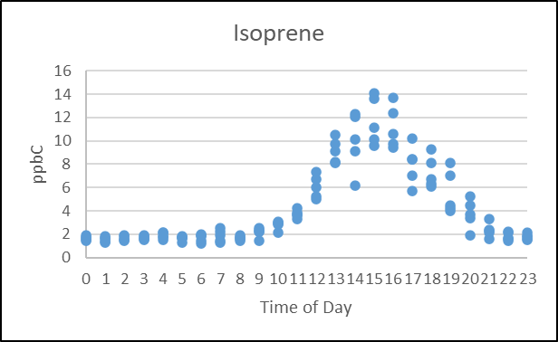

Figure 8. Diurnal Profile Illustrating Daytime Increase of Isoprene

* + - * 1. Level 2: Data that have undergone Level 1 validation are then compared to historical data to evaluate the *temporal consistency* with previous datasets.
        2. Level 3: Data that have undergone Level 2 validation are then compared to data from other sites within the airshed and/or collocated instruments to evaluate differences for systematic bias or to confirm expected differences.

1. DATA REPORTING

Data are to be reported to AQS following data verification and validation processes described in Sections XII and XIII. The reporting of data to AQS is outside the scope of this SOP.

Table 7. Quality Control Parameters and Acceptance Criteria

| **QC Parameter** | **Description** | **Required Frequency** | **Acceptance Criteria** | **Recommended Corrective Action** |
| --- | --- | --- | --- | --- |
| Initial calibration (ICAL) | Multi-point calibration of the auto-GC with minimally a representative hydrocarbon for each GC column-FID combination (e.g., propane and benzene). Minimum of three concentrations covering approximately 10 to 25 ppbC. At their discretion, agencies may use other high level concentrations (e.g., 50 or 80 ppbC). | Initially at the beginning of PAMS season, after maintenance to the instrument (such that the response is impacted), following failing continuing calibration checks, and at the end of PAMS season. Analysts may analyze the primary calibration standard weekly as an additional check to monitor system performance (this is not required). | For linear regression with non-zero y-intercept must show r2 of ≥ 0.99.  Also│intercept/slope│ ≤ 0.5 ppbC or ≤ MDL, whichever is lower. RSD of determined RFs must be ≤ 10%. Each standard level evaluated against the calibration curve must be within ±20% of the theoretical nominal concentration.  If all of the above criteria (r2, │intercept/slope│, RF of RSD, and standard ±20% of nominal) are met, the analyst has the option to use the average RF (note the linear regression is still preferred). Measurement exceeding the calibration range will be qualified as “EH”. | Prepare new calibration. It may be necessary to investigate for system contamination or interferences resulting in suppression or enhancement of analytes. System leaks and trap degradation may impede a proper calibration as well as carryover from high concentration samples or standards. Improperly conditioned traps may contribute chromatographic artifacts. PAMS data must not be reported unless calibration meets criteria. |
| System blank (SB) | Analysis of humidified zero air to ensure the system is sufficiently clean for continued analysis. | Prior to ICAL, and every 24 ± 4 hours of operation following or preceding the CCV (preference is to follow the CCV to ensure absence of carryover before analyzing ambient samples). | All target VOCs must be ≤ the determined MDL or 0.5 ppbC, whichever is lower | Analyze another blank, if possible, to investigate potential carryover from high concentration sample. Investigate system for contamination. Unless technical justification is provided to explain nonconformance, qualify as “LB” in AQS all samples for affected compounds since the last passing SB. |
| Continuing Calibration Verification (CCV) | Analysis of a known standard containing compounds representing the molecular weight range and prepared within the calibration curve to demonstrate the instrument calibration remains within tolerance. Concentration of CCV should be approximately 2 to 5 ppbC for target analytes. | Every 24 ± 4 hours of operation | All target VOCs must recover within ±30% of the expected theoretical nominal concentration. | Investigate chromatogram for retention time shifts which may result in peak misidentification. Investigate for instrument contamination resulting in co-eluting peaks. Investigate for system leaks or trap malfunction resulting in low recovery. Unless technical justification is provided to explain nonconformance, qualify as “QX” in AQS all samples for affected compounds since the most recent passing CCV. Invalidation as “AS” may be required at analyst discretion if compound recovery is exceptionally high or low. |
| Second Source Calibration Verification (SSCV) | Analysis of a known standard prepared from a stock gas including target analytes across the molecular weight range from a supplier different from the stock gas (primary standard) for preparing the ICAL. This check independently verifies the quality of the ICAL for compounds across the molecular weight range. | Immediately following ICAL and weekly thereafter – may serve as the CCV | All target VOCs must recover within ±30% of the expected theoretical nominal concentration. | Analysis cannot commence if propane or benzene fail in the SSCV immediately following the ICAL. Investigate for discrepancy between ICAL and SSCV. Investigate chromatogram for RT shifts which may result in peak misidentification. Investigate for instrument contamination resulting in co-eluting peaks. Investigate for system leaks or trap malfunction resulting in low recovery. Unless technical justification is provided to explain nonconformance, minimally qualify as “QX” and potentially invalidate as “AS” samples for affected compounds since the last acceptable SSCV. |
| Retention Time Standard (RTS) | Analysis of a ~59-component blend of VOCs in the ~2- 60 ppbC range to verify established retention time RT windows | Minimally weekly | All target VOCs must be within the established RT windows. | Review previous week’s ambient and QC check sample data to evaluate events resulting in RT shift. May require reassignment or adjustment of RT windows and reprocessing of data collected since the most recent RTS. Unless technical justification is provided to explain nonconformance, associated ambient sample data will be invalidated (reported with NULL code) as “BH” for compounds whose identities cannot be confirmed. |
| Precision check | Replicate analysis of the CCV to evaluate the reproducibility of the analysis replicates are analyzed sequentially (back to back) | Minimally weekly | Absolute relative percent difference for each target VOC must be ≤ 25% on a week- to-week basis. | Investigate system for contamination, leaks, or suppression, as indicated by trends in compound behavior. Qualify ambient sample data for affected compounds since the last passing precision check as “QX” in AQS. |
| Method Detection Limit (MDL) | Determination of the estimated concentration where the analyte is detected above the background level 99% of the time. The MDL is an estimate of this concentration and is to be determined following the method update rule (MUR) of the 40 CFR Part 136 Appendix B procedure as described in Section 4.3 of Revision 2 of the PAMS TAD. | Annually or following significant change to the instrument or method which would reasonably be expected to result in a significant change to the instrument sensitivity; such as detector replacement, trap replacement, change in carrier gas (i.e., from He to H2) | MDLs must be determined per the prescribed procedure and should be (are not required to be) ≤ 0.5 ppbC for each target VOC. | Investigate instrument for carryover or contamination. Verify spiking level for the MDL procedure is appropriate. Adjust spiking level and repeat procedure. Targets not meeting this specification should be reported with QA qualifier “QX” in AQS. |

1. RESOURCES
   1. Video for changing the preconcentrator trap in the Markes UNITY-xr: <https://www.markes.com/Resources/How-to-video/How-to-replace-the-focusing-trap-on-the-UNITY-xr.aspx>
   2. Video for changing the heated fused-silica transfer line from the Markes UNITY-xr to the GC:<https://www.markes.com/Resources/How-to-video/How-to-replace-the-fused-silica-transfer-line-to-the-GC.aspx>
2. REFERENCES
   1. U.S. EPA. (January 2017) QA Handbook for Air Pollution Measurement Systems: "Volume II: Ambient Air Quality Monitoring Program" EPA-454/B-17-001, Appendix F. Available at (accessed October 2020): <https://www3.epa.gov/ttnamti1/files/ambient/pm25/qa/vol2appf.doc>
   2. U.S. EPA. Technical Assistance Document for Sampling and Analysis of Ozone Precursors for the Photochemical Assessment Monitoring Stations Program. Revision 2. EPA-454/B-19-004 April 2019. Available at (accessed October 2020): <https://www.epa.gov/sites/production/files/2019-11/documents/pams_technical_assistance_document_revision_2_april_2019.pdf>
   3. 40 Code of Federal Regulations, Part 136 Appendix B, Clean Water Act Methods Update Rule for the Analysis of Effluent, August 28, 2017. Available at (accessed October 2020): <https://www.federalregister.gov/d/2017-17271>
   4. U.S. EPA. Quality Assurance Project Plan for the Photochemical Assessment Monitoring Stations (PAMS) Required Site Network for Speciated Volatile, Organic Compounds, Carbonyls, and Meteorological Parameters Including Mixing Layer Height – April 2019. EPA -454/B-19-003. Available at (accessed October 2020): <https://www3.epa.gov/ttnamti1/files/ambient/pams/PAMS_Model_QAPP.docx>

* 1. Thermal Desorption Product Site Preparation Document, QUI-1113, Version 1.0, Markes International, April 2016
  2. Installation Manual UNITY xr, Version 1.1, QUI-1117, Markes International, February 2017
  3. User Manual UNITY-xr, Version 2.0, QUI-1119, Markes International, March 2019
  4. CIA Advantage-xr Installation Manual, Version 2.0, QUI-1150, Markes International, March 2019
  5. CIA Advantage-xr User Manual, Version 2.0, QUI-1142, Markes International, March 2019
  6. CIA Advantage with Markes Instrument Control, Version 1.0, QUI-1126, Markes International, October 2016
  7. Kori-xr Installation Manual, Version 2.0, QUI-1138, Markes International, March 2020
  8. Kori-xr Specification Sheet, L-0050 (020616-1), Markes International
  9. MIC 2.0 Release Notes, Markes International, April 2019
  10. Agilent OpenLAB Data Analysis Getting Started. M8370-90000 Agilent Technologies, Inc. October 2012
  11. Agilent OpenLAB Chromatography Data System (CDS) EZChrom Edition Users Guide, P/N M8201-90014, Agilent Technologies, Inc. February 2015
  12. Agilent OpenLAB CDS Administration, Guide for Administrators, P/N M8305-90012, Agilent Technologies, Inc. January 2014
  13. Agilent OpenLAB Chromatography Data System (CDS), Workstation Installation and Configuration Guide, P/N M8301-90007, Agilent Technologies, Inc., October 2014
  14. Agilent OpenLAB CDS ChemStation Edition, Requirements, P/N M8301-90049 Rev. B, Agilent Technologies, Inc., June 2018
  15. Agilent 7890B Gas Chromatograph Operation Manual, P/N G3430-90054, First Edition, Agilent Technologies, Inc. January 2013
  16. Agilent 7890B Gas Chromatograph Getting Started, P/N G3430-90055, First Edition, Agilent Technologies, Inc. January 2013
  17. Agilent 7890 Series Gas Chromatograph Troubleshooting, P/N G3430-90053, First Edition, Agilent Technologies, Inc. January 2013
  18. Agilent 7890 Series Gas Chromatograph Maintaining Your GC, P/N G3430-90052, Second Edition, Agilent Technologies, Inc. October 2013
  19. Agilent 7890 Series Gas Chromatograph, Service Manual P/N G3430-90006, 9th Edition, August 2013
  20. Agilent Capillary Flow Technology: Deans Switch. Increase the Resolving Power of Your GC, 5989-9384EN, Agilent Technologies, Inc. June 2013
  21. Nomenclature for chromatography, (IUPAC Recommendations, 1993), PAC, 1993. *65*, 819
  22. U.S. EPA Office of Inspector General. *Promising Techniques Identified to Improve Drinking Water Laboratory Integrity and Reduce Public Health Risks*. Report No. 2006-P-00036, October 21, 2006. Available at (accessed October 2020): <https://www.epa.gov/sites/production/files/2015-11/documents/20060921-2006-p-00036.pdf>
  23. World Health Organization. Good Chromatography Practices *Draft for Comments*. Working Document QAS/19,791. February 2019. Available at (accessed October 2020): <https://www.who.int/medicines/areas/quality_safety/quality_assurance/qas19_791_good_chromotography_practices.pdf?ua=1>

Appendix A – Agilent GC Method Parameters

[*Note: alternate method parameters that provide appropriate performance and/or conserve resources are shown in underlined italics*]

GC

Oven

Temperature

Setpoint On

(Initial) 40 °C *(45°C combined with hold time of 15 minutes)*

Hold Time 12 min *(increase hold time to 15 mins if initial temp = 45°C)*

Post Run 200 °C

Program

#1 Rate 5 °C/min

#1 Value 170 °C

#1 Hold Time 0 min

#2 Rate 15 °C/min

#2 Value 200 °C

#2 Hold Time 4 min

Equilibration Time 1 min

Max Temperature 200 °C

Maximum Temperature Override Enabled

Slow Fan Disabled

Cryo Off

Front SS Inlet He

Mode Splitless

Heater On 150 °C *(optionally disable heater as this inlet only supplies carrier gas)*

Pressure On 36.349 psi

Total Flow On 23.1 mL/min

Septum Purge Flow On 0.1 mL/min *(higher flows of 1-2 mL/min reduces occurrence of split peaks and ghost peaks)*

Gas Saver Off

Purge Flow to Split Vent 20 mL/min at 999.99 min *(lower flows down to 1 mL/min are recommended to conserve gas)*

Column

Column #1

Flow

Setpoint On

(Initial) 3 mL/min

Post Run 3 mL/min

Agilent 123-105F

DB-1

0 °C—325 °C (350 °C): 50 m x 320 μm x 1.05 μm

Column lock Unlocked

In Front SS Inlet He

Out PCM C

(Initial) 40 °C

Pressure 36.349 psi

Flow 3 mL/min

Average Velocity 20.978 cm/sec

Holdup Time 3.9724 min

method: C:\CHEM32\1\METHODS\PAMS40C.M

Column #2

Flow

Setpoint On

(Initial) 4.5 mL/min

Post Run 4.5 mL/min

CP-AL203

0 °C—200 °C (200 °C): 50 m x 320 μm x 5 μm

Column lock Unlocked

In PCM C He

Out Back Detector FID

(Initial) 40 °C

Pressure 26.618 psi

Flow 4.5 mL/min

Average Velocity 50.933 cm/sec

Holdup Time 1.6361 min

Column Outlet Pressure 0 psi

Front Detector FID

Heater On 300 °C

H2 Flow On 35 mL/min

Air Flow On 350 mL/min

Makeup Flow On 10 mL/min

Carrier Gas Flow Correction Does not affect Makeup or Fuel Flow

Flame On

Electrometer On

Back Detector FID

Heater On 300 °C

H2 Flow On 35 mL/min

Air Flow On 350 mL/min

Makeup Flow On 10 mL/min

Carrier Gas Flow Correction Does not affect Makeup or Fuel Flow

Flame On

Electrometer On

Valve 1

Other Off

PCM C

PCM C He

PCM C He Supplies Column 2

Aux PCM C He

Pressure

Setpoint Off

(Initial) 10 psi

Post Run 0 psi

Signals

Signal #1: Back Signal

Description Back Signal

Details Back Signal (FID)

Save On

Data Rate 5 Hz

Dual Injection Assignment Front Sample

Signal #2: Front Signal

Description Front Signal

Details Front Signal (FID)

Save On

Data Rate 5 Hz

Dual Injection Assignment Front Sample

Signal #3: Test Plot

Description Test Plot

Details

Save Off

Data Rate 50 Hz

Dual Injection Assignment Back Sample

Signal #4: Test Plot

Description Test Plot

Details

Save Off

Data Rate 50 Hz

Dual Injection Assignment Back Sample

Run Time Events

Run Time Events

#1 Time 4 min

#1 Event Valve

#1 Position Valve 1

#1 Setpoint On

#2 Time 12 min

#2 Event Valve

#2 Position Valve 1

#2 Setpoint Off

Appendix B – Basics of Chromatography

This appendix is intended to assist the auto-GC-FID operator in understanding basic terms and concepts of chromatography as well as proper techniques for data interpretation and processing. It is not meant as an in-depth discussion of chromatographic principles and theory, for which there are numerous available resources.

* + - 1. Basic Chromatography Theory

Briefly, a gas chromatograph (GC) separates the substances in an injected sample within a separation column containing a solid phase which inhibits the substances to be separated as they are carried through the separation column by an inert carrier gas flowing at a constant rate. The introduced substances are separated within the column based on their affinity for the solid phase, and at the end of the column exit, or elute, to a detector – for PAMS auto-GCs, the detector is a flame ionization detector (FID). Typically, the GC oven containing the column is heated according to a temperature program to decrease the time it takes for later eluting substances and shorten the overall GC run time. The detector responds to the substance in proportion to the amount (i.e., mass) of substance as a function of time and the detector response and associated time since injection are continually recorded by the data system to prepare a chromatogram.

* + - 1. Anatomy of a Chromatogram

A GC chromatogram is a plot of the detector response as a function of time for a single injection on the GC. The detector response (on the y-axis or ordinate) is typically displayed in units of millivolts (mV), picoamperes (pA), counts per second (cps), or other relevant unit indicative of an electric or electronic change within the detector. Time (on the x-axis or abscissa) is displayed in minutes or seconds which starts at the injection time (the time the sample was injected onto the separation column). There will typically be a time delay for beginning data collection (acquisition) on a chromatogram such that the detector response recording begins just prior to the elution of the first expected target substance. Refer to Figure B-1 for a detailed example chromatogram illustrating basic chromatogram components.

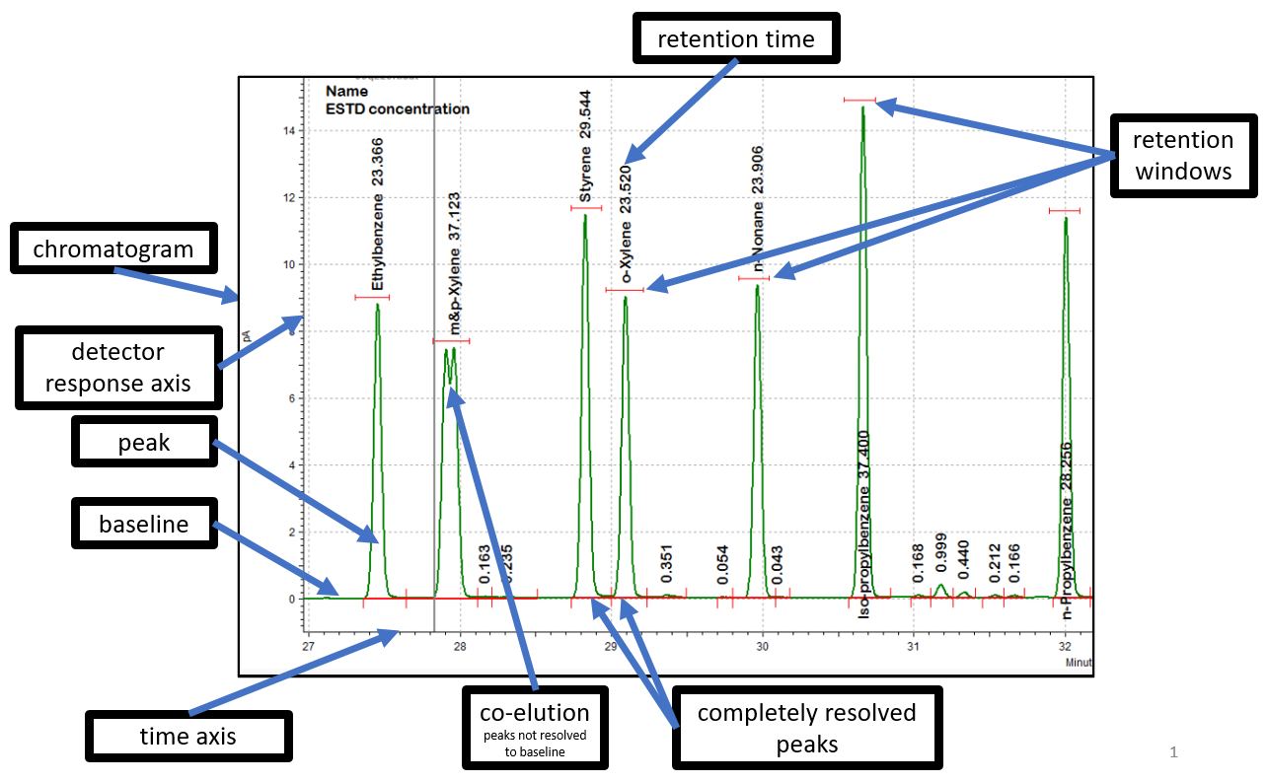**Figure B-1. Basic GC-FID Chromatogram Detailing Components**

* + - 1. Basic Chromatography Terminology

The following basic descriptions correlate to aspects of gas chromatography and/or chromatograms for which instrument operators must be familiar.

**Baseline**: The detector response to the carrier gas and make-up gas in the absence of a substance (refer to Figure B-1). The baseline should be sufficiently free from noise. Baselines will typically exhibit some level of electronic noise as shown below in Figure B-2. While baseline anomalies, such as dips, rises, or spikes, are common, they may interfere with proper data processing.

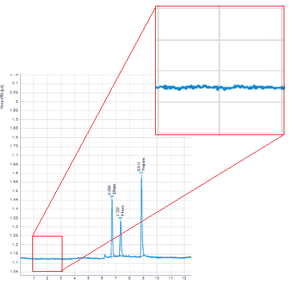

**Figure B-2. GC-FID Chromatogram Detailing Baseline Noise**

**Chromatographic Peak**: The increase and subsequent decrease of the detector response as a substance elutes from the GC column (refer to Figure B-1). Chromatographic peaks for a single substance are ideally normal Gaussian in profile shape where the peak starts at the baseline, increases to the apex, and decreases to return back to the baseline (refer to Figure   
B-3). It is common for peaks to be malformed, exhibiting asymmetry.

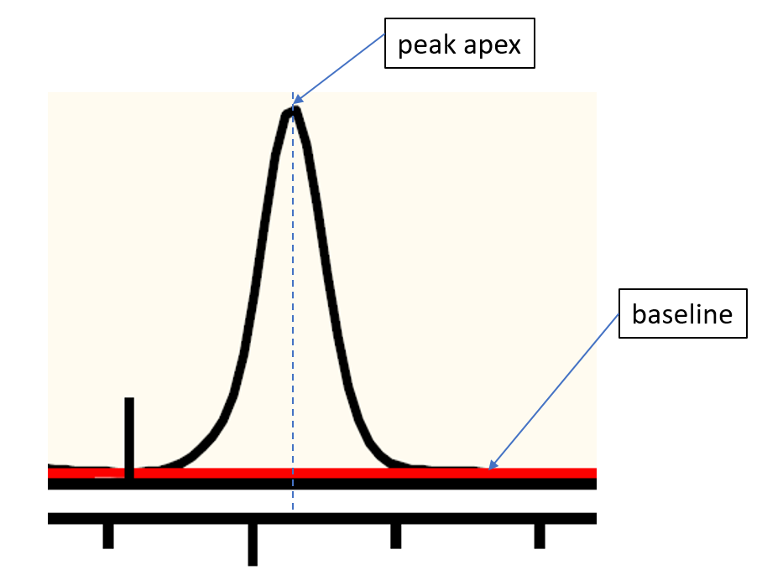

**Figure B-3. Example GC Chromatogram Detailing Peak Apex and Baseline**

**Co-elution**: Simultaneous elution from the GC column of two or more substances resulting in overlapping of their chromatographic peaks where the detector response does not return to baseline between the substances (refer to Figure B-1). Co-elutions for which one of the substances is of much smaller magnitude may show as peak shoulders or “riders” (refer to Figure B-4).

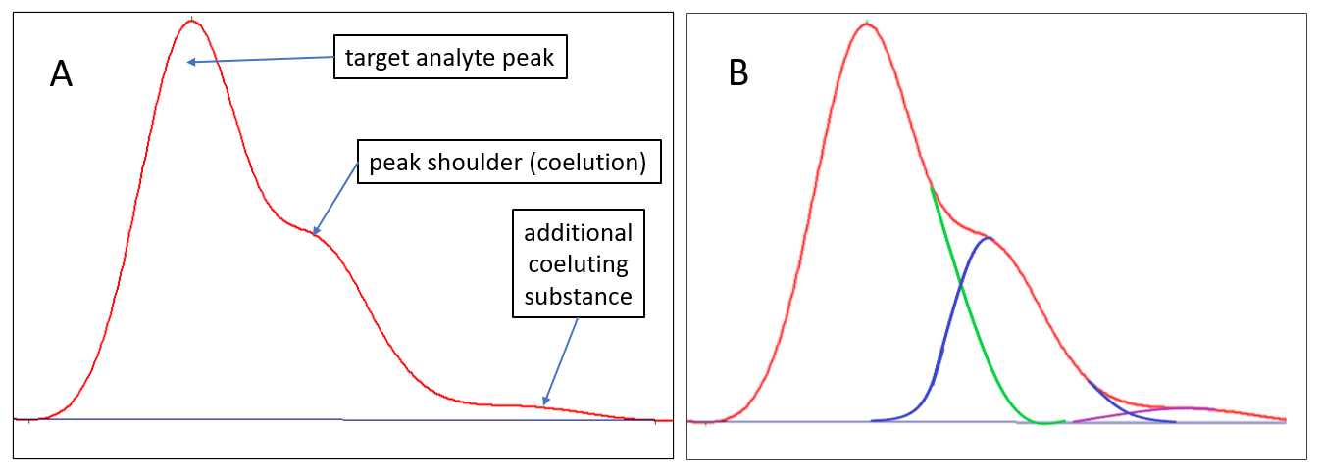

**Figure B-4. Chromatogram Showing Three Co-Eluting Substances (A) and Approximate Reconstruction of the Individual Peaks (B)**

**Retention Time (RT)**: The time relative to the time of injection that a substance elutes from the column (refer to Figure B-1). The RT is defined at the peak apex (refer to Figure B-3).

**Retention Window**: The range of time in the GC program during which a target analyte is expected to elute (refer to Figure B-1). The GC operator defines the retention window for a given substance.

**Resolution**: The extent to which the detector response returns to the baseline between chromatographic peaks (refer to Figure B-1). Peaks are considered to be completely resolved when the detector response returns to the baseline between peaks.

**Peak Area**: The defining of the bounds of the region under the detector response curve of a chromatographic peak (refer to Figure B-3). This is defined by drawing a line to represent the baseline at the bottom of the peak and the area within these bounds is the total response of the eluted substance. Co-elutions complicate the definition of peak area.

**Peak Integration**: The defining of the boundaries of area under a chromatographic peak. The parameters for defining integration are user-defined and may be accomplished by chromatography data system (CDS) software (automated integration) or by analyst manual manipulation (manual integration).

**Peak Tailing**: Asymmetric chromatographic peak shape for which the majority of the peak’s area occurs after the peak apex and typically exhibits a slow decay of the detector response back to the baseline (refer to Figure B-5). Tailing peaks typically occur due to the substance having a strong affinity to the column solid phase and/or there is an active site that further inhibits movement of the substance within the column or GC inlet.

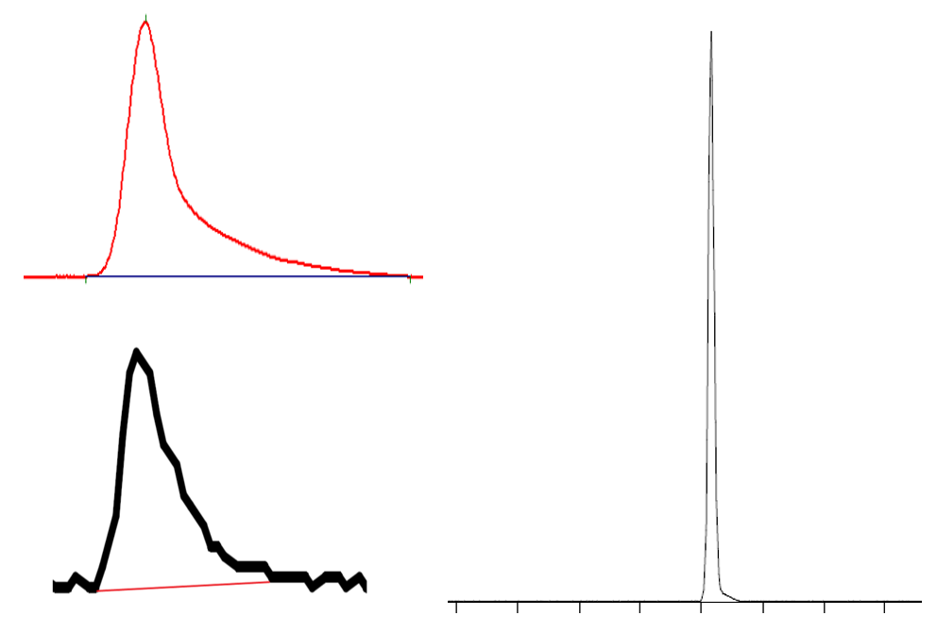

**Figure B-5. Examples of Tailing Chromatographic Peaks**

* + - 1. Chromatographic Peak Integration

Monitoring agencies must follow the procedures listed in the following section regarding chromatographic peak integration unless the monitoring agency has an existing SOP covering integration (reference governing SOP here, if such exists).

It is imperative that monitoring agencies define the methods of peak integration to be employed such that integrations are technically justifiable and consistently performed. For example, the chromatogram in Figure B-6 shows a series of four peaks integrated by two different technically justifiable conventions – tangent skim (A) and perpendicular drop (B). The tangent skim convention shown in this example represents the minimum peak area attributable to each peak; however, the perpendicular drop convention attempts to represent the peak areas when taking into account the baseline trend before and after this series of peaks. Given the magnitude of the baseline noise, both conventions are technically justified; however, this is an example for which the monitoring agency SOP must specify the convention preference to avoid ambiguity in justifying the selected convention.

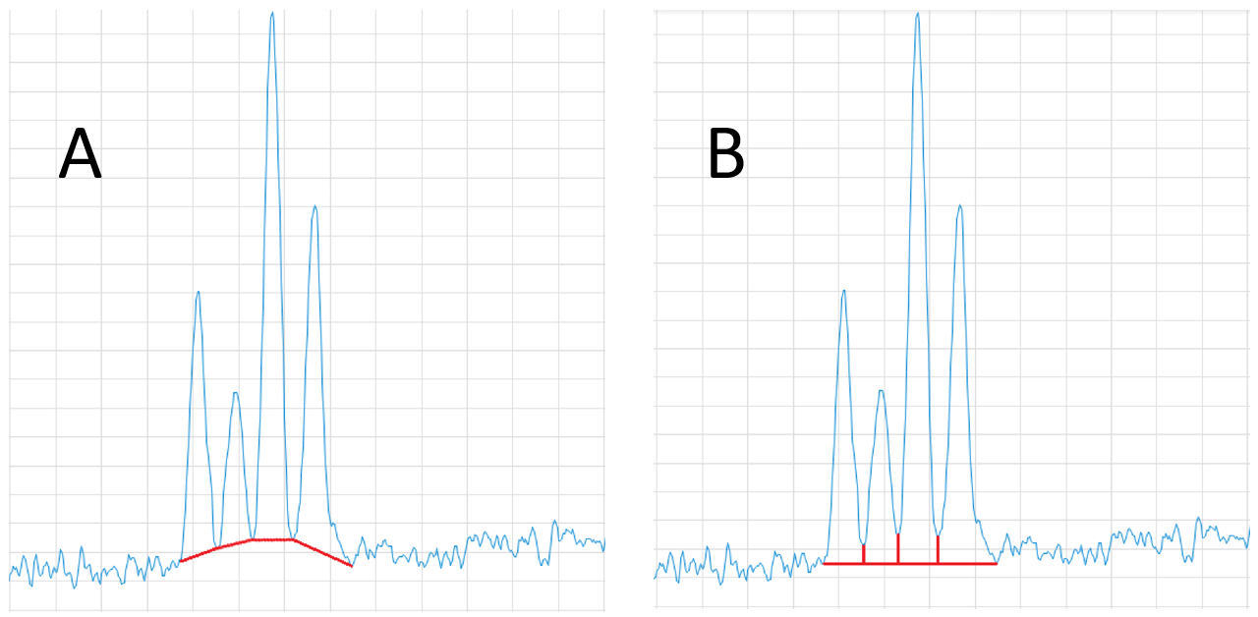

**Figure B-6. Example Integration of Incompletely Resolved Chromatographic Peaks Employing Tangent Skim (A) and Perpendicular Drop (B)**

*Under no circumstances may peak integration be improperly adjusted in order to enable calibration standards or QC samples (e.g., blanks or calibration checks) to meet acceptance criteria.*

The Agilent CDS software (whether the EZChrom, ChemStation, or OpenLab CDS) includes refined functions and routines for performing automated integration of chromatograms. The default integration parameter settings typically provide proper and suitable peak integration; however, some configuration adjustments may be needed for target analytes that exhibit a low response, are subject to RT shifts, exhibit co-elutions, and/or indicate other interferences.

**Proper Integration Techniques**

Peak integration is straightforward when chromatographic peaks occur on a stable baseline, have a sufficient (> 20:1) signal-to-noise ratio (S:N), and are completely baseline resolved (start and end at the baseline) without co-elutions. Integration becomes more difficult to perform properly when these conditions are not met and peaks exhibit a low signal-to-noise ratio, co-elutions, and/or the baseline is not stable or is very noisy. In these situations, the CDS automated integration parameters may appropriately integrate the given peak(s); however, may require manual override to integrate properly or according to monitoring agency policy.

A discussion of proper integration techniques follows:

**Baseline-to-Baseline**: Chromatographic peaks will be normally integrated such that the peak integration baseline start and stop corresponds to the portion of the detector response of the established baseline prior to and after the peak as shown below in Figure B-7.

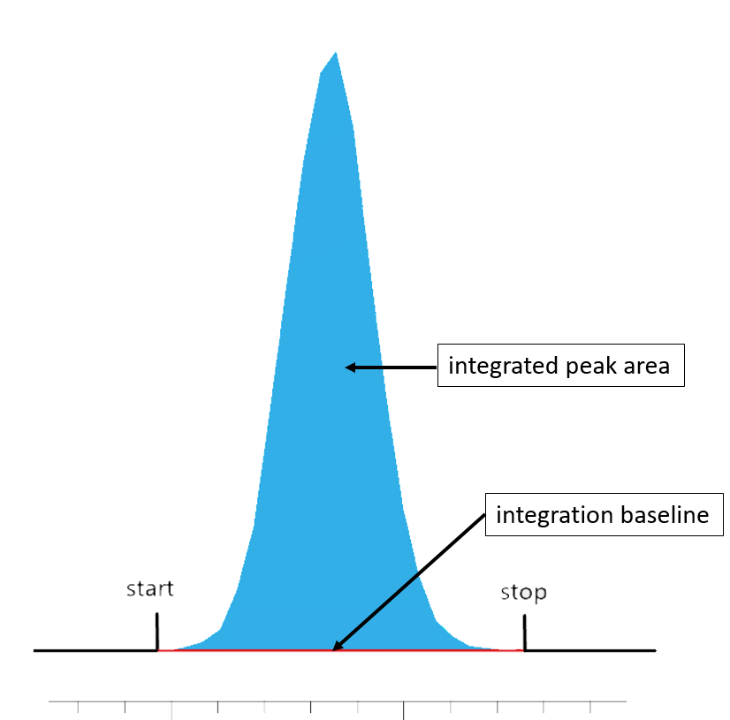

**Figure B-7. Example Baseline-to-Baseline Integration of a Chromatographic Peak**

Co-eluting chromatographic peaks result in an elevated detector response due to the contribution by the co-eluting substances. There are several methods for integrating the overlapping peaks, including the perpendicular drop and tangent skim.

**Perpendicular Drop**: For situations where the unresolved peaks are relatively similar in magnitude, the peaks can be integrated by dropping a perpendicular from the bottom of the valley between the peaks to the baseline to define the area of the peaks (refer to Figure B-8).

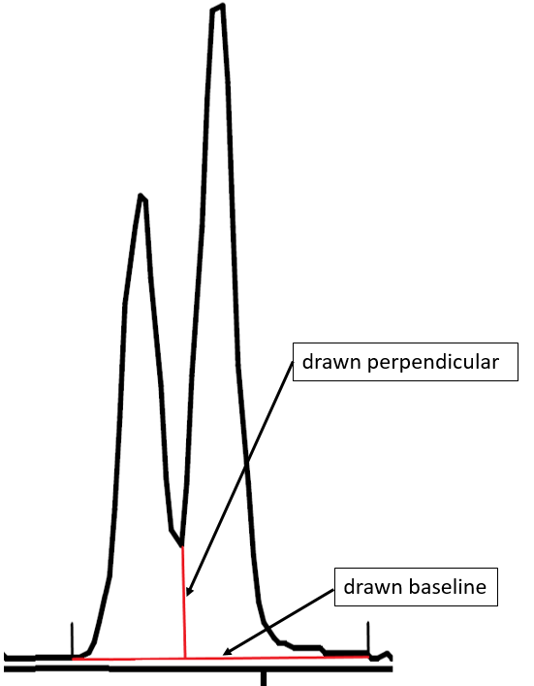

**Figure B-8. Perpendicular Drop Integration for Co-Eluting Peaks**

**Tangent Skim**: For co-eluting peaks where one peak is much larger in magnitude, the peak integration can be accomplished by tangent skim. Tangent skim options within the CDS typically permit use of straight line or exponential tangent skimming, as shown in Figure B-9, peaks (A) and (B), respectively.

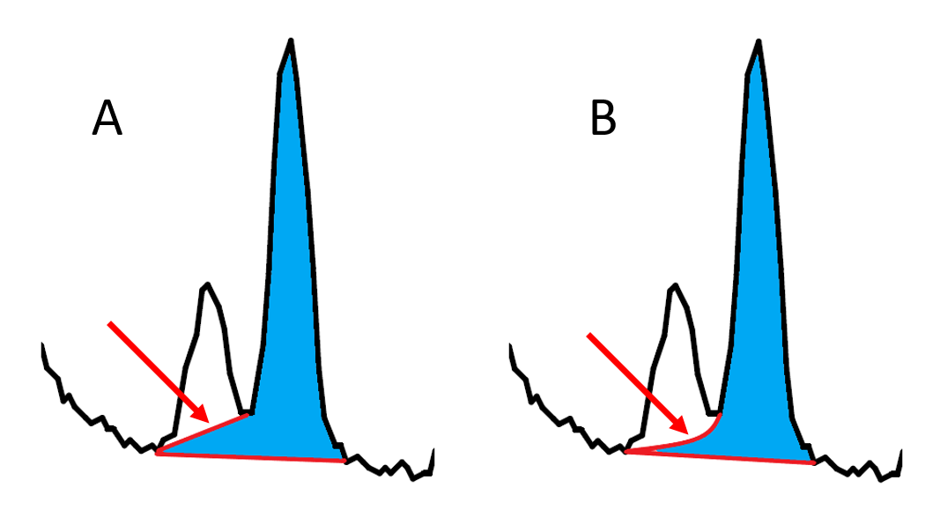

**Figure B-9. Examples of Straight Line (A) and Exponential (B) Tangent Skim Techniques**

**Improper Peak Integration Practices**

**Integrating Noise as Target Peak Area**: CDS automated integration parameters may improperly identify and integrate baseline noise as target analyte peaks (refer to Figure B-10). This typically occurs when the peak area reject threshold or peak height reject threshold parameter is set too low. Analysts will over-ride such automated identification and integration of noise as target analyte peaks.

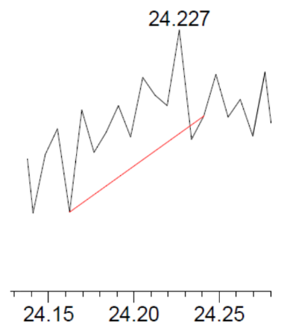

**Figure B-10. Baseline Noise Improperly Integrated as a Target Peak**

**Peak Shaving**: Peak shaving is the improper reducing of integrated peak area by improperly drawing baselines and/or perpendiculars. Examples of improper peak shaving integrations are detailed in Figure B-11.

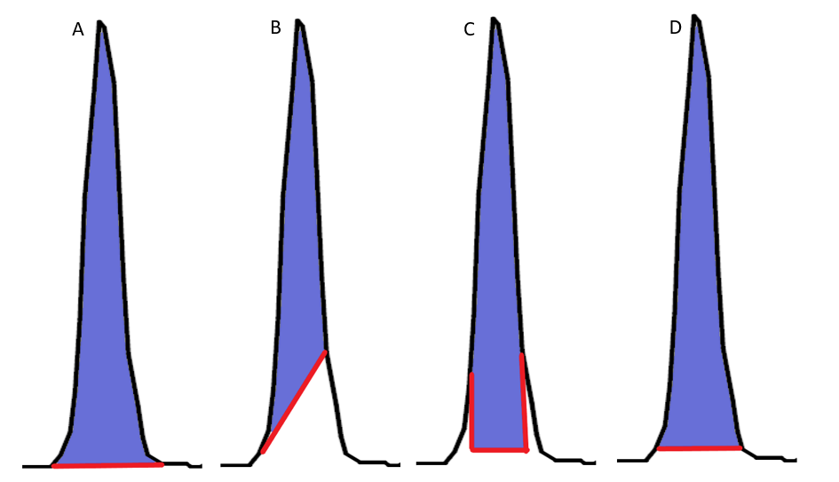

**Figure B-11. Proper Peak Integration (A), Improper Tangent Skim (B), Improper Perpendicular Drops (C), and Improperly Drawn Baseline (D)**

**Peak Enhancement**: Peak enhancement is the improper inclusion of peak area that does not belong to a chromatographic peak. Practices that improperly enhance peak area are shown in Figure B-12 and include:

1. including baseline noise or additional unrelated peaks before or after the target peak
2. including additional baseline area
3. including co-eluting peaks or shoulders

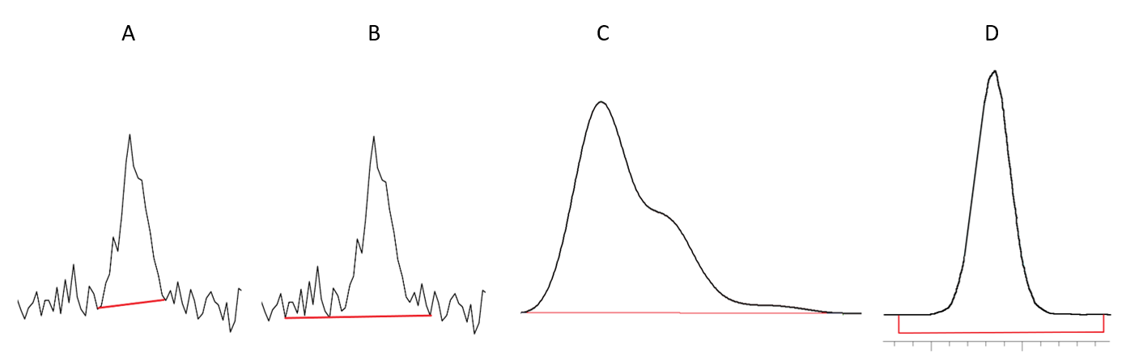

**Figure B-12. Proper Peak Integration (A), Improper Inclusion of Noise (B), Improper Inclusion of Co-Elutions (C), and Improper Inclusion of Baseline (D)**