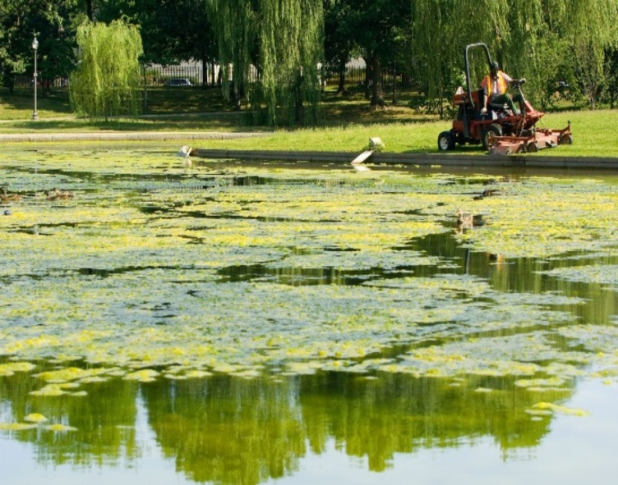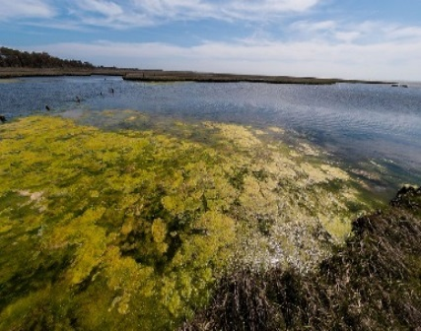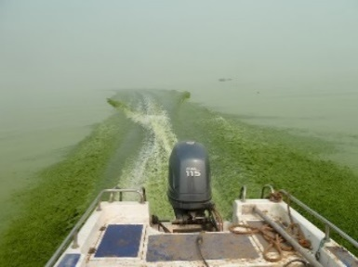
SOCIAL MEDIA
RECREATIONAL WATER ADVISORY or CLOSURE LIFTED

TWITTER
- “Beach closure update! The notification of [cyanotoxins or cyanobacteria] contamination for [location] has been lifted. For more information, see: [insert website link]”
- “[Testing Agencies name] confirms levels of [cyanotoxins or cyanobacteria] at [location] are safe for swimming. [Location] is now open. For more information, see: [insert website link]”

FACEBOOK

- “The notification of [cyanotoxins or cyanobacteria] contamination has been lifted for [location]. For more information, see: [insert website link]”

- “[Testing Agencies name] confirms levels of [cyanotoxins or cyanobacteria] acceptable for all recreation at [location]. [Location] is now open. For more information, see: [insert website link]”

AUTOMATED TEXT MESSAGES
- “Beach closure update! The [location] is now open. For additional information, please see [website link].”

- Wireless Emergency Alert message: “Update! The closure of [location] due to [cyanotoxins or cyanobacteria] contamination has been lifted. For more information, see: [insert website link]”

