Draft email
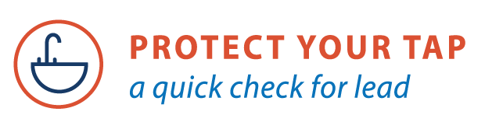

PROTECT YOUR TAP: A Quick Check for Lead is an online step-by-step guide to help you identify if you have lead pipes bringing water into your home and provide tips on reducing lead exposure in drinking water.

We encourage you to use this interactive guide. You’ll need a magnet and something to scratch a pipe, like a coin or a key.

Click on the banner above to go to the guide or copy and paste this address into your internet browser: www.epa.gov/protectyourtap

(Add your contact information here)

