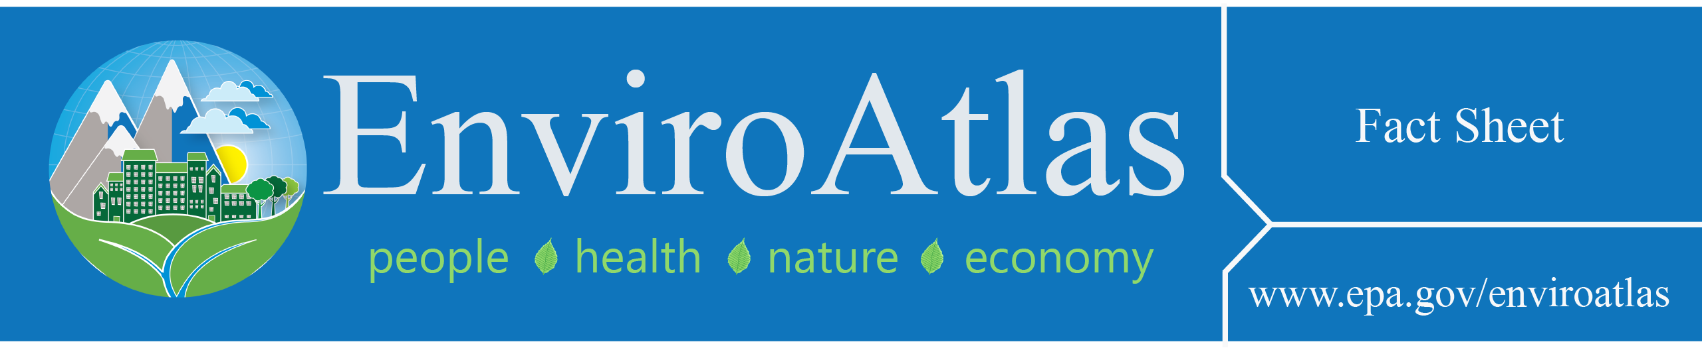
Percent Tree Cover
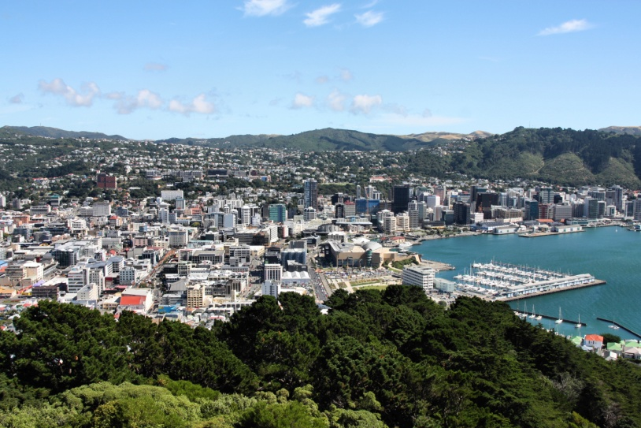
This EnviroAtlas community map illustrates the percent of total land within each census block group that is covered by trees. In EnviroAtlas, tree coverage takes many forms, including street trees, parks, urban forests, and single trees on various properties.

Why is tree cover important?
Tree cover provides many benefits, including air and water filtration, water and carbon storage, natural hazard mitigation, and appealing settings that encourage people to spend time outdoors. Trees can reduce noise, buffer pedestrians from traffic, and cool summer temperatures, making these spaces more hospitable environments. Trees also provide vital habitat for a wide range of species. There are many health benefits that can be gained from the natural services that trees provide; examples from scientific studies include decreases in asthma, obesity, and cardiovascular symptoms.
Trees often increase the aesthetic value, comfort, and safety of populated areas. In urban centers, people frequent parks and tree-lined districts to socialize, recreate, and engage with nature. Areas with trees also provide opportunities to observe and appreciate wild bird and animal species. Spending time in these settings has been shown to decrease stress, depression, and feelings of hostility. Additionally, simply viewing trees through a window may increase cognitive function and overall satisfaction, and aid in physical healing.
Urban trees also filter and divert airflow, reducing concentrations of nitrogen oxides (NOx), particulate matter (PM), ozone, and other harmful air pollutants. The efficiency of trees to reduce ambient concentrations of air pollutants varies by species. Given the fact that air pollutants negatively affect health by exacerbating and even causing conditions such as asthma and bronchitis, their removal or dilution has the potential to decrease cases of respiratory illnesses. Though pollen from trees can potentially act as an allergen, it has been found that higher street tree density is associated with lower prevalence of childhood asthma.
Green spaces, especially those with trees, are generally cooler and more shaded than other areas in the same vicinity and thus can offer a reprieve from extreme summer temperatures. Trees help reduce day- and nighttime ambient temperatures through shading and evapotranspiration. During heat events, tree cover can significantly reduce local ambient air temperatures, helping to reduce stress, hospital admissions, and mortality associated with extreme heat.
Tree cover further serves communities by filtering and absorbing water that flows off of impervious surfaces like roads and parking lots. Natural vegetation can increase downstream drinking water quality by filtering out high percentages of contaminants such as nitrogen, phosphorus, sediment, and certain pesticides. In addition, tree cover helps to regulate the flow of water through a watershed by intercepting, absorbing, and slowly releasing water. This “sponge” effect can reduce adverse impacts of stormwater runoff such as stream bank erosion, sediment transport, and the frequency and severity of floods and drought. The lack of significant tree cover and other vegetation in and around populated areas can result in more frequent and/or severe flooding, potentially resulting in adverse health effects associated with these events.

How can I use this information?
The map, Percent Tree Cover, provides a baseline for the percent of tree cover in any given block group in the greater community.
The map can be used to select neighborhoods and areas for restoration and reforestation projects. Used in conjunction with demographic data available in EnviroAtlas, this map can highlight which populations are likely receiving the benefits of tree cover and which populations may be more vulnerable to the potential risks associated with poor tree cover. It can also be used with urban planning data to determine potential future benefits and current benefits at risk from changes to tree cover in developing areas.

How were the data for this map created?
This map is based on the land cover data derived for each EnviroAtlas community. The land cover data was created from one-meter aerial photography through remote-sensing methods. Land cover that is considered to be green space includes all land that is vegetated; it excludes barren land, water, and impervious surfaces. This calculation was summarized by 2010 U.S. Census block group boundaries.

What are the limitations of these data?
All of the EnviroAtlas community maps that are based on land cover use remotely-sensed data. Remotely-sensed data in EnviroAtlas have been derived from imagery and have not been verified. These data are estimates and are inherently imperfect. The land cover maps used in the community component of EnviroAtlas typically have an overall accuracy of between 80 and 90 percent. This level of accuracy means that there is a probability of at least 80 percent that the land cover reported at any given point on the map is correct.
The land cover maps will be updated over time; updates may have improved accuracy as data and classification methods improve. This map is not meant to be used for inferring numbers or types of residents that are at risk for developing specific health conditions.

How can I access these data?
EnviroAtlas data can be viewed in the Interactive Map, accessed through web services, or downloaded. The EnviroAtlas land cover maps created for each community are available under the Supplemental Maps tab in the Interactive Map.

Where can I get more information?
There are numerous resources on the relationships between trees and forests, ecosystem services, and human health and well-being; a selection of these resources is below. In-depth information on the relationships between forests and human health and well-being can be found in EPA’s Eco-Health Relationship Browser. For additional information on how the data were created or their limitations, access the metadata for the data layer. To ask specific questions about these data, please contact the EnviroAtlas Development Team.

Acknowledgements
The data for Percent Tree Cover were generated by Alexandra Sears, EPA Student Services Contractor. The fact sheet was created by Jessica Daniel, EPA Student Services Contractor and Laura Jackson, EPA.

Selected Publications
Hibbert, Alden R. 1967. Forest treatment effects on water yield. Coweeta Hydrologic Laboratory, Southeastern Forest Experiment Station, Forest Service, U.S. Department of Agriculture, Asheville, North Carolina.
Lovasi GS, Quinn JW, et al. 2008. Children living in areas with more street trees have lower prevalence of asthma. Journal of Epidemiology and Community Health 62:647-9.
Morita E, Fukuda S, et al. 2007. Psychological effects of forest environments on healthy adults: Shinrin-yoku (forest-air bathing, walking) as a possible method of stress reduction. Public Health 121:54-63.
Netz YW, Wu M-J, et al. 2005. Physical activity and psychological well-being in advanced age: A meta-analysis of intervention studies. Psychology and Aging 20:272-84.
Nowak D J, D E Crane, et al. 2006. Air pollution removal by urban trees and shrubs in the United States. Urban Forestry & Urban Greening 4(3–4): 115-123.
Pretty J, Peacock J, et al. 2005. The mental and physical health outcomes of green exercise. International Journal of Environmental Health Research 15:319-37.
Shin WS. 2007. The influence of forest view through a window on job satisfaction and job stress. Scandinavian Journal of Forest Research 22:248-53.
Solecki WD, C Rosenzweig, et al. 2005. Mitigation of the heat island effect in urban New Jersey. Global Environmental Change Part B: Environmental Hazards 6(1): 39-49.
Ulrich RS. 1984. View through a window may influence recovery from surgery. Science 224(4647): 420-421.

