MEGACITIES PARTNERSHIP
Air Quality Management Plan Draft Template
May 2021

Table of Contents
Executive Summary 1
1. Introduction 2
2. AQMP Development Process 2
2.1. Stakeholder Engagement in the AQMP Development Process 2
2.2. Current Monitoring Network or other Data Sources 2
2.3. AQMP Development: Analytic Steps 2
3. Summary of the Air Quality Baseline Characterization 3
3.1. Baseline Emissions and Atmospheric Conditions 3
3.2. Expected emissions trends 3
3.3. Ambient air quality 3
3.4. Health implications of the baseline air quality scenario 3
3.5. Capacity assessment 3
4. Gaps and Limitations 4
4.1. Enhancing AQ monitoring capabilities 4
4.2. Improve emissions inventories 4
4.3. Improve access to laboratory facilities 4
4.4. Improve national-city cooperation 5
4.5. Enhance education and outreach on air pollution issues 5
5. Overall Objective and Goals of the AQMP 5
6. Implementation Plan 5
7. Monitoring and Evaluation 8
8. Conclusion 9

Executive Summary
Include an executive summary of main findings here.

Introduction
This section provides a brief history of air quality management, relevant authorities and impetus for development of the plan.

AQMP Development Process
This section outlines the various processes that contributed to the development of the AQMP with more detail in the following sections.

Stakeholder Engagement in the AQMP Development Process
This section summarizes stakeholder engagement (both outside and within the government) that has occurred in the development of the proposed standards.

Current Monitoring Network or other Data Sources
This section discusses the current monitoring network and air quality data considered during the baseline characterization and standards development. Maps and summary statistics of the monitors should be included here.

AQMP Development: Analytic Steps
Previous AQMPs have been developed through a process of collaboration and consultation with stakeholders in industry and government, with support from the USEPA. The process typically includes the steps listed below. Megacity Partner organizations and the host cities should provide relevant details, analyses undertaken, and collaborators included in each step.
- Review and update of emissions and ambient standards.
- Analysis of emissions source contributions.
- Evaluation of AQ monitoring data.
- Estimation of current and projected future health burden of air quality.
- Establishment of goals and objectives for the plan.
- Development of a detailed implementation plan. Achieving the goals and objectives of the plan requires a detailed implementation plan – this is proposed in Section 6 of this plan and will be continuously updated through stakeholder engagements and as part of the ongoing monitoring and evaluation of the plan’s effectiveness, which is outlined in Section 6.

Summary of the Air Quality Baseline Characterization
The air quality baseline reflects all air pollution regulations and policies currently in place or signed into law and adjusted to reflect a future economic growth scenario. Previous AQMPs have estimated future emissions growth at the same rate of projected GDP growth or projected growth of individual source sectors; discussions with the host agency will inform and drive the projected growth assumptions. Overall, the baseline reflects current emission sources, their expected trends for the foreseeable future, and current air quality. The baseline characterization also has implications for health status and includes the state of governmental air quality management capacity, national and local.

Baseline Emissions and Atmospheric Conditions
This section describes the set of sources including point sources (e.g. industrial sites), mobile sources (vehicles), and area sources, both from naturally occurring (wind-blown dusts and sea salt) and man-made (cook stoves and open burning of wastes) sources. This section will also include information regarding relevant meteorological conditions affecting air quality and demographic characteristics.

Expected emissions trends
The expected emissions trends section will detail what is known regarding expected emissions growth. If actual emission trend projections are not available for the megacity, projections can be forecasted using projections for the priority emission sources, such as projected growth of vehicle fleet, GDP, and population within the metropolitan area.

Ambient air quality
This section includes information on ambient air quality, including the data sources for the information. This includes government and academic research, as well as ground-based monitoring.

Health implications of the baseline air quality scenario
Quantifying the current and/or projected health burden is compelling evidence for motivating action on air pollution. The baseline health impact estimates the health implications of the baseline air quality scenario and the burden of particulate matter air pollution. Previous AQMPs have used the BenMAP-CE tool to calculate the baseline health burden estimate. Future scenarios of projected air quality and health impacts should also be included in this section, if data and resources permit.

Capacity assessment
This section includes an analysis of the governmental, academic, research, and local resources available to enhance air quality management efforts. Table 1 below can be used to provide a summary of capabilities for each major component of a complete air quality management system. For each component of the AQMS listed in Table 1, an initial status assessment and any potential capacity gaps should be filled in the corresponding columns.
Table 1. Status of Air Quality Management System Capabilities
COMPONENT OF AQMS | INITIAL ASSESSMENT OF STATUS | POTENTIAL CAPACITY GAPS
Laws and Regulations | - | -
Emission Inventory | - | -
Ambient and Source Air Quality Monitoring | - | -
Air Pollution Dispersion/Fate and Transport Modeling | - | -
Data Analysis and Interpretation | - | -
Public Participation and Environmental Justice | - | -
Control Strategy Planning and Development | - | -
Compliance and Enforcement | - | -

Gaps and Limitations
Next steps identified in the AQMP should aim to fill systemic, capacity, and resource gaps identified throughout the AQMP drafting process, and Partnership more generally. This section should list and describe major areas where capacity limitations can and should be addressed to further enhance the ability to plan, implement, monitor and evaluate emissions reduction performance. The examples should be specific to the megacity and targeted and may include:

Enhance AQ monitoring capabilities

Improve emissions inventories

Improve access to laboratory facilities

Improve national-city cooperation

Enhance education and outreach on air pollution issues

Overall Objective and Goals of the AQMP
The centerpiece of the AQMP is establishing an overall air quality objective for the Megacity, for example:
“Ambient particulate air quality is brought into full compliance with national ambient air quality standards by 2022, and the state of compliance is maintained as the region develops economically.”
To meet this objective, the section should set forward actionable goals by which the objective will be fulfilled, for example:
- Goal 1: Ambient concentrations of air pollutants comply with the relevant ambient air quality standards because of planned emission reductions
- Goal 2: Cooperative governance promotes the implementation of the AQMP
- Goal 3: Air quality management is supported by effective systems and tools
- Goal 4: Air quality decision-making is informed by sound research
- Goal 5: Knowledge and understanding amongst decision-makers, stakeholders, and the general public is improved according to an education and outreach plan

Implementation Plan
The implementation plan outlined below is designed to fulfill the goals for achieving the main objective of the AQMP. The implementation is detailed and specific, and includes the fundamentals of program execution, monitoring, and evaluation – concrete activities, responsible agencies, accountable timelines, and performance indicators to track progress over time.
The objectives below are examples of what might be included.
TAble 2. Outline of action items to meet AQMP goals.
Goal 1: Ambient concentrations of air pollutants comply with the relevant ambient air quality standards because of planned emission reductions
Objectives | Activities | Mandatory Responsibility | Participatory Responsibility | Time-frames | Indicators
Update ambient standards | - | - | - | - | -
Reduce emissions from personal vehicles | - | - | - | - | -
Reduce dust from unpaved roads | - | - | - | - | -
Reduce emission from industrial sources | - | - | - | - | -
Reduce open burning emissions | - | - | - | - | -

Goal 2: Cooperative governance promotes the implementation of the AQMP
Objectives | Activities | Mandatory Responsibility | Participatory Responsibility | Time-frames | Indicators
Align national and local vehicle emission standards | - | - | - | - | -
Implement and enforce vehicle emissions inspections | - | - | - | - | -

Goal 3: Air quality management is supported by effective systems and tools
Objectives | Activities | Mandatory Responsibility | Participatory Responsibility | Time-frames | Indicators
Effectively collect, manage, and disseminate emissions and air quality data to partners | - | - | - | - | -
Clarify data sharing and confidentiality policies | - | - | - | - | -
Enhance monitoring capabilities | - | - | - | - | -
Enhance “bottom-up” (building up from source to ambient AQ) systems and tools | - | - | - | - | -
Goal 4: Air Quality Decision-making is informed by sound research
Objectives | Activities | Mandatory Responsibility | Participatory Responsibility | Time-frames | Indicators
Coordinate and align public health air quality research being conducted by academia | - | - | - | - | -
Utilize existing monitor information to identify patterns and trends that can inform AQMP implementation | - | - | - | - | -
Develop local and external capabilities to perform analysis | - | - | - | - | -

Goal 5: Knowledge and understanding amongst decision-makers, stakeholders, and the general public is improved according to an education and outreach plan
Objectives | Activities | Mandatory Responsibility | Participatory Responsibility | Time-frames | Indicators
Enhance understanding among general public | - | - | - | - | -
Inform decision makers to take action on the key activities in AQMP and air policy decision making | - | - | - | - | -
Assist stakeholders and the regulated community to understand and comply with regulations under the AQMP | - | - | - | - | -

Monitoring and Evaluation
In order to meet the main objective established, Section 7 outlines the long-term plan to evaluate progress towards the goals and objectives.
Figure 1 below provides a summary of the ongoing process of air quality management envisioned. Steps 1 through 3 have been used to formulate this first draft of the plan. Available air quality data and information have been used to assess the current situation and identify key sources. These results have in turn been used to prioritize actions for the key industrial point sources and for continued progress in reducing emissions from mobile sources (using both tailpipe controls and fuels content regulation). This plan represents the first step in taking action (Step 4).
Figure 1. Air Quality Management Process Cycle
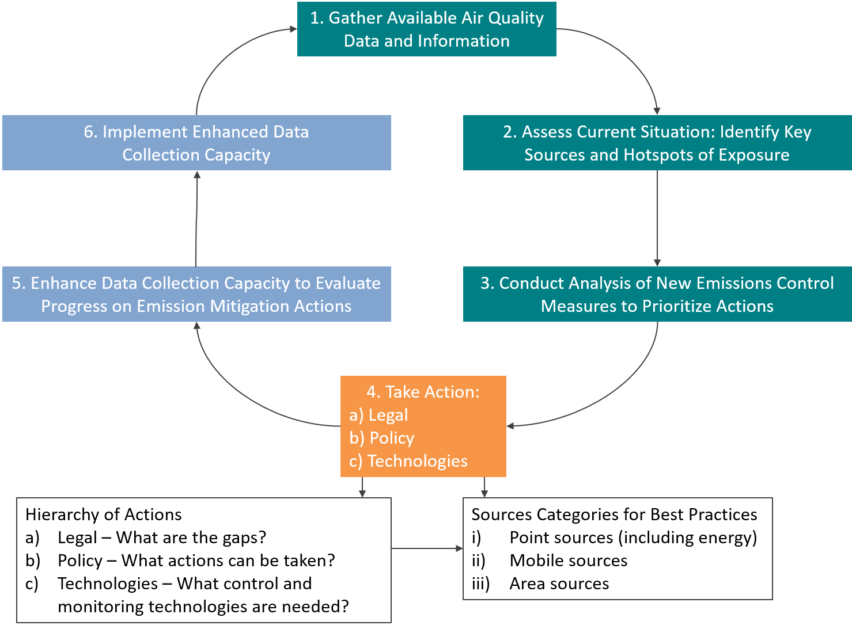

Note that the review will also evaluate the state of emissions drivers, including faster or slower growth in emissions rates, air pollutant exposures, and the economy. The 5-year formal evaluation will also include an update on the availability of financing for implementation of the plan and to support meaningful changes in emissions rates and transition to new technologies, particular for point sources but also for the turnover of the mobile source fleet to cleaner technologies and the availability in retail settings of cleaner, low sulfur diesel and gasoline.

Conclusion
Include final conclusions and next steps for the AQMP.

