**ATTENTION [SYSTEM NAME] RESIDENTS**

*Please Read the Following Backflow Prevention Guidelines*

*Carefully and Help Us Keep Our Water Safe!*

## What is Backflow?

Backflow is when a drop in the incoming water pressure allows a reverse flow from a homeowner’s plumbing system back into the public water system. For example, if you have a garden hose submerged to fill a bucket, Jacuzzi, fish tank, etc., and the water system suddenly loses pressure, the flow of water can be reversed, sucking any contaminants in the water backwards into the system.

A Cross-Connection is any physical connection between a possible source of contamination and the public water system. For example, if a homeowner uses a cistern or an old well for outdoor watering, it cannot be connected to pipes that are connected to the public water system. Even with a bypass valve in place, it is prohibited.

## Why is Preventing Backflow Important?

Cross connection control is extremely important in public water systems as it is a matter of public health and safety. Many contamination issues in public water systems, including bacteria from sewage, are not due to the water source but are due to cross-connections. Therefore, it is very important that all customers are aware of the dangers and take necessary precautions.

## Examples of Cross-Connection and Backflow Scenarios

* Water softener, under-sink reverse osmosis unit, or water filter discharge tubing connected to a drain creates a direct connection to the sewage system.
* A bottled water system such as a water cooler that is connected to the home’s plumbing system could contaminate the water system if the bottled water becomes contaminated.
* A toilet in your home installed prior to 1964 that does not have an anti-siphon fill valve to prevent backflow from the tank into the water supply.
* Soapy water or other cleaning compounds could back siphon into your water supply plumbing through a faucet or hose submerged in a bucket, basin, or mop sink.
* An aquarium, dishwasher, or sink that fills from below the normal water level provides a conduit for contaminants to enter the water supply plumbing.
* A hose submerged in a swimming pool creates a pathway for pool water to enter the water supply plumbing.
* Fertilizers/pesticides or animal waste can be drawn into the water supply plumbing from a lawn irrigation system with submerged nozzles.

## What Can You Do?

* Be aware of and eliminate cross-connections and backflow scenarios.
* Maintain air gaps. Do not submerge hoses or place them where they could become submerged (create a gap of air between supply and container, see attached photographs). The air gap should be a distance of twice the diameter of the outlet pipe.

Illustration showing an air gap between a pipe and container. The air gap distance must be twice the diameter of the outlet pipe.

Figure 1. Air Gap Separation

* Use hose bib vacuum breakers on fixtures (hose connections in the basement, laundry room and outside) (see attached photograph of a hose bib vacuum breaker).
* Make sure toilets have anti-siphon ballcock assemblies.
* Install approved, testable backflow prevention devices on lawn irrigation systems. Contact your water system on acceptable backflow devices to be installed and testing requirements.
* Do not create a connection between an auxiliary water system (well, cistern, body of water, puddles) and the water supply plumbing.

If you identify any cross-connections that cannot be eliminated contact [System Name] (see contact information below).

## Who Do I Contact with Questions or Concerns?

[System Name] works closely with the [state/local water quality agency] to follow cross connection control requirements for water systems to continuously protect you and your family’s health. If you have questions concerning any of the information in this handout or would like to report a possible cross-connection or backflow situation, please contact [Insert Name] with [system name] at [insert phone number].

**Backflow Prevention Examples**

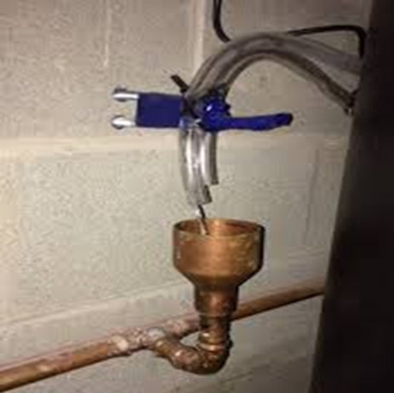 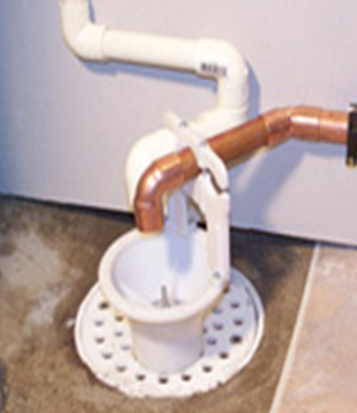

*Air Gap Example 1* *Air Gap Example 2*

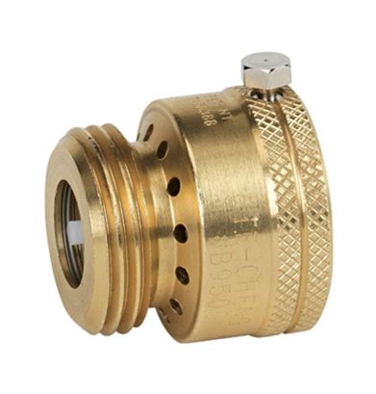

*Hose Bib Vacuum Breaker*