**Turbidity Exercise**

A stream has a water quality criterion for turbidity that states, “turbidity shall not exceed 25 NTU”. An industrial facility is permitted to discharge to this stream and its permit limits the effluent turbidity to a maximum of 25 NTU.

Water quality samples were collected upstream and downstream of the facility’s effluent discharge; the effluent was also sampled. These data are presented in the figure below.

Exercise questions:

1. When does it appear that the facility effluent has little to no effect upon in-stream turbidity?

*Answer: No effect at all on Days #1, #14, and #35. On those days, the upstream and downstream turbidity was the same. Also, on Days #8, #21, and #28 the upstream value was actually slightly higher than the downstream result, indicating that the facility had no effect on water quality. What could cause this? (Settling of instream particles, dilutions from a side channel, slight variations in turbidity in different parts of the flow profile.)*

1. When does it appear that the facility effluent had some effect upon in-stream turbidity?

*Answer: On Day #18, the downstream sample was about 6 NTUs higher than the upstream sample.*

1. What if the turbidity criterion was different? How about instead of simply a hard numeric limit of 25 NTUs, what if the criterion had an additional antidegradation provision that said “turbidity shall not be increased by more than 5 NTUs by any discharge.” Would we then see an exceedance from any of the data in the chart?

*Answer: Yes – on Day #18. On that day, the upstream result is 17 NTU, and the downstream result is 23 NTU. The effluent increased the in-stream turbidity by 6 NTU above background.*

**Nutrient Exercise**

The Nambe Tribe established a total inorganic nitrogen criterion for the high quality coldwater fishery use; the criterion is that total inorganic nitrogen “shall not exceed 1.0 mg/L”.

Water quality samples were collected from a stream that is designated a high quality coldwater fishery. The total inorganic nitrogen results are presented in the figure below.

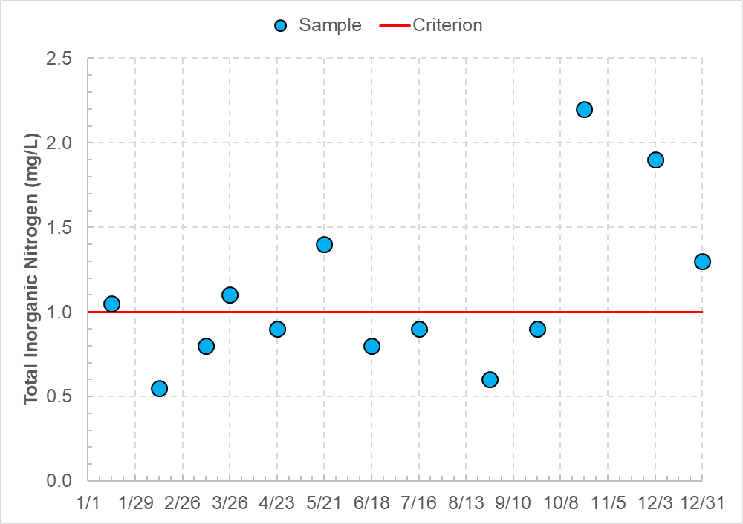

Exercise questions:

1. Do the water quality samples exceed the Nambe Tribe’s water quality criterion for total inorganic nitrogen?

*Answer: Yes. Six of 13 samples exceed the not-to-exceed criterion.*

1. Let’s look at a slightly different criterion. If the criterion specified that the 1.0 mg/L limit was only to be applied as a summer season average (June through September), would the water quality samples exceed the criterion?

*Answer: No. All four samples collected in June through September are less than 1.0 mg/L; thus, the average is going to be less than 1.0 mg/L. A calculator is not needed; however, the June through September average is 0.8 mg/L*

1. What about if the criterion stated that the numeric limit was to be applied as a growing season average (March through September), would the water quality samples exceed the criterion?

*Answer: No. While two of the seven samples collected in March through September exceed 1.0 mg/L, five samples are less than 1.0 mg/L. A calculator is not needed because the differential of the two points above the criterion is less than the differential of the five sites below the criterion; however, the March through September average is 0.9 mg/L.*

**Biological Indices Exercise**

The state of Ohio adopted numeric biological criteria for fish and macroinvertebrate communities. The criteria vary by several factors including designated use and stream assessment method.

The Index of Biotic Integrity measures fish community health using 12 metrics that can each score a maximum of 5 points (i.e., a perfect IBI score is 60). The table below presents the biological criteria for two designated uses (basic warmwater habitat and exceptional warmwater habitat) and for two stream assessment methods (headwaters and wading).

|  |  |  |
| --- | --- | --- |
| **Assessment Method** | **Basic Warmwater Habitat Minimum Score** | **Exceptional Warmwater Habitat Minimum Score** |
| Headwaters | 40 | 50 |
| Wading | 38 | 50 |

Six sites in a watershed are sampled; four sites are sampled using headwaters assessment methods and two sites are sampled using wading assessment methods. The results are shown in the figure below.

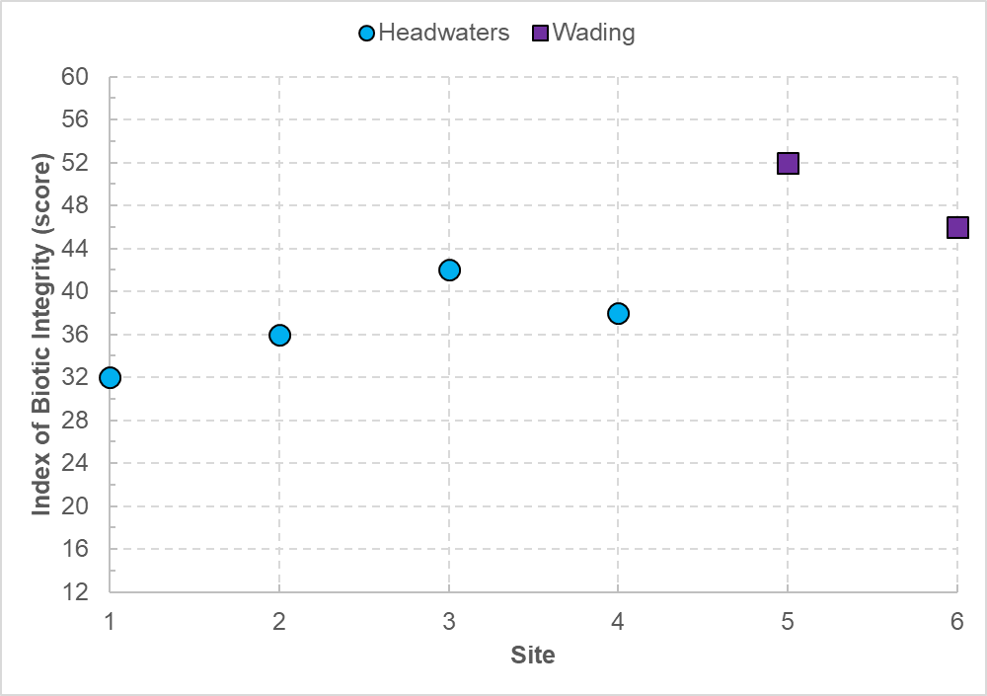

Exercise questions:

1. If the six sites were warmwater habitat, which sites would meet the biological criteria?

*Answer: Three sites. Site #3 (42) meets the WWH headwaters standard of 40, and sites #5 (52) and #6 (46) meet the WWH wading standard of 38.*

1. If the six sites were exceptional warmwater habitat, which sites would meet the biological criteria?

*Answer: Only site #5 (52) would meet the EWH standard of 50.*

1. Ohio’s biological criteria allow for nonsignificant departure from the criterion where a sample that is 4 points or less below the appropriate criterion will be considered “marginally” supporting its use. Which of the six sites meet the warmwater habitat “marginal” criteria? Which of the sites marginally meet the exceptional warmwater habitat criteria?

*Answers:*

*For the WWH standards, site #2 (36) and site #4 (38) are within 4 points of the WWH headwaters standard of 40, and thus, would marginally support the WWH use.*

*For the EWH standards, site #6 (46) is within 4 points of the EWH standard of 40, and thus, would marginally support the EWH use.*

**Metals Exercise**

The zinc (total) criterion for Grand Portage Reservation varies by hardness (calcium and magnesium) and is expressed in an equation. However, the Grand Portage Band of Chippewa also published the zinc criteria at certain hardness concentrations; these “shall not exceed” criteria are presented in the table below. Note that the zinc criterion for any hardness concentration greater than 400 mg/L is set equal to the zinc criterion at a hardness of 400 mg/L (i.e., when the hardness is greater than 400 mg/L, the zinc concentration shall not exceed the criterion set for 400 mg/L hardness).

|  |  |
| --- | --- |
| **Hardness (mg/L)** | **Zinc (mg/L)** |
| 50 | 67 |
| 100 | 120 |
| 200 | 216 |
| 300 | 304 |
| 400 | 388 |

Four sites along the Pigeon River were sampled and the results are presented in the figure below.

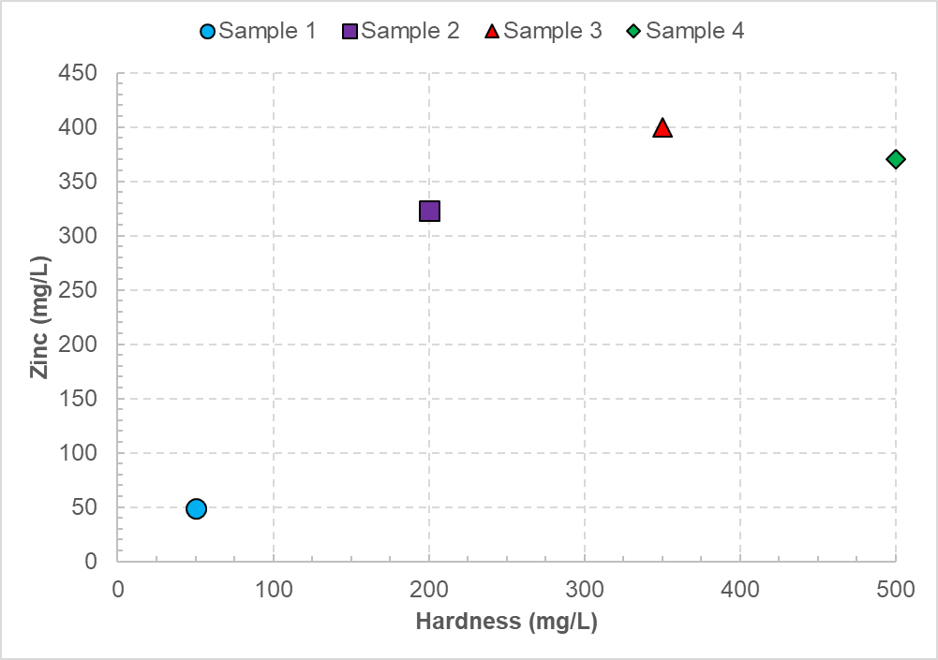

Exercise questions

1. Does sample #1 meet the zinc criterion?

*Answer: Yes. The zinc result of 50 mg/L is less than the zinc criterion of 67 mg/L for a hardness of 100 mg/L*

1. Does sample #2 meet the zinc criterion?

*Answer: No. The zinc result of 323 mg/L is greater than the zinc criterion of 216 mg/L for a hardness of 200 mg/L.*

1. Does sample #3 meet the zinc criterion? (Hint: You can still use the zinc-hardness criterion table)

*Answer: No. The zinc result of 400 mg/L (at hardness 350 mg/L) is greater than the zinc criterion of 388 mg/L for a hardness of 400 mg/L; the result is also greater than the zinc criterion of 304 mg/L for a hardness of 300 mg/L.*

1. Does sample #4 meet the zinc criterion? (Hint: The zinc criterion is in the zinc-hardness criterion table)

*Answer: Yes. The zinc result of 370 mg/L (at hardness 500 mg/L) is less than the zinc criterion of 388 mg/L for a hardness of 400 mg/L. Any zinc result at a hardness greater than 400 mg/L must be evaluated with the criterion for a hardness of 400 mg/L.*

**Pathogen Exercise**

The Fort Peck Assiniboine and Sioux Tribes developed primary contact recreation use criteria for the Fort Peck Indian Reservation using *E. coli* as a pathogen indicator. The criteria are composed of two parts: a geometric mean criterion and a single sample maximum criterion. A geometric mean of five or more samples equally spaced over a 30-day period shall not exceed 126 counts per 100 milliliters. A single sample shall not exceed 235 counts per 100 milliliters.

Ten water quality samples were collected from a site on Big Porcupine Creek (designated for primary contact recreation use) during the recreation season. The *E. coli* densities for each sample are presented in the figure below.

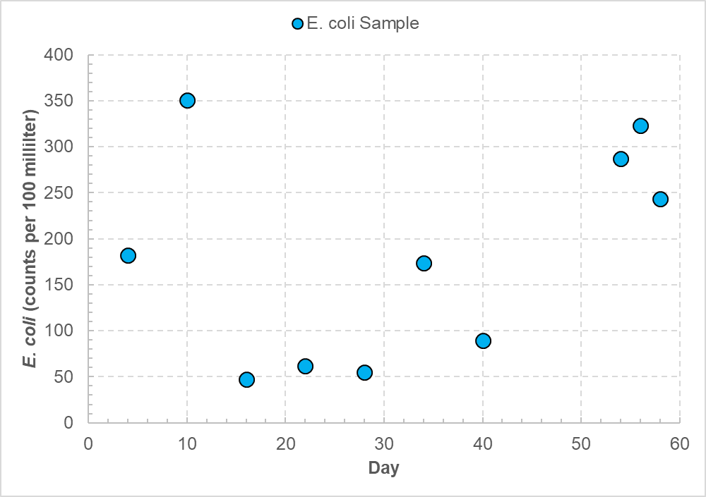

Exercise questions:

1. How many samples exceed the single sample maximum criterion?

*Answer: Four. Samples from days #10, #54, #56, and #58 are all greater than 235 counts per 100 milliliters.*

1. The following geometric means were calculated as the specified 30-day periods. Do they exceed the criterion? Why or why not?
   1. Days 1-30 yield a geometric mean of 100 counts per 100 milliliters.

*Answer: No. A geometric mean of 100 counts per 100 milliliters is less than the geometric mean criterion of 126 counts per 100 milliliters.*

* 1. Days 31-60 yield a geometric mean of 203 counts per 100 milliliters.

*Answer: No. The five samples were not equally spaced throughout the 30-day period. Only the single sample maximum criterion would apply.*

1. What other 30-day periods could a geometric mean be compared with the criterion? (Hint: There are two additional 30-day periods).

*Answer: Days 10-34 and days 16-40.*

1. Do the geometric means for the additional 30-day periods exceed the criterion? (Hint: You don’t need a calculator)

*Answers:*

*The geometric mean of days 10-40 meets the criterion. The geometric mean of days 10-40 is equivalent to days 1-30 because the day #34 result (in the days 10-40 period) is the same as the day# 6 result (in the days 1-30 period).*

*The geometric mean of days 16-40 meets the criterion. The geometric mean of days 16-40 is less than the geometric mean of days 1-30 (100 counts per milliliter) because (a) the day #34 result (in the days 16-40 period) is the same as the day# 6 result (in the days 1-30 period) and (b) the day #40 result is less than the day #10 result.*