Health
Protect Your Tap: A Quick Check for Lead
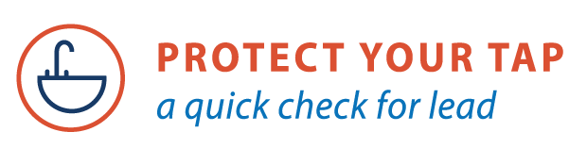
Lead in drinking water is an important public health matter in communities across the country. You may wonder how to know if you have lead in your drinking water. The U.S. EPA has created the Protect Your Tap: A Quick Check for Lead, an online guide that walks you through a series of steps to see if you have lead pipes bringing water into your home and provides tips on reducing your exposure to lead and getting your water tested.
There are no safe levels of lead. It is a persistent metal and can accumulate in the body over time. Even low levels of lead in the blood can be harmful, especially to the health and development of children. Irreversible effects include behavior and learning problems, lower IQ, slowed growth, hearing and speech problems, and anemia. Lead exposure can also seriously harm unborn babies, causing premature birth, lower birth weight, and delayed mental and physical development.
A family doctor or pediatrician can perform a blood test for lead and provide more information about the health effects of lead. State, city, or county departments of health can also provide information about how you can have your child's blood tested for lead. The Centers for Disease Control and Prevention (CDC) uses a blood lead reference value of 3.5 micrograms per deciliter (µg/dL) to identify children with blood lead levels that are much higher than most children’s levels. The good news is that childhood lead poisoning is 100% preventable.
Lead in homes can come from paint, dust, and soil, as well as drinking water. With pictures and easy directions, Protect Your Tap: A Quick Check for Lead helps you find out where your drinking water comes from, what type of plumbing materials are in your home, actions to reduce your exposure to lead in drinking water, water testing information, and resources to learn more.
In some cases, lead can enter drinking water through pipes that are called "lead service lines." Service lines are the sections of pipe used to connect a home to the main water line. Even if your service lines are not lead pipes, lead can also be found in other plumbing materials and faucets. Water that has high acidity or low mineral content can corrode pipes and faucets, causing lead to leach into your drinking water. This happens more readily with hot water. However, homes served by a lead service line have the most significant source of lead to drinking water.
The only way to know whether you have lead in your drinking water is to test it with a state-certified laboratory. Protect Your Tap: A Quick Check for Lead provides you with information about how to get your water tested. If you would like to find out more about lead in drinking water in your home, do the 10-minute lead check at: www.epa.gov/protectyourtap

