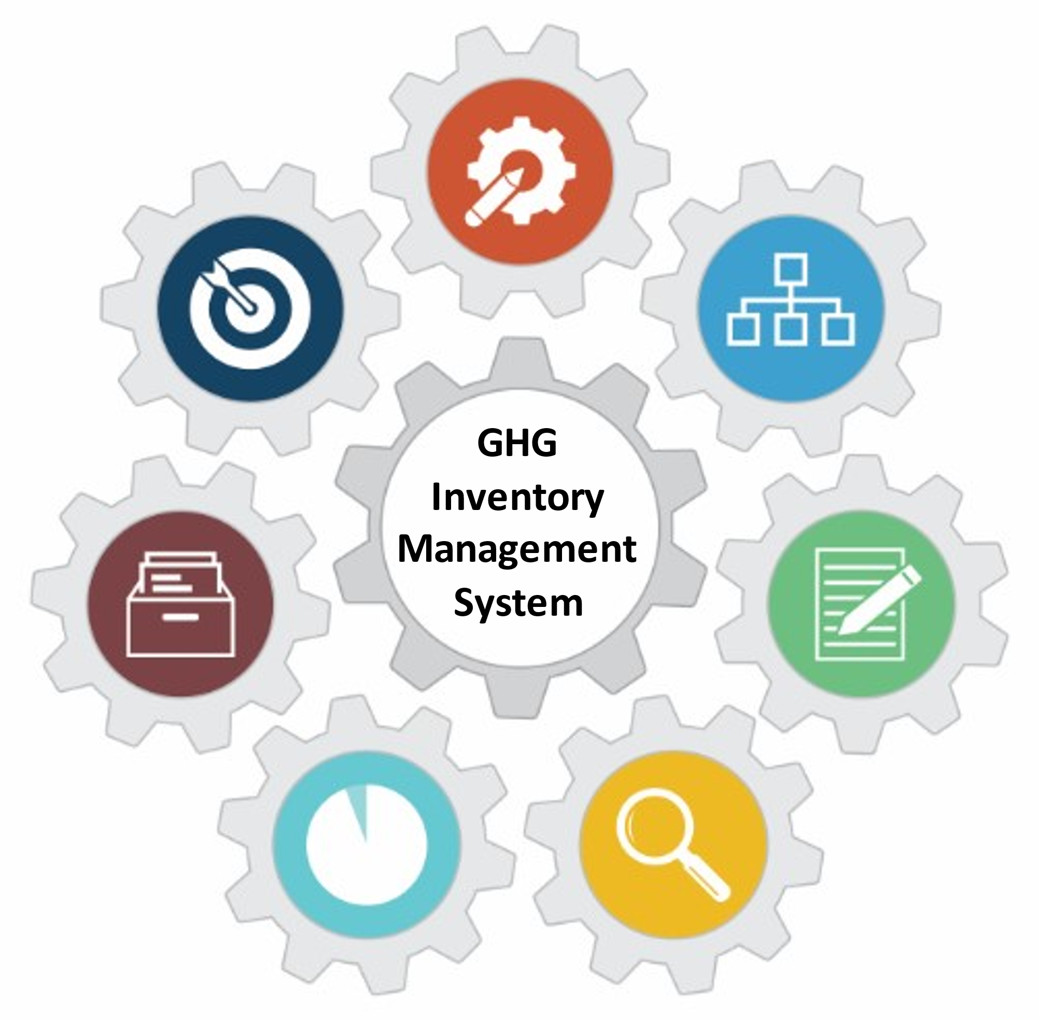

U.S. EPA Toolkit for Building National GHG Inventory Systems

2. Institutional Arrangements
1. Inventory Planning
2. Institutional Arrangements
3. Methods and Data Documentation
4. QA/QC Procedures
5. Key Category Analysis
6. Archiving System
7. National Inventory Improvement Plan
Staff member responsible for populating the template - Contact Information
Name: | [Enter Text] | Organization name:
Title/Position: |  | Organization postal address:
Phone number: |  | Organization web address:
Email: |  | Organization phone number:

Introduction to Template 2. Institutional Arrangements
In the U.S. EPA Toolkit for Building National GHG Inventory Systems, this is Template 2. Its purpose is to help you establish or improve the institutional arrangements (IA) that are the foundation of your national GHG inventory management system. The template helps countries develop, maintain, and improve management and reporting of inventory arrangements and is consistent with guidance under the Enhanced Transparency Framework (ETF) for national GHG inventories.
Institutional arrangements are formal or procedural agreements between the lead inventory agency, national inventory management team, and other institutions supporting inventory compilation (e.g., providing data, estimating emissions or removals, performing quality control). Additional guidance on inventory institutional arrangements and quality assurance and quality control (QA/QC) that complement this Toolkit are in the 2019 Refinement to the 2006 IPCC Guidelines, Volume 1, Chapter 1, available at https://www.ipcc-nggip.iges.or.jp/public/2019rf/vol1.html. For recommendations for institutional arrangements, see the UNFCCC’s Handbook on institutional arrangements to support MRV/transparency of climate action and support, Figure 1 titled “Key components of institutional arrangements,” available at https://unfccc.int/CGE/IA.
Your country’s IAs define the roles and responsibilities associated with preparing the national inventory, including which agencies and experts will provide what information and what tasks they will perform. This template will help your current and future inventory teams:
- Document all parties involved in the national inventory, and their roles and arrangements by sector,
- Archive key contacts for activity data for each sector or category included your inventory,
- Record the inventory schedule and coordinate future inventories,
- Assess how existing arrangements can be improved, and document the proposed improvements,
- Communicate your arrangements externally, such as to the United Nations Framework Convention on Climate Change (UNFCCC), and
- Inform new team members of existing IAs.
You may find that using the Memorandum of Cooperation (MoC) supporting template from the Toolkit helps you formalize your institutional arrangements. The MoC template provides the parties to the MoC with a clear format for describing mutual objectives, shared and differentiated responsibilities and activities, conditions for meeting and corresponding, points of contact, and the duration of the arrangement. The Memorandum of Cooperation Template is available here: https://www.epa.gov/ghgemissions/toolkit-building-national-ghg-inventory-systems.

Instructions
The tables in this template may be customized by adding, removing, or modifying columns or rows to better reflect your country’s particular needs or circumstances.
Complete the cells that are shaded this color:

Enter new information about your inventory in black text.
The blue text throughout each template provides detailed instructions and example responses to help you complete the tables. Once the tables are complete, delete all of the blue text throughout the template. The remaining text or tables in black text may be used for reporting or to contribute to a National GHG Inventory System Manual.
Suggested Roles and Responsibilities
To complete this template, the National Inventory Coordinator (NIC) and Sector/Category Leads will carry out the steps defined below by following the instructions above each table in this template. Suggested roles and responsibilities for completing this template are:
- National Inventory Coordinator
  - Complete Tables 2-1, 2-2, and Figure 1
  - Distribute this template to Sector/Category Leads, according to national circumstances, and collect templates once completed
- Sector/Category Leads
  - Complete Tables 2-3, 2-4, and 2-5
Depending on national circumstances, the NIC may distribute additional copies of this template to key members of the inventory team like Sector/Category Leads to complete certain tables. In this case, the NIC would also collect and compile all of the completed Institutional Arrangement templates from other inventory team members.
Overview of Steps
Step | Purpose
- Identify current inventory compilation team and potential contributors to the inventory | Identify people who could contribute to the creation and updating of the GHG inventory.
- Identify sector roles and arrangements | Improve efficiency by clearly stating who is responsible for creating each sector of the inventory, reporting the inventory, and checking work. It may not be necessary to have a large number of people working on the inventory, especially for simpler inventories. You can also include potential users of inventory information, if applicable.
- Identify improvements to institutional arrangements | Help your country institutionalize inventory processes and systems, which improves institutional memory and makes updating the inventory easier and more efficient. Continuous improvement should be a theme that underpins the inventory cycle.

STEP 1: Identify current inventory agencies or staff in Tables 2-1 and 2-2.
- In Table 2-1, record the name of the agency or organization that will lead inventory compilation, your country’s UNFCCC focal point and focal point agency, and the arrangements or relationship between the lead inventory agency and UNFCCC focal point agency. Add rows as necessary.
Table 2-1: Designated national GHG inventory agency and UNFCCC focal point
Designated National GHG Inventory Compilation  Agency/Organization | UNFCCC Focal Point (Name) and UNFCCC Focal Point Agency | Arrangements/relationship between Inventory Agency/Organization and UNFCCC Focal Point Agency, if different
[Enter Text]

- In Table 2-2, list core inventory coordination and compilation teams.
  - The Role column is prefilled with typical inventory roles. You may keep them or modify them according to your national circumstances. For example, you may combine roles, add roles, or remove roles. You may also assign multiple roles to the same person. For example, the three Energy sector leads in the table may be the same person. When assigning roles, some (e.g., archiving coordinator, QA/QC coordinator, uncertainty coordinator, key category analysis lead) are not full-time roles, and it's not uncommon for some staff to fill multiple inventory roles (e.g. NIC or sector lead plus one of the roles listed above).
  - In the Comments related to role column, you may wish to note the status of institutional arrangements. Also, you may find the Memorandum of Cooperation (MoC) supporting template from the EPA Toolkit helpful to formalize the assignment of responsibilities for sector leadership and to record the title of each MoC in the Comments related to role column.
  - The national inventory coordination and compilation team may have just a few or many leads, coordinators, or staff. One of these individuals (or perhaps a small team of them) should assume the role of National Inventory Coordinator (NIC) to coordinate the national GHG inventory compilation. For a list of the typical responsibilities of the NIC, see the supporting guide on National GHG Inventory Coordinator: Responsibilities and Qualifications in the EPA Toolkit, available here: https://www.epa.gov/ghgemissions/toolkit-building-national-ghg-inventory-systems.
  - For a list of typical responsibilities of the Sector Leads, see the supporting guide on Sector Lead Roles and Responsibilities for each sector (Energy, Industrial Processes and Product Use, Agriculture, LULUCF, and Waste) in the EPA Toolkit, available here: https://www.epa.gov/ghgemissions/toolkit-building-national-ghg-inventory-systems.
  - If your country assigns inventory leads at the subsector or category level, you may wish to record their names in Appendix 1, which has a detailed list of emission/removal categories from the 2006 IPCC Guidelines.
Table 2-2: National Inventory Leads/Coordinators
Role | Name | Organization | Contact information | Comments related to role
National Inventory Coordinator | [Enter Text]
Energy (Stationary sources) Sector Lead
Energy (Mobile sources) Sector Lead
Energy (Fugitive sources) Sector Lead
Industrial Processes and Product Use (IPPU) Sector Lead
Agriculture Sector Lead
Land Use, Land-Use Change, and Forestry (LULUCF) Sector Lead
Waste Sector Lead
Archiving Coordinator
QA/QC Coordinator
Uncertainty Analysis Coordinator
Key Category Analysis (KCA) Lead
Other (e.g., staff who tracks capacity building efforts and IPCC processes, staff who may use inventory information for mitigation tracking)

Institutional arrangements diagram
- In the box below (Figure 1), you may insert a diagram showing the structure of your country’s institutional arrangements for the compilation and reporting of your national GHG inventory. The diagram should include inventory stakeholders outside of the core coordination/compilation team, such as the ministries, departments and agencies, non-governmental organizations (NGOs), civil society organizations, or others that participate in compiling the national GHG inventory or are important users of the information. Clearly indicate the hierarchy and relationships between them in the diagram. It should also show the lead inventory agency, the agency responsible for inventory management and reporting, the GHG inventory sector leads (or sector lead agencies), and who is responsible for coordinating QA/QC and improvement activities.
- Three sample diagrams are provided below the box. Figures 2, 3, and 4 show institutional arrangements for Chile, the U.S., and the U.K., respectively. Remove these examples once you have updated this template with a diagram to illustrate the structure of your country’s arrangements for compiling and reporting your national GHG inventory.
Figure 1. Institutional Arrangements of [insert name of your country]

Figure 2. Example Institutional Arrangements of Chile, available at https://unfccc.int/documents/268469.

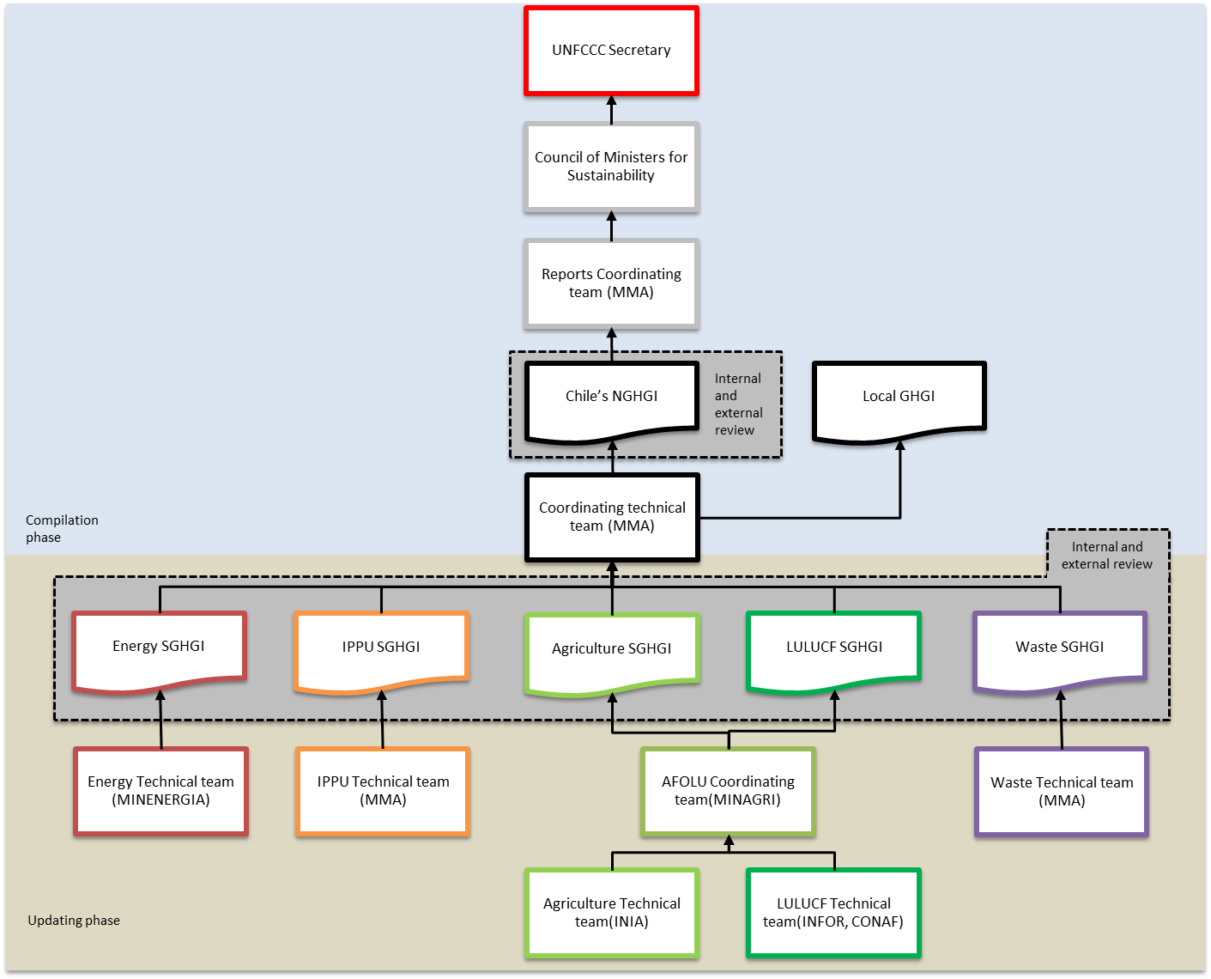
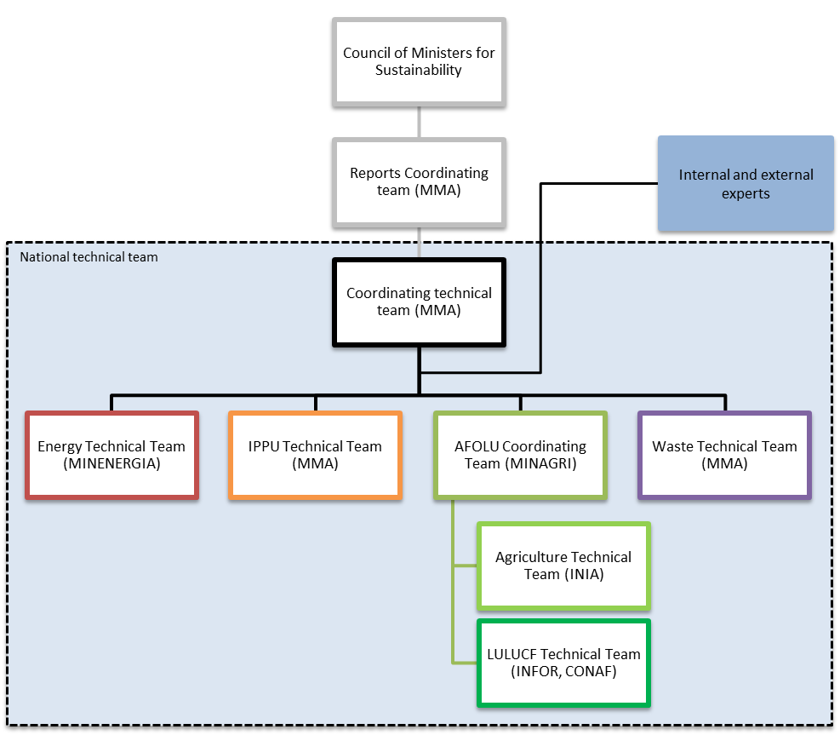
Source: Technical Team Coordinator, Ministry of Environment (Ministerio del Medio Ambiente (MMA))

Figure 3. Example Institutional Arrangements of the U.S., available at https://www.epa.gov/ghgemissions/inventory-us-greenhouse-gas-emissions-and-sinks-1990-2020
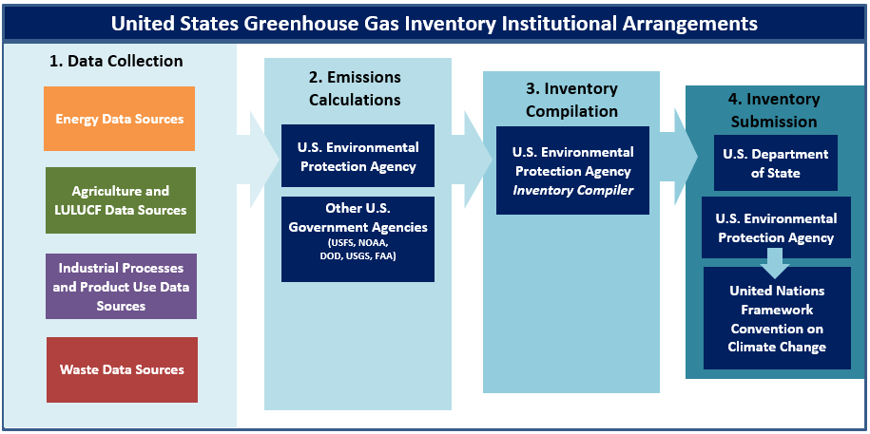

U.S. GHG Inventory Data Sources by Sector
Energy | Agriculture and LULUCF | IPPU | Waste
Energy Information Administration | EPA Office of Land and Emergency Management | EPA Greenhouse Gas Reporting Program (GHGRP) | EPA Greenhouse Gas Reporting Program (GHGRP)
U.S. Department of Commerce – Bureau of the Census | Alaska Department of Natural Resources | American Chemistry Council (ACC) | EPA Office of Land and Emergency Management
U.S. Department of Defense – Defense Logistics Agency | National Oceanic and Atmospheric Administration (NOAA) | U.S. Geological Survey (USGS) National Minerals Information Center | Data from research studies, trade publications, and industry associations
Federal Highway Administration | Association of American Plant Food Control Officials (AAPFCO) | American Iron and Steel Institute (AISI)
EPA Acid Rain Program | U.S. Census Bureau | U.S. Aluminum Association
EPA Office of Transportation and Air Quality MOVES Model | USDA Animal and Plant Health Inspection Service (APHIS) | U.S. International Trade Commission (USITC)
EPA Greenhouse Gas Reporting Program (GHGRP) | EPA Office of Air and Radiation | Air-Conditioning, Heating, and Refrigeration Institute
U.S. Department of Labor – Mine Safety and Health Administration | U.S. Department of Agriculture (USDA) National Agricultural Statistics Service and Agricultural Research Service | Data from other U.S. government agencies, research studies, trade publications, and industry associations
American Association of Railroads | USDA U.S. Forest Service Forest Inventory and Analysis Program
American Public Transportation Association | USDA Natural Resource Conservation Service (NRCS)
U.S. Department of Homeland Security | USDA Economic Research Service (ERS)
U.S. Department of Energy and its National Laboratories | USDA Farm Service Agency (FSA)
Federal Aviation Administration | U.S. Geological Survey (USGS)
U.S. Department of Transportation & Bureau of Transportation Statistics | U.S. Department of the Interior (DOE), Bureau of Land Management (BLM)
Data from research studies, trade publications, and industry associations | Data from research studies, trade publications, and industry associations

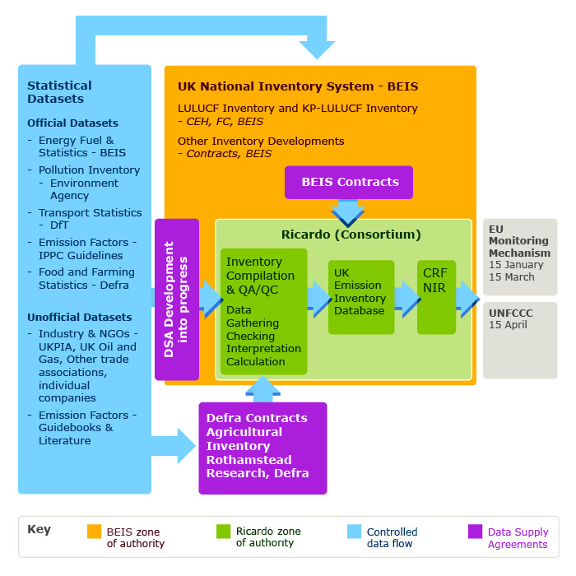
STEP 2: Identify sector roles and arrangements
Figure 4. Example Institutional Arrangements of the U.K., available at https://naei.beis.gov.uk/about/national-inventory-system
- In Table 2-3, you will identify arrangements for obtaining, compiling, reviewing, and reporting inventory data by sector, subsector, or category, according to your national circumstances. You will also record information about the contacts/experts for inventory development for each sector.
Complete one version of this table for each sector of your inventory. You may also create one version of this table for subsectors or categories, according to your national circumstances. For example, one option is to use this combination of sectors and subsectors:
  - Energy (stationary sources)
  - Energy (mobile sources)
  - Energy (fugitive sources)
  - Industrial Processes and Product Use (IPPU)
  - Agriculture
  - Land Use, Land-Use Change, and Forestry (LULUCF)
  - Waste
As you complete this table, you may find that you need additional institutional arrangements or identify improvements for your existing arrangements. Document these needs in Table 2-5.
- Role column instructions:
  - This column is prefilled with typical sector-specific inventory roles. You may modify them according to your national circumstances. For example, you may combine, add, or remove roles. You may also assign multiple roles to the same person.
  - Note that the first two roles, “Technical Coordinator” and “Staff compiling estimates,” may be the Sector Lead named in Table 2-2 or Appendix 1.
  - If you plan to engage consultants to compile estimates or to serve other roles during inventory preparation, you may find it helpful to first outline the consultants’ responsibilities using the Sample Scope of Work supporting template in the EPA Toolkit, available here: https://www.epa.gov/ghgemissions/toolkit-building-national-ghg-inventory-systems.
- Comments column instructions:
  - Example information to provide include:
    - the status of the institutional arrangements,
    - any special knowledge or skills that the assigned staff has,
    - the responsibilities of each role,
    - how different roles will collaborate, or
    - the degree to which the assigned staff participates in GHG inventory meetings (e.g., low, medium, or high participation).
  - This information will serve as a reference for future GHG inventory compilers. If necessary, explain in detail how the arrangements were established. For example, if you used the Memorandum of Cooperation (MoC) supporting template from the EPA Toolkit to formalize the assignment of responsibilities in the table below, you should record each MoC in this column.
- Mechanism of data collection row instructions:
  - Describe the strategies used to collect the necessary inventory data from an organization. Address the following questions and add additional comments as necessary:
    - When and how was the request for data made? At what level of management was the request made?
    - Were there difficulties in obtaining the data for the inventory? What were they, and how can they be addressed in for next inventory? Was the organization motivated to share its data and information with the inventory agency? If so, how?
    - Is there a formal agreement between the organizations (e.g., the Memorandum of Cooperation (MoC) supporting template from the EPA Toolkit)? Is it an informal arrangement (e.g., written or verbal communication with staff) because data is collected regularly for other purposes?
    - Did you organize a meeting with the experts, data providers, and other key contributors to explain the background and purpose of the inventory? Did the person or organization participate in meetings on GHG inventory development?
  - Note that information on institutions providing data, such as the Ministry of Energy, Bureau of Statistics, or other institutions noted in this table, might also be covered in Template 3. Methods and Data Documentation. Recording this information in only one of the templates is acceptable. If you record information on data providers here and not in Template 3, you may wish to include a note in Template 3 such as, “For information on data providers, please see 2. Institutional Arrangements.”
Table 2-3: Institutional arrangements for [sector, e.g., Energy (stationary sources)]
Role | Name | Organization | Contact information | Comments
Technical coordinator | [Enter Text]
Staff compiling estimates
Expert reviewer(s)
Institution(s) providing data
Reporting Manager(s)
QA/QC Manager(s)
Uncertainty Assessment Manager(s)
Other
Mechanism of data collection:

STEP 3: Complete Table 2-4 and Table 2-5 to document improvement options for institutional arrangements
- In Table 2-4, document the strengths of institutional arrangements for each sector.
  - Describe in what way the institutional arrangements that support inventory compilation are well-established and likely do not require improvement (e.g., communications between the institutions may be active and positive, institutions may have worked together before and have a good working relationship, data may be collected and managed adequately).
- In Table 2-5, describe potential ways to improve those institutional arrangements or establish new ones to address your inventory needs, taking key categories and existing institutional arrangements within each sector into account.
  - Consider whether any important tasks for inventory compilation have not been assigned and determine whether they could be. Also consider whether the Memorandum of Cooperation (MoC) supporting template from the EPA Toolkit, available at https://www.epa.gov/ghgemissions/toolkit-building-national-ghg-inventory-systems, may help improve the institutional arrangements for each sector, and record this decision as a needed step in this column, if helpful.
- You may find it helpful to create a more disaggregated version of these two tables by subsectors or categories, according to your national circumstances.
Table 2-4 - Strengths of institutional arrangements for national GHG inventory management system
Sector | Strengths of institutional arrangements | Key conditions for maintaining strengths | Staff in charge of managing arrangements
Energy (stationary sources) | [Enter Text]
Energy (mobile sources)
Energy (fugitive sources)
Industrial Processes and Product Use (IPPU)
Agriculture
Land Use, Land-Use Change, and Forestry (LULUCF)
Waste
Other (Optional)

Table 2-5: Potential improvements to institutional arrangements for national GHG inventory management system
Sector | Potential improvement | Staff in charge of leading this improvement | Priority of improvement  (Low, Medium, High)
Energy (stationary sources) | [Enter Text]
Energy (mobile sources)
Energy (fugitive sources)
Industrial Processes and Product Use (IPPU)
Agriculture
Land Use, Land-Use Change, and Forestry (LULUCF)
Waste
Other (Optional)

Appendix 1: Detailed list of GHG categories from the 2006 IPCC Guidelines, by sector and category lead
If you are using the IPCC Inventory Software to compile your national GHG inventory for some but not all sectors, you may wish to add an additional column to this table to indicate which sectors or categories are estimated using the IPCC Software.
Category Code | Category Title | Category Lead
1 | Energy
1.A | Fuel combustion activities | [Enter Text]
1.A.1 | Energy industries
1.A.2 | Manufacturing industries and construction
1.A.3 | Transport
1.A.4 | Other sectors
1.A.5 | Non-specified
1.B | Fugitive emissions from fuels
1.B.1 | Solid fuels
1.B.2 | Oil and natural gas
1.B.3 | Other emissions from energy production
1.C | Carbon dioxide transport and storage
1.C.1 | Transport of CO₂
1.C.2  1.C.3 | Injection and storage  Other
2 | Industrial Processes and Product Use (IPPU)
2.A | Mineral industry
2.A.1 | Cement production
2.A.2 | Lime production
2.A.3 | Glass production
2.A.4 | Other process uses of carbonates
2.A.5 | Other (please specify)
2.B | Chemical industry
2.B.1 | Ammonia production
2.B.2 | Nitric acid production
2.B.3 | Adipic acid production
2.B.4 | Caprolactam, glyoxal and glyoxylic acid production
2.B.5 | Carbide production
2.B.6 | Titanium dioxide production
2.B.7 | Soda ash production
2.B.8 | Petrochemical and carbon black production
2.B.9 | Fluorochemical production
2.B.10 | Other (please specify)
2.C | Metal industry
2.C.1 | Iron and steel production
2.C.2 | Ferroalloy production
2.C.3 | Aluminum production
2.C.4 | Magnesium production
2.C.5 | Lead production
2.C.6 | Zinc production
2.C.7 | Other (please specify)
2.D | Non-energy products from fuels and solvent use
2.D.1 | Lubricant use
2.D.2 | Paraffin wax use
2.D.3 | Solvent use
2.D.4 | Other (please specify)
2.E | Electronics industry
2.E.1 | Integrated circuit or semiconductor
2.E.2 | TFT flat panel display
2.E.3 | Photovoltaics
2.E.4 | Heat transfer fluid
2.E.5 | Other (please specify)
2.F | Product uses as substitutes for ozone depleting substances
2.F.1 | Refrigeration and air conditioning
2.F.2 | Foam blowing agents
2.F.3 | Fire protection
2.F.4 | Aerosols
2.F.5 | Solvents
2.F.6 | Other applications (please specify)
2.G | Other product manufacture and use
2.G.1 | Electrical equipment
2.G.2 | SF₆ and PFCs from Other Product Uses
2.G.3 | N₂O from product uses
2.G.4 | Other (please specify)
2.H | Other
2.H.1 | Pulp and paper industry
2.H.2 | Food and beverages industry
2.H.3 | Other (please specify)
3 | Agriculture, Forestry, and Other Land Use (AFOLU)
3.A | Livestock
3.A.1 | Enteric fermentation
3.A.2 | Manure management
3.B | Land
3.B.1 | Forest land
3.B.2 | Cropland
3.B.3 | Grassland
3.B.4 | Wetlands
3.B.5 | Settlements
3.B.6 | Other land
3.C | Aggregate sources of non-CO₂ emissions sources on land
3.C.1 | Emissions from biomass burning
3.C.2 | Liming
3.C.3 | Urea application
3.C.4 | Direct N₂O emissions from managed soils
3.C.5 | Indirect N₂O emissions from managed soils
3.C.6 | Indirect N₂O emissions from manure management
3.C.7 | Rice cultivations
3.C.8 | Other (please specify)
3.D | Other
3.D.1 | Harvested wood products
3.D.2 | Other (please specify)
4 | Waste
4.A | Solid waste disposal
4.A.1 | Managed waste disposal sites
4.A.2 | Unmanaged waste disposal sites
4.A.3 | Uncategorized waste disposal sites
4.B | Biological treatment of solid waste
4.C | Incineration and open burning of waste
4.C.1 | Waste incineration
4.C.2 | Open burning of waste
4.D | Wastewater treatment and discharge
4.D.1 | Domestic wastewater treatment and discharge
4.D.2 | Industrial wastewater treatment and discharge
4.E | Other (please specify)
5 | Other
5.A | Indirect N₂O and CO₂
5.B | Other (please specify, e.g. precursor emissions of NO_{X}, CO, NMVOC, and SO_{X})

Revision History
June 2022: Updated text and graphics for clarity. Updated formatting to improve accessibility and usability.

See 18/CMA.1, Modalities, Procedures and Guidelines (MPGs), Annex Chapter II, Section B. National Circumstances and Institutional Arrangements guidance for National Greenhouse Gas Inventory Report, available at https://unfccc.int/sites/default/files/resource/CMA2018_03a02E.pdf.
Most arrangements will be formal, but situations exist where an arrangement is informal. The informal arrangements may evolve to be formal overtime. Depending on national circumstances, arrangements with data suppliers may be informal because the data is already collected and published regularly for other purposes (e.g., economic statistics, energy data, etc.). Informal arrangements may involve regular consultation with the institution collecting the data and dedicated point of contact to understand trends, completeness, uncertainties, data quality, and other relevant pieces of information The point of contact should be included in planning meetings and communications throughout the inventory cycle to understand when data will be required and any required formats.
This is the person responsible for developing the GHG estimates for each category.
If you are also using the 2019 Refinement to the 2006 IPCC Guidelines, you may be including this additional category: hydrogen production.
If you are also using the 2019 Refinement to the 2006 IPCC Guidelines, you may be including this additional category: rare earth metals production.
If you are also using the 2019 Refinement, you may be including this additional category: microelectromechanical systems (MEMS).

