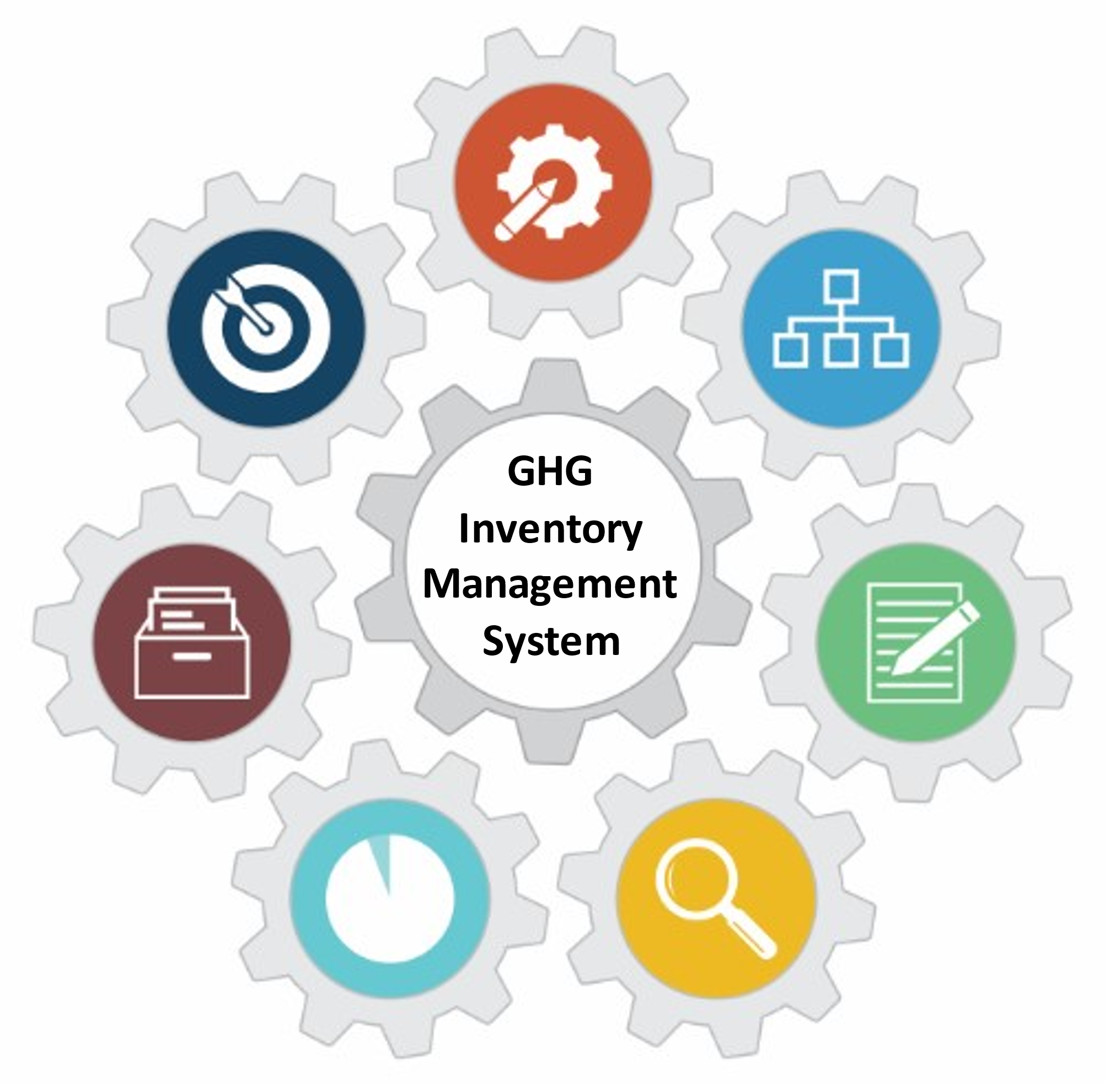

U.S. EPA Toolkit for Building National GHG Inventory Systems

6. Archiving System
1. Inventory Planning
2. Institutional Arrangements
3. Methods and Data Documentation
4. QA/QC Procedures
5. Key Category Analysis
6. Archiving System
7. National Inventory Improvement Plan
Staff member responsible for populating the template - Contact Information
Name: | [Enter Text] | Organization name:
Title/Position: |  | Organization postal address:
Phone number: |  | Organization web address:
Email: |  | Organization phone number:

Introduction to Template 6. Archiving System
In the U.S. EPA Toolkit for Building National GHG Inventory Systems (‘Toolkit’), this is Template 6. Its purpose is to help you create a complete and accessible archive of your national GHG inventory. The template is also consistent with archiving guidance for future reporting requirements under the Enhanced Transparency Framework (ETF) for National GHG Inventories.
An inventory archive is a collection of information related to the GHG inventory compilation process, reporting, and institutional arrangements. Having easy access to such information will help:
- Current and future inventory compilers understand previously used data, methodologies, structures, processes, etc., so that they can prepare the inventory efficiently and in a manner that is consistent with prior inventories,
- Increase the sustainability of the national GHG inventory management system over time, and
- Increase the transparency of current reporting under the UNFCCC (e.g., for National Communications and Biennial Update Reports), in addition to transparency of future reporting under the ETF. This can be particularly valuable for peer review processes, such as International Consultation and Analysis.
The Archiving Coordinator (see roles documented in Template 2. Institutional Arrangements) is encouraged to use this template to develop an Archiving System before the national GHG inventory compilation cycle begins, and to document potential improvements to the Archiving System based on lessons learned from archiving materials or accessing these materials later. An Archiving System enables the efficient compilation of an archive that is consistent across all sectors and categories. The Archiving Coordinator may need to work with the National Inventory Coordinator (NIC) and other inventory team members to develop this plan.
The Archiving Coordinator should archive all material associated with each GHG inventory compilation cycle and not overwrite material. An inventory archive differs from routine electronic file backup. The archive should be a collection of materials that specifically facilitates replicating the compilation steps of a prior GHG inventory.
The inventory archive should include at least the following materials, customized for your country’s context:
- Inventory compilation plan (National GHG Inventory Inception Memorandum supporting template)
- Institutional arrangements (Template 2)
- Methods and data documentation (Template 3)
- Any files used for calculation (e.g., spreadsheets, models, databases, IPCC Inventory Software)
- QA/QC procedures (Template 4)
- Key category analysis (Template 5)
- Drafts and final electronic versions of the inventory report (e.g., National Inventory Document and any submitted common reporting tables, and any technical annexes)
- Internal and external review comments and responses (Template 4)
- Archiving system (Template 6)
- Improvement plan (Template 7)

Instructions
The tables in this template may be customized by adding, removing, or modifying columns or rows to better reflect your country’s particular needs or circumstances.
Complete the cells that are shaded this color:

Enter new information about your inventory in black text.
The blue text throughout each template provides detailed instructions and example responses to help you complete the tables. Once the tables are complete, delete all of the blue text throughout the template. The remaining text or tables in black text may be used for reporting or to contribute to a National GHG Inventory System Manual.
Suggested Roles and Responsibilities
To complete this template, the Archiving Coordinator should carry out the steps defined below by following the instructions above each table in this template, with support from other key inventory team members as needed. Suggested roles and responsibilities for completing this template are:
- National Inventory Coordinator
  - Support the Archiving Coordinator in completing the template
- Archiving Coordinator
  - Complete the template
- Sector/Category Leads
  - Provide input for Tables 6-2 and 6-3, as needed
Overview of Steps
Step | Purpose
- Assess the existing archiving steps and procedures | These may be used as foundations for an updated Archiving System.
- Develop the Archiving System | The Archiving System will clearly indicate who is responsible for taking what actions, and how and when to take them. This should help ensure that all archiving activities are carried out in a targeted manner and can be tracked.
- Identify improvements to the Archiving System | Identify improvements to help increase the quality of the Archiving System and therefore improve inventory quality over time. The prioritization of improvements and the development of an improvement plan are covered in Template 7. National Inventory Improvement Plan.

STEP 1: Use Table 6-1 to assess the existing archiving steps and procedures
Describe any archiving procedures implemented in previous inventory compilation cycles. The questions below will help identify these procedures. You may add to or remove from this list, or modify the questions that are currently there, according to your needs. Consider which procedures could support current and future inventory compilation cycles. These may form the basis for the Archiving System you will develop in Step 2.
Table 6-1. Assessment questions
Example Assessment Questions | Assessment Findings and Comments
Is there an archiving system from previous compilation cycles, or are archiving procedures documented in any other way? | [Enter Text]
Where is previous GHG inventory compilation material stored and in which format (e.g., electronically, on paper)?
Who has access to archives from previous GHG inventories?
Which documents were archived?
Were both drafts and final versions archived? If so, at which points in the GHG inventory compilation cycle were drafts archived?
For categories with recalculations due to methodological changes or refinements, where are the data sources and references for both the past and the new methodologies, and the documentation of time series consistency archived?
If there is an archiving system, was its implementation tracked (e.g., using a checklist or spreadsheet)?
If files were archived electronically, was a folder structure used to enable easy access to the documents? If so, describe the structure.
Was a naming convention for files used (e.g., to indicate sectors, categories, status, type of document, version or date, or responsible staff)? If so, describe the convention used.

STEP 2: Develop the Archiving System
The following section describes what to include in the Archiving System for your national inventory. The overall objective of your plan should be to identify what information created during the compilation of your national inventory will be archived, where it will be archived, when it will be archived, by whom it will be archived, and who will have access to it and how. It is important that you save information throughout the compilation of your national inventory, rather than only at the end of the process, and that your plan address the gaps you may have identified in Table 6-1, above. By developing a detailed Archiving System, you are laying the foundation for efficiently compiling an archive that is consistent across all sectors and categories.

Responsibilities of the National Inventory Coordinator
This subsection will be part of the Archiving System and provides an overview of the responsibilities of the National Inventory Coordinator (NIC). You may modify this bulleted list of responsibilities according to your needs.
The responsibilities of the NIC are to:
Examples:
- Coordinate with Sector/Category Leads and the Archiving Coordinator to convey relevant archiving responsibilities to all inventory compilers and data providers
- Ensure that the inventory archive is saved in a secure location
- Confirm that the inventory archive includes your latest inventory report, estimation files, and all completed templates (i.e., Templates 1-7). These files, preferably in an editable format, can serve as the starting point for your next inventory cycle.
[Enter Text]

Responsibilities of the Archiving Coordinator
This subsection will be part of the Archiving System and provides an overview of the responsibilities of the Archiving Coordinator. It is included in the Archiving Plan for ease of access by the Archiving Coordinator. You may modify these bulleted lists of responsibilities according to your needs.
The responsibilities of the Archiving Coordinator are to:
Examples:
- Develop and oversee implementation of the Archiving System
- Maintain the Archiving System, and review and update it as required (at least every inventory compilation cycle)
- Convey the Archiving System to the inventory compilers, including:
  - The responsibilities for each inventory compiler regarding the documents to be archived and archiving timelines
  - The location of the archive
  - Instructions regarding access, the file structure, and file/folder naming conventions
- Tracking the implementation of activities in the Archiving System
[Enter Text]

Responsibilities of the Inventory Compilers
This subsection will be part of the Archiving System and provides an overview of the responsibilities of the Inventory Compilers, which are identified in Table 2-3 of Template 2. Institutional Arrangements. You may modify this bulleted list of responsibilities according to your needs.
The responsibilities of the inventory compilers are to:
Examples:
- Understand the implementation of the Archiving system (e.g., location, file structure, access, file/folder naming conventions)
- Identify which documents should be archived, and the timeline under which documents must be archived
[Enter Text]

Archive Location, Backup, and Point-of-Contact
This subsection indicates where files are archived, where a backup is kept, and who the Archiving Coordinator is. It is helpful to store files used to compile each inventory report together in one archive and create at least one backup archive to reduce the risk of losing your records to a human, natural, or computer disaster. Additionally, archiving some files at key points in the inventory compilation cycle can help avoid partial loss of files and data. The archive and its backup should be stored in different locations. Complete these bullets by replacing the blue text with your own information.
- The Archiving Coordinator is: [Insert name and contact information of the individual in charge of the archive]
[Enter Text]

- Archived inventory files are stored here: [Insert location of electronic and/or hardcopy files]
[Enter Text]

- Who has access to the archive: [Insert relevant inventory roles from Template 2 (e.g., National Inventory Leads/Coordinators listed in Table 2-2 of Template 2, Institutional Arrangements)]
[Enter Text]

- How to access the archive: [Describe how to request access (e.g., contact Archiving Coordinator, whether access to the archive is password-protected, and if so, how a password may be obtained)]
[Enter Text]

- A backup of the archive is kept here: [Insert location of electronic and/or hardcopy files]
[Enter Text]

- Backup procedures are as follows: [Insert description of backup procedures (e.g., how often or when a backup is created]
[Enter Text]

Archive structure and file/folder naming convention
This subsection indicates how files and folders in the archive are structured and named to ensure a standardized, consistent approach and easy access.
- The archive is structured as follows: [Insert list of folders/subfolders or an image showing the folder structure. Folder names should clearly indicate what documents are in them. See Appendix 2 for an example.]
[Enter Text or Image]
- The naming convention for files is as follows: [Insert detailed description of the file naming convention (e.g., inventory year, category code, etc). Provide several examples using the naming convention (i.e., one for a calculation spreadsheet, one for the QA/QC plan, one for activity data as obtained from a data provider). The file naming convention should include a version control element, unless you are using a storage solution which automatically performs version control.]
[Enter Text or Image]

Materials to be archived
Consider which drafts should be archived and how often (e.g., at the end of each stage of the inventory compilation cycle, upon completing the first draft of the inventory report, and upon reviewing and finalizing the report). Archiving drafts increases effort but provides additional protection from file corruption or loss.
If using the IPCC Inventory Software, activity data and emissions factors used in calculations (whether country-specific or default) can be exported. Ensure they are documented as part of Template 3. Methods and Data Documentation.

Use Table 6-2 to record which materials should be archived
Table 6-2 provides an overview of the materials to be archived. It is prepopulated with a list of recommended materials in the “Materials to be archived” column. Example responses are listed in blue in this column. You may modify any of the information in this table according to your needs. If you decide to use any of the example responses, copy them to the second and third columns and change the font color to black.
Once you identify what to archive and when, customize the archiving procedures checklist in Appendix 1 to reflect your national GHG inventory management system and help you track submissions to the archive.
Table 6-2. Materials to be archived
Materials to be archived | Staff from whom the materials should be obtained | Point in time at which the materials should be archived
- Institutional Arrangements (Template 2)  Example: NIC; At the beginning of the inventory compilation cycle | [Enter text]
- Inventory compilation plan (Template 1, Inception Memorandum supporting template)
Example: NIC; At the end of the inventory compilation cycle
- Methods and Data Documentation (Template 3)
Example: Sector/Category Leads; At the beginning and at the end of the inventory compilation cycle
- Any files used for calculations and recalculations (e.g., spreadsheets, models)
Example: Sector/Category Leads; At the end of the inventory compilation cycle
- Uncertainty assessment files (category-level and overall)
Example: Sector/Category Leads, NIC; At the end of the inventory compilation cycle
- QA/QC Procedures (Template 4)
Example: NIC; At the end of the inventory compilation cycle
- Results of quality control processes (Template 4)
Example: Sector/Category Leads; At the end of the inventory compilation cycle
- Key Category Analysis (Template 5)
Example: NIC; At the end of the inventory compilation cycle
- Draft and final versions of the inventory report
Example: NIC; After each version of the report is compiled
- Internal and external review comments and responses
Example: NIC; At the end of the inventory compilation cycle
- Archiving System (Template 6)
Example: Archiving Coordinator; At the end of the inventory compilation cycle
- National Inventory Improvement Plan (Template 7)
Example: NIC; At the end of the inventory compilation cycle
- Contacts and contact information for data sources
Example: Sector/Category Leads; At the end of the inventory compilation cycle
- Communication with data sources and the data obtained
Example: Sector/Category Leads; At the end of the inventory compilation cycle
- Decision-making documents related to the compilation process (e.g., minutes of meetings of the GHG inventory compilers, email communication, minutes of phone communication, any documentation of official consideration and approval processes that precede submission to the UNFCCC )
Example: NIC and Sector/Category Leads; Whenever communication has taken place

STEP 3: Identify improvements to the Archiving System
Improvements to the Archiving System may include improvements associated with roles and responsibilities and with archiving procedures, including file/folder naming conventions, file storage, and document and data retention. This information will also be documented as part of Template 7. National Inventory Improvement Plan. For efficiency, document these improvements throughout the inventory compilation cycle to avoid having to retroactively identify improvements.

In Table 6-3, below, record potential improvements to the Archiving System
- Add as many rows to the table as necessary to list the improvement options.
- Instructions by column:
  - Issue: Describe the issue to be improved.
  - Improvement Option: Describe the potential improvement to the Archiving System (e.g., ensure that all final calculation spreadsheets and text documents for each sector are sent to the National Inventory Coordinator in a single zipped file to minimize the risk of files being misplaced or not sent)
  - Implementation Action: Describe any actions needed to implement the improvement option (e.g., at the beginning of the next inventory cycle, highlight this revised procedure and deadline to all inventory compilers in the inception memorandum and via email)
Table 6-3, below, provides a list of suggested improvements to the Archiving System. These improvements, together with improvement options suggested in the other templates, form the basis for the national GHG inventory improvement plan.
Improvement Number | Issue | Improvement Option | Implementation Action
1 | [Enter Text]
2
3
Table 6-3. Improvements to the Archiving System

Appendix 1. Archiving Procedures Checklist
A checklist can be a useful tool to help you implement a successful archiving system and compile a complete and consistent archive. An archiving procedures checklist should show all archiving activities, staff responsible for each activity, and due dates. The Archiving Coordinator can use the checklist to ensure that all archiving activities occur in a timely and complete manner. The Archiving Coordinator is responsible for clearly conveying all activities and due dates to the inventory compilers at the start of the national GHG inventory compilation cycle, all information which can be shared in this checklist. The checklist below contains recommended archiving activities that can be adapted to inventory needs.
In the checklist below, record archiving tasks by responsible party, their due dates, and status. You may modify this checklist according to your needs by adding, removing, or customizing activities. In the checklist, all activities are initially assigned to the Archiving Coordinator. You may reassign activities to other staff as it suits your country’s circumstances and objectives.
The “Due Date” column will help you communicate this information to the Inventory Compilers. This information does not need to be included in your national system report for the purpose of describing archive procedures.
When using the checklist at the beginning of the next inventory cycle, develop due dates in accordance with the “Inventory Cycle” in the Template 1. Inventory Planning and the National GHG Inventory Inception Memorandum supporting template. Save materials when first collected and used for the inventory to avoid spending time searching for them later.

Checklist: Archive Activities, Responsibilities, and Schedule
Activity | Due Date | Activity Completed
 |  | Completed by (name) | Date
Archiving Coordinator
Create official archive, backup, and access requirements | [Enter Date] | [Enter Text]
Generate folder structure and naming convention
Update the archiving system and deadlines
Convey archive structure, naming convention, access, and archiving system to inventory compilers
Collect and archive documents describing institutional arrangements (Template 2)
Collect and archive documents describing methods and data collected (Template 3)
Collect and archive the inventory compilation plan (Template 1, National GHG Inventory Inception Memorandum supporting template)
Collect and archive any files used for calculation or recalculations (e.g., data from IPCC Inventory Software, spreadsheets, models)
Collect and archive any files used for assessing uncertainty of the Inventory estimates overall and at the category level (e.g., spreadsheets, data from IPCC Inventory Software)
Collect and archive the QA/QC plan and results of QA/QC assessments (Template 4)
Collect and archive results of quality control processes (Template 4)
Collect and archive the key category analysis (Template 5)
Collect and archive drafts and final versions of the inventory report
Collect and archive external review comments and responses
Archive documentation of the archiving system (Template 6)
Collect and archive the national inventory improvement plan (Template 7)
Collect and archive contacts and contact information for data sources
Collect and archive communication with data sources and the data obtained
Collect and archive documents indicating decision-making related to the compilation process (e.g., minutes of meetings of the GHG inventory compilers, email correspondence)

Appendix 2. Example Archive Structure
The following figure provides an example of a structure for a national inventory archive.
Figure 1. Example Archive Structure

Revision History
June 2022: Updated text and graphics for clarity. Updated formatting to improve accessibility and usability. Added Appendix 2.

See 18/CMA.1, Modalities, Procedures and Guidelines (MPGs), Annex Chapter II, Section B. National Circumstances and Institutional Arrangements guidance for National Greenhouse Gas Inventory Report, available at https://unfccc.int/sites/default/files/resource/CMA2018_03a02E.pdf.

