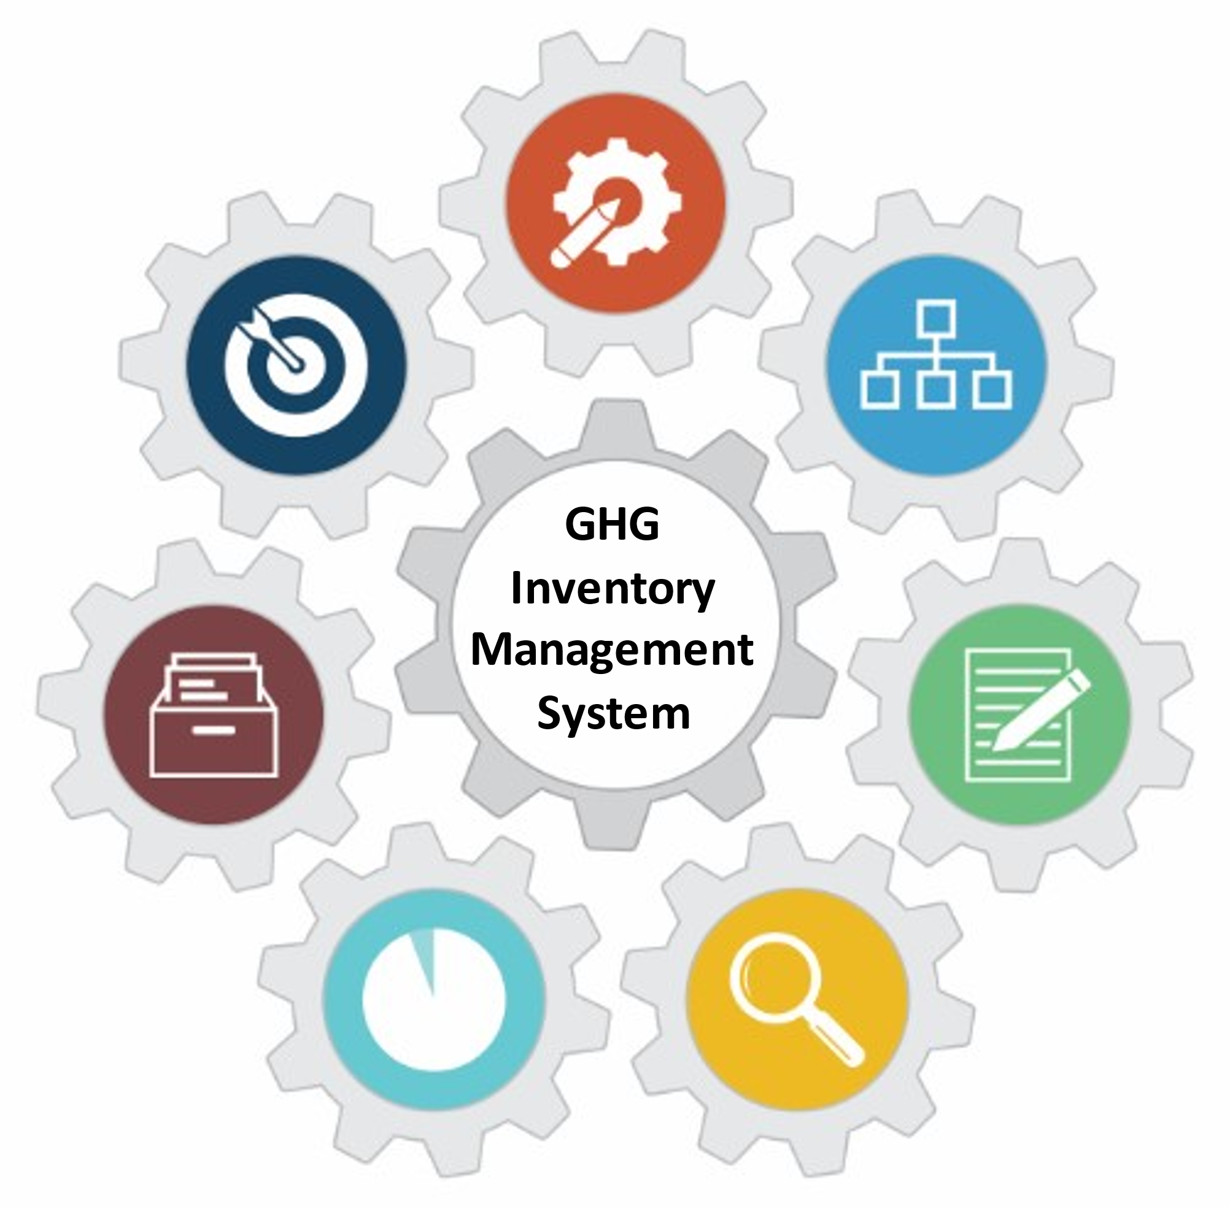

U.S. EPA Toolkit for Building National GHG Inventory Systems

7. National Inventory Improvement Plan
1. Inventory Planning
2. Institutional Arrangements
3. Methods and Data Documentation
4. QA/QC Procedures
5. Key Category Analysis
6. Archiving System
7. National Inventory Improvement Plan
Staff member responsible for populating the template - Contact Information
Name: | [Enter Text] | Organization name:
Title/Position: |  | Organization postal address:
Phone number: |  | Organization web address:
Email: |  | Organization phone number:

Introduction to Template 7. National Inventory Improvement Plan
In the U.S. EPA Toolkit for Building National GHG Inventory Systems (‘Toolkit’), this is Template 7. Its purpose is to help the National Inventory Coordinator (NIC) develop a National Inventory Improvement Plan (NIIP). Every country should have a comprehensive improvement plan including identifying improvements to methods, data, and the inventory system to improve inventory quality over time, including the transparency, consistency, comparability, completeness, and accuracy of subsequent reported national GHG inventories. Beyond identifying improvement projects, the improvement plan should also the assign a priority level to each proposed project. The plan should also provide an explanation of why certain improvement options should be considered high priority (e.g., key categories), outline implementation details (e.g., projected budget and resource needs), and indicate the time horizon for implementation (e.g., near-term such as the next inventory or long-term meaning future inventories). The plan will likely focus on improvements to key categories, consistent with IPCC good practice guidance, any priority capacity-building needs identified during technical analysis of Biennial Update Reports, Biennial Transparency Reports, or other QA/QC processes, and on all other aspects of the inventory as resources permit.
Preparing and reporting an improvement plan is consistent with future reporting requirements under the Enhanced Transparency Framework (ETF). To facilitate continuous improvement, countries should identify, regularly update, and report information on areas of improvement. In addition to areas noted above, improvements should also address capacity constraints related to use of flexibility and in the future, responding to improvements identified by technical expert review teams.

Instructions
The tables in this template may be customized by adding, removing, or modifying columns or rows to better reflect your country’s particular needs or circumstances.
Complete the cells that are shaded this color:

Enter new information about your inventory in black text.
The blue text throughout each template provides detailed instructions and example responses to help you complete the tables. Once the tables are complete, delete all of the blue text throughout the template. The remaining text or tables in black text may be used for reporting or to contribute to a National GHG Inventory System Manual.
Suggested Roles and Responsibilities
The NIC will complete this template after Templates 2 through Template 6 and the inventory have been completed, because this template draws upon the improvement options identified in those templates and during the inventory preparation process. You may also need to adjust your inventory schedule or compilation cycle to facilitate the implementation of improvements. Suggested roles and responsibilities for completing this template are:
- National Inventory Coordinator
  - Complete the template
- Sector/Category Leads
  - Provide input for Table 7-2, as needed
Follow the instructions above each table below to complete this template and prepare a national inventory improvement plan.
National Inventory Improvement Plan
This National Inventory Improvement Plan (NIIP) presents options for improving the national GHG inventory system to support compilation of a high-quality inventory consistent with the 2006 IPCC Guidelines. The NIIP will guide future efforts to increase the transparency, consistency, comparability, completeness, and accuracy of future inventories. It will inform the overall improvement of the national GHG inventory, including strengthening institutional capacity over the coming years. These improvements have been identified through documentation of existing institutional arrangements, category-by-category analyses of methods and data, QA/QC procedures, key categories, and the archiving system.
Table 7-1 identifies the improvement options for this NIIP and their level of priority. Table 7-2 proposes inventory improvement projects, consisting of the high-priority options from Table 7-1.

STEP 1: Compile the list of improvement options in Table 7-1.
Purpose of Table 7-1 | To provide a clear overview of the improvement options identified by the inventory team in Templates 2 through 6 and an explanation of the basis of the assigned priority level.
How to use the table when complete | To guide efforts to increase the transparency, accuracy, consistency, comparability, and completeness (TACCC) of future national GHG inventories.
General instructions | Consolidate all improvements listed in Templates 2 through 6 into this table. Ensure that these improvements include enough identified in Templates 2 through 6. Improvements in these categories need to be specific, not general. Improvements that are too general are unlikely to be completed  Also include improvements suggested during external assessments or reviews (e.g., International Consultation and Analysis). If you or another Party has evaluated your inventory using the Inventory Progress Indicator (IPI) tool, you may also record in Table 7-1 any improvements that would address inventory gaps noted in the evaluation. Add rows to the table as necessary. Improvements in these categories need to be specific, not general. Improvements that are too general are unlikely to be completed.
Instructions by column | Key Category: Record “Yes” if the category to which the issue applies is a key category. Record “No” if it is not a key category. Record “N/A” if the issue does not pertain to an individual category.
 | Category Code and Name: If the relevant improvement is related to methods and data documentation, record the IPCC code and name of the source or sink category to which this improvement relates. The codes are in the 2006 IPCC Guidelines, Volume 1, Chapter 8, Table 8.2, available here: https://www.ipcc-nggip.iges.or.jp/public/2006gl/vol1.html.
 | Issue: Describe the issue and why an improvement is recommended.
 | Improvement Option: Describe what will be done to address the issue.
Priority of Improvement: Indicate the priority of the improvement: High, Medium, or Low.
Explain why this level of priority is warranted. For example, acquiring activity data for a category that has not been estimated to date but is considered to have substantial emissions, will likely be more important than developing a country-specific emission factor for a non-key category.

Consider what your high-level priorities for the GHG inventory should be (e.g., improving completeness, enhancing accuracy with key categories, reducing overall uncertainty, improving time series consistency, increasing transparency, improving data availability, enhancing institutional structures). This may help you decide whether an improvement option should be high-priority.
 | Timing of Improvement: Indicate the timeframe during which the improvement should be made (e.g., short-term/next inventory cycle, long-term/after the next inventory cycle or future inventory cycles).
 | Additional Information Needed for Improvement: Describe any additional information or data needed to implement the improvement.
Table 7-1. Improvement options
Number | Key Category  (yes/no) | Category Code and Name | Issue | Improvement Option | Priority of Improvement | Timing of Improvement | Additional Information Needed for Improvement
1 | [Enter Text]
2
3
4
5
6
7
8
9
10
11
12
13
14
15

STEP 2: Propose high-priority inventory improvement projects, including implementation information in Table 7-2, below.
Purpose of Table 7-2 | To estimate the time and effort (i.e., staff time, services, equipment) that may be required to implement the high-priority options listed in Table 7-1. This should enable budget planning and inform the timing of improvement implementation.
How to use the table when done | To determine which improvement options to implement.
Instructions by column | Number: Identify the number of the improvement from the first column of Table 7-1 and record it here for use as a cross-reference.
Estimated Staff Time (in workdays): Where the Inventory Compilers can contribute to the improvement, enter the estimated staff time required in workdays.

Example: 10 days to complete the improvement (e.g., identification of stakeholders, organize and hold events to secure commitments, establish Memorandum of Cooperation, support study for the development of land-representation maps).
Estimated Cost for Services (in local currency): Enter the cost for services (e.g., studies, laboratory assessments).

Example: 10,000 units of the local currency for the development of land representation maps in cooperation with the Inventory Compilers and stakeholders.
Estimated Cost of Equipment (in local currency): Enter capital and (if applicable) operational cost for equipment required for the improvement.

Example: 1,000 units of the local currency to acquire necessary software applications and sufficient digital storage space.
Reference to Further Information: Include a reference to a more detailed assessment describing required implementation actions and estimated costs, where applicable.

Example: See project proposal to review data for enhanced characterization of livestock
 | Responsible Staff: Enter the name of the staff member responsible for the implementation of the improvement project.

Table 7-2. Potential high-priority projects for improving the national GHG inventory
Number  (from Table 7-1) | Estimated Staff Time  (workdays) | Estimated Cost for Services  (local currency) | Estimated Cost of Equipment  (local currency) | Reference to Further Information | Responsible Staff
[Enter Text]

Revision History
June 2022: Updated text and graphics for clarity. Updated formatting to improve accessibility and usability.

See 18/CMA.1, Modalities, Procedures and Guidelines (MPGs), Annex Chapter II, Section D. Facilitating improved reporting and transparency over time, available at https://unfccc.int/sites/default/files/resource/CMA2018_03a02E.pdf.

