Community Description Example and Template
The Community Description sub-section of the EE Grant application asks applicants to provide information that determines whether one or more of their target community(ies) and the populations they aim to serve meet this solicitation’s definition of underserved communities (see Section I (C) of solicitation to review definition of underserved communities). Responses should clearly identify sources of information used. The table below serves as an example of how this information can be organized within the Community Description sub-section of your application.
Community Description Example
Target Communities
Location Details |  |  | Underserved Community Status
City/Town & State | County | Census Tract Code | High Poverty Area  (Poverty Rate) |  | Persistent Poverty County | Title I School Participation  (# and Name) | Climate and Economic Justice Screening Tool
 |  |  | By County | By Census Tract
Park Town, MD | Prince George’s County | *********** | Yes  20.66% | NA | Yes2 | Yes (2 – East Elementary School, West Middle School)3 | 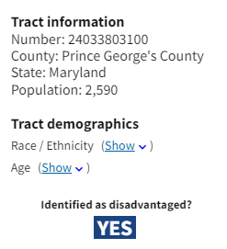4
Silver Spring, MD | Montgomery County | *********** | No | Yes  34.86%5 | No | No | 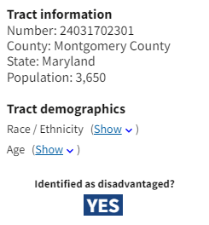6
Tree City, VA | Fairfax County | *********** | No | No | No | Yes  (1 – Long Branch Middle School)7 | 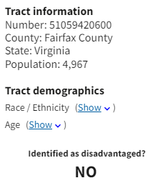

Optional Community Description Template
The template below is provided as a reference, and grant applicants are not required to use it. Grant applicants may develop their own format for providing information that determines whether one or more of their target community(ies) and the populations they aim to serve meet this solicitation’s definition of underserved communities.

Target Communities
Location Details |  |  | Underserved Community Status
City/Town & State | County | Census Tract Code | High Poverty Area  (Poverty Rate) |  | Persistent Poverty County | Title I School Participation  (# and Name) | Climate and Economic Justice Screening Tool
 |  |  | By County | By Census Tract

Data from the 2017-2021 American Community Survey at https://www.census.gov/acs/www/data/data-tables-and-tools/narrative-profiles/
2 Data from Congressional Research Service’s The 10-20-30 Provision: Defining Persistent Poverty Counties (updated February 27, 2023) at https://crsreports.congress.gov/product/pdf/R/R45100
3 Data from National Center for Education Statistics Search for Schools and Colleges at https://nces.ed.gov/globallocator/
4 Data from the Council on Environmental Quality’s Climate and Economic Justice Screening Tool at https://screeningtool.geoplatform.gov/en#12.94/38.9251/-76.9282
5 Data from EPA’s Environmental Justice Screening and Mapping Tool at: https://ejscreen.epa.gov/mapper/
6 Data from the Council on Environmental Quality’s Climate and Economic Justice Screening Tool at https://screeningtool.geoplatform.gov/en#12.94/38.9251/-76.9282
7 Data from National Center for Education Statistics Search for Schools and Colleges at https://nces.ed.gov/globallocator/

