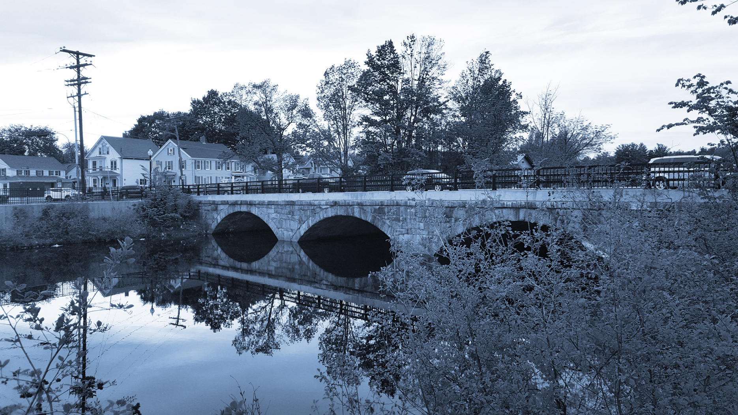
Long-Term Stormwater Planning
Part of the Suite of Integrated Planning Resources
Characterize Existing Systems

Worksheet 4: Mapping and Data Management
This worksheet is part of a series of 10 worksheets referenced in Long-Term Stormwater Planning: A Voluntary Guide for Communities. The worksheets present questions and prompts for each step in the planning process to help communities document their process and decisions. They are intended to be an easy-to-use tool that a community can reference; populate; expand upon; and even incorporate directly into an integrated plan, long-term stormwater plan, or other community plan.
This worksheet supports one of the first parts of the planning process, which is assessing where you are now. Answering the groundwork questions in the worksheet below will help characterize your existing mapping and data management systems and identify any data gaps. Remember that the long-term stormwater planning process should be tailored to your community. Feel free to add questions and/or modify this worksheet to best suit your needs.
This worksheet helps a community to characterize existing systems as part of Element 2 of the Integrated Planning Framework.

Groundwork Questions to Characterize Existing Mapping and Data Management Systems
Groundwork Questions | Response
What types of stormwater assets (e.g., pipes, catch basins, ponds, outfalls, green infrastructure) does your community have?
Are your community’s stormwater assets fully, partially, or not mapped?
What types of assets are mapped?
How do you document mapped assets (e.g., hardcopy, GIS)?
Are stormwater assets tracked via another method outside of mapping?
Who is responsible for tracking stormwater asset data and how are the data updated?
Have you fully characterized the capacity, condition, and age of your existing stormwater system?
Do you have the data and capability to perform stormwater system modeling?
If yes, note examples of prior or future modeling efforts. If no, note what data gaps exist and describe examples of your desired system modeling capabilities.
Does your community have an asset management program for stormwater or other water-related utilities?
If so, describe what aspects of stormwater management are included in the asset management approach.
If relevant to your goals (or if you are performing long-term stormwater planning as a part of integrated planning) can you characterize the flows going in and out of the stormwater system? If not, identify the data needed to do so.
What stormwater asset data gaps exist that need to be filled as a part of your long-term stormwater planning process?

