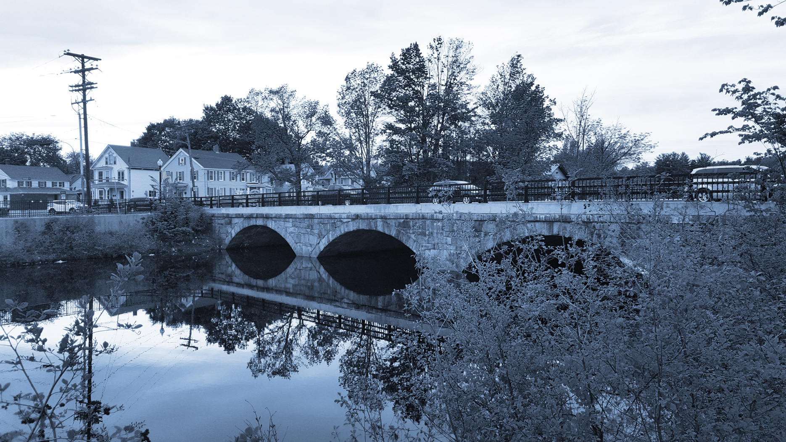
Long-Term Stormwater Planning
Part of the Suite of Integrated Planning Resources
Develop, Evaluate, and Select Preferred Alternatives

Worksheet 9: Financial Needs
This worksheet is part of a series of 10 worksheets referenced in Long-Term Stormwater Planning: A Voluntary Guide for Communities. The worksheets present questions and prompts for each step in the planning process to help communities document their process and decisions. They are intended to be an easy-to-use tool that a community can reference; populate; expand upon; and even incorporate directly into an integrated plan, long-term stormwater plan, or other community plan.
This worksheet is part of the middle portion in the planning process: analyze opportunities. Filling it in will help create a snapshot of funding needs for an entire stormwater program. You will need to gather and analyze a variety of information to do so, but keep in mind that the long-term stormwater planning process—and therefore this worksheet—should be tailored to the needs of your community. That means you may want to remove sections or rows from it that aren’t relevant, rather than spending time gathering that information. You may also need to add rows or make other changes to better capture information that is part of your focus.
Information on the activities and corresponding budgets may come from various sources: budgeting documents, stormwater program records, individual staff knowledge, and others. This information can be updated over time as more data become available.
This worksheet helps a community develop, evaluate, and select preferred alternatives as part of Element 4 of the Integrated Planning Framework.

Financial Needs
Item No. | Stormwater-Related Activity | Department Responsible | Annual Budget (Estimate) | Source of Budget (Estimate) | Other Notes  (e.g., Is Additional Budget Expected?)
Administration and Finance
1 | Budgeting and accounting (for general fund allocation for stormwater activities)
2 | Customer service (e.g., complaint hotline related to stormwater)
3 | Stormwater utility administration
4 | Documentation and recordkeeping (e.g., work orders, hard copy maps)
5 | Stormwater consultant fees
Operation and Maintenance
6 | Street sweeping
7 | Catch basin/inlet cleaning
8 | Stream channel cleaning
9 | Storm sewer cleaning and televising
10 | Complaint response
11 | Emergency response
12 | Street maintenance  (e.g., drainage infrastructure maintenance during street repairs)
13 | Bank stabilization repairs
14 | Inspections of structural and non-structural best management practices (BMPs) on public property
15 | Maintenance for structural and non-structural BMPs on public property
16 | Major capital storm sewer system improvements
17 | Minor capital storm sewer system improvements
18 | Land, easement, and right-of-way purchase
19 | Construction management for drainage improvements
Regulatory Compliance and Enforcement (If Any)
20 | MS4 program—public education and outreach (e.g., educational materials development and distribution)
21 | MS4 program—public involvement (e.g., household hazardous waste events, community hotline)
22 | MS4 program—illicit discharge detection and elimination (e.g., outfall screening, mapping, cleaning up illegal dumping)
23 | MS4 program—construction site runoff control (e.g., erosion and sediment control inspections)
24 | MS4 program—post-construction runoff control (e.g., stormwater control inspections and maintenance)
25 | MS4 program—municipal facility pollution prevention/good housekeeping (e.g., facility inspections)
26 | MS4 program—surface water quality (e.g., rivers and streams) monitoring program
27 | MS4 program—reports (e.g., stormwater management plan, annual report)
28 | Inspections of industrial and commercial facilities
29 | Fertilizer management program expenditures
30 | General watershed management activities
31 | Offsite stormwater management program expenditures
32 | Other MS4 program expenditures
Engineering and Planning
33 | Design of structural and non-structural BMPs (public projects)
34 | Stream restoration (e.g., bank stabilization efforts)
35 | Asset management
Development Support Services
36 | Plan review to ensure projects meet stormwater design criteria and standards (private projects)
37 | Erosion and sediment control inspection services for construction projects (private projects)
38 | Field acceptance inspections to ensure construction meets city standards (private projects)
39 | Stormwater code enforcement
Flood Management
40 | Flood insurance program support
41 | Flooding hazard mitigation
Geographic Information System (GIS) and Technology Support
42 | GIS licenses
43 | GIS staff time for stormwater program assistance
44 | System mapping
45 | Data management
46 | Stormwater website design and support
47 | Asset management—software licenses
Staff Training/Certification
48 | Specific technical training/‌certification

