[Important note: The information provided below are example responses to common questions and should be thoroughly reviewed and customized to suit the specific information about the water system/community. Systems can update the program name and should include relevant contact information for your water system. Not all of these questions will be applicable to all water systems. Information in yellow highlight and italics should be modified or removed before this document is distributed to customers.]

Drinking Water Lead Reduction Program Frequently Asked Questions

What is the <Drinking Water Lead Reduction Program>?
<System name> is committed to reducing the risk of lead exposure from drinking water. We are doing all we can to protect our customers and give you information along with steps you can take to reduce your exposure. This program includes <insert information on steps the water system is taking or planning to take (e.g., taking corrosion control steps, developing an inventory of service line materials, replacing lead service lines, providing third-party certified point-of-use or pitcher filters for lead reduction such as ANSI/NSF 53 and particulate removal such as ANSI/NSF 42, and continuing outreach and education to our customers)>. For more information on our program, please see the section on Additional Questions below.

Lead in Drinking Water Basics

What is lead and why is it a health concern?
Lead is a naturally occurring element found in small amounts in the earth’s crust. It is also a toxic, soft metal that can be found in paint, dust, air, soil, food, and water, and can be harmful to human health. There is no safe level of exposure to lead in drinking water. Lead is persistent, and it can bioaccumulate in the body over time. Exposure to lead in drinking water can cause serious health effects in all age groups. Infants and children can have decreases in IQ and attention span. Lead exposure can lead to new learning and behavior problems or exacerbate existing learning and behavior problems. The children of women who are exposed to lead before or during pregnancy can have increased risk of these adverse health effects. Adults can have increased risks of heart disease, high blood pressure, kidney, or nervous system problems.

How does lead get into drinking water?
Lead can enter drinking water when plumbing materials that contain lead corrode. The most common sources of lead in drinking water are lead and galvanized pipes, faucets, and fixtures. In homes served by lead services lines, these pipes are typically the most significant source of lead in the water. Lead can attach to the inner surface of galvanized service lines and be released into drinking water over time. Service lines made of galvanized iron or steel that are (or were previously) downstream of lead service lines are classified as galvanized requiring replacement (GRR). Identifying and ultimately removing lead and GRR service lines is an important way to protect public health.

What is a water service line?
A water service line is the pipe that connects the water main to your home or building inlet. Service lines may be made of copper or other materials such as galvanized iron or steel, plastic, brass, or lead. If any portion of the pipe is made of lead, it is called a lead service line (LSL).

Is water the only source of lead in houses and buildings?
No. While water may be a source of exposure to lead in houses and buildings, lead-based paint, dust, contaminated soil, lead-glazed pottery, and some toys and jewelry may also contain lead. Lead-based paint and lead-containing toys pose a significant risk especially for young children. For more information on protecting your family from lead in your home, please visit: https://www.epa.gov/lead/protect-your-family-sources-lead.

Reducing Lead Exposure

What can I do to reduce my exposure to lead from my drinking water?
Below are recommended actions that you may take, separately or in combination, if you are concerned about lead in your drinking water. The list is not intended to be a complete list or to imply that all actions equally reduce lead from drinking water.
Have your water tested
Contact <system name> to have your water tested and to learn more about the lead levels in your drinking water.
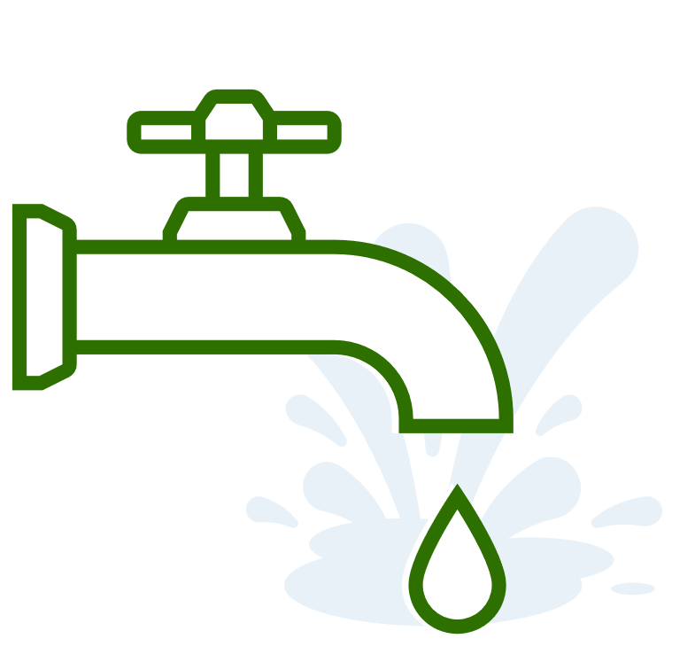 | Run your water  The more time water has been sitting in your home’s pipes, the more lead it may contain. Before drinking, flush your home’s pipes by running the tap, taking a shower, doing laundry, or doing a load of dishes. The amount of time to run the water will depend on whether your home has a lead service line or not, and the length of the lead service line. Residents should contact their water utility for recommendations about flushing times in their community. <Insert utility recommendations on how long to flush pipes.>
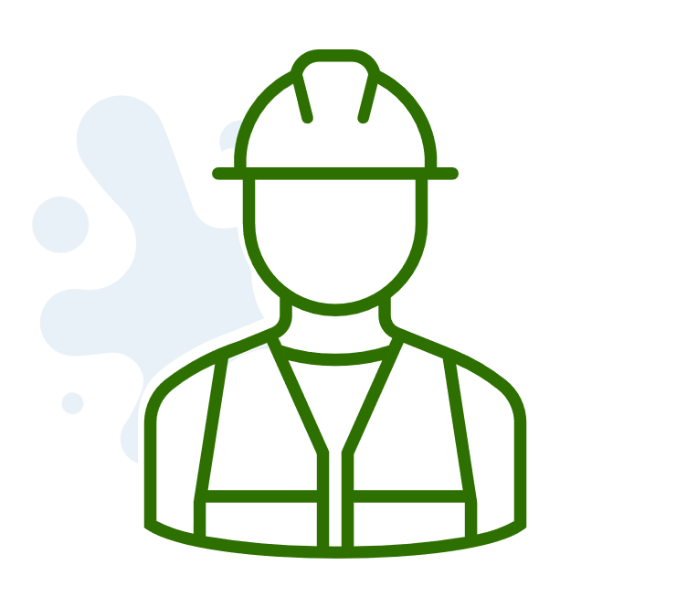 | Learn about construction in your neighborhood  Be aware of any construction or maintenance work that could disturb your lead service line. Construction may cause more lead to be released from a lead service line.
Use cold water
Only use cold water for cooking, drinking, and making baby formula. Hot water dissolves lead more quickly than cold water.
Clean your aerator regularly
Aerators are small attachments to faucet tips which regulate water flow. Your aerator can accumulate lead particles which can contaminate your water so it should be cleaned regularly.
Use your filter properly
If you use a filter, make sure that is certified by a third-party certifier to remove lead. Check the filter and cartridge packaging for these certifications. Read the directions to learn how to properly install and use your cartridge and when to replace it. Using the cartridge after it has expired can make it less effective at removing lead. Do not run hot water through the filter.
Work with your service provider to identify and/or assist replacing lead or GRR service lines.
<For water systems that are conducting programs to identify service line materials and/or replacement programs, provide information on how customers can find more information on these programs and opportunities to have their lead or GRR service lines replaced. This can include replacement and funding opportunities through state or water system programs.>
Get Your Child Tested to Determine Lead Levels in His or Her Blood
Your healthcare provider and your public health agency <insert name and link to public health agency contact information> can provide information about how you can have your child's blood tested for lead. The Centers for Disease Control and Prevention recommends that public health actions be initiated when the level of lead in a child’s blood is 3.5 micrograms per deciliter (µg/dL) or more.

How do I know if my home has a lead service line, GRR service line, or lead plumbing?
1) You can call <system name> and we may be able to provide you with information about whether you have a lead or GRR service line. <Insert contact information for utility and/or website of any publicly accessible lead service line inventory.>
2) A licensed plumber may be able to assess your faucets, fixtures, and service line for lead.
3) EPA has developed an online step-by-step guide, Protect Your Tap, to help people identify lead pipes in their homes. The online tool is located at www.epa.gov/pyt. <Insert information about the system also sending a factsheet with instructions on how to identify the service line material if applicable (Customer Guide to Identifying Lead Service Lines).>

Can I shower in lead-contaminated water?
Yes. Bathing and showering should be safe for you and your children. Human skin does not absorb lead in water.

Is it safe to wash dishes and do laundry?
Yes, but dry them after. Wash dishes, bottles, and toys with soapy water. Dry before use. Lead in water will not be absorbed by porcelain, metal, or glass. Clothes washed in plain tap water will not contain enough lead to cause harm.

Additional Questions on Our Lead Reduction Program
<These are additional questions that you as a utility may include, tailor, or remove based on applicability to your system and reduction program. These are also not meant to be all encompassing and you may have additional questions to incorporate.>

What does <system name> do to protect my household from lead?
<Insert information on efforts to reduce lead in drinking water (examples may include monitoring lead levels, corrosion control, providing filters). Please list LSLR programs/opportunities first if applicable.>

How does the filter program work?
<If your system has a program to provide filters, describe the way the program works here, including when and how customers can request filters, frequency of replacement cartridges, details about type of filter provided, costs (or lack of costs) to customers, etc.> Water filters can be an effective way to reduce lead in water if the filters are certified, properly installed and maintained. <Be sure to explain that they are certified, state what style(s) you are providing, mention other options if you are only distributing one type.>

How is <system name> identifying lead service lines?
<Insert information on service line inventory activities the water system is doing and how the public can access service line information. Be sure to include relevant contact information for your water system.>

How is <system name> prioritizing lead service lines for replacement?
<Insert information on your prioritization efforts.>

How and when are customers being notified about the lead service line replacement program?
<Insert information on customer notification processes on when the lead service line replacement program will occur.>

What is the replacement process for my lead service line?
<Insert information on replacement process, information may include pre-replacement assessment, when the replacement will take place, and who will perform the replacement.>

Where can I go to ask questions and get more information?
More information about the <Drinking Water Lead Reduction Program> can be found at <system website>. For more information on lead in drinking water, visit: https://www.epa.gov/ground-water-and-drinking-water/basic-information-about-lead-drinking-water. <Insert state agency website if applicable.>

