Customer Guide for Identifying Service Lines
[Important note: this is an example template that water systems can use to provide information to customers to help them identify the material used in their service line. You can customize this notice for your individual water system. Not all sections may be applicable to your system. Information in yellow or dark blue highlight and italics should be modified or removed before this document is distributed to customers.]

What is a water service line?
A water service line is the pipe that connects the water main to your home or building inlet. Service lines may be made of copper or other materials such as galvanized iron or steel, plastic, brass, or lead. If any portion of the pipe is made of lead, it is called a lead service line (LSL).

Why is it important for me to check if my home has a lead or galvanized service line?
Lead is a toxin that poses serious health risks, and infants, young children, and pregnant people are particularly vulnerable to lead exposure. Lead service lines and plumbing materials (including solder, fixtures, and faucets) are the most common sources of lead in a home’s drinking water. Galvanized iron or steel pipe can pose a risk if it has ever been connected downstream of a lead service line, as lead can attach to the inner surface of galvanized steel and be released into drinking water over time. Service lines made of galvanized iron or steel that are (or were previously) downstream of LSLs are classified as galvanized requiring replacement (GRR) service line. For more information on the health effects of lead visit the Environmental Protection Agency’s (EPA) website https://www.epa.gov/ground-water-and-drinking-water/basic-information-about-lead-drinking-water.

Steps to check the materials of the service line.
Does <system name> have information on your service line material? <Water system specific information: Include a statement as to why customers may want to check what information the water system has on their service line, such as “If you are interested to find what records we have about your service line…” Describe any available resources customers can use to check their pipe material. For example, does the utility have service line inventory data publicly available (e.g., GIS map, online spreadsheet or documents)? Should customers contact their water system?>

The following steps will help you determine what the pipe in your home is made of and/or information on how to send the <system name> a photo of your service line for verification (regardless of if you are able to determine the material yourself). <The following guidance will work for most utilities and building configurations but not all. Consider adding instructions or tailoring them based on your customer’s needs, and your state's requirements.>
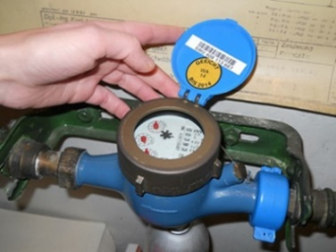 | 1. Find your water meter: Your water meter may be located inside or outside of the building.  - Typical inside locations include the basement, crawl space, or garage.  - Typical outside locations are between the water main in the street and the house, on the sidewalk, or in the yard.
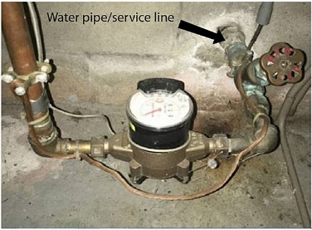 | 2. Find your service line  - If your meter is inside, the service line will enter the house near the meter, on the same wall.  - If your meter is outside, the service line most likely enters the house at a point closest to the meter.  - If your service line is not visible, contact your water system for guidance.
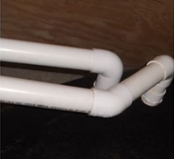 | 3. Identify your service line material  Plastic: The pipe is typically white or gray but can also be other colors. Although plastic does not contribute to lead in drinking water, lead may still be present in other parts of the plumbing system such as faucets and bonding material called solder.
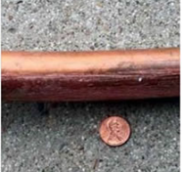 | Metal: To find out what kind of metal pipe you have, perform two simple tests 1) a scratch test with a coin or key and 2) a magnet test. You will need a key and/or penny and a magnet for these tests.  First, use the coin or key to gently scratch the pipe close to where it comes in through the wall or floor. Then, place the magnet on the pipe and see if it sticks. Using the information below, you can determine what your pipe is made of Copper. After scratching, if the pipe is the same color as a penny and may have a solid or splotchy film, varying in color from bright green to dark brown, you may have a copper pipe. A scratch test on copper pipe will expose a shiny copper penny color. If you place the magnet on the pipe and it does not stick, this confirms this is not copper.
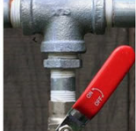 | 3. Identify your service line material (continued)  Galvanized iron or steel. If the pipe is silver or gray, hard to scratch with a key or coin you may have an iron or steel pipe. If you place a magnet on the pipe and it sticks to the pipe, you may have galvanized steel pipes.
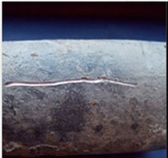 | Lead. If a scratch test produces a shiny silver color, your pipe is likely made of lead. If you try to attach the magnet to the pipe and it does not stick, you may have a lead pipe.

How do I submit my test results to my water system?
<Add information on how customers can submit their information and photo of service line to the water system.>

Contact Information
<Add system contact information.>

Resources
EPA’s Protect Your Tap tool can be found here: https://www.epa.gov/pyt.
For more information on health effects of lead and steps you can take to reduce exposure, visit EPA’s website here: https://www.epa.gov/ground-water-and-drinking-water/basic-information-about-lead-drinking-water.

